Physiologically-based Pharmacokinetic Modeling as a New Approach Methodology for Monoclonal Antibodies
Krina Mehta^{1,2,} Akshat Shah^{1,3}, Stephan Schaller⁴
¹ NAMLink, Cypress, CA, USA
² Enveda Therapeutics Inc., Boulder, CO, USA
³Aivaura, Bhavnagar, Gujarat, India
⁴ ESQlabs GmbH, 26683 Saterland, Germany

Abstract
Monoclonal antibody (mAb) pharmacokinetics (PK) is governed by mechanistically well-characterized processes, making physiologically based pharmacokinetic (PBPK) modeling well suited to support human PK prediction. We evaluated whether in vitro-informed “a priori” PBPK modeling can predict first-in-human mAb PK and serve as a new approach methodology (NAM) to reduce reliance on monkey PK studies.
A semi-automated PK-Sim/MoBi–R workflow integrated molecule-specific FcRn binding, target binding, target expression/turnover, and internalization with monkey and human physiology. Intravenous single-dose PK data for eight mAbs across five targets were used for retrospective evaluation. PBPK simulations were performed without fitting to monkey PK data and compared with observed Cmax and AUC0-28d, used to assess the predominantly linear elimination component, and terminal clearance, used to assess nonlinear target-mediated elimination. As a benchmark, monkey-fitted quasi-steady-state TMDD models were translated to humans. For mAbs with at least one “a priori” monkey AUC0-28d prediction outside two-fold criteria, reduced monkey PK designs were evaluated using virtual population simulations with top-down models as the reference.
“A priori” PBPK predictions were within two-fold of observed data for XYZ% of monkey Cmax, XYZ% of monkey AUC0-28d, and XYZ% of monkey terminal clearance values. For human predictions, the corresponding proportions were XYZ%, XYZ%, and XYZ%, compared with XYZ%, XYZ%, and XYZ%, respectively, for monkey-fitted TMDD translation. For the four mAbs whose “a priori” prediction fell outside twofold for at least one dose level, reduced-study simulations (two dose groups of two animals each) recovered the reference AUC0-28d within twofold in XYZ% of replicates, suggesting feasibility of reduced monkey PK studies for mAb PK characterization. These findings support “a priori” PBPK as a practical NAM for mAb PK translation and for targeted reduction of monkey PK studies.

Introduction
Adequate characterization of pharmacokinetics (PK) is crucial for a successful drug development program because it is the quantitative link between administered dose, systemic and tissue exposure, target engagement, pharmacodynamic (PD) response, and safety [1]. For monoclonal antibodies (mAbs) and other protein therapeutics, systemic and tissue exposures depend on target-mediated drug disposition (TMDD), neonatal Fc receptor (FcRn)-mediated recycling, and tissue distribution processes that can differ across species. Physiologically-based pharmacokinetic (PBPK) modeling is a mechanistic modeling approach that integrates species-specific physiology with drug- and target-specific parameters to simulate PK. For mAbs, PBPK models incorporate key determinants of disposition, including vascular convection, lymphatic return, tissue partitioning, pinocytosis, FcRn binding and recycling, proteolytic catabolism, target binding, target turnover, and target-receptor complex internalization, into a quantitative framework [2, 3, 4]. Overall, extensive work on PBPK models for mAbs has already established a robust scientific foundation, enabled reliable characterization of their PK, and supported their regulatory acceptance.
Momentum for new approach methodologies (NAMs) has increased exponentially since the FDA's April 2025 Roadmap to Reducing Animal Testing in Preclinical Safety Studies [5, 6, 7, 8]. Within this evolving regulatory infrastructure, current NAM-focused investment has focused on establishing context-of-use (COU) frameworks, advancing complex in vitro systems (organoids, microphysiological systems, organ-on-chip platforms), and AI/ML-based computational toxicology tools. On the other hand, preclinical evaluations are increasingly being framed around whether human-relevant biological pathways are perturbed at clinically meaningful plasma and tissue exposure levels. Plasma and tissue exposures therefore provide a common quantitative measure for integrating in vitro dose-response data, in silico simulations, prior clinical knowledge, biomarkers, and safety thresholds. For example, in vitro findings from cell-based or microphysiological systems can be contextualized through predicted human concentration-time profiles, exposure margins, and time above biologically active or adverse effect thresholds [9, 10, 11, 12]. In this context, mechanistic PBPK models are uniquely positioned to bridge NAM-derived biological observations with quantitative predictions of human plasma and tissue exposure. A recent FDA/CDER landscape analysis of 15 years of NAM-related submissions found that 93% fell into the in vitro and in silico categories broadly, though this landscape analysis does not break out mechanistic PK/PD/safety modeling, such as PBPK, as distinct categories, leaving their specific representation within the NAM submission landscape unclear [13]. By contrast, mechanistic modeling approaches, such as, PBPK, quantitative systems pharmacology (QSP), and quantitative systems toxicology (QST), despite an established and steadily growing regulatory submission record under the parallel model-informed drug development (MIDD) paradigm and demonstrated translational utility [7, 14], have received comparatively limited dedicated attention within the emerging NAM ecosystem, representing both a gap and an opportunity. Overall, the emerging NAM ecosystem presents a significant opportunity for greater integration of mechanistic modeling approaches.
Focusing on mAb PK characterization and the role of mechanistic PK modeling, although a scientific framework for mAb PBPK exists, preclinical PK characterization mostly relies on PK studies in monkeys (often cynomolgus monkeys). A traditional mAb development program typically includes preclinical PK evaluations in at least two studies: an exploratory single-dose PK study (n =12-18 monkeys) and a definitive repeat-dose PK study (n = 12-24 monkeys). Together, these studies generally require a minimum of 24–42 monkeys per mAb development program. The scientific maturity of mAb PBPK modeling has advanced to the point where “a priori” PK predictions based on in vitro data can be considered for prospective evaluation in preclinical development workflows, as NAMs. Published examples have shown that mAb-specific in vitro measurements, together with species physiology and FcRn-mAb interaction-related parameters, can support prediction of mAb linear PK without in vivo data [15, 16]; however, these frameworks did not incorporate target-mAb interactions governing nonlinear, target-mediated clearance. Although some mAbs exhibit linear PK at dose range of interest, target-mediated drug disposition is inherent to therapeutic antibodies. For example, at high doses, even mAbs known to exhibit non-linear PK can appear linear upon target saturation, and at low doses, even mAbs known as linear may show nonlinearity. Overall, extending “a priori” PBPK frameworks to incorporate target-mediated disposition is therefore important for their broader application as NAMs with the potential to reduce preclinical monkey studies across the full range of mAb PK profiles.
The objectives of this manuscript were, (1) to perform a retrospective, proof-of-concept analysis of “a priori” PBPK modeling as a NAM to support human PK predictions for mAbs, (2) to perform population simulations of preclinical monkey study designs to investigate feasibility of reduced sample size and number of dosing groups to characterize mAbs PK.

Methods

Data
Pharmacokinetic profiles for eight monoclonal antibodies, spanning across 5 different targets, following intravenous dosing in monkeys and in humans were digitized from literature using webplotdigitizer tool [https://automeris.io/]. For most of the monoclonal antibodies included in the analysis, the literature sources did not specify whether the digitized concentration data represented free or total antibody. In vitro experimental parameters relevant to drug-FcRn binding, drug-target binding, drug-target complex internalization rate, and target reference concentrations were obtained through literature search. Digitized data, parameter values, measurement methods, assumptions, and source references are provided in Supplementary material 1.
“A priori” PBPK Approach
A large molecule structural model was first incorporated in PK-Sim, including its binding to FcRn and to a generic target. The model was exported to MoBi and TMDD processes were added using a modular approach [17]. Next, we created target expression profiles in monkeys and humans for each of the targets including relevant localization. PKML simulation files containing generic large molecule PK model and target expressions, one file per target and species (monkey or human), were exported [18, 19]. IV single dose simulations were performed using R scripts using esqlabsR and ospsuite packages [20, 21]. Exposure metrics (Cmax, AUC0-28d, and terminal clearance) and fold errors were calculated for each molecule and dose level, where observed data were available. Full details of the workflow and all files and codes are provided in Supplementary material 1. Cmax and AUC0-28d were used as markers of the predominantly linear elimination component. Terminal clearance was calculated as total intravenous dose divided by AUCinf and was used as a marker of nonlinear target-mediated elimination.

Top-Down TMDD Approach for Comparison
In the top-down TMDD modeling approach, a quasi-steady-state (QSS) TMDD model was fitted to monkey PK profiles for each molecule using the nlmixr2 and rxode2 packages in R. In the model, clearance (CL), central volume (Vc), intercompartmental clearance (Q), peripheral volume (Vp), and proportional and additive residual-error terms were estimated. Molecule-specific TMDD parameters, including target reference concentration, binding kinetics, target degradation rate (kdeg), and internalization rate constant (kint), were fixed to literature-derived monkey input values. The same molecule-specific in vitro inputs used in the “a priori” monkey PBPK approach were used for the top-down monkey fits.
Human PK predictions were generated by translating the final Run 4 monkey TMDD model to humans. Monkey CL and Q estimates were allometrically scaled with an exponent of 0.85, while Vc and Vp were scaled with an exponent of 1.0. All molecule-specific TMDD inputs used in the human simulations—including target reference concentration, binding affinity (KD), dissociation rate (koff), target degradation rate (kdeg), and internalization rate constant (kint)—were obtained from the human parameter dataset, and the human QSS binding constant was recalculated from the human kinetic inputs. Simulated monkey and human Cmax, AUC0-28d, and terminal clearance values were compared with observed values, and fold-errors were calculated.
Evaluating Reduced Monkey PK Study Designs Using Simulations
To evaluate appropriateness of reduced PK studies (sample size and dose groups) in case “a priori” PBPK predictions fall out of 2-fold, monkey PK study simulations were performed. Molecules with at least one a priori AUC0-28d fold-error outside the 2-fold interval were considered cases where a reduced monkey PK study would be needed. For these molecules, the observed-informed top-down monkey model was used as the retrospective reference for monkey PK. A virtual population of 100 monkeys was generated by sampling body weights using a normal distribution (mean 4 kg, sd 0.8) and parameters of top-down models for the selected molecules incorporating 30% inter-individual variability in all parameters (estimated and fixed in top-down simulations above). Reduced PK studies were simulated by sampling small groups (2, 3, 4, and 5) of animals and practical sampling timepoints (hrs 0.25, 1, 2, 4, 8; day 1, 2, 6, 10, 14, 21, 28) from a virtual population. Two (0.3 and 10 mg/kg) and three (0.3, 3, and 10 mg/kg) dose groups were simulated for all molecules. Simulated study geometric mean AUC0-28d values were compared with the full top-down population geometric mean AUC0-28d calculated using rich sampling timepoints (hrs 0.25, 0.5, 1, then once every hour upto 28 days) and sample size of 100. This reduced-study analysis intentionally used AUC0-28d as a marker of the predominantly linear elimination component and did not use terminal clearance as a design-selection criterion.

Results

Comparing “a priori” PBPK with Top-Down TMDD Approach for Human PK Predictions
Both “a priori” PBPK and top-down TMDD approaches were first compared in monkeys to evaluate how well each workflow reproduced the PK data (Table 1). Across the 8 drugs and 14 dose levels evaluated, the “a priori” PBPK predictions captured the markers of predominantly linear elimination with 13 of 14 Cmax values within two-fold of observed data (accuracy 0.93) and 8 of 14 AUC0-28d values within two-fold (accuracy 0.57). For terminal clearance, used as a marker of nonlinear target-mediated elimination, 8 of 14 “a priori” predictions were within two-fold (accuracy 0.57). As expected, the final Run 4 top-down TMDD model, which estimated CL, Vc, Q, and Vp while fixing molecule-specific TMDD inputs, reproduced all 14 monkey Cmax, all 14 monkey AUC0-28d, and all 14 monkey terminal-clearance values within two-fold (accuracy 1.00 for each metric). Human PK predictions from the “a priori” PBPK workflow were then compared with those translated from the monkey top-down TMDD model (Figures 1, 2, and 4; Tables 1 and 2). For the predominantly linear elimination markers, 29 of 30 human Cmax predictions from “a priori” PBPK were within two-fold (accuracy 0.97), compared with 27 of 30 top-down TMDD predictions (accuracy 0.90), while 25 of 30 human AUC0-28d predictions from “a priori” PBPK were within two-fold (accuracy 0.83), compared with 26 of 30 top-down predictions (accuracy 0.87). For terminal clearance, 23 of 30 “a priori” PBPK predictions were within two-fold (accuracy 0.77), compared with 28 of 30 top-down predictions (accuracy 0.93). Thus, top-down translation provided a one-dose improvement in AUC0-28d and a five-dose improvement in terminal-clearance accuracy, but lower Cmax accuracy. Although top-down fitting improved recovery of monkey PK data, it did not provide a consistent advantage for human prediction across all metrics, supporting the conclusion that the “a priori” PBPK framework captured the major mechanistic determinants of human mAb disposition sufficiently well in this dataset.
Evaluating Reduced Monkey PK Study Designs Using Simulations
Based on the “a priori” PBPK simulations, four of the eight evaluated mAbs, atezolizumab, avelumab, nivolumab, and pembrolizumab, had at least one dose level with an AUC0-28d prediction outside the prespecified two-fold criterion. These molecules were therefore carried forward into the reduced-study simulation analysis. Across the four molecules and simulated dose levels, reduced-study designs robustly recovered the reference AUC0-28d derived from the full top-down virtual population with rich sampling. For sample sizes of 2 to 5 animals per dose group, evaluated using both two-dose and three-dose designs, the probability that the reduced-study geometric mean AUC0-28d remained within two-fold of the model-based full-population geometric mean AUC0-28d was 100% across all molecules and dose levels (Figure 3). The 5th–95th percentile fold-error intervals also remained well within the two-fold interval, further supporting the adequacy of the reduced PK design under the simulated variability assumptions.
Both the two-dose and three-dose designs achieved 100% success across all simulated replicates and evaluated sample sizes. Therefore, increasing the sample size beyond two animals per dose group or adding a third dose group did not improve performance against the prespecified AUC0-28d recovery criterion in these simulations. Overall, these results support a reduced, PBPK-informed monkey PK study design, for example, two dose groups with two animals per group, as a practical confirmatory strategy (Figure 5).

Discussion
In this retrospective, proof-of-concept analysis, the “a priori” PBPK approach showcased similar human predictive performance as compared to top-down monkey to human translation approach for first-in-human PK prediction of mAbs. The results support the feasibility of using mechanistic PBPK approach, informed by in vitro parameters as an early translational tool for human mAb PK prediction and as a basis for reducing reliance on conventional monkey preclinical PK studies. Using the prespecified illustrative study-design comparison, the proposed workflow was estimated to substantially reduce the animal use required for mAbs’ PK characterization. A conventional single-dose preclinical PK study design consisting of at least 3 animals per dose group and 5 dose groups would require at least 15 animals for single-dose PK study, whereas the reduced design would require only 4-6 animals, corresponding to 60% reduction in animal use for the single-dose PK study design. In addition to reducing animal use, the PBPK-informed strategy shifts key dose-selection and exposure-translation decisions earlier in development, allowing NHP studies, when still needed, to be designed as targeted confirmatory studies rather than empirical screening studies.
Our analysis focused on IV single-dose PK evaluations for mAbs, which represent an appropriate starting point for “a priori” PBPK workflow evaluation because their disposition is comparatively well understood relative to many newer therapeutic modalities. Although TMDD, FcRn binding, and tissue-specific target expression can introduce complexity, the major processes governing systemic mAb PK are mechanistically defined and can often be parameterized using in vitro measurements, prior knowledge from other mAbs, “a priori” PBPK modeling, and reduced-design single-dose in vivo data. Unlike oral, small molecules, where bioavailability, absorption, first-pass metabolism, and metabolic induction can make single-dose behavior less predictive of steady-state exposure, IV mAb PK is generally more amenable to extrapolation from single-dose characterization. Once dose-dependent clearance, relevant mechanistic parameters, and single-dose exposures are adequately characterized, steady-state exposures and accumulation ratios under repeat-dose regimens can be predicted by simulation without requiring a separate multi-dose PK study. This is supported by preclinical and clinical evidence showing that mAb PK parameters estimated from single ascending IV doses in cynomolgus monkeys can accurately predict multi-dose exposure profiles, with clearance at target-saturating concentrations translating reliably to humans [22, 23]. Within a PBPK framework incorporating the key mechanistic determinants of mAb PK, a well-characterized single-dose dataset can therefore provide a mechanistically sufficient basis for projecting repeat-dose PK in monkeys. This strategy is also complementary to other animal-use reduction approaches in preclinical mAb development; for example, PK/TK sampling embedded within dose-range finding toxicology or GLP repeat-dose toxicology studies can provide repeat-dose exposure characterization without a dedicated standalone PK study [24], further compressing the preclinical package while preserving scientific rigor. Once IV PK is adequately characterized, the same framework can be extended to subcutaneous mAb predictions by incorporating absorption-related processes such as lymphatic uptake, pre-systemic catabolism, bioavailability, and formulation- or injection-site–dependent absorption kinetics. Lessons learned from mAbs can subsequently inform analogous PBPK, or hybrid PBPK-QSP, workflows for other modalities, including bispecific antibodies, antibody-drug conjugates, fusion proteins, and gene or cell therapy platforms, where PK, biodistribution, target engagement, and safety are tightly linked. Together, these considerations support IV single-dose mAb PBPK evaluation as a scientifically justified, animal-sparing foundation for predicting repeat-dose exposure and informing broader “a priori” NAM-based workflows across therapeutic modalities.
The proposed “a priori” PBPK modeling as NAM approach is feasible when robust in vitro experimental data for mechanistic parameters are available. In our retrospective analysis, in vitro parameters were derived from literature search (Supplementary Material 1). Drug–target binding affinity was available from experimental binding assays for all included molecules, either from equilibrium binding or SPR/Biacore assays. FcRn binding affinity was available from SPR/Biacore for only atezolizumab and pembrolizumab while a common model-based FcRn KD estimate from a published meta-analysis was used for several other mAbs where molecule-specific FcRn binding data were not available [25]. Drug-target complex internalization rate from flow-cytometry–based internalization assay was available for only two molecules, whereas for other molecules this parameter was assumed same as target degradation rate. Target reference concentrations represented the least standardized component of the input parameters. VEGF-A and IL-6R reference concentrations and target degradation rates were available from quantitative fluorescence or ligand-binding receptor assay data or were estimated in prior analyses. Overall, the compiled input parameters highlight the limitation of standardized in vitro experimental methods. Thus, standardization of experimental package for mAbs would further strengthen prospective PBPK-based NAM workflows.
Ours was a retrospective, proof-of-concept analysis, constrained by the limited availability of public datasets that included monkey PK, human PK, and sufficient in vitro parameters for mechanistic PBPK modeling. The dataset was therefore modest in size and included heterogeneous literature-derived inputs, with some parameters requiring assumptions or use of prior values. Nevertheless, the analysis provides an important initial evaluation of PBPK as a NAM for mAb PK characterization. In this framework, we propose monkey studies, when still needed, to be designed to address specific uncertainty rather than to broadly characterize PK. Larger-scale retrospective analyses and prospective pilot programs can further validate and refine this workflow. Future studies should include a broader set of mAbs across different targets, PK behaviors, target-expression patterns, and degrees of species cross-reactivity. Ideally, prospective evaluations should generate standardized in vitro input data, perform “a priori” PBPK simulations before in vivo PK data are available, prespecify quantitative success criteria, and then compare predictions with observed monkey and human PK outcomes. This evidence base can help define an appropriate context of use for PBPK as a NAM and to support regulatory confidence in PBPK-informed reduction of preclinical monkey PK studies.
In our study, PK-Sim/MoBi together with the R packages ospsuite and esqlabsR, provided a practical open-source framework for implementing reproducible, semi-automated workflow. A key advantage of this platform is that it combines physiologically structured PBPK models with curated species-specific physiology and expression databases, enabling target-expression profiles to be defined across monkeys and humans in a consistent manner [19, 20]. In addition, the ability to export models, modify them in MoBi in structured manner, and run simulations programmatically in R allows scalable and reproducible evaluation of multiple molecules, targets, species, and dose levels. This is particularly important for prospective PBPK-based NAM workflows, where standardized model generation, parameter updates, simulation execution, and exposure-metric extraction will be needed to support larger retrospective analyses and future prospective validation studies.

Conclusions
This retrospective proof-of-concept analysis supports the feasibility of “a priori” PBPK modeling as a NAM for mAbs to support first-in-human PK characterization. Across the evaluated mAbs, in vitro-informed PBPK predictions provided human PK prediction performance broadly comparable to monkey-to-human top-down translation, suggesting that the major mechanistic determinants of mAb disposition can be captured without empirical fitting to preclinical PK data in many cases. Moreover, model-guided reduced monkey PK studies can serve as a targeted confirmatory step rather than defaulting to conventional larger exploratory and repeat-dose PK programs. Overall, the proposed workflow provides a practical framework to integrate standardized in vitro parameter generation, open-source PBPK modeling, and reduced in vivo PK studies to support human exposure prediction while reducing animal use in the exploratory single-dose monkey PK study by >60%.

References
1. Sun D, Gao W, Hu H, Zhou S. Why 90% of clinical drug development fails and how to improve it?. Acta Pharmaceutica Sinica B. 2022;12(7):3049-3062. doi:10.1016/j.apsb.2022.02.002.
2. Garg A, Balthasar JP. Physiologically-based pharmacokinetic (PBPK) model to predict IgG tissue kinetics in wild-type and FcRn-knockout mice. Journal of Pharmacokinetics and Pharmacodynamics. 2007;34(5):687-709. doi:10.1007/s10928-007-9065-1.
3. Shah DK, Betts A. Towards a platform PBPK model to characterize the plasma and tissue disposition of monoclonal antibodies in preclinical species and human. Journal of Pharmacokinetics and Pharmacodynamics. 2011;39(1):67-86. doi:10.1007/s10928-011-9232-2.
4. Niederalt C, Kuepfer L, Solodenko J, Eißing T, Siegmund H, Block MS, et al. A generic whole body physiologically based pharmacokinetic model for therapeutic proteins in PK-Sim. Journal of Pharmacokinetics and Pharmacodynamics. 2017;45(2):235-257. doi:10.1007/s10928-017-9559-4.
5. US Food and Drug Administration. Roadmap to Reducing Animal Testing in Preclinical Safety Studies. Silver Spring, MD: FDA; April 2025. Available from: https://www.fda.gov/media/186092/download
6. PLACEHOLDER: additional FDA New Approach Methodologies guidance (2025-2026) cited in the Introduction. Please specify the exact document(s), for example the April 2026 FDA progress report and any 2026 draft NAM validation guidance, with URLs and access dates.
7. Mehta K, Maaß C, Cucurull-Sanchez L, Pichardo‐Almarza C, Subramanian K, Androulakis IP, et al. Modernizing Preclinical Drug Development: The Role of New Approach Methodologies. ACS Pharmacology & Translational Science. 2025;8(6):1513-1525. doi:10.1021/acsptsci.5c00162.
8. PLACEHOLDER: NIH Common Fund (2026) reference cited in the Introduction. Please provide the specific program announcement or publication with URL and access date.
9. Sillé FC, Härtung T. Metabolomics in Preclinical Drug Safety Assessment: Current Status and Future Trends. Metabolites. 2024;14(2):98-98. doi:10.3390/metabo14020098.
10. Kreutz A, Chang X, Högberg HT, Wetmore BA. Advancing understanding of human variability through toxicokinetic modeling, in vitro-in vivo extrapolation, and new approach methodologies. Human Genomics. 2024;18(1):129-129. doi:10.1186/s40246-024-00691-9.
11. Sillé F, Hartung T. Metabolomics in Preclinical Drug Safety Assessment: Current Status and Future Trends. Metabolites. 2024;14(2):98. doi:10.3390/metabo14020098.
12. Kreutz A, Chang X, Hogberg HT, Wetmore BA. Advancing Understanding of Human Variability Through Toxicokinetic Modeling, In Vitro–In Vivo Extrapolation, and New Approach Methodologies. Human Genomics. 2024;18(1):129. doi:10.1186/s40246-024-00691-9.
13. Dao T, Sadrieh N. A CDER perspective: Landscape of New Approach Methodologies (NAMs) submitted in drug development programs. Regulatory Toxicology and Pharmacology. 2025;165:106007-106007. doi:10.1016/j.yrtph.2025.106007.
14. Bai JPF, Liu G, Zhao M, Wang J, Xiong Y, Truong TM, et al. Landscape of regulatory quantitative systems pharmacology submissions to the U.S. Food and Drug Administration: An update report. CPT Pharmacometrics & Systems Pharmacology. 2024;13(12):2102-2110. doi:10.1002/psp4.13208.
15. Jones HM, Zhang Z, Jasper P, Luo H, Avery LB, King LE, et al. A Physiologically‐Based Pharmacokinetic Model for the Prediction of Monoclonal Antibody Pharmacokinetics FromIn VitroData. CPT Pharmacometrics & Systems Pharmacology. 2019;8(10):738-747. doi:10.1002/psp4.12461.
16. Hu S, Datta‐Mannan A, D’Argenio DZ. Physiologically Based Modeling to Predict Monoclonal Antibody Pharmacokinetics in Humans from in vitro Physiochemical Properties. mAbs. 2022;14(1):2056944-2056944. doi:10.1080/19420862.2022.2056944.
17. PLACEHOLDER: PK-Sim v12 modular model-building approach. This appears to be a conference poster or Open Systems Pharmacology documentation rather than a peer-reviewed article. Please cite the specific poster/abstract or the OSP documentation (Modules), with access date.
18. Meyer M, Schneckener S, Ludewig B, Kuepfer L, Lippert J. Using Expression Data for Quantification of Active Processes in Physiologically Based Pharmacokinetic Modeling. Drug Metabolism and Disposition. 2012;40(5):892-901. doi:10.1124/dmd.111.043174.
19. Cordes H, Rapp H. Gene expression databases for physiologically based pharmacokinetic modeling of humans and animal species. CPT Pharmacometrics & Systems Pharmacology. 2023;12(3):311-319. doi:10.1002/psp4.12904.
20. Lippert J, Burghaus R, Edginton AN, Frechen S, Karlsson MO, Kovar A, et al. Open Systems Pharmacology Community—An Open Access, Open Source, Open Science Approach to Modeling and Simulation in Pharmaceutical Sciences. CPT Pharmacometrics & Systems Pharmacology. 2019;8(12):878-882. doi:10.1002/psp4.12473.
21. PLACEHOLDER: esqlabsR and ospsuite R packages. Please cite each with author, version, year, and URL, for example: esqLABS GmbH. esqlabsR: R package version X.Y.Z; 2025. https://github.com/esqLABS/esqlabsR (accessed ). Open Systems Pharmacology. ospsuite: R package version X.Y.Z; 2025. https://github.com/Open-Systems-Pharmacology/OSPSuite-R (accessed ).
22. Deng R, Iyer S, Theil F, Mortensen DL, Fielder PJ, Prabhu S. Projecting human pharmacokinetics of therapeutic antibodies from nonclinical data. mAbs. 2011;3(1):61-66. doi:10.4161/mabs.3.1.13799.
23. Dong J, Salinger DH, Endres CJ, Gibbs JP, Hsu C, Stouch B, et al. Quantitative Prediction of Human Pharmacokinetics for Monoclonal Antibodies. Clinical Pharmacokinetics. 2011;50(2):131-142. doi:10.2165/11537430-000000000-00000.
24. Chapman K, Holzgrefe HH, Black LE, Brown MJ, Chellman GJ, Copeman C, et al. Pharmaceutical toxicology: Designing studies to reduce animal use, while maximizing human translation. Regulatory Toxicology and Pharmacology. 2013;66(1):88-103. doi:10.1016/j.yrtph.2013.03.001.
25. PLACEHOLDER: published meta-analysis of FcRn-IgG binding affinity used for the common model-based FcRn KD. Please provide the citation (a commonly used source is Abdiche YN, et al. mAbs. 2015;7(2):331-343).

Figures
Figure 1. Observed and “a priori” PBPK-predicted human plasma concentration-time profiles across molecules and dose levels.

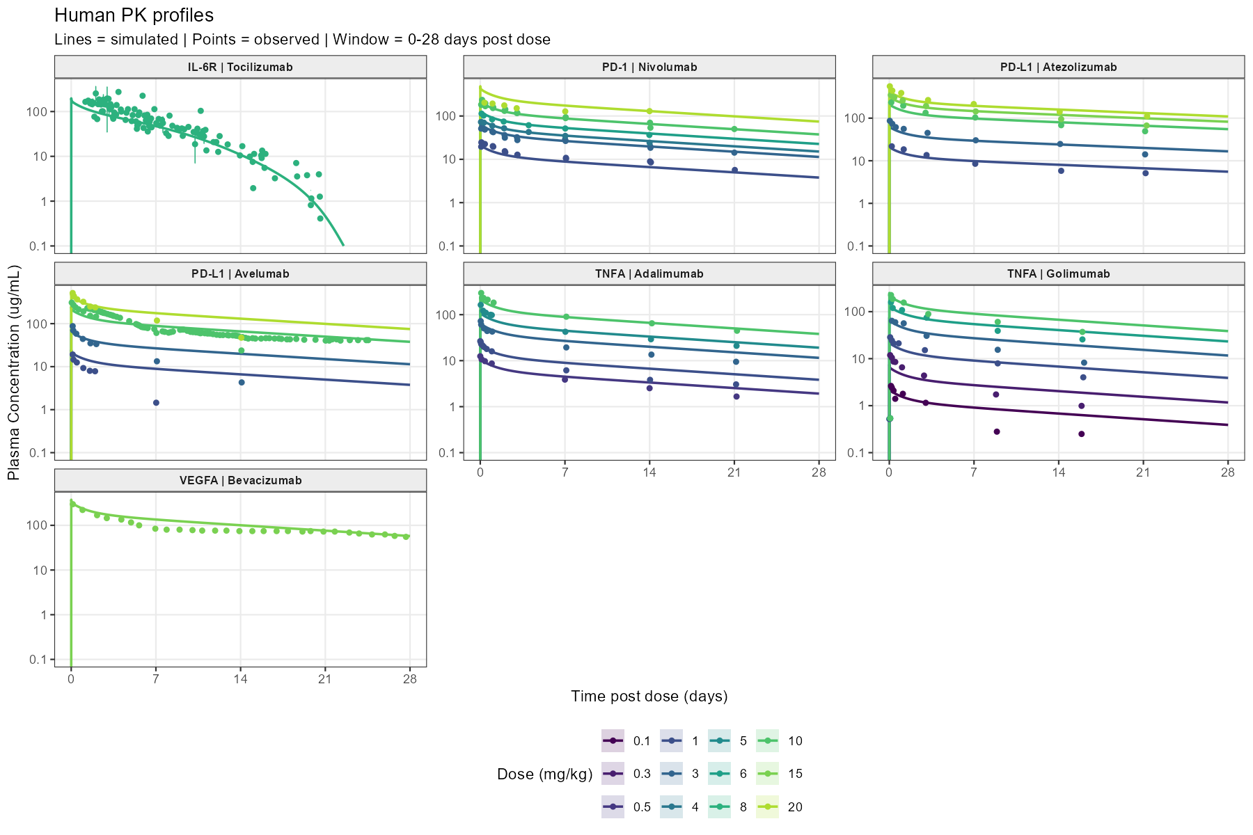

Figure 2. Observed and predicted human plasma concentration-time profiles from monkey-to-human translation of the top-down QSS TMDD approach.

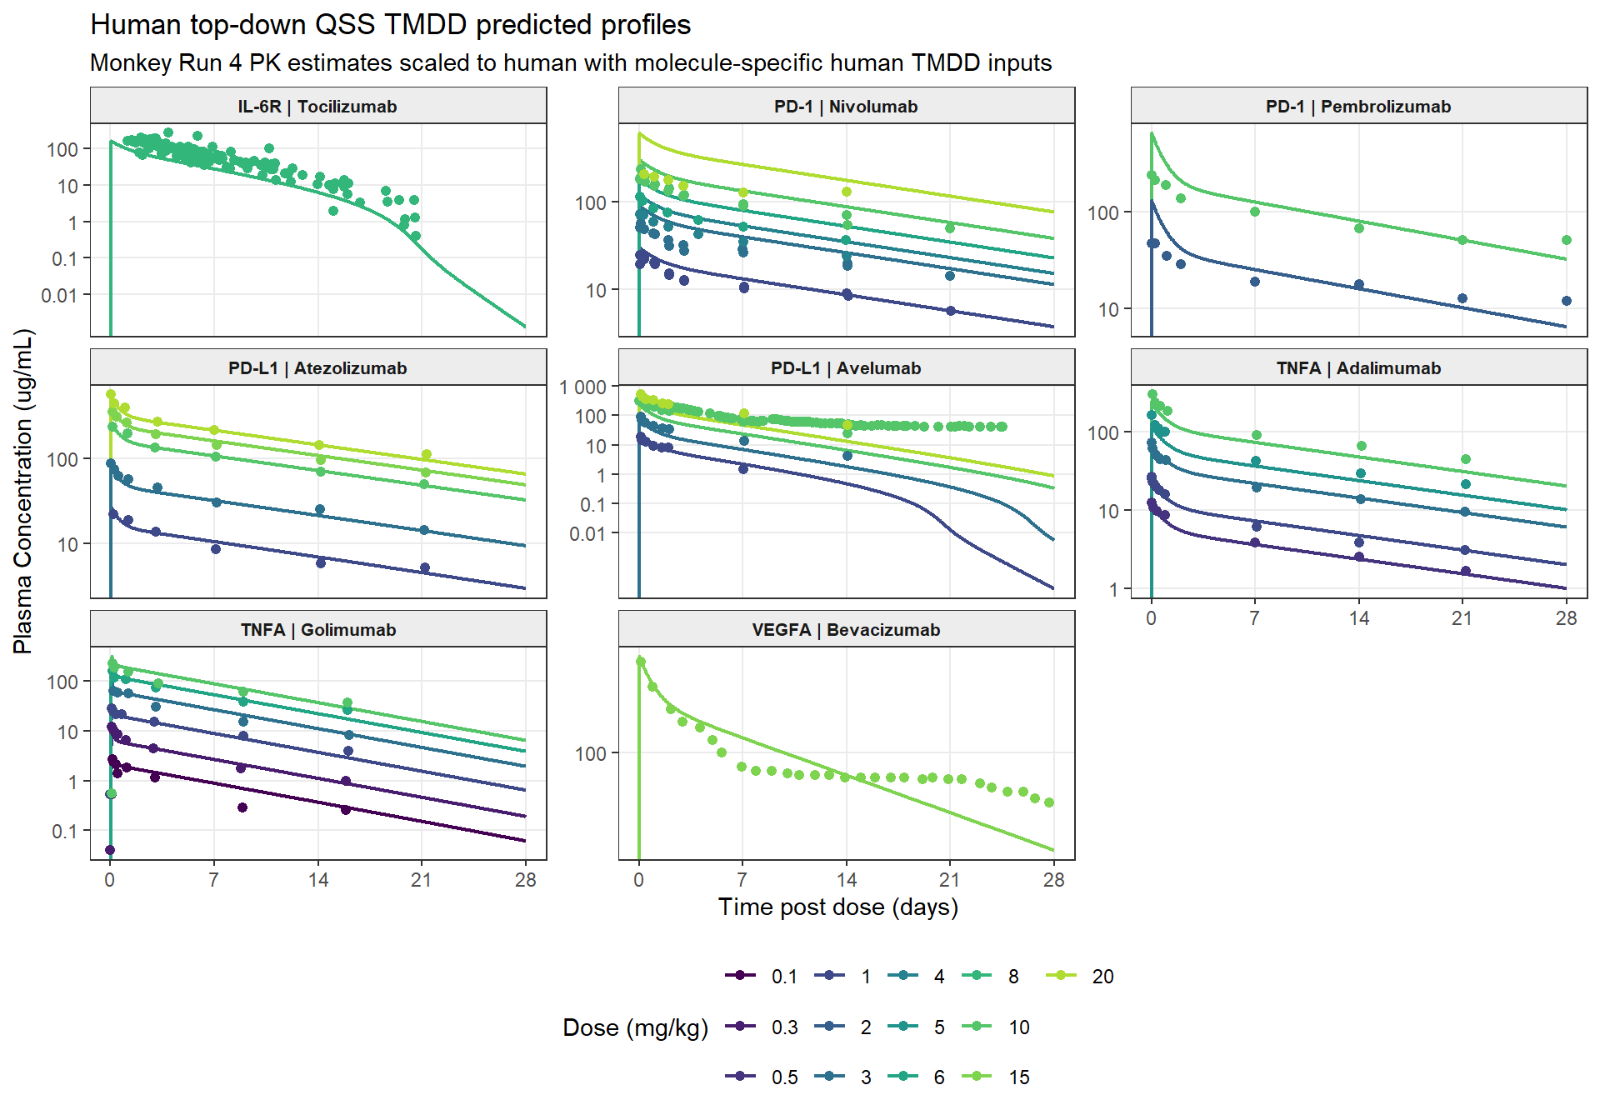

Figure 3. Reduced Monkey PK Study Designs Maintain AUC0-28d Fold-Error Within Two-Fold Criteria.

Figure 4. Directional fold-error comparison for human terminal clearance, AUC0-28d, and Cmax predicted using “a priori” PBPK and monkey-fitted top-down TMDD translation. (A) Terminal clearance, representing nonlinear target-mediated elimination; (B) AUC0-28d and (C) Cmax, representing the predominantly linear elimination component. Fold error equals predicted divided by observed; bars extend from 1 on a base-2 logarithmic scale, and the shaded region and dashed lines indicate the 0.5- to 2-fold interval.
(A) Human terminal clearance
[INSERT: FoldError_Human_Terminal_CL.png]
(B) Human AUC0-28d
[INSERT: FoldError_Human_AUC0_28d.png]
(C) Human Cmax
[INSERT: FoldError_Human_Cmax.png]

Figure 5. Proposed “a priori” PBPK workflow for monoclonal antibody PK translation as a NAM. The conventional workflow relies on multiple monkey PK studies before model-based first-in-human exposure prediction. In the proposed workflow, molecule- and target-specific in vitro data are integrated into “a priori” PBPK models before in vivo PK testing. Then, data from reduced PK studies along with PBPK models can be used to optimize any additional monkey PK studies (only if needed), support human PK/exposure prediction while reducing reliance on empirical preclinical species to human translation. FIH = first-in-human; PBPK = physiologically based pharmacokinetics. Figure generated with GPT-5.5.

Supplementary Materials
Supplementary Material 1. Github link to full project: https://github.com/namlink-org/APriori_PBPK_mAb
Supplementary Figure S1. Observed and predicted monkey plasma concentration-time profiles for (A) the “a priori” PBPK approach and (B) the top-down QSS TMDD approach. Provided in S1.docx.
Use of Artificial Intelligence
OpenAI ChatGPT/GPT-5.5 was used to assist with language editing, manuscript organization, and generation/refinement of Figure 1. Codex/GPT-5.5 was used as a coding assistant, especially to write codes for figures and tables generation. The authors reviewed and edited all AI-assisted content and take full responsibility for the accuracy, integrity, and final content of the manuscript.

