Physiologically-based Pharmacokinetic Modeling as a New Approach Methodology for Monoclonal Antibodies
Akshat Shah^{1,2}, Krina Mehta^{2,3}
¹ Aivaura, Bhavnagar, Gujarat, India
² NAMLink, Cypress, CA, USA
³ Enveda Therapeutics Inc., Boulder, CO, USA

Abstract
Monoclonal antibody (mAb) pharmacokinetics (PK) is governed by mechanistically well-characterized processes, making physiologically based pharmacokinetic (PBPK) modeling well suited to support human PK prediction. We evaluated whether in vitro-informed “a priori” PBPK modeling can predict first-in-human mAb PK and serve as a new approach methodology (NAM) to reduce reliance on monkey PK studies.
A semi-automated PK-Sim/MoBi–R workflow integrated molecule-specific FcRn binding, target binding, target expression/turnover, and internalization with monkey and human physiology. Intravenous single-dose PK data for eight mAbs across five targets were used for retrospective evaluation. PBPK simulations were performed without fitting to monkey PK data and compared with observed exposures. As a benchmark, monkey-fitted quasi-steady-state TMDD models were translated to humans. For mAbs with at least one “a priori” monkey AUC prediction outside two-fold criteria, reduced monkey PK designs were evaluated using virtual population simulations with top-down models as the reference.
“A priori” PBPK predicted 8/14 monkey AUC values and 23/28 human AUC values within two-fold of observed data. Human prediction performance matched monkey-fitted TMDD translation, which also predicted 23/28 human AUC values within two-fold, indicating no added advantage from empirical monkey PK fitting. Four mAbs where “a priori” approach did not meet prespecified criteria for at least one dose level, reduced-study simulations, designs with two animals per dose group and two dose groups, recovered reference AUC within two-fold in 100% of replicates, suggesting feasibility of reduced monkey PK studies for mAbs PK characterization. These findings support “a priori” PBPK as a practical NAM for mAb PK translation and for targeted reduction of monkey PK studies.

Introduction
Adequate characterization of pharmacokinetics (PK) is crucial for a successful drug development program because it is the quantitative link between administered dose, systemic and tissue exposure, target engagement, pharmacodynamic (PD) response, and safety [PMIDs: 35865092]. For monoclonal antibodies (mAbs) and other protein therapeutics, systemic and tissue exposures depend on target-mediated drug disposition (TMDD), neonatal Fc receptor (FcRn)-mediated recycling, and tissue distribution processes that can differ across species. Physiologically-based pharmacokinetic (PBPK) modeling is a mechanistic modeling approach that integrates species-specific physiology with drug- and target-specific parameters to simulate PK. For mAbs, PBPK models incorporate key determinants of disposition, including vascular convection, lymphatic return, tissue partitioning, pinocytosis, FcRn binding and recycling, proteolytic catabolism, target binding, target turnover, and target-receptor complex internalization, into a quantitative framework [PMIDs: 17636457, 22143261, 29234936]. Overall, extensive work on PBPK models for mAbs has already established a robust scientific foundation, enabled reliable characterization of their PK, and supported their regulatory acceptance.
Momentum for new approach methodologies (NAMs) has increased exponentially since the FDA's April 2025 Roadmap to Reducing Animal Testing in Preclinical Safety Studies [ref: FDA roadmap and other NAM related guidance from 2025 and 2026; Mehta et al., 2025; NIH Common Fund, 2026]. Within this evolving regulatory infrastructure, current NAM-focused investment has focused on establishing context-of-use (COU) frameworks, advancing complex in vitro systems (organoids, microphysiological systems, organ-on-chip platforms), and AI/ML-based computational toxicology tools. On the other hand, preclinical evaluations are increasingly being framed around whether human-relevant biological pathways are perturbed at clinically meaningful plasma and tissue exposure levels. Plasma and tissue exposures therefore provide a common quantitative measure for integrating in vitro dose-response data, in silico simulations, prior clinical knowledge, biomarkers, and safety thresholds. For example, in vitro findings from cell-based or microphysiological systems can be contextualized through predicted human concentration-time profiles, exposure margins, and time above biologically active or adverse effect thresholds [PMIDs: 38392990, 39574200, 40462462, 38201394]. In this context, mechanistic PBPK models are uniquely positioned to bridge NAM-derived biological observations with quantitative predictions of human plasma and tissue exposure. A recent FDA/CDER landscape analysis of 15 years of NAM-related submissions found that 93% fell into the in vitro and in silico categories broadly, though this landscape analysis does not break out mechanistic PK/PD/safety modeling, such as PBPK, as distinct categories, leaving their specific representation within the NAM submission landscape unclear [PMID: 41360337]. By contrast, mechanistic modeling approaches, such as, PBPK, quantitative systems pharmacology (QSP), and quantitative systems toxicology (QST), despite an established and steadily growing regulatory submission record under the parallel model-informed drug development (MIDD) paradigm and demonstrated translational utility [PMID: 40567279, PMID: 39423143], have received comparatively limited dedicated attention within the emerging NAM ecosystem, representing both a gap and an opportunity. Overall, the emerging NAM ecosystem presents a significant opportunity for greater integration of mechanistic modeling approaches.
Focusing on mAb PK characterization and the role of mechanistic PK modeling, although scientific framework for mAb PBPK is there, preclinical PK characterization mostly relies on PK studies in monkeys (often cynomolgus monkeys). A traditional mAb development program typically includes preclinical PK evaluations in at least two studies: an exploratory single-dose PK study (n =12-18 monkeys) and a definitive repeat-dose PK study (n = 12-24 monkeys). Together, these studies generally require a minimum of 24–42 monkeys per mAb development program. The scientific maturity of mAb PBPK modeling has advanced to the point where ““a priori”” PK predictions based on in vitro data can be considered for prospective evaluation in preclinical development workflows, as NAMs. Published examples have shown that mAb-specific in vitro measurements, together with species physiology and FcRn-mAb interaction-related parameters, can support prediction of mAb linear PK without in vivo data [PMIDs: 31464379, 35491902]; however, these frameworks did not incorporate target-mAb interactions governing nonlinear, target-mediated clearance. Although some mAbs exhibit linear PK at dose range of interest, target-mediated drug disposition is inherent to therapeutic antibodies. For example, at high doses, even mAbs known to exhibit non-linear PK can appear linear upon target saturation, and at low doses, even mAbs known as linear may show nonlinearity. Overall, extending “a priori” PBPK frameworks to incorporate target-mediated disposition is therefore important for their broader application as NAMs with the potential to reduce preclinical monkey studies across the full range of mAb PK profiles.
The objectives of this manuscript were, (1) to perform a retrospective, proof-of-concept analysis of “a priori” PBPK modeling as a NAM to support human PK predictions for mAbs, (2) to perform population simulations of preclinical monkey study designs to investigate feasibility of reduced sample size and number of dosing groups to characterize mAbs PK.

Methods

Data
Pharmacokinetic profiles for eight monoclonal antibodies, spanning across 5 different targets, following intravenous dosing in monkeys and in humans were digitized from literature using webplotdigitizer tool [https://automeris.io/]. In vitro experimental parameters relevant to drug-FcRn binding, drug-target binding, drug-target complex internalization rate, and target reference concentrations were obtained through literature search. Digitized data, parameter values, measurement methods, assumptions, and source references are provided in Supplementary material 1.
“A priori” PBPK Approach
A large molecule structural model was first incorporated in PK-Sim, including its binding to FcRn and to a generic target. The model was exported to Mobi and TMDD processes were added using a modular approach [PMIDs: ref to PK-Sim V12 modular approach paper/poster]. Next, we created target expressions profiles in monkeys and humans for each of the targets including relevant localization. PKML simulations files containing generic large molecule PK model and target expressions, one file per target and species (monkey or human), were exported [PMIDs: ref to expression database paper by OSPS]. IV single dose simulations were performed using R scripts using esqlabsr and ospsuite packages [PMIDs: ref]. Exposure metrics (Cmax, AUC_{0-28d}) and fold errors were calculated for each molecule and dose level, where observed data were available. Full details of the workflow and all files and codes are provided in Supplementary material 1.

Top-Down TMDD Approach for Comparison
In top-down TMDD modeling approach, quasi-steady-state (QSS) TMDD model was fitted to monkey PK profiles for each molecule using nlmxir2 package in R. Target concentration and binding affinity were fixed to literature-derived in vitro measured values. The same values that were used per molecule in “a priori” approach were used in this approach. Two parameters, clearance (CL) and internalization rate constant (kint) were estimated by model fitting. Other alternative models estimating target concentrations, target degradation rate (kdeg), etc were also evaluated. Given limited dose levels data available for fitting TMDD, fitting of minimal number of parameters was considered. Final model structure was selected based on objective function values (OFV).
Human PK predictions were generated by translating the final monkey TMDD model to humans. Linear clearance was scaled using standard allometric scaling with an exponent of 0.85, while distribution volumes were scaled proportionally to body weight. The internalization rate constant (kint) and binding affinity (KD) were assumed to be conserved across species and fixed to the monkey estimates. Human target concentrations were obtained from literature sources and remained same across both “a priori” and top-down approach. Simulated monkey and human exposures, Cmax, AUC, were compared against the observed and fold-errors were calculated.
Evaluating Reduced Monkey PK Study Designs Using Simulations
To evaluate appropriateness of reduced PK studies (sample size and dose groups) in case “a priori” PBPK predictions fall out of 2-fold, monkey PK study simulations were performed. Molecules with at least one a priori AUC fold-error outside the 2-fold interval were considered cases where a reduced monkey PK study would be needed. For these molecules, the observed-informed top-down monkey model was used as the retrospective reference for true monkey PK. A virtual population of 100 monkeys was generated by sampling body weights using a normal distribution (mean 4 kg, sd 0.8) and parameters of top-down models for the selected molecules incorporating 30% inter-individual variability in all parameters (estimated and fixed in top-down simulations above). Reduced PK studies were simulated by sampling small groups (2, 3, 4, and 5) of animals and practical sampling timepoints (hrs 0.25, 1, 2, 4, 8; day 1, 2, 6, 10, 14, 21, 28) from a virtual population. Two (0.3, 3, and 10 mg/kg) and three (0.3 and 10 mg/kg) dose groups were simulated for all molecules. Simulated study geometric mean AUC were compared with the full top-down population geometric mean AUC calculated using rich sampling timepoints (hrs 0.25, 0.5, 1, then once every hour upto 28 days) and sample size of 100.

Results

Comparing “a priori” PBPK with Top-Down TMDD Approach for Human PK Predictions
Both “a priori” PBPK and top-down TMDD approaches were first compared in monkeys to evaluate how well each workflow reproduced the PK data (Table 1). Across the 8 drugs and 14 dose levels evaluated, “a priori” PBPK predictions captured Cmax well, with 13 of 14 Cmax values within two-fold of observed data (accuracy 0.92). AUC predictions were more variable, with 8 of 14 values within two-fold (accuracy 0.58). As expected, in top-down TMDD approach, in which monkey PK data were fitted by estimating CL and kint, all AUC values were within two-fold, and 13 of 14 Cmax values were within two-fold. Human PK predictions were then compared to priori PBPK workflow performance compared to translation from monkeys (Figure 1, Figure 2, Table 1, Table 2). Overall, both approaches provided comparable human prediction accuracy. For AUC, both approaches showed similar overall performance, with 23 of 28 human dose levels within two-fold (accuracy 0.82). For Cmax, 27 of 28 human dose levels were within two-fold for both “a priori” PBPK and top-down TMDD predictions (accuracy 0.96). Taken together, these results indicate that “a priori” PBPK provided human PK predictions that were broadly comparable to those translated from monkey-fitted top-down TMDD approach. Although top-down fitting improved recovery of monkey PK data, it did not provide a consistent advantage for human prediction across molecules. Given that empirical fitting to monkey PK did not consistently improve human predictions compared to “a priori” approach, these findings support that the “a priori” PBPK framework captures the major mechanistic determinants of human mAb disposition sufficiently well.
Evaluating Reduced Monkey PK Study Designs Using Simulations
Based on the “a priori” PBPK simulations, four of the eight evaluated mAbs, atezolizumab, avelumab, nivolumab, and pembrolizumab, had at least one dose level with an AUC prediction outside the prespecified two-fold criterion. These molecules were therefore carried forward into the reduced-study simulation analysis. Across the four molecules and simulated dose levels, reduced-study designs robustly recovered the reference AUC derived from the full top-down virtual population with rich sampling. For sample sizes of 2 to 5 animals per dose group, evaluated using both two-dose and three-dose designs, the probability that the reduced-study geometric mean AUC remained within two-fold of the full-population true geometric mean AUC was 100% across all molecules and dose levels (Figure 4). The 5th–95th percentile fold-error intervals also remained well within the two-fold interval, further supporting the adequacy of the reduced PK design under the simulated variability assumptions.
Both the two-dose and three-dose designs achieved 100% success across all simulated replicates and evaluated sample sizes. Therefore, increasing the sample size beyond two animals per dose group or adding a third dose group did not improve performance against the prespecified AUC recovery criterion in these simulations. Overall, these results support a reduced, PBPK-informed monkey PK study design, for example, two dose groups with two animals per group, as a practical confirmatory strategy.

Discussion
In this retrospective, proof-of-concept analysis, the “a priori” PBPK approach showcased similar human predictive performance as compared to top-down monkey to human translation approach for first-in-human PK prediction of mAbs. The results support the feasibility of using mechanistic PBPK approach, informed by in vitro parameters as an early translational tool for human mAb PK prediction and as a basis for reducing reliance on conventional monkey preclinical PK studies. Using the prespecified illustrative study-design comparison, the proposed workflow was estimated to substantially reduce the animal use required for mAbs’ PK characterization. A conventional single-dose preclinical PK study design consisting of at least 3 animals per dose group and 5 dose groups would require at least 15 animals for single-dose PK study, whereas the reduced design would require only 4-6 animals, corresponding to 60% reduction in animal use for the single-dose PK study design. In addition to reducing animal use, the PBPK-informed strategy shifts key dose-selection and exposure-translation decisions earlier in development, allowing NHP studies, when still needed, to be designed as targeted confirmatory studies rather than empirical screening studies.
Our analysis focused on IV single-dose PK evaluations for mAbs, which represent an appropriate starting point for “a priori” PBPK workflow evaluation because their disposition is comparatively well understood relative to many newer therapeutic modalities. Although TMDD, FcRn binding, and tissue-specific target expression can introduce complexity, the major processes governing systemic mAb PK are mechanistically defined and can often be parameterized using in vitro measurements, prior knowledge from other mAbs, “a priori” PBPK modeling, and reduced-design single-dose in vivo data. Unlike oral, small molecules, where bioavailability, absorption, first-pass metabolism, and metabolic induction can make single-dose behavior less predictive of steady-state exposure, IV mAb PK is generally more amenable to extrapolation from single-dose characterization. Once dose-dependent clearance, relevant mechanistic parameters, and single-dose exposures are adequately characterized, steady-state exposures and accumulation ratios under repeat-dose regimens can be predicted by simulation without requiring a separate multi-dose PK study. This is supported by preclinical and clinical evidence showing that mAb PK parameters estimated from single ascending IV doses in cynomolgus monkeys can accurately predict multi-dose exposure profiles, with clearance at target-saturating concentrations translating reliably to humans [PMIDs: 20962582, 21241072]. Within a PBPK framework incorporating the key mechanistic determinants of mAb PK, a well-characterized single-dose dataset can therefore provide a mechanistically sufficient basis for projecting repeat-dose PK in monkeys. This strategy is also complementary to other animal-use reduction approaches in preclinical mAb development; for example, PK/TK sampling embedded within dose-range finding toxicology or GLP repeat-dose toxicology studies can provide repeat-dose exposure characterization without a dedicated standalone PK study [PMID: 23524271], further compressing the preclinical package while preserving scientific rigor. Once IV PK is adequately characterized, the same framework can be extended to subcutaneous mAb predictions by incorporating absorption-related processes such as lymphatic uptake, pre-systemic catabolism, bioavailability, and formulation- or injection-site–dependent absorption kinetics. Lessons learned from mAbs can subsequently inform analogous PBPK, or hybrid PBPK-QSP, workflows for other modalities, including bispecific antibodies, antibody-drug conjugates, fusion proteins, and gene or cell therapy platforms, where PK, biodistribution, target engagement, and safety are tightly linked. Together, these considerations support IV single-dose mAb PBPK evaluation as a scientifically justified and reduction in animal use foundation for predicting repeat-dose exposure and informing broader “a priori” NAM-based workflows across therapeutic modalities.
The proposed “a priori” PBPK modeling as NAM approach is feasible when robust in vitro experimental data for mechanistic parameters are available. In our retrospective analysis, in vitro parameters were derived from literature search (Supplementary Material 1). Drug–target binding affinity was available from experimental binding assays for all included molecules, either from equilibrium binding or SPR/Biacore assays. FcRn binding affinity was available from SPR/Biacore for only atezolizumab and pembrolizumab while a common model-based FcRn KD estimate from a published meta-analysis was used for several other mAbs where molecule-specific FcRn binding data were not available [ref.]. Drug-target complex internalization rate from flow-cytometry–based internalization assay was available for only two molecules, whereas for other molecules this parameter was assumed same as target degradation rate. Target reference concentrations represented the least standardized component of the input parameters. VEGF-A and IL-6R reference concentrations and target degradation rates were available from quantitative fluorescence or ligand-binding receptor assay data or were estimated in prior analyses. Overall, the compiled input parameters highlight the limitation of standardized in vitro experimental methods. Thus, standardization of experimental package for mAbs would further strengthen prospective PBPK-based NAM workflows.
Our was a retrospective, proof-of-concept analysis, constrained by the limited availability of public datasets that included monkey PK, human PK, and sufficient in vitro parameters for mechanistic PBPK modeling. The dataset was therefore modest in size and included heterogeneous literature-derived inputs, with some parameters requiring assumptions or use of prior values. Nevertheless, the analysis provides an important initial evaluation of PBPK as a NAM for mAb PK characterization. In this framework, we propose monkey studies, when still needed, to be designed to address specific uncertainty rather than to broadly characterize PK. Larger-scale retrospective analyses and prospective pilot programs can further validate and refine this workflow. Future studies should include a broader set of mAbs across different targets, PK behaviors, target-expression patterns, and degrees of species cross-reactivity. Ideally, prospective evaluations should generate standardized in vitro input data, perform “a priori” PBPK simulations before in vivo PK data are available, prespecify quantitative success criteria, and then compare predictions with observed monkey and human PK outcomes. This evidence base can help define an appropriate context of use for PBPK as a NAM and to support regulatory confidence in PBPK-informed reduction of preclinical monkey PK studies.
In our study, PK-Sim/Mobi together with the R packages ospsuite and esqlabsR, provided a practical open-source framework for implementing reproducible, semi-automated workflow. A key advantage of this platform is that it combines physiologically structured PBPK models with curated species-specific physiology and expression databases, enabling target-expression profiles to be defined across monkeys and humans in a consistent manner [refs to be added]. In addition, the ability to export models, modify them in MoBi in structured manner, and run simulations programmatically in R allows scalable and reproducible evaluation of multiple molecules, targets, species, and dose levels. This is particularly important for prospective PBPK-based NAM workflows, where standardized model generation, parameter updates, simulation execution, and exposure-metric extraction will be needed to support larger retrospective analyses and future prospective validation studies.

Conclusions
This retrospective proof-of-concept analysis supports the feasibility of “a priori” PBPK modeling as a NAM for mAbs’ to support first-in-human PK characterization. Across the evaluated mAbs, in vitro-informed PBPK predictions provided human PK prediction performance broadly comparable to monkey-to-human top-down translation, suggesting that the major mechanistic determinants of mAb disposition can be captured without empirical fitting to preclinical PK data in many cases. Moreover, model-guided reduced monkey PK studies can serve as a targeted confirmatory step rather than defaulting to conventional larger exploratory and repeat-dose PK programs. Overall, the proposed workflow provides a practical framework to integrate standardized in vitro parameter generation, open-source PBPK modeling, and reduced in vivo pk studies to support human exposure prediction while reducing animal use by >60%.

References

Figures
Figure 1. Proposed “a priori” PBPK workflow for monoclonal antibody PK translation as a NAM. The conventional workflow relies on multiple monkey PK studies before model-based first-in-human exposure prediction. In the proposed workflow, molecule- and target-specific in vitro data are integrated into “a priori” PBPK models before in vivo PK testing. Then, data from reduced PK studies along with PBPK models can be used to optimize any additional monkey PK studies (only if needed), support human PK/exposure prediction while reducing reliance on empirical preclinical species to human translation. FIH = first-in-human; PBPK = physiologically based pharmacokinetics. Figure generated with GPT-5.5.
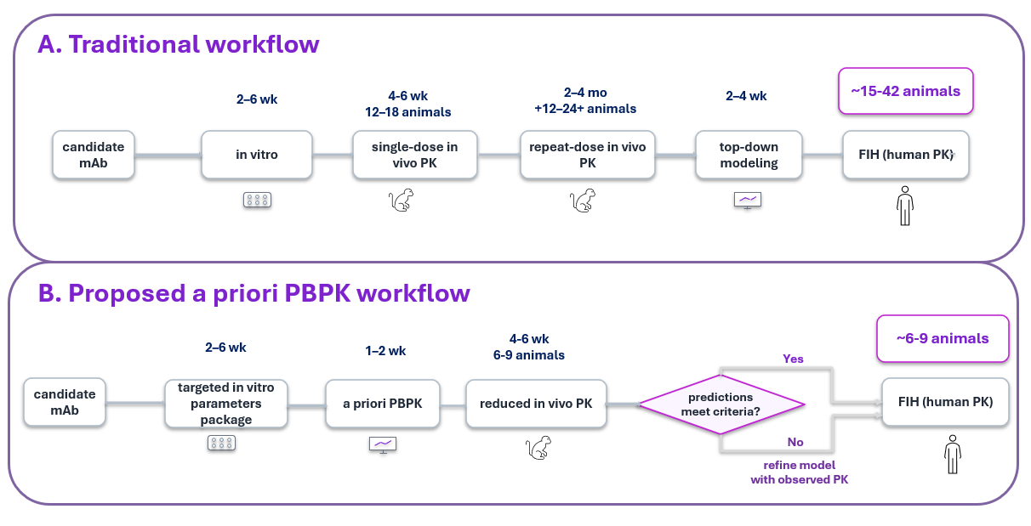

Figure 2. Observed vs. Predicted for “A Priori” PBPK Approach for (1) Monkeys, (2) Humans.
(i) Monkey
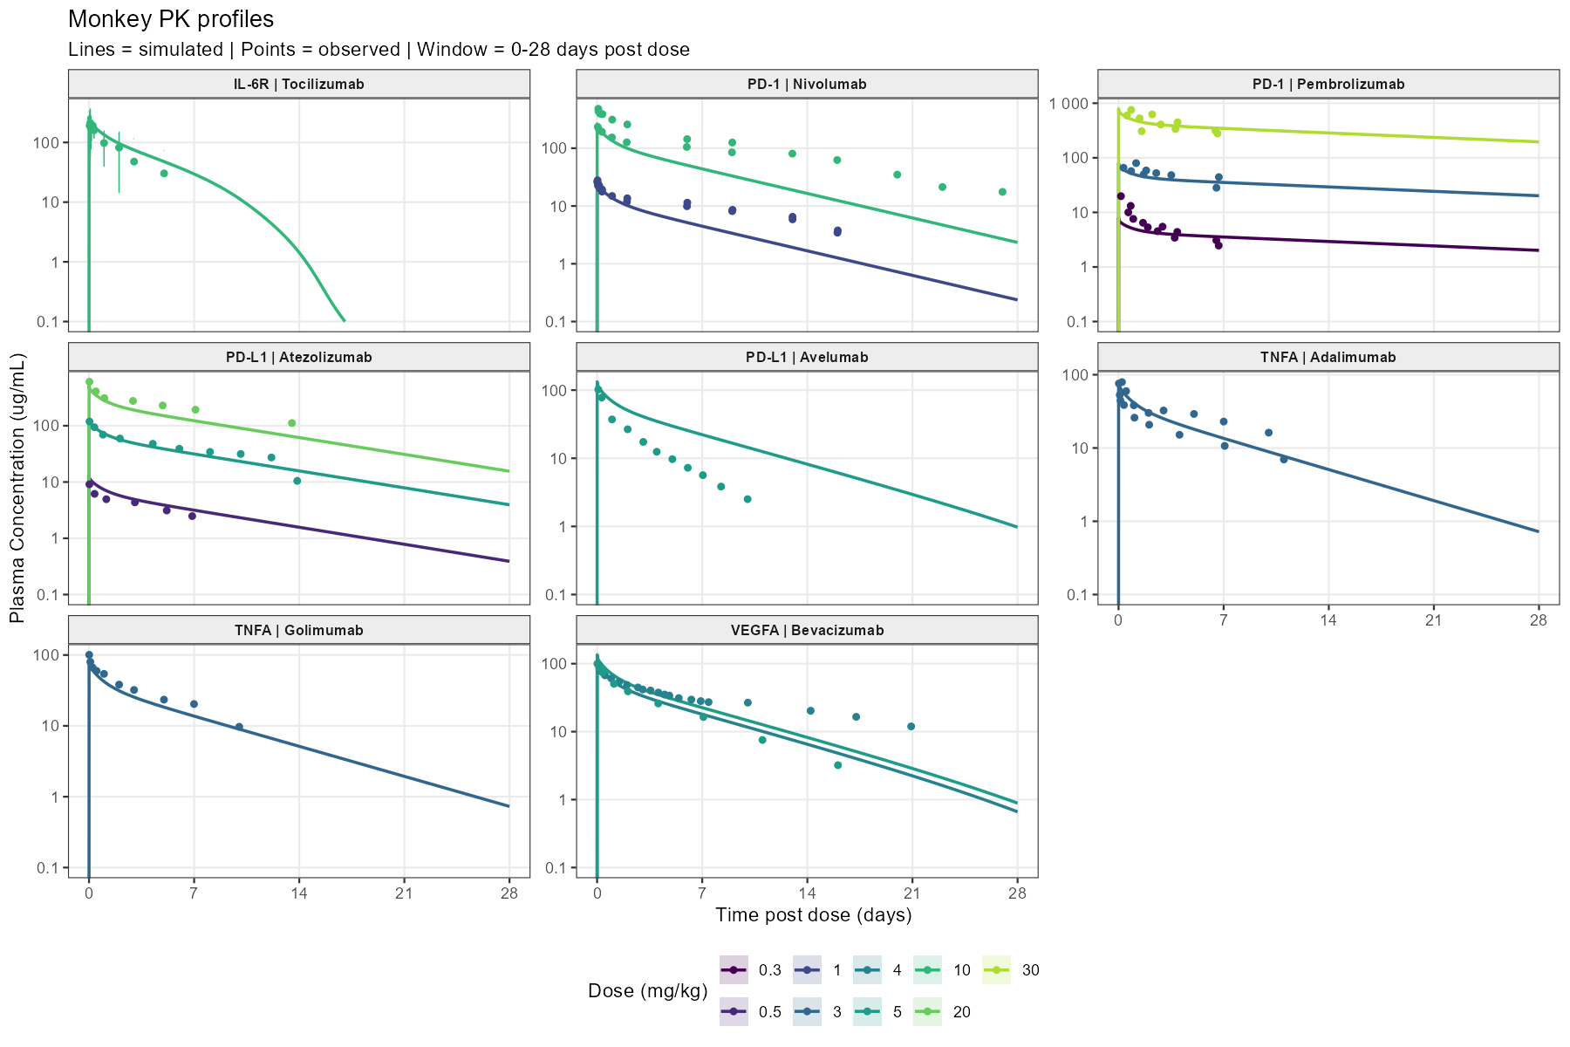
(ii) Human
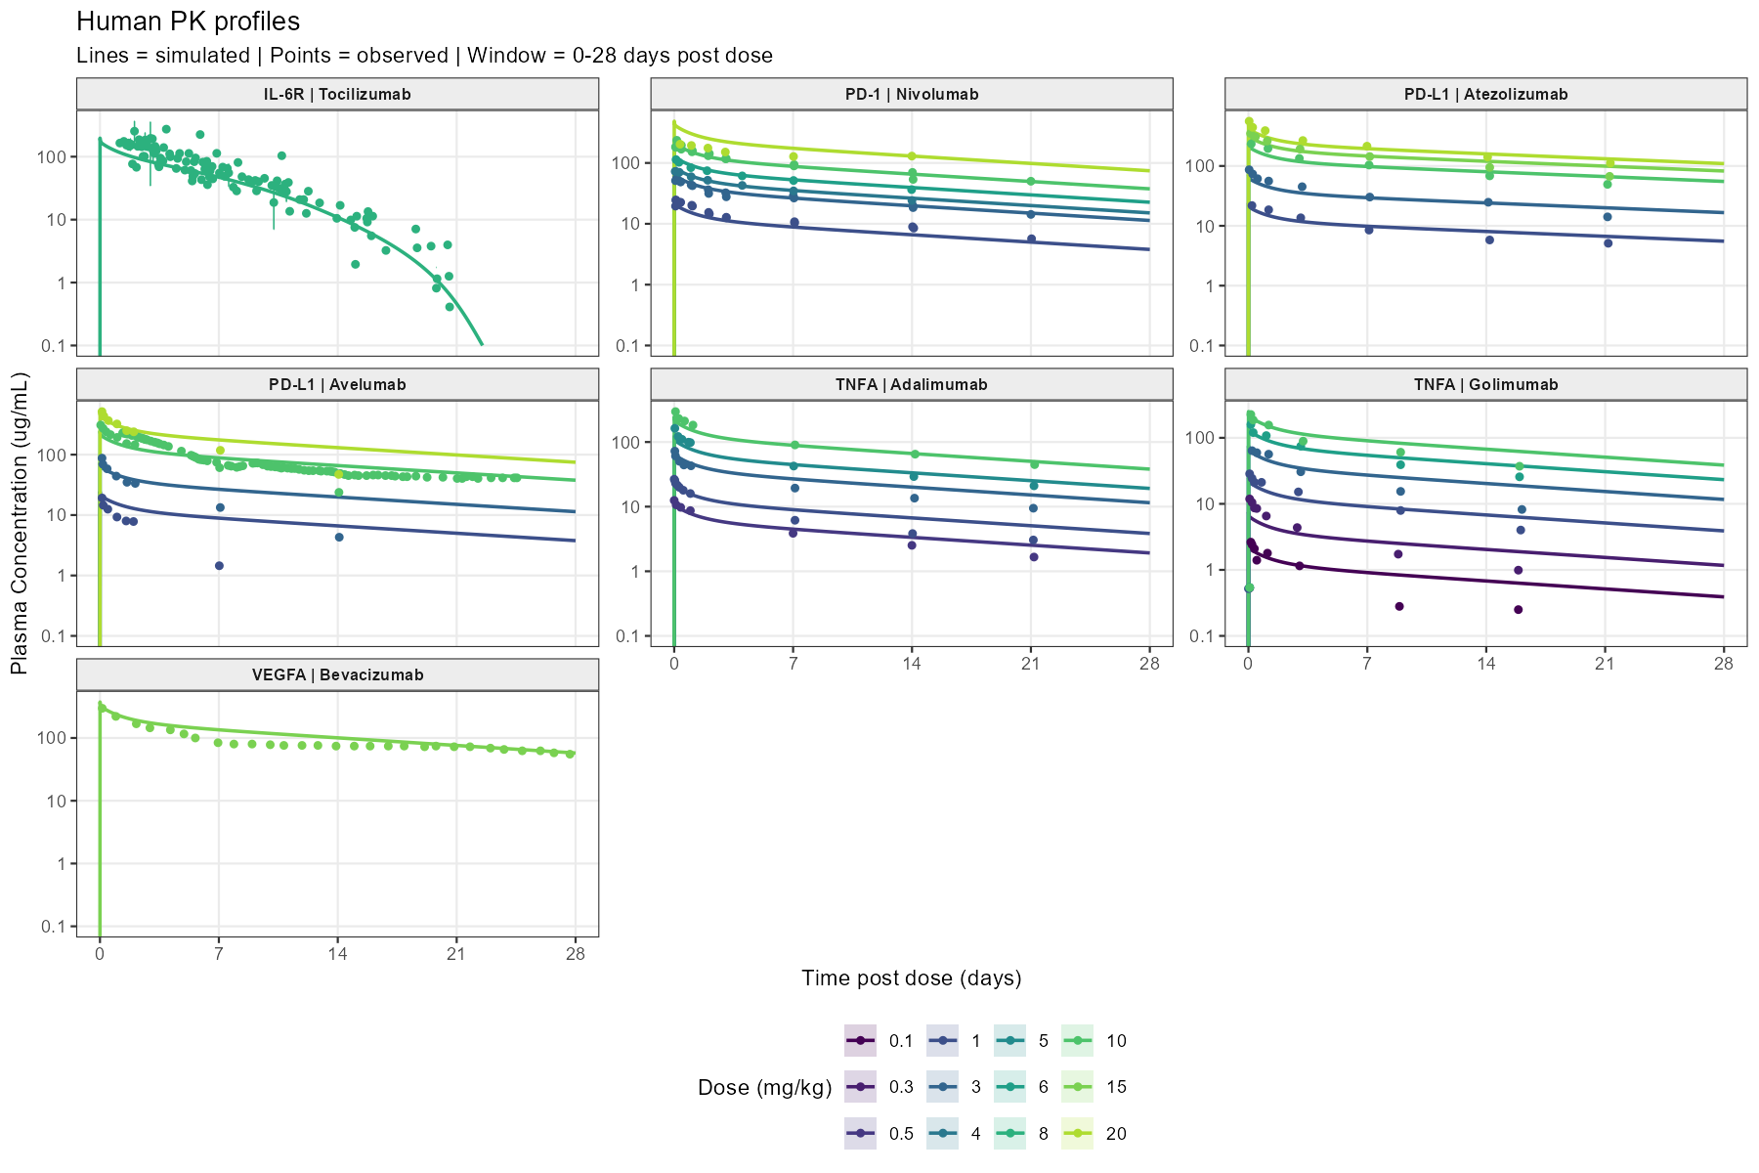

Figure 3. Observed vs. Predicted for top-down PBPK Approach for (1) Monkeys, (2) Translation from Monkey Top-Down to Humans.
(i) Monkey
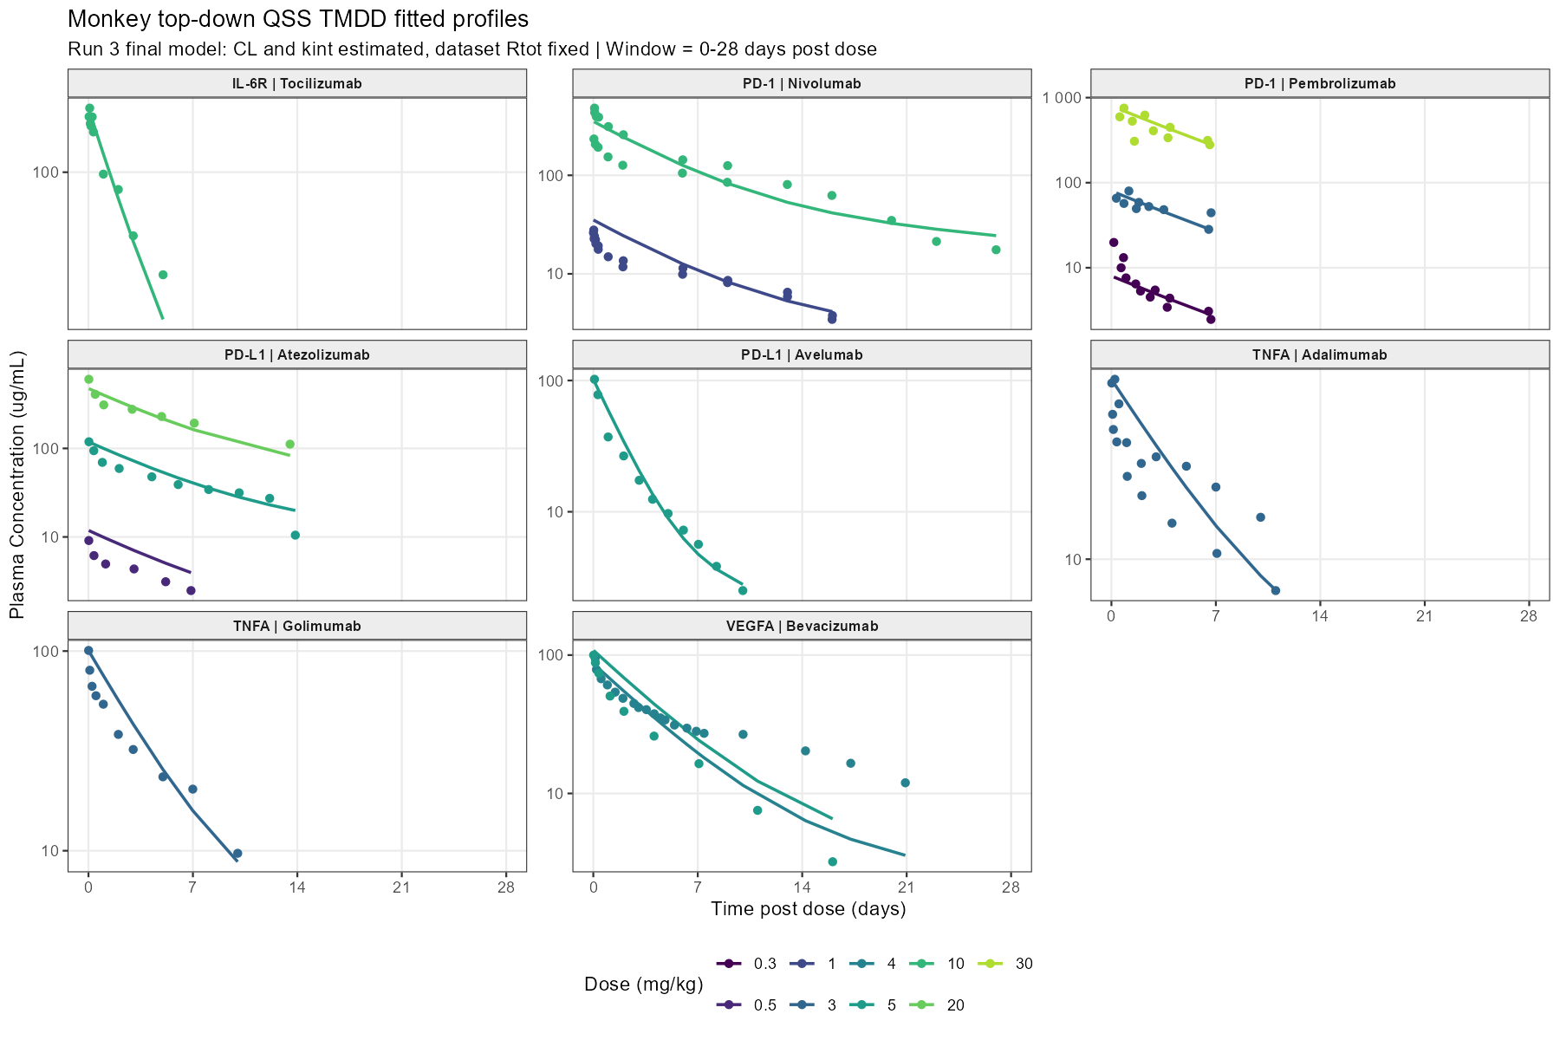
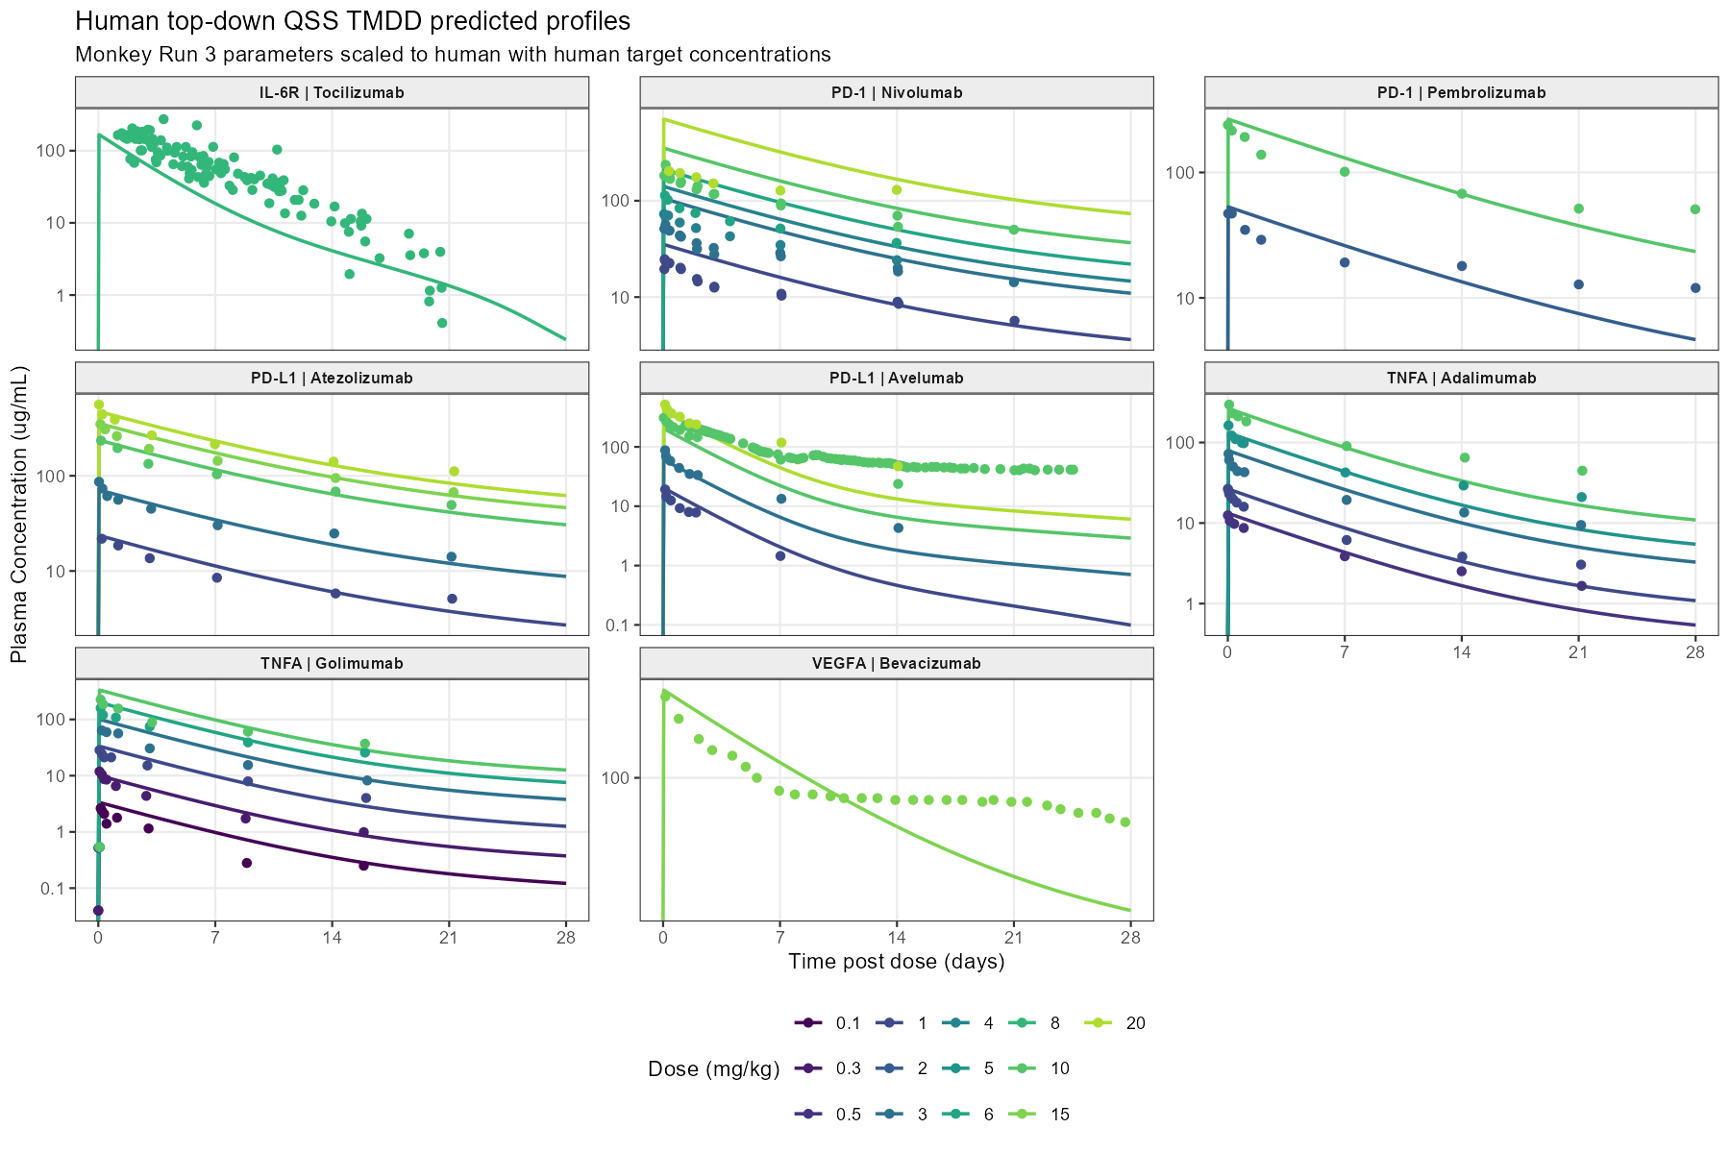
(ii) Human

Figure 4. Reduced Monkey PK Study Designs Maintain AUC Fold-Error Within Two-Fold Criteria.
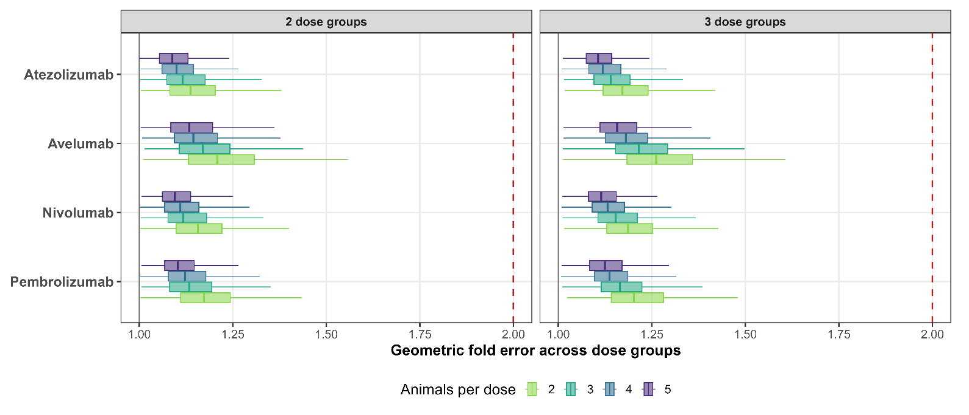

Tables
Table 1. Monkey Cmax and AUC fold-error by modeling approach. Fold-error is reported as predicted/observed. Green indicates within twofold (0.50–2.00); red indicates outside twofold.
Molecule | Dose (mg/kg) | Cmax fold-error |  | AUC fold-error
 |  | “a priori” | Top-down (Fitted) | “a priori” | Top-down (Fitted)
Adalimumab | 3 | 1.21 | 0.99 | 1.22 | 1.20
Atezolizumab | 0.5 | 1.42 | 1.30 | 2.27 | 1.70
Atezolizumab | 5 | 1.09 | 0.99 | 1.11 | 1.19
Atezolizumab | 20 | 0.86 | 0.78 | 0.87 | 0.96
Avelumab | 5 | 1.30 | 0.96 | 2.80 | 1.20
Bevacizumab | 4 | 1.14 | 0.89 | 0.64 | 0.71
Bevacizumab | 5 | 1.35 | 1.08 | 1.48 | 1.60
Golimumab | 3 | 0.80 | 1.00 | 1.00 | 1.21
Nivolumab | 1 | 0.97 | 1.27 | 0.62 | 1.34
Nivolumab | 10 | 0.74 | 0.73 | 0.49 | 0.96
Pembrolizumab | 0.3 | 0.40 | 0.39 | 2.39 | 0.87
Pembrolizumab | 3 | 0.99 | 0.95 | 2.88 | 1.01
Pembrolizumab | 30 | 1.05 | 0.97 | 3.23 | 1.08
Tocilizumab | 10 | 1.06 | 0.98 | 1.80 | 1.00

Table 2. Human Cmax and AUC fold-error by modeling approach. Fold-error is reported as predicted/observed. Green indicates within twofold (0.50–2.00); red indicates outside twofold.
Molecule | Dose (mg/kg) | Cmax fold-error |  | AUC fold-error
 |  | “a priori” | Top-down | “a priori” | Top-down
Adalimumab | 0.5 | 0.98 | 1.05 | 1.28 | 1.06
Adalimumab | 1 | 0.93 | 0.99 | 1.50 | 1.25
Adalimumab | 3 | 1.02 | 1.09 | 1.50 | 1.24
Adalimumab | 5 | 0.75 | 0.81 | 1.12 | 0.93
Adalimumab | 10 | 0.83 | 0.89 | 1.08 | 0.90
Atezolizumab | 1 | 1.10 | 1.09 | 1.34 | 1.26
Atezolizumab | 3 | 0.83 | 0.82 | 1.13 | 1.09
Atezolizumab | 10 | 1.02 | 1.01 | 1.21 | 1.19
Atezolizumab | 15 | 1.03 | 1.02 | 1.29 | 1.28
Atezolizumab | 20 | 0.86 | 0.85 | 1.15 | 1.14
Avelumab | 1 | 1.27 | 1.06 | 5.51 | 1.69
Avelumab | 3 | 0.84 | 0.70 | 2.46 | 0.79
Avelumab | 10 | 0.91 | 0.66 | 1.47 | 0.35
Avelumab | 20 | 0.95 | 0.79 | 2.05 | 0.68
Bevacizumab | 15 | 1.26 | 1.09 | 1.25 | 0.95
Golimumab | 0.1 | 0.95 | 1.27 | 2.13 | 2.01
Golimumab | 0.3 | 0.63 | 0.84 | 1.44 | 1.36
Golimumab | 1 | 0.87 | 1.17 | 1.31 | 1.24
Golimumab | 3 | 1.17 | 1.57 | 1.82 | 1.73
Golimumab | 6 | 0.94 | 1.26 | 1.52 | 1.45
Golimumab | 10 | 1.11 | 1.48 | 1.78 | 1.71
Nivolumab | 1 | 1.00 | 1.42 | 1.09 | 1.50
Nivolumab | 3 | 1.17 | 1.54 | 1.38 | 1.92
Nivolumab | 4 | 1.34 | 1.94 | 1.56 | 2.44
Nivolumab | 6 | 1.28 | 1.86 | 1.61 | 2.53
Nivolumab | 10 | 1.17 | 1.49 | 1.32 | 1.82
Nivolumab | 20 | 2.39 | 3.46 | 2.11 | 3.37
Pembrolizumab | 2 | 1.03 | 1.13 | 1.27 | 0.99
Pembrolizumab | 10 | 1.02 | 1.11 | 1.41 | 1.10
Tocilizumab | 8 | 0.51 | 0.61 | 0.71 | 0.57

Supplementary Materials
Supplementary Material 1. Github link to full project: https://github.com/namlink-org/APriori_PBPK_mAb
Use of Artificial Intelligence
OpenAI ChatGPT/GPT-5.5 was used to assist with language editing, manuscript organization, and generation/refinement of Figure 1. Codex/GPT-5.5 was used as a coding assistant, especially to write codes for figures and tables generation. The authors reviewed and edited all AI-assisted content and take full responsibility for the accuracy, integrity, and final content of the manuscript.

