Physiologically-based Pharmacokinetic Modeling as a New Approach Methodology for Monoclonal Antibodies

Abstract

Introduction
Adequate characterization of pharmacokinetics (PK) is crucial for a successful drug development program because it is the quantitative link between administered dose, systemic and tissue exposure, target engagement, pharmacodynamic (PD) response, and safety [PMIDs: 35865092]. For monoclonal antibodies (mAbs) and other protein therapeutics, systemic and tissue exposures depend on target-mediated drug disposition (TMDD), neonatal Fc receptor (FcRn)-mediated recycling, and tissue distribution processes that can differ across species. Physiologically-based pharmacokinetic (PBPK) modeling is a mechanistic modeling approach that integrates species-specific physiology with drug- and target-specific parameters to simulate PK. For mAbs, PBPK models incorporate key determinants of disposition, including vascular convection, lymphatic return, tissue partitioning, pinocytosis, FcRn binding and recycling, proteolytic catabolism, target binding, target turnover, and target-receptor complex internalization, into a quantitative framework [PMIDs: 17636457, 22143261, 29234936]. Published examples have shown that mAb-specific in vitro measurements, together with species physiology and FcRn-mAb and target-mAb interactions related parameters, can support prediction of mAb PK without extensive in vivo data [PMIDs: 31464379, 35491902]. Overall, extensive work on PBPK models for mAbs has already established a robust scientific foundation, enabled reliable characterization of their PK, and supported their regulatory acceptance.
Momentum for new approach methodologies (NAMs) has increased exponentially since the FDA's April 2025 Roadmap to Reducing Animal Testing in Preclinical Safety Studies [ref: FDA roadmap and other NAM related guidance from 2025 and 2026]. [Mehta et al., 2025; NIH Common Fund, 2026]. Within this evolving regulatory infrastructure, current NAM-focused investment has focused on establishing context-of-use (COU) frameworks, advancing complex in vitro systems (organoids, microphysiological systems, organ-on-chip platforms), and AI/ML-based computational toxicology tools [https://www.fda.gov/regulatory-information/search-fda-guidance-documents/general-considerations-use-new-approach-methodologies-drug-development; https://fnih.org/our-programs/validation-qualification-network-design-phase/nams-pilot-projects/]. Consistent with this emphasis, a recent FDA/CDER landscape analysis of 15 years of NAM-related submissions found that 93% fell into the in vitro and in silico categories broadly, though this landscape analysis does not break out mechanistic PK/PD/safety modeling, such as PBPK, as distinct categories, leaving their specific representation within the NAM submission landscape unclear [PMID: 41360337]. By contrast, mechanistic modeling approaches, such as, PBPK, quantitative systems pharmacology (QSP), and quantitative systems toxicology (QST), despite an established and steadily growing regulatory submission record under the parallel model-informed drug development (MIDD) paradigm and demonstrated translational utility [PMID: 40567279, PMID: 39423143], have received comparatively limited dedicated attention within the emerging NAM ecosystem, representing both a gap and an opportunity. Overall, the emerging NAM ecosystem presents a significant opportunity for greater integration of mechanistic modeling approaches.
Focusing on mAb PK characterization and the role of mechanistic PK modeling, although scientific framework for mAb PBPK is there, preclinical PK characterization mostly relies on PK studies in monkeys (often cynomolgus monkeys). A traditional mAb development program typically includes preclinical PK evaluations in at least two studies: an exploratory single-dose PK study (n =12-18 monkeys) and a definitive repeat-dose PK study (n = 12-24 monkeys). Together, these studies generally require a minimum of 24–42 monkeys per mAb development program. The scientific maturity of mAb PBPK modeling has advanced to the point where “a priori” PK predictions based on in vitro data can be considered for prospective evaluation in preclinical development workflows, as NAMs.
The objective of this manuscript is to evaluate PBPK modeling as a NAM for mAbs, with emphasis on its ability to support exposure-driven preclinical-to-clinical translation while reducing reliance on animal PK studies. Specifically, we describe an “a priori” PBPK" workflow and use preclinical study simulations to compare traditional and reduced study designs. By quantifying predictive performance, precision, power, and potential reductions in animal use, this work aims to define a practical context of use for PBPK-guided mAb development and to identify the experimental measurements most important for credible, translational PK predictions, with reduced number of monkeys used in the evaluations. In the near term, PBPK modeling is most practically positioned not as a complete replacement for all animal PK studies, but as a quantitative tool to optimize preclinical studies: selecting rational dose levels, reducing the number of animals, improving sampling schedules, identifying parameters that require experimental refinement, and determining when additional in vivo PK studies are unlikely to be decision-informative. Over time, as model credibility, input-data standards, and context-of-use-specific qualification improve, PBPK-based NAM workflows may enable broader replacement of dedicated animal PK studies for selected mAbs.

Methods

Data

Digitization of Observed Concentration-Time Profiles Data
xxx

Retrieval of Parameters Relevant to Target and Drug Properties

A Priori PBPK Workflow
A large molecule structural model was first incorporated in PK-Sim, including its binding to FcRn and to a generic target. The model was exported to Mobi and TMDD processes were added using a modular approach [PMIDs: ref to PK-Sim V12 modular approach paper/poster]. Next, we created target expressions profiles in monkeys for each of the targets including relevant localization. PKML simulations files containing generic large molecule PK model and target expressions, one file per target, were exported [PMIDs: ref to expression database paper by OSPS]. IV single dose scenarios for were generated and simulations were performed using R scripts using esqlabsr and ospsuite packages [PMIDs: ref]. Exposure metrics (Cmax, AUC_{0-28d}) and fold errors were calculated for each molecule and dose level, where observed data were available.

Preclinical Study Simulations
Use top-down PBPK model simulate full study designs calculate precision and power
Using a priori PBPK model simulate various reduced study design (n=4 (2 dose group with n=2/group), n=6 (3 dose group with n=3/group, …. With increasing dose group and n per dose group upto total n=30) calculate precision and power for each scenario

Results

A Priori PBPK

Preclinical Study Simulations

Discussion
Importance of in vitro measurements of parameters
mAbs represent an appropriate starting point for this evaluation because their disposition is comparatively well understood relative to many newer therapeutic modalities. Although target-mediated disposition, immunogenicity, Fc engineering, and tissue-specific target expression can introduce complexity, the major processes governing systemic mAb PK are mechanistically defined and can often be parameterized using in vitro measurements or curated prior knowledge. Lessons learned from mAbs can subsequently inform analogous PBPK and hybrid PBPK-QSP workflows for other large therapeutics, including bispecific antibodies, antibody-drug conjugates, fusion proteins, and gene or cell therapy platforms, where PK, biodistribution, target engagement, and safety are tightly linked.
Within a new approach methodologies (NAMs) paradigm, preclinical evaluation should increasingly be framed around whether human-relevant biological pathways are perturbed at clinically meaningful plasma and tissue exposure levels, rather than whether adverse findings are observed in an animal species at a nominal dose. Plasma and tissue exposures provide a common quantitative currency for integrating in vitro dose-response data, in silico simulations, prior clinical knowledge, biomarkers, and safety thresholds. For example, in vitro findings from cell-based or microphysiological systems can be contextualized through predicted human concentration-time profiles, exposure margins, and time above biologically active or toxic thresholds. This exposure-driven approach is well aligned with quantitative systems toxicology (QST) frameworks, which connect drug exposure, pathway perturbation, biomarkers, and adverse outcomes to support safety decision-making [PMIDs: 38392990, 39574200, 40462462, 38201394].

Conclusions

References

Figures
Figure 1.
Proposed Workflow
Current Workflow
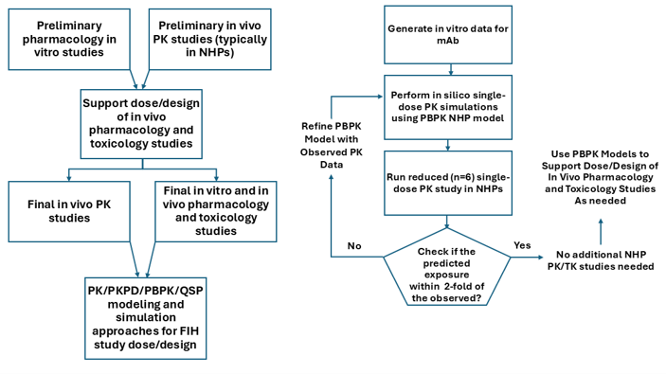
Figure 3. Observed vs. “A Priori” Predicted PK Profiles of Study Monoclonal Antibodies in Monkeys. Points represent observed and lines represent predicted.
Akshat to please create a publication ready figure for all 8 molecules – one panel each with label including molecule and target names - organized by target; remove title and subtitles from current plot (i.e., monkey, predicted observed etc that is in the current plots).
Figure 4. Observed vs. “A Priori” Predicted PK Profiles of Study Monoclonal Antibodies in Humans. Points represent observed and lines represent predicted.
Akshat to please create a publication ready figure for all 8 molecules – same comments as above

Tables
Table 1. Observed vs. “A Priori” Predicted Exposures of Study Monoclonal Antibodies in Monkeys and in Humans. FE = Predicted / Observed.
Add target names in the table and organize by target

