Supplementary Material S1
S1.1. Observed and model-predicted monkey plasma concentration-time profiles across molecules and dose levels. (A) A priori PBPK simulations generated without fitting to monkey PK data. (B) Top-down QSS TMDD Run 4 fits with CL, Vc, Q, and Vp estimated and molecule-specific TMDD inputs fixed. Points represent observed data and lines represent model predictions.
(A) A priori PBPK monkey profiles
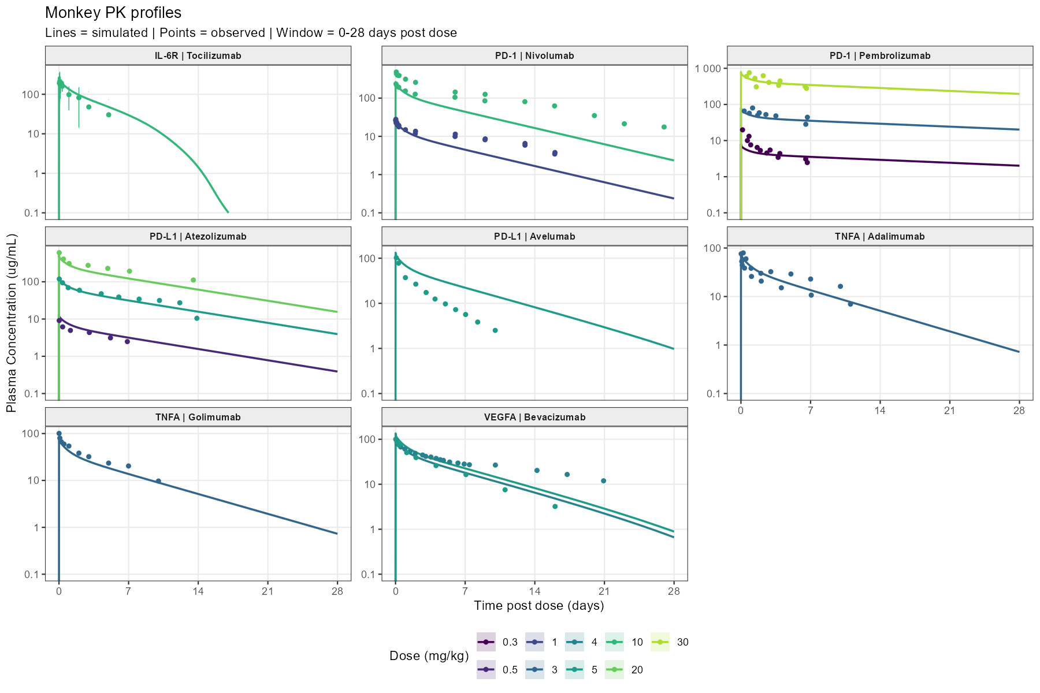

(B) Top-down QSS TMDD monkey fitted profiles
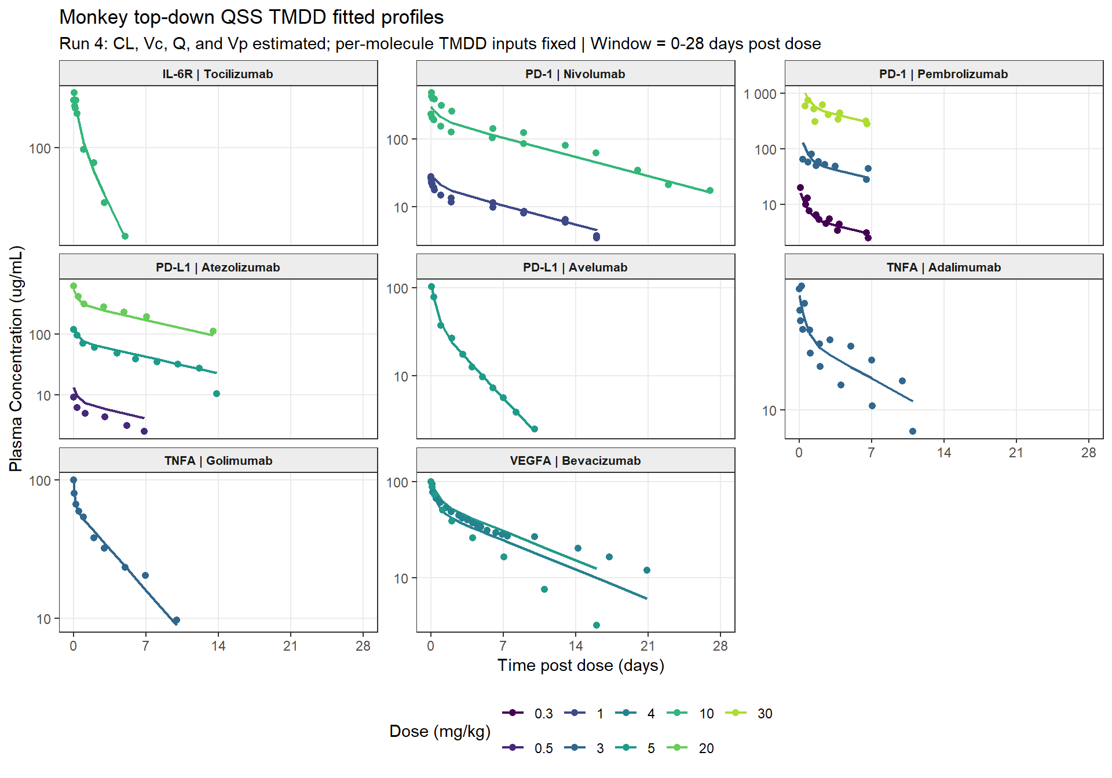

S1.2. Fold-error comparison for monkey terminal clearance, AUC0-28d, and Cmax predicted using “a priori” PBPK and monkey-fitted top-down TMDD translation. (A) Terminal clearance, representing nonlinear target-mediated elimination; (B) AUC0-28d and (C) Cmax, representing the predominantly linear elimination component. Fold error equals predicted divided by observed; bars extend from 1 on a base-2 logarithmic scale, and the shaded region and dashed lines indicate the 0.5- to 2-fold interval.
(A) Monkey terminal clearance
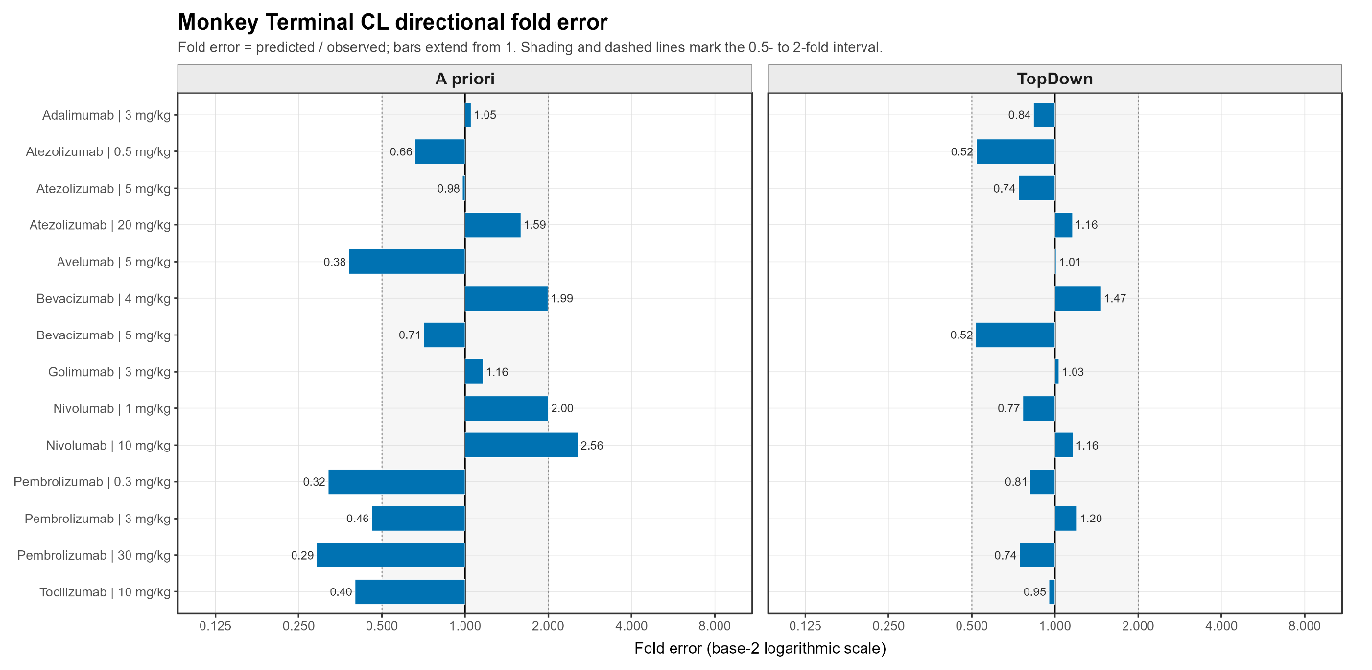
(B) Monkey AUC0-28d
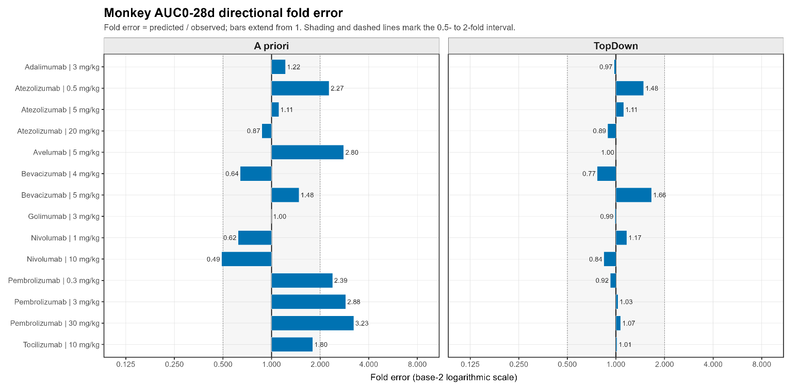
(C) Monkey Cmax
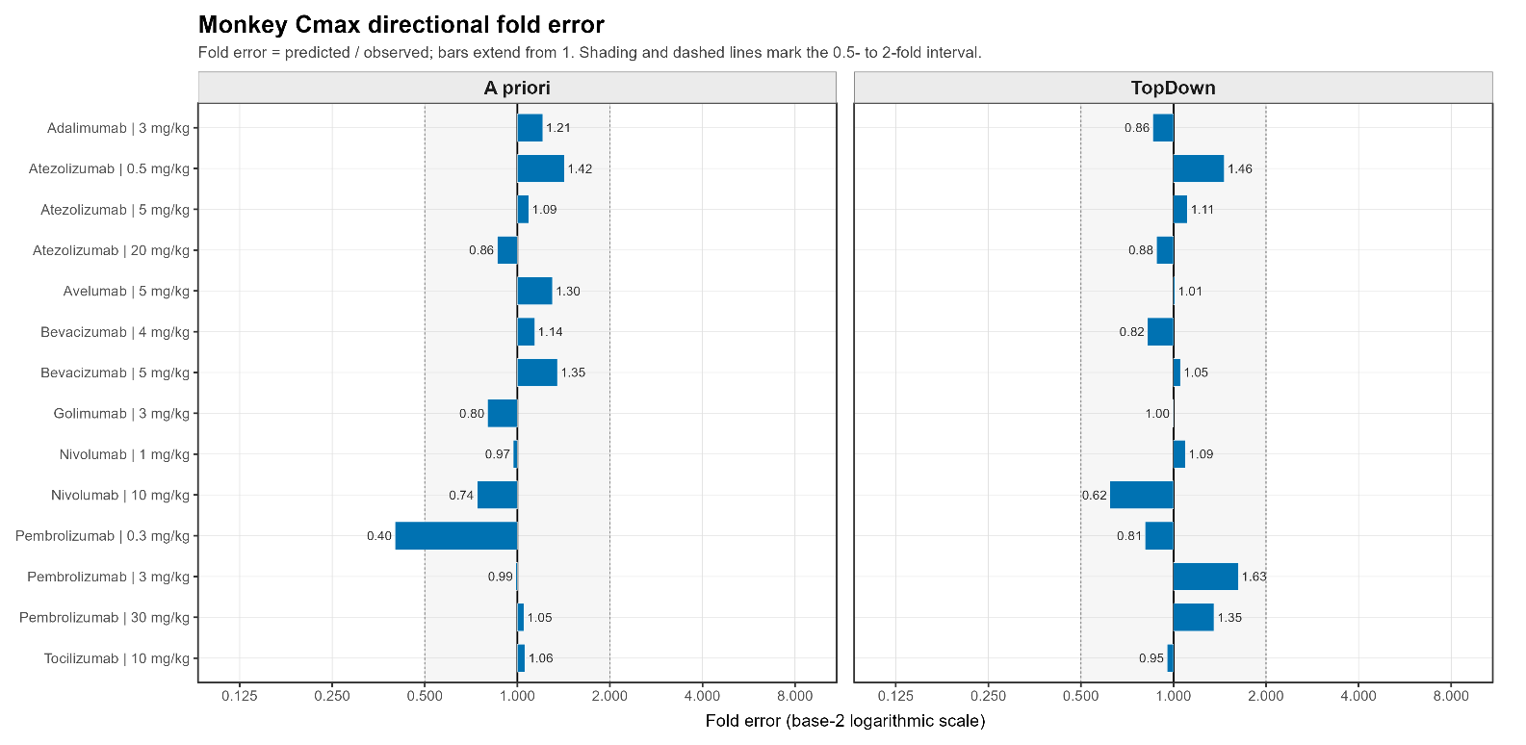

S1.3. Parameters Used in A Priori and Top-Down Simulations
Molecule | Species | Parameter | Value | Unit | Method for deriving the parameter in the analytical method | Parameter Group | Source
Adalimumab | Monkey | Kd | 0.000127 | uM | SPR/Biacore (Biacore 3000); KD = 127 pM for soluble TNF-alpha trimer; 1:1 binding model | A Priori and Top Down | Shealy et al., 2011; PMC3180089
Adalimumab | Monkey | koff | 0.0096 | 1/min | SPR/Biacore (Biacore 3000); kd = 16 x 10^-5 s^-1 converted to 0.0096 min^-1 | A Priori and Top Down | Shealy et al., 2011; PMC3180089
Adalimumab | Monkey | kint | 0.866 | 1/h | Estimated from minimal PBPK model; internalization rate constant for mAb-TNF complex in serum | A Priori and Top Down | Zheng et al., 2020; PMC7531524
Adalimumab | Monkey | Reference target concentration | 0.001 | nM | TNF-alpha baseline concentration in healthy subject | A Priori and Top Down | Montes de Oca et al., 2025; doi: 10.3390/pharmaceutics18040445
Adalimumab | Monkey | kdeg | 0.223 | 1/h | First-order degradation rate constant for soluble TNF-alpha in PBPK-PD model | A Priori and Top Down | Montes de Oca et al., 2025; doi: 10.3390/pharmaceutics18040445
Adalimumab | Monkey | Kd (FcRn) in endosomal space | 1.05 | uM | Model-based meta analysis | A Priori | Benamara et al., 2025; PMID: 41536283
Atezolizumab | Monkey | Kd | 0.299 | uM | Equilibrium binding studies using human PD-L1 expressed on 293 cells; weighted mean KD from reported in vitro values | A Priori and Top Down | Huang et al., 2022 PMID: 36225583
Atezolizumab | Monkey | koff | 0.00936 | 1/min | SPR/Biacore | A Priori and Top Down | Huang et al., 2022 PMID: 36225583
Atezolizumab | Monkey | kint | 0.606 | 1/h | Flow cytometry internalization assay in BxPC-3 cells; percent PD-L1 remaining at cell surface | A Priori and Top Down | Huang et al., 2022 PMID: 36225583
Atezolizumab | Monkey | Reference target concentration | 0.609 | nM | Assumed same across species (estimated in source) | A Priori and Top Down | Huang et al., 2022 PMID: 36225583
Atezolizumab | Monkey | kdeg | 0.0426 | 1/h | Median PD-L1 degradation rate from meta-analysis | A Priori and Top Down | Huang et al., 2022 PMID: 36225583
Atezolizumab | Monkey | Kd (FcRn) in endosomal space | 0.65 | uM | SPR/Biacore | A Priori | Huang et al., 2022 PMID: 36225583
Avelumab | Monkey | Kd | 0.0000467 | uM | SPR assay (Biacore T200), 1:1 kinetic fitting | A Priori and Top Down | Jin et al., 2021 PMID: 34484871
Avelumab | Monkey | koff | 0.00174 | 1/min | SPR assay (Biacore T200), 1:1 kinetic fitting | A Priori and Top Down | Benicky et al., 2022 PMID: 33073996
Avelumab | Monkey | kint | 0.25 | 1/h | pHrodo flow-cytometry internalization assay | A Priori and Top Down | Jin et al., 2021 PMID: 34484871
Avelumab | Monkey | Reference target concentration | 0.609 | nM | Assumed same across species (estimated in source) | A Priori and Top Down | Huang et al., 2022 PMID: 36225583
Avelumab | Monkey | kdeg | 0.0426 | 1/h | Median PD-L1 degradation rate from Huang et al. meta-analysis; used as target-level parameter | A Priori and Top Down | Huang et al., 2022 PMID: 36225583
Avelumab | Monkey | Kd (FcRn) in endosomal space | 1.05 | uM | Model-based meta analysis | A Priori | Benamara et al., 2025
Bevacizumab | Monkey | Kd | 0.000058 | uM | SPR-Biacore; bevacizumab captured on Protein A sensor chip; human VEGF-A165 KD = 58 pM | A Priori and Top Down | Papadopoulos et al., 2012; https://doi.org/10.1007/s10456-011-9249-6
Bevacizumab | Monkey | koff | 0.00186 | 1/min | SPR-Biacore; kd = 3.10e-5 s^-1 converted to 0.00186 min^-1 | A Priori and Top Down | Papadopoulos et al., 2012; https://doi.org/10.1007/s10456-011-9249-6
Bevacizumab | Monkey | kint | 0.48 | 1/h | Assumed same as kdeg | A Priori and Top Down | Sarabipour et al., 2024 PMID 38324585
Bevacizumab | Monkey | Reference target concentration | 0.013 | nM | quantitative fluorescence | A Priori and Top Down | Imoukhuede et al., 2012 PMID: 21185287
Bevacizumab | Monkey | kdeg | 0.48 | 1/h |  | A Priori and Top Down | Sarabipour et al., 2024 PMID 38324585
Bevacizumab | Monkey | Kd (FcRn) in endosomal space | 1.05 | uM | Model-based meta analysis | A Priori | Benamara et al., 2025
Golimumab | Monkey | Kd | 0.000018 | uM | SPR/Biacore (Biacore 3000); KD = 18 pM for soluble TNF-alpha trimer; 1:1 binding model | A Priori and Top Down | Shealy et al., 2011; PMC3180089
Golimumab | Monkey | koff | 0.005583 | 1/min | SPR/Biacore (Biacore 3000); kd = 9.3 x 10^-5 s^-1 converted to 0.00558 min^-1 | A Priori and Top Down | Shealy et al., 2011; PMC3180089
Golimumab | Monkey | kint | 0.866 | 1/h | Estimated from minimal PBPK model; internalization rate constant for mAb-TNF complex in serum | A Priori and Top Down | Zheng et al., 2020; PMC7531524
Golimumab | Monkey | Reference target concentration | 0.001 | nM | TNF-alpha baseline concentration in healthy subject | A Priori and Top Down | Montes de Oca et al., 2025; doi: 10.3390/pharmaceutics18040445
Golimumab | Monkey | kdeg | 0.223 | 1/h | First-order degradation rate constant for soluble TNF-alpha in PBPK-PD model | A Priori and Top Down | Montes de Oca et al., 2025; doi: 10.3390/pharmaceutics18040445
Golimumab | Monkey | Kd (FcRn) in endosomal space | 1.05 | uM | Model-based meta analysis | A Priori | Benamara et al., 2025; PMID: 41536283
Nivolumab | Monkey | Kd | 0.00145 | uM | SPR assay (BIAcore T100) using mammalian-expressed human PD-1; WT PD-1 KD = 1.45 nM | A Priori and Top Down | Tan et al., 2017; https://doi.org/10.1038/ncomms14369
Nivolumab | Monkey | koff | 0.114 | uM | SPR/Biacore | A Priori and Top Down | Tan et al., 2017; https://doi.org/10.1038/ncomms14369
Nivolumab | Monkey | kint | 0.027 | 1/h | Assumed same as kdeg | A Priori and Top Down | Lindauer et al., 2017; https://doi.org/10.1002/psp4.12130
Nivolumab | Monkey | Reference target concentration | 0.0166 | nM | Assumed same across species (estimated in source) | A Priori and Top Down | Lindauer et al., 2017; https://doi.org/10.1002/psp4.12130
Nivolumab | Monkey | kdeg | 0.027 | 1/h | Estimated in source | A Priori and Top Down | Lindauer et al., 2017; https://doi.org/10.1002/psp4.12130
Nivolumab | Monkey | Kd (FcRn) in endosomal space | 1.05 | uM | Model-based meta analysis | A Priori | Benamara et al., 2025
Pembrolizumab | Monkey | Kd | 0.00031 | uM | SPR/Biacore | A Priori and Top Down | Lindauer et al., 2017 PMID: 27863176
Pembrolizumab | Monkey | koff | 0.0017 | 1/min | SPR/Biacore | A Priori and Top Down | Lindauer et al., 2017 PMID: 27863176
Pembrolizumab | Monkey | kint | 0.027 |  | Estimated in source | A Priori and Top Down | Lindauer et al., 2017 PMID: 27863176
Pembrolizumab | Monkey | Reference target concentration | 0.0166 | nM | Assumed same across species (estimated in source) | A Priori and Top Down | Lindauer et al., 2017 PMID: 27863176
Pembrolizumab | Monkey | kdeg | 0.027 | 1/h | Estimated in source | A Priori and Top Down | Lindauer et al., 2017 PMID: 27863176
Pembrolizumab | Monkey | Kd (FcRn) in endosomal space | 0.081 | uM | SPR/Biacore | A Priori | Lindauer et al., 2017 PMID: 27863176
Tocilizumab | Monkey | Kd | 0.00134 | uM | SPR/Biacore | A Priori and Top Down | Xu et al., 2021 PMID: 33314148
Tocilizumab | Monkey | koff | 0.01284 | 1/min | SPR/Biacore | A Priori and Top Down | Xu et al., 2021 PMID: 33314148
Tocilizumab | Monkey | kint | 0.28 | 1/h | Assumed same as kdeg | A Priori and Top Down | Gerhartz et al., 1994 PMID: 8033901
Tocilizumab | Monkey | Reference target concentration | 2.2 | nM | Ligand-binding receptor assay (assumed same across species) | A Priori and Top Down | Nesbitt et al., 1992 PMID: 1550952
Tocilizumab | Monkey | kdeg | 0.28 | 1/h | Pulse chase experiments | A Priori and Top Down | Gerhartz et al., 1994 PMID: 8033901
Tocilizumab | Monkey | Kd (FcRn) in endosomal space | 1.05 | uM | Model-based meta analysis | A Priori | Benamara et al., 2025
Adalimumab | Human | Kd | 0.000127 | uM | SPR/Biacore (Biacore 3000); KD = 127 pM for soluble TNF-alpha trimer; 1:1 binding model | A Priori and Top Down | Shealy et al., 2011; PMC3180089
Adalimumab | Human | koff | 0.0096 | 1/min | SPR/Biacore (Biacore 3000); kd = 16 x 10^-5 s^-1 converted to 0.0096 min^-1 | A Priori and Top Down | Shealy et al., 2011; PMC3180089
Adalimumab | Human | kint | 0.866 | 1/h | Estimated from minimal PBPK model; internalization rate constant for mAb-TNF complex in serum | A Priori and Top Down | Zheng et al., 2020; PMC7531524
Adalimumab | Human | Reference target concentration | 0.001 | nM | TNF-alpha baseline concentration in healthy (assumed same across species) | A Priori and Top Down | Montes de Oca et al., 2025; doi: 10.3390/pharmaceutics18040445
Adalimumab | Human | kdeg | 0.223 | 1/h |  | A Priori and Top Down | Montes de Oca et al., 2025; doi: 10.3390/pharmaceutics18040445
Adalimumab | Human | Kd (FcRn) in endosomal space | 1.05 | uM | Model-based meta analysis | A Priori | Benamara et al., 2025; PMID: 41536283
Atezolizumab | Human | Kd | 0.299 | uM | Equilibrium binding studies using human PD-L1 expressed on 293 cells; weighted mean KD from reported in vitro values | A Priori and Top Down | Huang et al., 2022 PMID: 36225583
Atezolizumab | Human | koff | 0.00936 | 1/min | SPR/Biacore | A Priori and Top Down | Huang et al., 2022 PMID: 36225583
Atezolizumab | Human | kint | 0.606 | 1/h | Flow cytometry internalization assay in BxPC-3 cells; percent PD-L1 remaining at cell surface | A Priori and Top Down | Huang et al., 2022 PMID: 36225583
Atezolizumab | Human | Reference target concentration | 0.609 | nM | Assumed same across species (estimated in source) | A Priori and Top Down | Huang et al., 2022 PMID: 36225583
Atezolizumab | Human | kdeg | 0.0426 | 1/h | Median PD-L1 degradation rate from meta-analysis | A Priori and Top Down | Huang et al., 2022 PMID: 36225583
Atezolizumab | Human | Kd (FcRn) in endosomal space | 0.65 | uM | SPR/Biacore | A Priori | Huang et al., 2022 PMID: 36225583
Avelumab | Human | Kd | 0.0000467 | uM | SPR assay (Biacore T200), 1:1 kinetic fitting | A Priori and Top Down | Jin et al., 2021 PMID: 34484871
Avelumab | Human | koff | 0.00174 | 1/min | SPR assay (Biacore T200), 1:1 kinetic fitting | A Priori and Top Down | Benicky et al., 2022 PMID: 33073996
Avelumab | Human | kint | 0.25 | 1/h | pHrodo flow-cytometry internalization assay | A Priori and Top Down | Jin et al., 2021 PMID: 34484871
Avelumab | Human | Reference target concentration | 0.609 | nM | Assumed same across species (estimated in source) | A Priori and Top Down | Huang et al., 2022 PMID: 36225583
Avelumab | Human | kdeg | 0.0426 | 1/h | Median PD-L1 degradation rate from Huang et al. meta-analysis; used as target-level parameter | A Priori and Top Down | Huang et al., 2022 PMID: 36225583
Avelumab | Human | Kd (FcRn) in endosomal space | 1.05 | uM | Model-based meta analysis | A Priori | Benamara et al., 2025
Bevacizumab | Human | Kd | 0.000058 | uM | SPR-Biacore; bevacizumab captured on Protein A sensor chip; human VEGF-A165 KD = 58 pM | A Priori and Top Down | Papadopoulos et al., 2012; https://doi.org/10.1007/s10456-011-9249-6
Bevacizumab | Human | koff | 0.00186 | 1/min | SPR-Biacore; kd = 3.10e-5 s^-1 converted to 0.00186 min^-1 | A Priori and Top Down | Papadopoulos et al., 2012; https://doi.org/10.1007/s10456-011-9249-6
Bevacizumab | Human | kint | 0.48 | 1/h | Assumed same as kdeg | A Priori and Top Down | Sarabipour et al., 2024 PMID 38324585
Bevacizumab | Human | Reference target concentration | 0.013 | nM | quantitative fluorescence (assumed same across species) | A Priori and Top Down | Imoukhuede et al., 2012 PMID: 21185287
Bevacizumab | Human | kdeg | 0.48 | 1/h |  | A Priori and Top Down | Sarabipour et al., 2024 PMID 38324585
Bevacizumab | Human | Kd (FcRn) in endosomal space | 1.05 | uM | Model-based meta analysis | A Priori | Benamara et al., 2025
Golimumab | Human | Kd | 0.000018 | uM | SPR/Biacore (Biacore 3000); KD = 18 pM for soluble TNF-alpha trimer; 1:1 binding model | A Priori and Top Down | Shealy et al., 2011; PMC3180089
Golimumab | Human | koff | 0.005583 | 1/min | SPR/Biacore (Biacore 3000); kd = 9.3 x 10^-5 s^-1 converted to 0.00558 min^-1 | A Priori and Top Down | Shealy et al., 2011; PMC3180089
Golimumab | Human | kint | 0.866 | 1/h | Estimated from minimal PBPK model; internalization rate constant for mAb-TNF complex in serum | A Priori and Top Down | Zheng et al., 2020; PMC7531524
Golimumab | Human | Reference target concentration | 0.001 | nM | TNF-alpha baseline concentration in healthy (assumed same across species) | A Priori and Top Down | Montes de Oca et al., 2025; doi: 10.3390/pharmaceutics18040445
Golimumab | Human | kdeg | 0.223 | 1/h |  | A Priori and Top Down | Montes de Oca et al., 2025; doi: 10.3390/pharmaceutics18040445
Golimumab | Human | Kd (FcRn) in endosomal space | 1.05 | uM | Model-based meta analysis | A Priori | Benamara et al., 2025; PMID: 41536283
Nivolumab | Human | Kd | 0.00145 | uM | SPR assay (BIAcore T100) using mammalian-expressed human PD-1; WT PD-1 KD = 1.45 nM | A Priori and Top Down | Tan et al., 2017; https://doi.org/10.1038/ncomms14369
Nivolumab | Human | koff | 0.114 | uM | SPR/Biacore | A Priori and Top Down | Tan et al., 2017; https://doi.org/10.1038/ncomms14369
Nivolumab | Human | kint | 0.027 | 1/h | Assumed same as kdeg | A Priori and Top Down | Lindauer et al., 2017; https://doi.org/10.1002/psp4.12130
Nivolumab | Human | Reference target concentration | 0.07138 | nM | Calculated based on tumor to blood ratio ~4.3 in source | A Priori and Top Down | Lindauer et al., 2017; https://doi.org/10.1002/psp4.12130
Nivolumab | Human | kdeg | 0.027 | 1/h | Estimated in source | A Priori and Top Down | Lindauer et al., 2017; https://doi.org/10.1002/psp4.12130
Nivolumab | Human | Kd (FcRn) in endosomal space | 1.05 | uM | Model-based meta analysis | A Priori | Benamara et al., 2025
Pembrolizumab | Human | Kd | 0.00031 | uM | SPR/Biacore | A Priori and Top Down | Lindauer et al., 2017 PMID: 27863176
Pembrolizumab | Human | koff | 0.0017 | 1/min | SPR/Biacore | A Priori and Top Down | Lindauer et al., 2017 PMID: 27863176
Pembrolizumab | Human | kint | 0.027 |  | Estimated in source | A Priori and Top Down | Lindauer et al., 2017 PMID: 27863176
Pembrolizumab | Human | Reference target concentration | 0.07138 | nM | Calculated based on tumor to blood ratio ~4.3 in source | A Priori and Top Down | Lindauer et al., 2017 PMID: 27863176
Pembrolizumab | Human | kdeg | 0.027 | 1/h | Estimated in source | A Priori and Top Down | Lindauer et al., 2017 PMID: 27863176
Pembrolizumab | Human | Kd (FcRn) in endosomal space | 0.081 | uM | SPR/Biacore | A Priori | Lindauer et al., 2017 PMID: 27863176
Tocilizumab | Human | Kd | 0.00134 | uM | SPR/Biacore | A Priori and Top Down | Xu et al., 2021 PMID: 33314148
Tocilizumab | Human | koff | 0.01284 | 1/min | SPR/Biacore | A Priori and Top Down | Xu et al., 2021 PMID: 33314148
Tocilizumab | Human | kint | 0.28 | 1/h | Assumed same as kdeg | A Priori and Top Down | Gerhartz et al., 1994 PMID: 8033901
Tocilizumab | Human | Reference target concentration | 1 | nM | Ligand-binding receptor assay (assumed same across species) | A Priori and Top Down | Nesbitt et al., 1992 PMID: 1550952
Tocilizumab | Human | kdeg | 0.28 | 1/h | Pulse chase experiments | A Priori and Top Down | Gerhartz et al., 1994 PMID: 8033901
Tocilizumab | Human | Kd (FcRn) in endosomal space | 1.05 | uM | Model-based meta analysis | A Priori | Benamara et al., 2025

S1.4. Top-down Linear Clearance Estimates for Monkey
Molecule | Target | TopDown Monkey Estimated CL (L/h/kg) | CL RSE (%)
Adalimumab | TNFA | 0.0003397 | 22.2
Atezolizumab | PD-L1 | 0.0002275 | 7.9
Avelumab | PD-L1 | 0.0011553 | 1.8
Bevacizumab | VEGFA | 0.0003208 | 14.5
Golimumab | TNFA | 0.0003822 | 5.9
Nivolumab | PD-1 | 0.0001861 | 5.4
Pembrolizumab | PD-1 | 0.0001889 | 18.6
Tocilizumab | IL-6R | 0.0008003 | 7.8

