Physiologically-based Pharmacokinetic – Informed New Approach Methodology Framework for Monoclonal Antibodies

Supplementary Material S1
S1.1. Observed and model-predicted monkey plasma concentration-time profiles across molecules and dose levels. (A) A priori PBPK simulations generated without fitting to monkey PK data. (B) Top-down QSS TMDD Run 4 fits with CL, Vc, Q, and Vp estimated and molecule-specific TMDD inputs fixed. Points represent observed data and lines represent model predictions.
(A) A priori PBPK monkey profiles
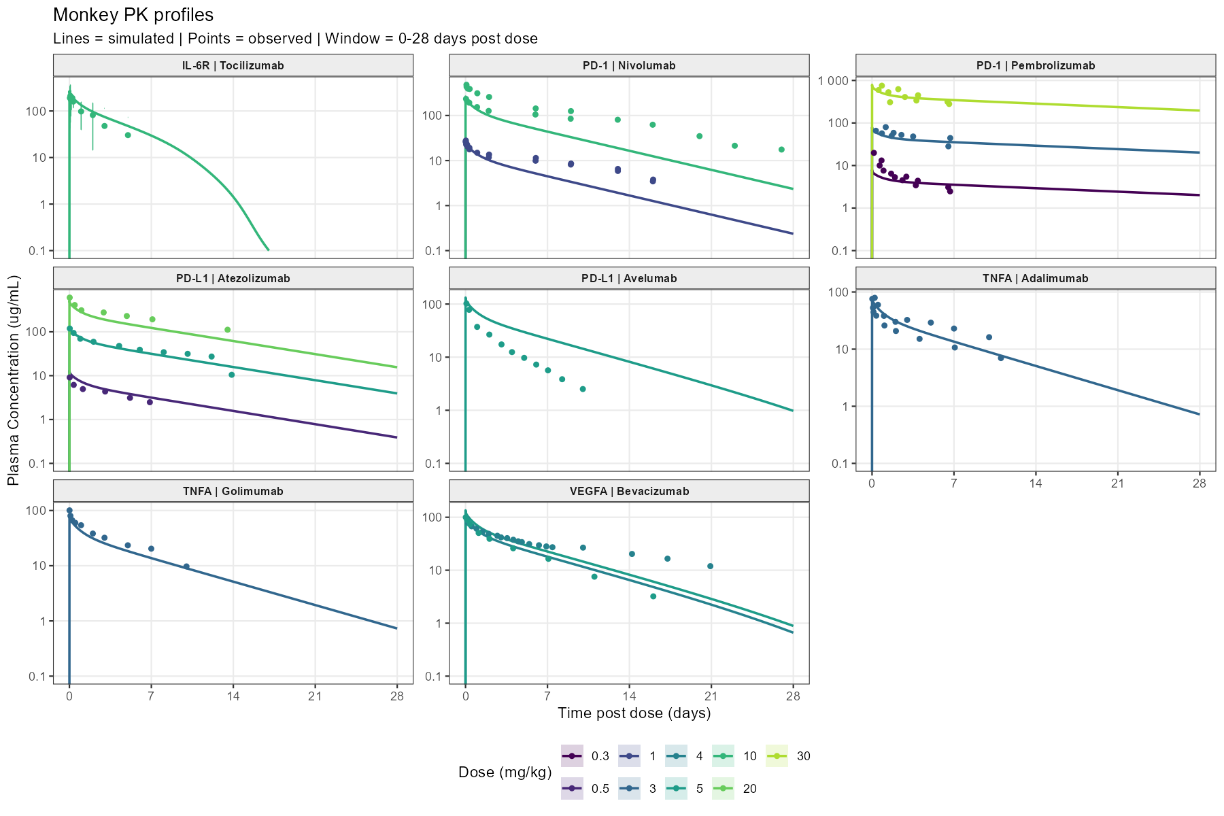

(B) Top-down QSS TMDD monkey fitted profiles
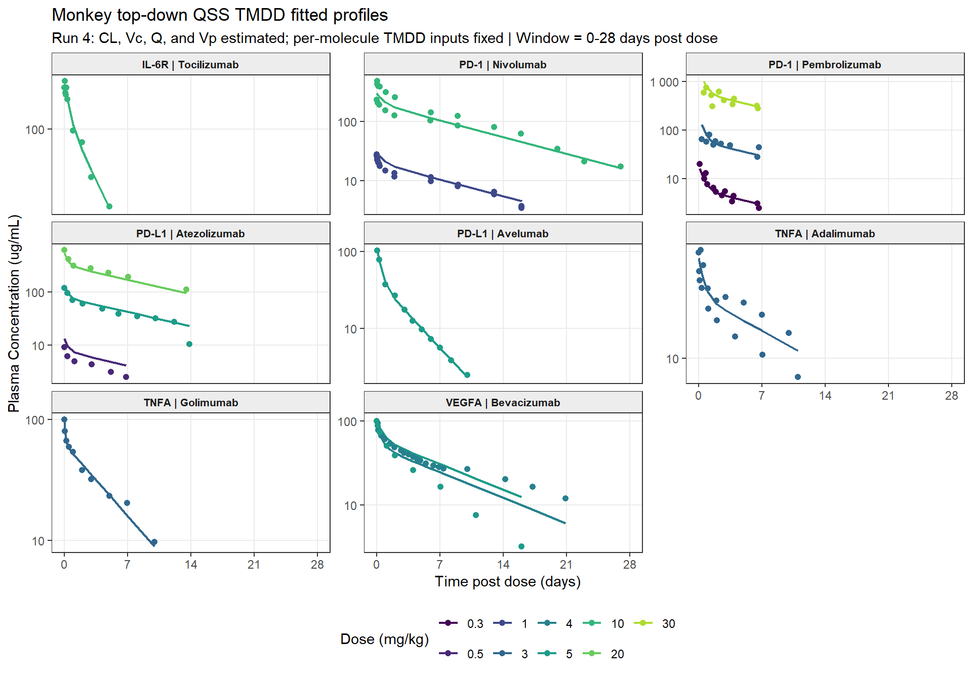

S1.2. Fold-error comparison for monkey clearance, AUC0-28d, and Cmax predicted using “a priori” PBPK and monkey-fitted top-down TMDD translation. (A) Clearance, calculated as dose/AUCinf and representing total systemic clearance; (B) AUC0-28d; and (C) Cmax. At target-saturating doses, clearance is expected to be dominated by linear clearance. Fold error equals predicted divided by observed; bars extend from 1 on a base-2 logarithmic scale, and the shaded region and dashed lines indicate the 0.5- to 2-fold interval.
(A) Monkey clearance
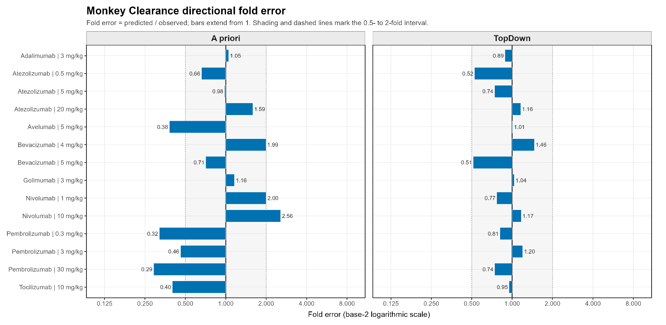

(B) Monkey AUC0-28d
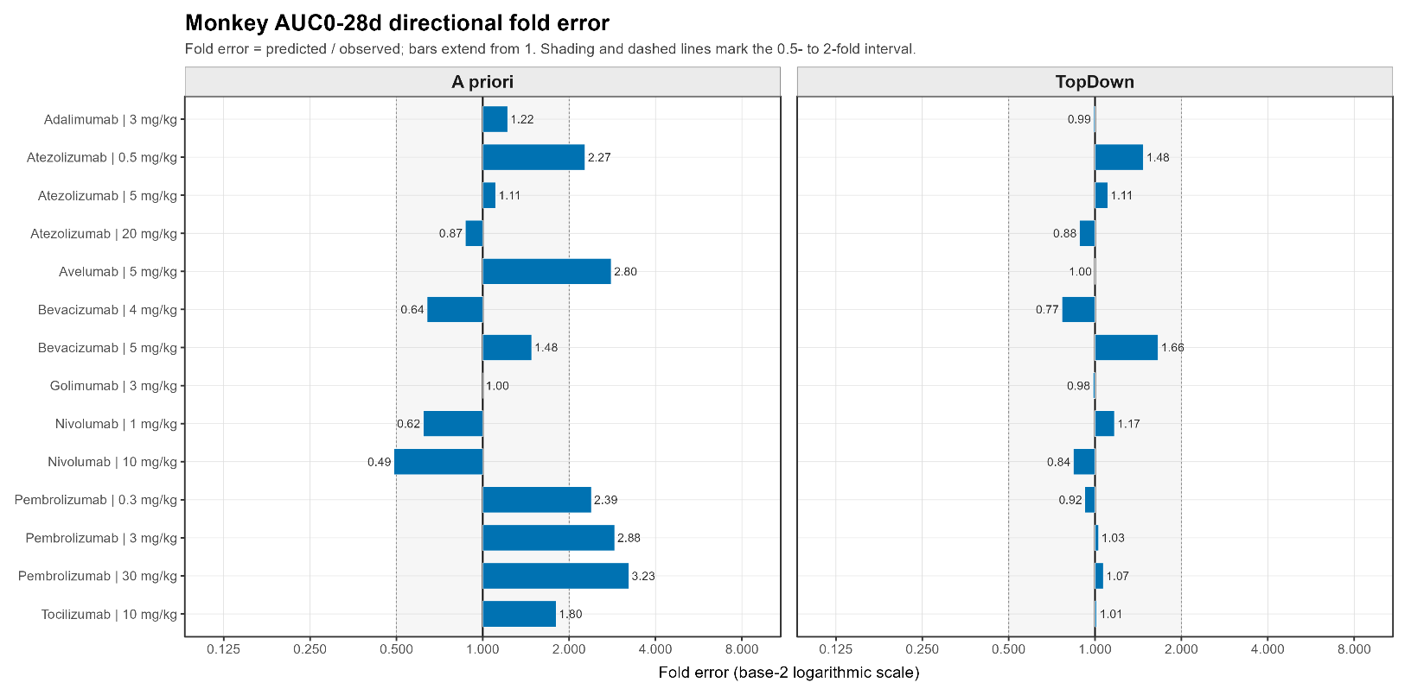

(C) Monkey Cmax
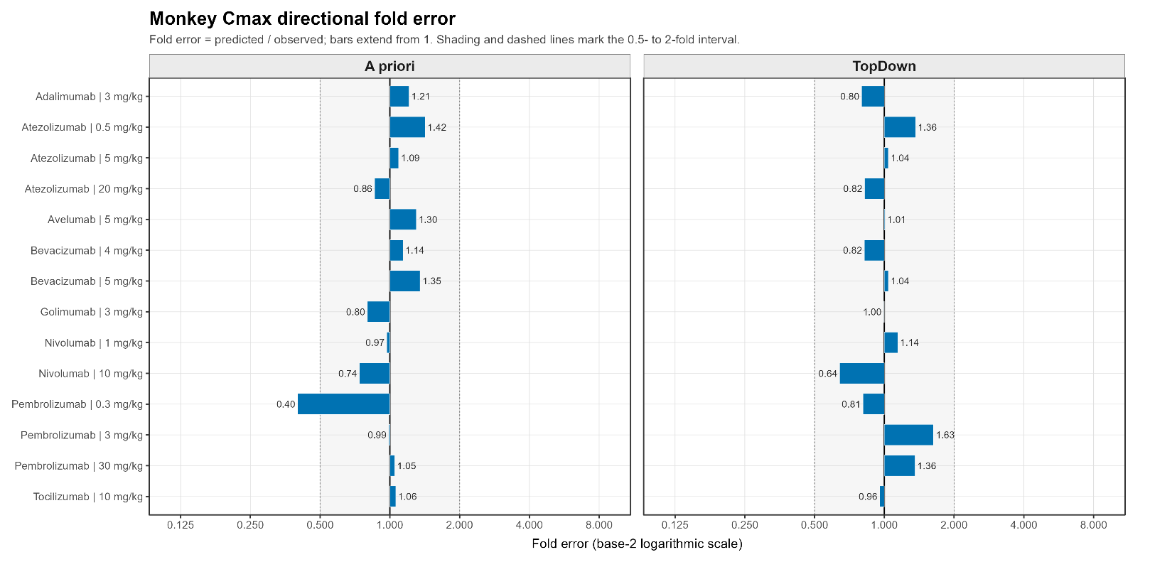
S1.3. Parameters Used in A Priori and Top-Down Simulations
Molecule | Species | Parameter | Value | Unit | Analytical Method for deriving the parameter | Parameter Group | Source
Adalimumab | Monkey | Kd | 0.000127 | uM | SPR/Biacore (Biacore 3000) | A Priori and Top Down | [1]
Adalimumab | Monkey | koff | 0.0096 | 1/min | SPR/Biacore (Biacore 3000) | A Priori and Top Down | [1]
Adalimumab | Monkey | kint | 0.866 | 1/h | Model fitting by the authors of [2] | A Priori and Top Down | [2]
Adalimumab | Monkey | Reference target concentration | 0.001 | nM | Model fitting by the authors of [3] | A Priori and Top Down | [3]
Adalimumab | Monkey | kdeg | 0.223 | 1/h | Model parameter from anti-TNF PBPK analysis | A Priori and Top Down | [4]
Adalimumab | Monkey | Kd (FcRn) in endosomal space | 1.07 | uM | Model-based meta-analysis [5] | A Priori | [5]
Atezolizumab | Monkey | Kd | 0.299 | uM | Equilibrium binding studies using human PD-L1 expressed on 293 cells | A Priori and Top Down | [6]
Atezolizumab | Monkey | koff | 0.00936 | 1/min | SPR/Biacore | A Priori and Top Down | [6]
Atezolizumab | Monkey | kint | 0.606 | 1/h | Flow cytometry internalization assay in BxPC-3 cells | A Priori and Top Down | [6]
Atezolizumab | Monkey | Reference target concentration | 0.609 | nM | Model fitting by the authors of [6] | A Priori and Top Down | [6]
Atezolizumab | Monkey | kdeg | 0.0426 | 1/h | Model fitting by the authors of [6] | A Priori and Top Down | [6]
Atezolizumab | Monkey | Kd (FcRn) in endosomal space | 0.65 | uM | SPR/Biacore | A Priori | [6]
Avelumab | Monkey | Kd | 0.0000467 | uM | SPR assay (Biacore T200) | A Priori and Top Down | [7]
Avelumab | Monkey | koff | 0.00174 | 1/min | SPR assay (Biacore T200) | A Priori and Top Down | [8]
Avelumab | Monkey | kint | 0.25 | 1/h | pHrodo flow-cytometry internalization assay | A Priori and Top Down | [7]
Avelumab | Monkey | Reference target concentration | 0.609 | nM | Model fitting by the authors [6] | A Priori and Top Down | [6]
Avelumab | Monkey | kdeg | 0.0426 | 1/h | Model fitting by the authors [6] | A Priori and Top Down | [6]
Avelumab | Monkey | Kd (FcRn) in endosomal space | 1.07 | uM | Model-based meta-analysis | A Priori | [5]
Bevacizumab | Monkey | Kd | 0.000058 | uM | SPR-Biacore | A Priori and Top Down | [9]
Bevacizumab | Monkey | koff | 0.00186 | 1/min | SPR-Biacore | A Priori and Top Down | [9]
Bevacizumab | Monkey | kint | 0.48 | 1/h | Assumed same as kdeg | A Priori and Top Down | [10]
Bevacizumab | Monkey | Reference target concentration | 0.013 | nM | quantitative fluorescence | A Priori and Top Down | [11]
Bevacizumab | Monkey | kdeg | 0.48 | 1/h | cycloheximide-chase protein degradation assay; western blot dosimetry | A Priori and Top Down | [10]
Bevacizumab | Monkey | Kd (FcRn) in endosomal space | 1.07 | uM | Model-based meta-analysis | A Priori | [5]
Golimumab | Monkey | Kd | 0.000018 | uM | SPR/Biacore (Biacore 3000) | A Priori and Top Down | [1]
Golimumab | Monkey | koff | 0.005583 | 1/min | SPR/Biacore (Biacore 3000) | A Priori and Top Down | [1]
Golimumab | Monkey | kint | 0.866 | 1/h | model estimated by the authors of the source | A Priori and Top Down | [2]
Golimumab | Monkey | Reference target concentration | 0.001 | nM | Model-derived TNF-alpha baseline assumption (1 pM) | A Priori and Top Down | [3]
Golimumab | Monkey | kdeg | 0.223 | 1/h | Model parameter from anti-TNF PBPK analysis | A Priori and Top Down | [4]
Golimumab | Monkey | Kd (FcRn) in endosomal space | 1.07 | uM | Model-based meta-analysis | A Priori | [5]
Nivolumab | Monkey | Kd | 0.00145 | uM | SPR assay (BIAcore T100) | A Priori and Top Down | [12]
Nivolumab | Monkey | koff | 0.114 | uM | SPR/Biacore | A Priori and Top Down | [12]
Nivolumab | Monkey | kint | 0.027 | 1/h | Model estimated by the authors | A Priori and Top Down | [13]
Nivolumab | Monkey | Reference target concentration | 0.0166 | nM | Model estimated by the authors | A Priori and Top Down | [13]
Nivolumab | Monkey | kdeg | 0.027 | 1/h | Model estimated by the authors | A Priori and Top Down | [13]
Nivolumab | Monkey | Kd (FcRn) in endosomal space | 1.07 | uM | Model-based meta-analysis | A Priori | [5]
Pembrolizumab | Monkey | Kd | 0.00031 | uM | SPR/Biacore | A Priori and Top Down | [13]
Pembrolizumab | Monkey | koff | 0.0017 | 1/min | SPR/Biacore | A Priori and Top Down | [13]
Pembrolizumab | Monkey | kint | 0.027 |  | Model estimated by the authors | A Priori and Top Down | [13]
Pembrolizumab | Monkey | Reference target concentration | 0.0166 | nM | Model estimated by the authors | A Priori and Top Down | [13]
Pembrolizumab | Monkey | kdeg | 0.027 | 1/h | Model estimated by the authors | A Priori and Top Down | [13]
Pembrolizumab | Monkey | Kd (FcRn) in endosomal space | 0.081 | uM | SPR/Biacore | A Priori | [13]
Tocilizumab | Monkey | Kd | 0.00134 | uM | SPR/Biacore | A Priori and Top Down | [14]
Tocilizumab | Monkey | koff | 0.01284 | 1/min | SPR/Biacore | A Priori and Top Down | [14]
Tocilizumab | Monkey | kint | 0.28 | 1/h | Assumed same as kdeg; Pulse chase experiments | A Priori and Top Down | [15]
Tocilizumab | Monkey | Reference target concentration | 2.2 | nM | Ligand-binding receptor assay (assumed same across species) | A Priori and Top Down | [16]
Tocilizumab | Monkey | kdeg | 0.28 | 1/h | Pulse chase experiments | A Priori and Top Down | [15]
Tocilizumab | Monkey | Kd (FcRn) in endosomal space | 1.07 | uM | Model-based meta analysis | A Priori | [5]
Adalimumab | Human | Kd | 0.000127 | uM | SPR/Biacore (Biacore 3000) | A Priori and Top Down | [1]
Adalimumab | Human | koff | 0.0096 | 1/min | SPR/Biacore (Biacore 3000) | A Priori and Top Down | [1]
Adalimumab | Human | kint | 0.866 | 1/h | Estimated from minimal PBPK model by the authors | A Priori and Top Down | [2]
Adalimumab | Human | Reference target concentration | 0.001 | nM | Model fitting by the authors of [3] | A Priori and Top Down | [3]
Adalimumab | Human | kdeg | 0.223 | 1/h | Model parameter from anti-TNF PBPK analysis | A Priori and Top Down | [4]
Adalimumab | Human | Kd (FcRn) in endosomal space | 1.07 | uM | Model-based meta-analysis | A Priori | [5]
Atezolizumab | Human | Kd | 0.299 | uM | Equilibrium binding studies | A Priori and Top Down | [6]
Atezolizumab | Human | koff | 0.00936 | 1/min | SPR/Biacore | A Priori and Top Down | [6]
Atezolizumab | Human | kint | 0.606 | 1/h | Flow cytometry internalization assay in BxPC-3 cells | A Priori and Top Down | [6]
Atezolizumab | Human | Reference target concentration | 0.609 | nM | model fitting by the authors | A Priori and Top Down | [6]
Atezolizumab | Human | kdeg | 0.0426 | 1/h | Model estimated by the authors [6] | A Priori and Top Down | [6]
Atezolizumab | Human | Kd (FcRn) in endosomal space | 0.65 | uM | SPR/Biacore | A Priori | [6]
Avelumab | Human | Kd | 0.0000467 | uM | SPR assay (Biacore T200) | A Priori and Top Down | [7]
Avelumab | Human | koff | 0.00174 | 1/min | SPR assay (Biacore T200) | A Priori and Top Down | [8]
Avelumab | Human | kint | 0.25 | 1/h | pHrodo flow-cytometry internalization assay | A Priori and Top Down | [7]
Avelumab | Human | Reference target concentration | 0.609 | nM | Model estimated by the authors [6] | A Priori and Top Down | [6]
Avelumab | Human | kdeg | 0.0426 | 1/h | Model estimated by the authors | A Priori and Top Down | [6]
Avelumab | Human | Kd (FcRn) in endosomal space | 1.07 | uM | Model-based meta-analysis | A Priori | [5]
Bevacizumab | Human | Kd | 0.000058 | uM | SPR-Biacore | A Priori and Top Down | [9]
Bevacizumab | Human | koff | 0.00186 | 1/min | SPR-Biacore | A Priori and Top Down | [9]
Bevacizumab | Human | kint | 0.48 | 1/h | Assumed same as kdeg | A Priori and Top Down | [17]
Bevacizumab | Human | Reference target concentration | 0.013 | nM | quantitative fluorescence (assumed same across species) | A Priori and Top Down | [11]
Bevacizumab | Human | kdeg | 0.48 | 1/h | cycloheximide-chase protein degradation assay; western blot dosimetry | A Priori and Top Down | [17]
Bevacizumab | Human | Kd (FcRn) in endosomal space | 1.07 | uM | Model-based meta-analysis | A Priori | [5]
Golimumab | Human | Kd | 0.000018 | uM | SPR/Biacore (Biacore 3000) | A Priori and Top Down | [1]
Golimumab | Human | koff | 0.005583 | 1/min | SPR/Biacore (Biacore 3000) | A Priori and Top Down | [1]
Golimumab | Human | kint | 0.866 | 1/h | Model estimated by the authors [2] | A Priori and Top Down | [2]
Golimumab | Human | Reference target concentration | 0.001 | nM | Model-derived TNF-alpha baseline assumption (1 pM) | A Priori and Top Down | [3]
Golimumab | Human | kdeg | 0.223 | 1/h | Model estimated by the authors [4] | A Priori and Top Down | [4]
Golimumab | Human | Kd (FcRn) in endosomal space | 1.07 | uM | Model-based meta-analysis | A Priori | [5]
Nivolumab | Human | Kd | 0.00145 | uM | SPR assay (BIAcore T100) | A Priori and Top Down | [12]
Nivolumab | Human | koff | 0.114 | uM | SPR/Biacore | A Priori and Top Down | [12]
Nivolumab | Human | kint | 0.027 | 1/h | Model estimated by the authors [13] | A Priori and Top Down | [13]
Nivolumab | Human | Reference target concentration | 0.07138 | nM | Model estimated by the authors [13] | A Priori and Top Down | [13]
Nivolumab | Human | kdeg | 0.027 | 1/h | Model estimated by the authors [13] | A Priori and Top Down | [13]
Nivolumab | Human | Kd (FcRn) in endosomal space | 1.07 | uM | Model-based meta-analysis | A Priori | [5]
Pembrolizumab | Human | Kd | 0.00031 | uM | SPR/Biacore | A Priori and Top Down | [13]
Pembrolizumab | Human | koff | 0.0017 | 1/min | SPR/Biacore | A Priori and Top Down | [13]
Pembrolizumab | Human | kint | 0.027 |  | Model estimated by the authors [13] | A Priori and Top Down | [13]
Pembrolizumab | Human | Reference target concentration | 0.07138 | nM | Model estimated by the authors [13] | A Priori and Top Down | [13]
Pembrolizumab | Human | kdeg | 0.027 | 1/h | Model estimated by the authors of the source | A Priori and Top Down | [13]
Pembrolizumab | Human | Kd (FcRn) in endosomal space | 0.081 | uM | SPR/Biacore | A Priori | [13]
Tocilizumab | Human | Kd | 0.00134 | uM | SPR/Biacore | A Priori and Top Down | [14]
Tocilizumab | Human | koff | 0.01284 | 1/min | SPR/Biacore | A Priori and Top Down | [14]
Tocilizumab | Human | kint | 0.28 | 1/h | Pulse chase experiments | A Priori and Top Down | [15]
Tocilizumab | Human | Reference target concentration | 1 | nM | Ligand-binding receptor assay | A Priori and Top Down | [16]
Tocilizumab | Human | kdeg | 0.28 | 1/h | Pulse chase experiments | A Priori and Top Down | [15]
Tocilizumab | Human | Kd (FcRn) in endosomal space | 1.07 | uM | Model-based meta-analysis | A Priori | [5]

S1.4. Top-down Linear Clearance Estimates for Monkey
Molecule | CL (L/h/kg)  [RSE %] | V1 (L/kg) [RSE %] | Q (L/h/kg) [RSE %] | V2 (L/kg) [RSE %]
Adalimumab | 0.0004 [14.9] | 0.0467 [11.1] | 0.0010 [Fixed] | 0.0276 [Fixed]
Atezolizumab | 0.0002 [8.1] | 0.0396 [8.5] | 0.0010 [Fixed] | 0.0221 [23.4]
Avelumab | 0.0012 [1.8] | 0.0435 [6.2] | 0.0015 [21.8] | 0.0394 [8.6]
Bevacizumab | 0.0003 [14.5] | 0.0474 [5.6] | 0.0010 [Fixed] | 0.0270 [31.2]
Golimumab | 0.0004 [5.9] | 0.0288 [3.2] | 0.0038 [24.4] | 0.0171 [9.8]
Nivolumab | 0.0002 [5.4] | 0.0312 [8.5] | 0.0010 [Fixed] | 0.0149 [32.8]
Pembrolizumab | 0.0002 [18.6] | 0.0150 [23.8] | 0.0007 [23.5] | 0.0254 [22.5]
Tocilizumab | 0.0008 [5.2] | 0.0477 [3.8] | 0.0010 [Fixed] | 0.0206 [28.6]

S1.5. Percent Extrapolated in AUCinf Calculations in Observed Data.
Species | Molecule | Dose (mg/kg) | % Extrapolated in AUC_{inf}
Monkey | Adalimumab | 3 | 29
Monkey | Atezolizumab | 0.5 | 37
Monkey | Atezolizumab | 5 | 13
Monkey | Atezolizumab | 20 | 31
Monkey | Avelumab | 5 | 5
Monkey | Bevacizumab | 4 | 22
Monkey | Bevacizumab | 5 | 5
Monkey | Golimumab | 3 | 16
Monkey | Nivolumab | 1 | 21
Monkey | Nivolumab | 10 | 20
Monkey | Pembrolizumab | 0.3 | 28
Monkey | Pembrolizumab | 3 | 59
Monkey | Pembrolizumab | 30 | 38
Monkey | Tocilizumab | 10 | 15
Human | Adalimumab | 0.5 | 25
Human | Adalimumab | 1 | 30
Human | Adalimumab | 3 | 30
Human | Adalimumab | 5 | 31
Human | Adalimumab | 10 | 32
Human | Atezolizumab | 1 | 31
Human | Atezolizumab | 3 | 25
Human | Atezolizumab | 10 | 31
Human | Atezolizumab | 15 | 31
Human | Atezolizumab | 20 | 35
Human | Avelumab | 1 | 11
Human | Avelumab | 3 | 9
Human | Avelumab | 10 | 24
Human | Avelumab | 20 | 15
Human | Bevacizumab | 15 | 33
Human | Golimumab | 0.1 | 14
Human | Golimumab | 0.3 | 15
Human | Golimumab | 1 | 19
Human | Golimumab | 3 | 19
Human | Golimumab | 6 | 23
Human | Golimumab | 10 | 31
Human | Nivolumab | 1 | 50
Human | Nivolumab | 3 | 45
Human | Nivolumab | 4 | 45
Human | Nivolumab | 6 | 48
Human | Nivolumab | 10 | 42
Human | Nivolumab | 20 | 70
Human | Pembrolizumab | 2 | 42
Human | Pembrolizumab | 10 | 35
Human | Tocilizumab | 8 | 0

S1.6. Local Sensitivity Analysis of Target Related Parameters on Clearance Estimate Using PBPK Model. An a priori PBPK modeling framework was used to assess parameter sensitivity by varying the target reference concentration, target degradation rate (kdeg), and internalization rate (kint) one at a time while holding all other model parameters constant. Each parameter was varied by decreasing to 0.1-fold and increasing to 10-fold of its reference value, and the resulting terminal clearance was compared with the reference simulation. The normalized sensitivity coefficient was calculated as ln(CLvaried/CLreference)/ln(Pvaried/Preference), and a sensitivity index of 1+ the normalized coefficient was reported, such that a value of 1 indicates no sensitivity. Sensitivity indices were averaged across evaluated doses for each molecule and ranked from highest to lowest in the figure.
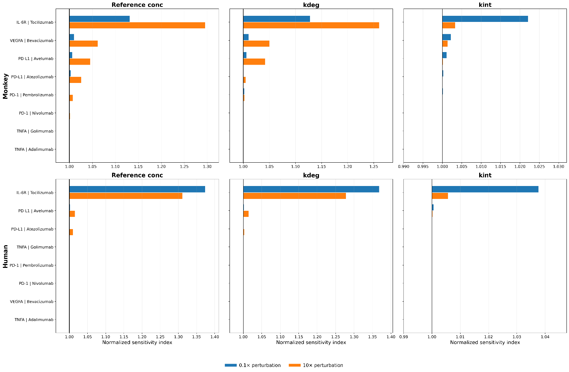

References
1. Shealy DJ, Cai A, Staquet K, Baker A, Lacy ER, Johns L, et al. Characterization of golimumab, a human monoclonal antibody specific for human tumor necrosis factor alpha. mAbs. 2010;2(4):428-439. doi:10.4161/mabs.2.4.12304.
2. Zheng S, Niu J, Geist B, Fink D, Xu Z, Zhou H, Wang W. A minimal physiologically based pharmacokinetic model to characterize colon TNF suppression and treatment effects of an anti-TNF monoclonal antibody in a mouse inflammatory bowel disease model. mAbs. 2020;12(1):1813962. doi:10.1080/19420862.2020.1813962.
3. Reig-López J, García-Otero X, Cuquerella-Gilabert M, Bandín-Vilar E, Otero-Espinar FJ, Fernández-Ferreiro A, et al. A physiologically based pharmacokinetic model to describe [89Zr]Zr-DFO-adalimumab specific activity after intravitreal administration to rats with endotoxin-induced uveitis. International Journal of Pharmaceutics. 2025;681:125845. doi:10.1016/j.ijpharm.2025.125845.
4. Chen J, Lin R, Guo G, Wu W, Ke M, Ke C, et al. Physiologically-Based Pharmacokinetic Modeling of Anti-Tumor Necrosis Factor Agents for Inflammatory Bowel Disease Patients to Predict the Withdrawal Time in Pregnancy and Vaccine Time in Infants. Clinical Pharmacology & Therapeutics. 2023;114(6):1254-1263. doi:10.1002/cpt.3031.
5. Benamara S, Sjögren E, Gattacceca F, Chenel M, Deslandes A, Nguyen L, Teutonico D. Prediction of Monoclonal Antibodies Pharmacokinetics in Human: Identification of a Reference Neonatal Fc Receptor (FcRn) Binding Affinity Using Physiologically Based Pharmacokinetic (PBPK) Modeling. ACS Pharmacology & Translational Science. 2026;9:177-190. doi:10.1021/acsptsci.5c00674.
6. Huang W, Stader F, Chan P, Shemesh CS, Chen Y, Gill KL, et al. Development of a pediatric physiologically-based pharmacokinetic model to support recommended dosing of atezolizumab in children with solid tumors. Frontiers in Pharmacology. 2022;13:974423. doi:10.3389/fphar.2022.974423.
7. Jin H, D'Urso V, Neuteboom B, McKenna SD, Schweickhardt R, Gross AW, et al. Avelumab internalization by human circulating immune cells is mediated by both Fc gamma receptor and PD-L1 binding. OncoImmunology. 2021;10(1):1958590. doi:10.1080/2162402X.2021.1958590.
8. Benicky J, Sanda M, Brnakova Kennedy Z, Grant OC, Woods RJ, Zwart A, Goldman R. PD-L1 Glycosylation and Its Impact on Binding to Clinical Antibodies. Journal of Proteome Research. 2021;20(1):485-497. doi:10.1021/acs.jproteome.0c00521.
9. Papadopoulos N, Martin J, Ruan Q, Rafique A, Rosconi MP, Shi E, et al. Binding and neutralization of vascular endothelial growth factor (VEGF) and related ligands by VEGF Trap, ranibizumab and bevacizumab. Angiogenesis. 2012;15(2):171-185. doi:10.1007/s10456-011-9249-6.
10. Calera MR, Venkatakrishnan A, Kazlauskas A. VE-cadherin increases the half-life of VEGF receptor 2. Experimental Cell Research. 2004;300(1):248-256. doi:10.1016/j.yexcr.2004.07.007.
11. Imoukhuede PI, Popel AS. Quantification and cell-to-cell variation of vascular endothelial growth factor receptors. Experimental Cell Research. 2011;317(7):955-965. doi:10.1016/j.yexcr.2010.12.014.
12. Tan S, Zhang H, Chai Y, Song H, Tong Z, Wang Q, et al. An unexpected N-terminal loop in PD-1 dominates binding by nivolumab. Nature Communications. 2017;8:14369. doi:10.1038/ncomms14369.
13. Lindauer A, Valiathan CR, Mehta K, Sriram V, de Greef R, Elassaiss-Schaap J, de Alwis DP. Translational Pharmacokinetic/Pharmacodynamic Modeling of Tumor Growth Inhibition Supports Dose-Range Selection of the Anti-PD-1 Antibody Pembrolizumab. CPT Pharmacometrics & Systems Pharmacology. 2017;6(1):11-20. doi:10.1002/psp4.12130.
14. Xu C, Rafique A, Potocky T, Paccaly A, Nolain P, Lu Q, et al. Differential Binding of Sarilumab and Tocilizumab to IL-6Rα and Effects of Receptor Occupancy on Clinical Parameters. Journal of Clinical Pharmacology. 2021;61(5):714-724. doi:10.1002/jcph.1795.
15. Gerhartz C, Dittrich E, Stoyan T, Rose-John S, Yasukawa K, Heinrich PC, Graeve L. Biosynthesis and half-life of the interleukin-6 receptor and its signal transducer gp130. European Journal of Biochemistry. 1994;223(1):265-274. doi:10.1111/j.1432-1033.1994.tb18991.x.
16. Nesbitt JE, Fuller GM. Differential regulation of interleukin-6 receptor and gp130 gene expression in rat hepatocytes. Molecular Biology of the Cell. 1992;3(1):103-112. doi:10.1091/mbc.3.1.103.
17. Sarabipour S, Kinghorn K, Quigley KM, Kovacs-Kasa A, Annex BH, Bautch VL, Mac Gabhann F. Trafficking dynamics of VEGFR1, VEGFR2, and NRP1 in human endothelial cells. PLOS Computational Biology. 2024;20(2):e1011798. doi:10.1371/journal.pcbi.1011798.

