Physiologically-Based Pharmacokinetic Modeling to Guide Reduced Monkey PK Studies for Monoclonal Antibodies: A Tutorial
Krina Mehta^{1,} Akshat Shah^{1,2}, Stephan Schaller³
¹ NAMLink, Cypress, CA, USA
²Aivaura, Bhavnagar, Gujarat, India
³ ESQlabs GmbH, 26683 Saterland, Germany
Funding
No funding was received for this work.
Use of Artificial Intelligence
OpenAI GPT-5.5/5.6 was used to assist with language editing, manuscript organization, and generation/refinement of Figures 1 and 3. Codex GPT-5.5/5.6 was used as a coding assistant. The authors reviewed and edited all AI-assisted content. The authors take full responsibility for the accuracy, integrity, and final content of the manuscript.

Abstract
Objectives: This tutorial presents a reproducible PK-Sim/MoBi-R workflow for predicting monkey and human monoclonal antibody (mAb) pharmacokinetics without calibration to in vivo PK profiles and for evaluating reduced monkey study designs within a new approach methodology framework.
Methods: Species physiology, FcRn binding, and target-mediated disposition inputs were integrated to predict intravenous single-dose PK for eight mAbs across five targets. Predicted AUC0–tlast, Cmax, and clearance were compared with observed values. Candidate monkey designs for golimumab and nivolumab were evaluated under 30% and 60% CV scenarios, incorporating uncertainty in five mechanistic inputs and between-subject variability in body weight and target concentration. Sparse-study means were compared primarily with replicate-matched dense-population means.
Results: AUC0–tlast and Cmax were predicted within two-fold of observed values at all evaluated doses for five of eight mAbs. Across individual profiles, the proportions within two-fold for AUC0–tlast, Cmax, and evaluable clearance were 85.7%, 92.9%, and 50.0% in monkeys and 96.7%, 96.7%, and 66.7% in humans, respectively. Golimumab required no calibration, whereas nivolumab was refined by fitting FcRn affinity to mean PK data from two sparsely sampled dose groups. Two dose groups of two monkeys (n=4) were the smallest adequate design; three per group (n=6) modestly improved precision and may be more conservative.
Conclusions: This tutorial provides a reproducible workflow for evaluating monkey and human mAb PK predictions without calibration to the analyzed profiles and for testing smaller exploratory monkey PK study designs. Prospective application should use larger datasets and experimentally measured mechanistic inputs. Models, refinement rules, and decision criteria should be pre-specified before examining new PK data, with explicit evaluation of study objectives, uncertainty, assumptions, and feasible alternatives.

Introduction
Adequate characterization of pharmacokinetics (PK) is crucial for a successful drug development program because it is the quantitative link between administered dose, systemic and tissue exposure, target engagement, pharmacodynamic (PD) response, and safety [1]. For monoclonal antibodies (mAbs) and other protein therapeutics, systemic and tissue exposures depend on target-mediated drug disposition (TMDD), neonatal Fc receptor (FcRn)-mediated recycling, and tissue distribution processes that can differ across species. Physiologically-based pharmacokinetic (PBPK) modeling is a mechanistic modeling approach that integrates species-specific physiology with drug- and target-specific parameters to simulate PK. For mAbs, PBPK models incorporate key determinants of disposition, including vascular convection, lymphatic return, tissue partitioning, pinocytosis, FcRn binding and recycling, proteolytic catabolism, target binding, target turnover, and target-receptor complex internalization, into a quantitative framework [2-4]. Published examples have shown that in vitro measurements, together with species physiology and FcRn-mAb interaction-related parameters, can support prediction of mAb linear PK without in vivo data [5-6]; however, these frameworks did not incorporate target-mAb interactions governing nonlinear, target-mediated clearance. This foundation provides an opportunity to incorporate established PBPK and TMDD methods within a new approach methodologies (NAMs) decision framework.
Interest in NAMs has increased substantially following the FDA’s April 2025 Roadmap to Reducing Animal Testing in Preclinical Safety Studies [7-11]. Current NAM efforts encompass context-of-use (COU) frameworks, complex in vitro systems, including organoids, microphysiological systems, and organ-on-chip platforms, and AI/ML-enabled computational toxicology. These approaches increasingly evaluate whether human-relevant biological pathways are perturbed at clinically meaningful plasma or tissue exposures. Exposure therefore provides a common quantitative basis for integrating in vitro concentration-response data, in silico predictions, prior clinical knowledge, biomarkers, and safety thresholds. For example, findings from cell-based or microphysiological systems can be interpreted in the context of predicted human concentration-time profiles, exposure margins, and the duration for which concentrations exceed biologically active or adverse-effect thresholds [12-13].
Despite the growing interest, the role of quantitative pharmacology within the NAM landscape remains insufficiently delineated. A recent FDA/CDER analysis of 15 years of NAM-related submissions reported that 93% involved broadly defined in vitro or in silico approaches, but did not clearly identify examples of mechanistic quantitative pharmacology approaches, such as physiologically based pharmacokinetic (PBPK), quantitative systems pharmacology (QSP), or quantitative systems toxicology (QST) modeling [14]. Consequently, the extent to which these model-informed drug development (MIDD) approaches are being applied specifically as NAMs remains unclear, despite their established and growing use in regulatory submissions [10, 15]. Mechanistic quantitative pharmacology can play an important role at the interface between preclinical evidence and clinical translation by connecting NAM-derived biological observations to predictions of clinically relevant plasma and tissue exposures.
Here, we illustrate this role through a practical workflow that applies in vitro data, PBPK modeling, TMDD principles, and study simulations to inform the design of mAb PK studies. The example focuses on optimizing monkey PK studies, including dose groups and animal numbers, to address defined uncertainty while reducing animal use. The same workflow can be adapted to other types of preclinical studies and can complement strategies such as cassette dosing, microsampling, animal reuse, and integration of PK/PD or toxicology endpoints into existing studies [16-18]. It can also support evaluation of alternatives to nonhuman primates, including hybrid approaches that scale human PK from transgenic human FcRn mice using allometric or PBPK methods. This article presents a reproducible, tutorial-oriented workflow for applying established PBPK and TMDD methods within a NAM decision framework for mAb development. The primary objectives are (1) to demonstrate how to generate monkey and human PBPK predictions in PK-Sim/MoBi without calibration to the analyzed in vivo PK profiles and (2) to explore opportunities to reduce animal numbers in monkey PK studies using those models. A secondary objective is to evaluate the workflow retrospectively using eight intravenously administered mAbs across five targets. The analysis assesses predictive performance and uses simulations to show how uncertainty in mechanistic inputs and interindividual variability affects confidence that candidate designs can recover model-defined PK characteristics. These examples are intended to help preclinical pharmacology and modeling teams develop models, interpret outputs, and design fit-for-purpose PK studies with fewer dose groups and animals while identifying the additional evidence needed for prospective application.

Overview
Figure 1 summarizes the four-part workflow used to develop and evaluate the PBPK models. First, six drug- and target-specific parameters were obtained from in vitro studies or the literature to provide independent mechanistic inputs: antibody–FcRn binding affinity, antibody–target binding affinity and dissociation rate, target–antibody complex internalization rate, target degradation rate, and target reference concentration. Published intravenous plasma PK profiles for eight mAbs targeting five proteins in monkeys and humans were digitized using WebPlotDigitizer. Most reports did not specify whether concentrations represented free or total antibody. Literature sources also provided the drug–FcRn, drug–target, complex internalization, target degradation, and target concentration inputs. Target concentration and degradation values were shared among mAbs directed against the same target. Inputs derived from previous modeling studies rather than independent in vitro measurements are identified in Supplementary Material 2 and were considered when interpreting predictive performance.
Second, species- and target-specific models were constructed in PK-Sim and extended in MoBi with target-mediated drug disposition reactions describing complex internalization and target degradation. The resulting models were exported as compiled PKML files so that R-generated configuration files could apply the appropriate molecule-, species-, dose-, and administration-specific inputs consistently. Third, these configurations were used to predict monkey and human PK without calibration to observed data. Predicted concentration–time profiles and PK endpoints (Cmax, AUC0–tlast, AUCinf, and clearance) were then compared retrospectively with observations using predicted-to-observed fold errors and a prespecified 0.5- to 2-fold criterion. The fully reproducible workflow and instructions are provided in Supplementary Material 1.
The fourth part evaluated whether smaller exploratory monkey studies could reliably recover “true PK” endpoints under defined assumptions about parameter uncertainty and population variability. Reference models for golimumab and nivolumab generated densely sampled profiles for 50 monkeys across five doses. For each molecule and variability scenario (30% or 60% CV), 100 Monte Carlo replicates were performed. Within each replicate, one lognormal draw for each of five uncertain model parameters was shared across all monkeys and doses, whereas body weight and target reference concentration varied among monkeys. This generated 100,000 population profiles for evaluating candidate designs with two, three, or five dose groups; two, three, or six monkeys per group; and sparse sampling through day 28. For the primary analysis, each sparse study-group mean was compared with the mean of the corresponding 50 replicate-matched dense individual endpoints; a secondary analysis instead used fixed nominal typical-subject endpoints. Fold-error distributions for AUC0–28d, Cmax, and clearance were evaluated against the prespecified 0.5- to 2-fold criterion.
Software: PK-Sim/MoBi and the R packages esqlabsR and ospsuite provide a practical open-source framework for a reproducible, semi-automated workflow [19-21]. The platform combines physiologically structured PBPK models with curated species-specific physiology and expression databases, allowing target-expression profiles to be defined consistently across monkeys and humans [22-23]. Export to MoBi and programmatic simulation in R also enable scalable evaluation across molecules, targets, species, and dose levels. This reproducibility is important for prospective PBPK-based NAM workflows, in which model generation, parameter updates, simulations, and exposure-metric extraction should be prespecified and independently traceable. The example workflow was implemented with PK-Sim 12.2 and MoBi 12.2 for model construction, R 4.5.1 for programmatic execution and analysis, esqlabsR 5.6.0 and ospsuite 12.4.2 for the R interface to the Open Systems Pharmacology Suite, and Quarto for the executable tutorial documents [19-21, 24].

Generating PBPK Predictions Without In Vivo PK Calibration

Configuring Target-Specific PBPK Models
In this tutorial, we began with the generic large-molecule structural model in PK-Sim, including its binding to FcRn and to a generic target [4]. The model was exported to MoBi and TMDD processes were added using a modular approach [25]. Next, we created target expression profiles in monkeys and humans for each of the targets, including relevant localization, using PK-Sim's expression database [22-23]. The expression database provides relative abundance of target expression across tissues. Absolute reference concentrations for each target, that is, the concentration in the tissue with the highest expression, were set to literature-derived values and are provided in Supplementary Material 2. PKML simulation files containing the generic large-molecule PK model and target expression, one file per target and species, were then exported [25]. The 01_Models folder in Supplementary Material 1 documents the model-building steps and supplies the files used in the executable workflow.

Running Simulations
Intravenous single-dose simulations for each of the eight molecules were run programmatically for monkeys and humans through 2,880 hours, which covered the latest observed sampling time. C_{max}, AUC_{0-tlast}, clearance, and fold errors were calculated for each molecule-species-dose profile with observed digitized data. For each observed profile, tlast was the last quantifiable sampling time. The corresponding predicted profile was interpolated to the observed sampling times, and observed and predicted AUC_{0-tlast} were calculated over the identical interval from time zero to tlast using the same linear-up/log-down trapezoidal rule. When no time-zero concentration was available, both profiles were anchored at zero concentration at time zero. AUC_{inf} was calculated as AUC to the last positive concentration plus the last concentration divided by the terminal rate constant (lambda-z); lambda-z was selected from consecutive post-C_{max} points using the fit with the largest adjusted R-squared and at least three positive concentrations. Clearance was calculated as dose divided by AUC_{inf} and reflects total systemic elimination, including any target-mediated contribution. Observed clearance was considered evaluable only when the extrapolated fraction of AUC_{inf} was no greater than 20%. Profiles above this threshold, or for which the extrapolated fraction could not be estimated, were marked not evaluable and excluded from clearance accuracy calculations. The 02_APriori_PBPK_Workflow folder in Supplementary Material 1 provides the detailed steps and executable code for the predictions and endpoint calculations.

Predictive Performance
Figure 2 compares PBPK predictions generated without calibration to the analyzed in vivo PK profiles with the corresponding observed monkey and human data. For monkeys, across the eight drugs and 14 dose levels evaluated, 12/14 AUC_{0-tlast} predictions (85.7% accuracy) and 13/14 C_{max} predictions (92.9% accuracy) were within two-fold of the observed values. Observed clearance was evaluable for six monkey scenarios, of which 3/6 predictions (50.0%) were within two-fold. For humans, across the eight drugs and 30 dose levels evaluated, 29/30 AUC_{0-tlast} predictions (96.7% accuracy) and 29/30 C_{max} predictions (96.7% accuracy) were within two-fold. Observed clearance was evaluable for 15 human scenarios, of which 10/15 predictions (66.7%) were within two-fold. The remaining eight monkey and 15 human clearance scenarios were not evaluable because the observed AUC_{inf} extrapolated fraction exceeded 20% or could not be estimated (Supplementary Material 2).
The PBPK framework predicted both AUC_{0-tlast} and C_{max} within two-fold of the observed values across all evaluated doses for five of the eight molecules. For human PK, AUC_{0-tlast} was within two-fold for every dose except one of the four avelumab doses, and C_{max} was within two-fold for every dose except the highest nivolumab dose. Human clearance was evaluable for 15 of 30 scenarios. Overall, the PBPK approach reasonably predicted observed AUC_{0-tlast} and C_{max}, while the clearance analysis was limited by terminal sampling in many observed profiles.

Within-Target Comparisons
Within-target comparisons included two antibodies each for PD-L1, PD-1, and TNFα. For PD-L1, human C_{max} predictions met the two-fold criterion for both atezolizumab and avelumab at all matched doses. AUC_{0-tlast} predictions met the criterion for all atezolizumab doses, whereas the lowest avelumab dose did not. At the shared monkey dose, C_{max} met the criterion for both antibodies, whereas avelumab AUC_{0-tlast} did not. For PD-1 in humans, all AUC_{0-tlast} predictions and all but one C_{max} prediction for nivolumab and pembrolizumab met the two-fold criterion, including both endpoints at the matched dose. Monkey results were less consistent, with one AUC_{0-tlast} prediction for nivolumab and one C_{max} prediction for pembrolizumab outside the criterion. For TNFα, all human AUC_{0-tlast} and C_{max} predictions for adalimumab and golimumab met the two-fold criterion, including at matched doses. Clearance predictions also met the criterion at matched doses where this endpoint was evaluable for both antibodies. At the shared monkey dose, AUC_{0-tlast} and C_{max} predictions met the criterion for both molecules. Because target reference concentration and target degradation rate were shared by antibodies against the same target, the within-target differences cannot be attributed to those shared inputs alone. The PD-L1 divergence is more consistent with molecule-specific FcRn binding, target-binding kinetics, internalization, or unmodeled antibody properties; the distinct PD-1 miss patterns likewise point to drug-specific inputs or data context. Conversely, the consistent TNFα results occurred with shared target-system inputs, complex internalization, and the common FcRn Kd, despite different target-binding kinetics. These comparisons generate mechanistic hypotheses rather than causal conclusions because each molecule was evaluated against different literature profiles and not all doses or populations were matched.

Evaluation of Simulation-Based Study Designs
Study design simulations were performed to determine whether smaller, sparsely sampled monkey studies could recover reference “true” PK endpoints under predefined assumptions about parameter uncertainty and between-subject variability. Golimumab and nivolumab represented two outcomes from the preceding predictive evaluation. The uncalibrated golimumab model adequately predicted the observed PK and was therefore used without modification. In contrast, the nivolumab model showed poorer agreement for AUC0–tlast and clearance. To establish a representative truth model for the study-design analysis, FcRn binding affinity was fitted to observed mean PK data from two sparsely sampled dose groups. The original anti-PD-1 model structure and all other parameters were retained. These cases therefore illustrate proceeding with either an unmodified model when predictive performance is adequate or a targeted model refinement when it is not (Figure 3).
For each molecule and variability scenario (30% or 60% CV), 100 Monte Carlo replicates were generated. Positive-valued uncertain parameters were sampled from lognormal distributions centered on the corresponding truth-model values. Within each replicate, FcRn binding affinity, target binding affinity, target dissociation rate, drug–target complex internalization rate, and target degradation rate were drawn once and shared across all 50 monkeys and five doses. Between-monkey variability was limited to body weight and target reference concentration; endogenous IgG and FcRn abundance and function were held constant. Body weights were generated using the configured 3–7 kg PK-Sim population range. The target-concentration population was generated once for each molecule and variability scenario, recentered to the specified arithmetic mean, and reused across replicates and doses. Thus, target concentration varied among monkeys but was not independently resampled at the replicate level. Combining two molecules, two variability scenarios, 100 replicates, 50 monkeys, and five doses (0.1, 1, 3, 10, and 30 mg/kg) produced 100,000 population profiles.
Candidate studies included two dose groups (1 and 10 mg/kg), three dose groups (0.1, 1, and 10 mg/kg), or all five dose groups, with two, three, or six distinct monkeys per group. Dense profiles were sampled every 0.25 h through 8 h and hourly thereafter through day 28. Sparse sampling was performed at 0.25, 1, 2, 4, and 8 h and on days 1, 2, 6, 10, 14, 21, and 28. For each molecule, variability scenario, replicate, dose, and group size, monkeys were selected without replacement within a dose group and independently across dose groups. The same selected animals were used to calculate all endpoints, and designs sharing a dose and group size used the same animals for that dose.
The evaluated endpoints were AUC0–28d, Cmax, and clearance. AUC0–28d was calculated using the linear-up/log-down trapezoidal method, and Cmax was the maximum sampled concentration. The terminal phase was selected as the post-Cmax sequence of at least three points with the highest adjusted R²; this phase was used to estimate AUCinf and clearance. When no time-zero sample was available, the first measured concentration was carried back to time zero.
For the primary analysis, fold error was calculated as the arithmetic mean of the sparse study-group endpoints divided by the arithmetic mean of the corresponding 50 replicate-matched dense individual endpoints. This comparison isolates the ability of a candidate design to recover the PK of its underlying simulated population. A secondary analysis instead used the fixed dense nominal typical-subject endpoint as the denominator, thereby incorporating both study-sampling error and the replicate-level shift from the nominal model.
Joint success required AUC0–28d, Cmax, and clearance at every included dose to fall within the prespecified 0.5- to 2-fold interval. Endpoint-specific success required the indicated endpoint to meet this criterion at every included dose. The two-fold interval was used as a tutorial performance criterion. The complete workflow and executable code are provided in the 03_Study_Simulations folder of Supplementary Material 1.

Study Design Simulation Outputs
In the primary replicate-matched analysis, all 36 combinations of molecule, variability scenario, dose-group design, and group size achieved 100% joint success across 100 replicates. This included the smallest design—1 and 10 mg/kg with two monkeys per group (total n=4)—for both molecules and both variability scenarios. Individual fold errors ranged from 0.624 to 1.386.
The secondary analysis, which used fixed nominal typical-subject endpoints as the reference, showed larger deviations because it captured both sparse-study sampling error and replicate-level shifts from the nominal model (Tables 1 and 2). Across designs, mean RMSE ranged from 26.7% to 29.6% for AUC0–28d, 13.1% to 17.6% for Cmax, and 34.5% to 34.6% for clearance. Endpoint-specific success ranged from 89.3% to 96.5% for AUC0–28d and from 93.0% to 93.8% for clearance, while Cmax success was 100% for all designs.
Together, these analyses indicate that two dose groups were sufficient for the objective of recovering PK endpoints under the simulated conditions. In the primary analysis, relative to the two-dose design, the three-dose design improved mean AUC0–28d and Cmax RMSE by no more than 0.16% , while the five-dose design reduced RMSE by at most 0.30%. With two dose groups, increasing the group size from two to three monkeys reduced AUC0–28d and Cmax RMSE from approximately 15.6% to 12.5%, while increasing from three to six monkeys per group further reduced RMSE to approximately 8.9% and 8.8%, respectively, with essentially no improvement in clearance. The secondary analysis likewise showed only modest reductions with six monkeys per group, particularly for AUC0–28d, and no reduction in clearance RMSE because additional animals could not correct replicate-level parameter shifts. Thus, two monkeys per group represented the smallest adequate design evaluated (n=4), whereas three monkeys per group (n=6) provided a modest increase in precision and may offer a more conservative design choice. Increasing to six monkeys per group doubled animal use relative to three per group but provided limited additional practical benefit. These conclusions remain conditional on the truth models, variability assumptions, sampling schedule, endpoints, and success criterion examined.

Application and Key Considerations
This tutorial illustrates how an established computational framework, i.e., PBPK/TMDD models, can be used as a NAM to connect mechanistic input data with efforts to reduce the number of animals needed for preclinical assessments.
In this retrospective analysis, PBPK predictions generated without calibration to the analyzed in vivo PK data met the two-fold criterion for 85.7% of monkey and 96.7% of human AUC_{0-tlast} comparisons and for 92.9% of monkey and 96.7% of human C_{max} comparisons. Clearance was less consistently characterized: observed clearance was evaluable for only 6 of 14 monkey and 15 of 30 human scenarios, and 50.0% and 66.7% of those evaluable predictions, respectively, met the two-fold criterion. The high proportion of non-evaluable observed clearance estimates shows that late sampling and terminal-phase characterization materially constrain clearance-based model evaluation. Target reference concentration, target degradation rate, and complex internalization rate for several targets or molecules were derived from prior modeling analyses rather than molecule-specific in vitro measurements. Direct experimental characterization of these parameters may improve prospective prediction and would reduce dependence on assumptions inherited from earlier models. The local one-at-a-time sensitivity analysis in Supplementary Material 2 supported this interpretation. Clearance was most responsive to target reference concentration and target degradation rate for tocilizumab in monkeys and humans, with smaller effects for selected bevacizumab and avelumab scenarios; complex internalization had a smaller effect across the evaluated cases. This analysis indicates that uncertainty in target-system inputs can contribute to selected clearance discrepancies, while the large number of non-evaluable observed clearances remains a separate consequence of limited terminal sampling.
The value of such approach depends on the quality and independence of the mechanistic inputs. Antibody-target binding affinity was available from experimental assays for all eight molecules, but the remaining inputs were less consistently measured (Supplementary Material 2). Molecule-specific FcRn binding affinity from SPR/Biacore was available for atezolizumab and pembrolizumab; for the other six mAbs, we used the human-derived default FcRn Kd of 1.07 µmol/L obtained from a PBPK analysis of 50 mAbs [26]. The final 1.07-µmol/L value was derived from the full 50-mAb dataset. Adalimumab, bevacizumab, and golimumab were included in that dataset and receive the default value here; adalimumab belonged to the original test subset, whereas bevacizumab and golimumab belonged to the training subset. Therefore, the human exposure evaluation for these three molecules is not fully independent of the data used to derive the default. Atezolizumab also appeared in the 50-mAb dataset but uses a molecule-specific measured FcRn value in this analysis. We also applied the human-derived 1.07-µmol/L default to monkeys. In comparison, Stader et al. scaled human FcRn Kd by 0.45 for monkey simulations and reported strong overprediction of human exposure without an additional systemic clearance term [27]. We did not include an empirically fitted additional systemic clearance term; species scaling of FcRn affinity and unmodeled target-independent clearance may therefore contribute to residual errors. A measured complex internalization rate was available for only two molecules, while for others it was assumed to equal the target degradation rate. Target reference concentration was also difficult to standardize across targets and tissues. These substitutions are useful for demonstrating the workflow, but parameters estimated in earlier PK analyses may carry information from prior in vivo studies. Accordingly, prediction without calibration to the profiles evaluated here should not be interpreted as prediction from independent in vitro evidence alone. A prospective evaluation would benefit from a defined experimental package for binding, target abundance and localization, turnover, internalization, and target-independent clearance, with uncertainty ranges attached to each input.
In this example analysis, the study-design exercise addressed a narrower question: under specified levels of population variability and uncertainty in mechanistic inputs, could a smaller exploratory study recover the “true” PK characteristics? True PK is defined by the representative models that describe the observed data well in these analyses. Golimumab and nivolumab were selected from the preceding predictive evaluation to illustrate two outcomes within the PBPK-guided pathway shown in Figure 3. The uncalibrated golimumab model adequately predicted the observed PK and was therefore used without modification. In contrast, the nivolumab model showed poorer agreement for AUC_{0–tlast} and clearance, so FcRn binding affinity alone was calibrated to observed mean PK data from only two sparsely sampled dose groups; the original anti-PD-1 model structure and all other parameters were retained. These examples illustrate proceeding with an unmodified a priori model when its predictive performance is adequate or using limited exploratory in vivo data for targeted model refinement when it is not. In the primary replicate-matched analysis, every evaluated scenario met the joint two-fold performance criterion in 100/100 replicates, including the two-dose design with two monkeys per group for both molecules and variability levels. Four animals rather than 15 represents a 73% reduction relative to the modeled five-dose design with three animals per group. This is a comparison between the modeled designs, not a universal comparison with current industry practice or a reduction across an entire development program. The lower success rates in the secondary nominal-reference analysis show that reducing sampling error does not eliminate uncertainty in the underlying model inputs. Figure 3 places these examples within a broader workflow, but the animal-number ranges are schematic. In practice, a sponsor may already use fewer dose groups, microsampling, cassette dosing, animal reuse, or PK/TK measurements incorporated into another study [17-18, 28]. Anti-drug antibodies may also eliminate late PK observations, while biological variability or additional pharmacodynamic and safety endpoints may require more animals. The model-informed design should therefore be compared with the program's actual feasible alternatives, including the use of data from an existing safety study or a suitable alternative model. The most defensible outcome is a fit-for-purpose design supported by explicit evidence and prespecified decision criteria.
The model is most useful for reducing study size when the intended decision is defined before the design is selected. The team should specify which exposure or PK features must be estimated, the required precision, and whether the study must also evaluate immunogenicity, target engagement, pharmacodynamics, or toxicity. PBPK simulations can then inform the selection of dose levels, dose groups, animal numbers, and sampling times needed to distinguish among plausible parameter sets. For a poorly characterized target, this process may indicate that a targeted in vitro measurement or a small pilot PK study would be more informative than proceeding directly to a larger, fixed design. Performance criteria should be defined in advance, and model inputs, data sources, and assumptions should be documented to support traceability and future refinement. Class-level linear mAb PK parameters can provide informative priors for early design simulations [29], while statistical planning should quantify uncertainty and avoid treating a small model-conditional exercise as universal evidence [30].
Our analysis focused on IV single-dose mAb PK, an appropriate initial context because the principal disposition processes are comparatively well characterized. Single-dose data and mechanistic models can support projection of repeat-dose exposure and accumulation, and published examples show successful translation for selected mAbs [31-32]. However, these examples do not establish that a dedicated repeat-dose PK study can be omitted for every molecule. When scientifically and operationally appropriate, PK/TK sampling embedded in dose-range-finding or GLP repeat-dose toxicology studies may provide repeat-dose exposure information without a separate PK study [28], but the toxicology studies and their animal use remain outside the scope of the present analysis. The framework could subsequently be extended to subcutaneous mAbs by incorporating lymphatic uptake, pre-systemic catabolism, bioavailability, and formulation- and injection-site-dependent absorption. Hybrid approaches using human FcRn transgenic mice are another potential comparator for human PK projection, but were not tested here. Lessons from mAbs may also inform PBPK or hybrid PBPK-QSP workflows for more complex modalities; each extension will require its own context-of-use definition and validation. Related reviews and OSP-based translational analyses describe additional mechanistic and cross-species considerations for mAb PBPK modeling [33-34].
This study was a small retrospective proof-of-concept analysis constrained by the availability of public monkey PK, human PK, and mechanistic input data. All eight antibodies were marketed products against comparatively well-studied targets, so the results may not transfer to a first-in-class antibody for which target abundance, turnover, shedding, or localization is poorly characterized. Several target-system inputs, including target reference concentration, k_{int}, and k_{deg}, were taken from prior modeling studies rather than direct in vitro measurements. Because some values may have been selected with knowledge of observed PK, the inputs are not fully independent and may make retrospective performance appear optimistic. Human PK for the oncology mAbs was obtained from patients with potentially variable and high tumor-target burden rather than first-in-human healthy volunteers; disease-related target expression and population differences are plausible contributors to prediction error. For most source profiles, it was also unclear whether the assay measured free or total antibody, and some observed clearance estimates relied on substantial terminal extrapolation. Finally, the generic target representation did not distinguish soluble from membrane target or explicitly represent shedding, despite differences among TNF, VEGF, IL-6R, and PD-1/PD-L1 systems. These limitations restrict mechanistic interpretation and generalization of both the predictive results and the conditional study-design finding.
The next step is prospective testing with a clearly defined context of use. Such studies should obtain standardized mechanistic inputs where feasible, lock the PBPK model before examining new PK data, prespecify success criteria, and retain individual-level profiles, late samples, and immunogenicity information. A larger retrospective set, including multiple antibodies per target and less characterized targets, would help distinguish molecule effects from target assumptions. Together, those data would show when PBPK can support a reduced exploratory study, when a different design is warranted, and how much confidence can be placed in human exposure projections.

Conclusions
This tutorial provides a reproducible method for using PBPK models to predict monkey and human mAb PK without calibration with in vivo PK profiles and to explore smaller monkey PK study designs. In the eight-antibody retrospective example, the PBPK framework predicted both AUC_{0-tlast} and C_{max} within two-fold of observed values across all evaluated doses for five of the eight molecules. Study-design simulations indicated that a two-dose group study with two animals (n=4 total) was sufficient to recover the model-defined PK endpoints, while two-dose group study with three animals each (n=6 total) provided modestly greater precision and can be considered a sufficient design. Prospective evaluation should use larger datasets, experimentally measured mechanistic inputs, prespecified decision criteria, and explicit assessment of study objectives, uncertainties, and model and study-design assumptions.

References
1. Sun D, Gao W, Hu H, Zhou S. Why 90% of clinical drug development fails and how to improve it?. Acta Pharmaceutica Sinica B. 2022;12(7):3049-3062. doi:10.1016/j.apsb.2022.02.002.
2. Garg A, Balthasar JP. Physiologically-based pharmacokinetic (PBPK) model to predict IgG tissue kinetics in wild-type and FcRn-knockout mice. Journal of Pharmacokinetics and Pharmacodynamics. 2007;34(5):687-709. doi:10.1007/s10928-007-9065-1.
3. Shah DK, Betts A. Towards a platform PBPK model to characterize the plasma and tissue disposition of monoclonal antibodies in preclinical species and human. Journal of Pharmacokinetics and Pharmacodynamics. 2011;39(1):67-86. doi:10.1007/s10928-011-9232-2.
4. Niederalt C, Kuepfer L, Solodenko J, Eißing T, Siegmund H, Block MS, et al. A generic whole body physiologically based pharmacokinetic model for therapeutic proteins in PK-Sim. Journal of Pharmacokinetics and Pharmacodynamics. 2018;45(2):235-257. doi:10.1007/s10928-017-9559-4.
5. Jones HM, Zhang Z, Jasper P, Luo H, Avery LB, King LE, et al. A Physiologically-Based Pharmacokinetic Model for the Prediction of Monoclonal Antibody Pharmacokinetics From In Vitro Data. CPT: Pharmacometrics & Systems Pharmacology. 2019;8(10):738-747. doi:10.1002/psp4.12461.
6. Hu S, Datta-Mannan A, D’Argenio DZ. Physiologically Based Modeling to Predict Monoclonal Antibody Pharmacokinetics in Humans from In Vitro Physiochemical Properties. mAbs. 2022;14(1):2056944. doi:10.1080/19420862.2022.2056944.
7. US Food and Drug Administration. Roadmap to Reducing Animal Testing in Preclinical Safety Studies. Silver Spring, MD: FDA; April 2025. Available from: https://www.fda.gov/media/186092/download (accessed July 26, 2026).
8. US Food and Drug Administration. General Considerations for the Use of New Approach Methodologies in Drug Development. Draft Guidance for Industry. March 2026. Docket FDA-2025-D-6131. Available from: https://www.fda.gov/regulatory-information/search-fda-guidance-documents/general-considerations-use-new-approach-methodologies-drug-development (accessed July 26, 2026).
9. US Food and Drug Administration. Reducing Animal Testing in Nonclinical Studies: Year One Progress and the Path Forward. April 2026. Available from: https://www.fda.gov/media/191986/download (accessed July 26, 2026).
10. Mehta K, Maaß C, Cucurull-Sanchez L, Pichardo-Almarza C, Subramanian K, Androulakis IP, et al. Modernizing Preclinical Drug Development: The Role of New Approach Methodologies. ACS Pharmacology & Translational Science. 2025;8(6):1513-1525. doi:10.1021/acsptsci.5c00162.
11. National Institutes of Health Common Fund. NIH invests $150 million in human-based research to reduce use of animal models. March 18, 2026. Available from: https://commonfund.nih.gov/complementarie/news/nih-invests-150-million-human-based-research-reduce-use-animal-models (accessed July 26, 2026).
12. Sillé FC, Härtung T. Metabolomics in Preclinical Drug Safety Assessment: Current Status and Future Trends. Metabolites. 2024;14(2):98. doi:10.3390/metabo14020098.
13. Kreutz A, Chang X, Högberg HT, Wetmore BA. Advancing understanding of human variability through toxicokinetic modeling, in vitro-in vivo extrapolation, and new approach methodologies. Human Genomics. 2024;18(1):129. doi:10.1186/s40246-024-00691-9.
14. Dao T, Sadrieh N. A CDER perspective: Landscape of New Approach Methodologies (NAMs) submitted in drug development programs. Regulatory Toxicology and Pharmacology. 2025;165:106007. doi:10.1016/j.yrtph.2025.106007.
15. Bai JPF, Liu G, Zhao M, Wang J, Xiong Y, Truong TM, et al. Landscape of regulatory quantitative systems pharmacology submissions to the U.S. Food and Drug Administration: An update report. CPT: Pharmacometrics & Systems Pharmacology. 2024;13(12):2102-2110. doi:10.1002/psp4.13208.
16. Germovsek E, Cheng M, Giragossian C. Allometric Scaling of Therapeutic Monoclonal Antibodies in Preclinical and Clinical Settings. mAbs. 2021;13(1):1964935. doi:10.1080/19420862.2021.1964935.
17. Ménochet K, Yu H, Wang B, Tibbitts J, Hsu CP, Kamath AV, Richter WF, Baumann A. Non-human Primates in the PKPD Evaluation of Biologics: Needs and Options to Reduce, Refine, and Replace. A BioSafe White Paper. mAbs. 2022;14(1):2145997. doi:10.1080/19420862.2022.2145997.
18. Nagayasu M, Ozeki K. Combination of Cassette-Dosing and Microsampling for Reduced Animal Usage for Antibody Pharmacokinetics in Cynomolgus Monkeys, Wild-Type Mice, and Human FcRn Transgenic Mice. Pharmaceutical Research. 2021;38(4):583-592. doi:10.1007/s11095-021-03028-6.
19. Lippert J, Burghaus R, Edginton AN, Frechen S, Karlsson MO, Kovar A, et al. Open Systems Pharmacology Community—An Open Access, Open Source, Open Science Approach to Modeling and Simulation in Pharmaceutical Sciences. CPT: Pharmacometrics & Systems Pharmacology. 2019;8(12):878-882. doi:10.1002/psp4.12473.
20. esqLABS GmbH. esqlabsR: Utility Functions for Modelling and Simulation Workflows within ESQlabs Organization. R package version 5.6.0. Released March 31, 2026. Available from: https://github.com/esqLABS/esqlabsR/releases/tag/v5.6.0 (accessed July 26, 2026).
21. Open Systems Pharmacology. ospsuite: R Interface to the Open Systems Pharmacology Suite. R package version 12.4.2. Released April 8, 2026. Available from: https://github.com/Open-Systems-Pharmacology/OSPSuite-R/releases/tag/v12.4.2 (accessed July 26, 2026).
22. Meyer M, Schneckener S, Ludewig B, Kuepfer L, Lippert J. Using Expression Data for Quantification of Active Processes in Physiologically Based Pharmacokinetic Modeling. Drug Metabolism and Disposition. 2012;40(5):892-901. doi:10.1124/dmd.111.043174.
23. Cordes H, Rapp H. Gene expression databases for physiologically based pharmacokinetic modeling of humans and animal species. CPT: Pharmacometrics & Systems Pharmacology. 2023;12(3):311-319. doi:10.1002/psp4.12904.
24. Geci R, Gadaleta D, García de Lomana M, Ortega-Vallbona R, Colombo E, Serrano-Candelas E, et al. Systematic evaluation of high-throughput PBK modelling strategies for the prediction of intravenous and oral pharmacokinetics in humans. Archives of Toxicology. 2024;98(8):2659-2676. doi:10.1007/s00204-024-03764-9.
25. Open Systems Pharmacology. Modularization concept. Open Systems Pharmacology Suite documentation, version 12. Available from: https://docs.open-systems-pharmacology.org/v12/working-with-mobi/mobi-documentation/modularization-concept (accessed July 26, 2026).
26. Benamara S, Sjögren E, Gattacceca F, Chenel M, Deslandes A, Nguyen L, Teutonico D. Prediction of Monoclonal Antibodies Pharmacokinetics in Human: Identification of a Reference Neonatal Fc Receptor (FcRn) Binding Affinity Using Physiologically Based Pharmacokinetic (PBPK) Modeling. ACS Pharmacology & Translational Science. 2026;9(1):177-190. doi:10.1021/acsptsci.5c00674.
27. Stader F, Sharma P, Huang W, Choules MP, Willemin ME, Zhang X, et al. Physiologically Based Pharmacokinetic Modeling of Biologic Case Studies in Monkeys and Humans Reveals the Necessity of an Additional Clearance Term. Pharmaceutics. 2025;17(5):560. doi:10.3390/pharmaceutics17050560.
28. Chapman K, Holzgrefe HH, Black LE, Brown MJ, Chellman GJ, Copeman C, et al. Pharmaceutical toxicology: Designing studies to reduce animal use, while maximizing human translation. Regulatory Toxicology and Pharmacology. 2013;66(1):88-103. doi:10.1016/j.yrtph.2013.03.001.
29. Betts A, Keunecke A, van Steeg TJ, van der Graaf PH, Avery LB, Jones H, Berkhout J. Linear pharmacokinetic parameters for monoclonal antibodies are similar within a species and across different pharmacological targets: A comparison between human, cynomolgus monkey and hFcRn Tg32 transgenic mouse using a population-modeling approach. mAbs. 2018;10(5):751-764. doi:10.1080/19420862.2018.1462429.
30. Gosselin RD. Guidelines on statistics for researchers using laboratory animals: the essentials. Laboratory Animals. 2019;53(1):28-42. doi:10.1177/0023677218783223.
31. Deng R, Iyer S, Theil F, Mortensen DL, Fielder PJ, Prabhu S. Projecting human pharmacokinetics of therapeutic antibodies from nonclinical data. mAbs. 2011;3(1):61-66. doi:10.4161/mabs.3.1.13799.
32. Dong J, Salinger DH, Endres CJ, Gibbs JP, Hsu C, Stouch B, et al. Quantitative Prediction of Human Pharmacokinetics for Monoclonal Antibodies. Clinical Pharmacokinetics. 2011;50(2):131-142. doi:10.2165/11537430-000000000-00000.
33. Glassman PM, Balthasar JP. Physiologically-based modeling of monoclonal antibody pharmacokinetics in drug discovery and development. Drug Metabolism and Pharmacokinetics. 2019;34(1):3-13. doi:10.1016/j.dmpk.2018.11.002.
34. Chen W, Wang L, Ruan Z, Lou H, Jiang B. Translate Pharmacokinetics of PD-1/PD-L1 Monoclonal Antibodies from Cynomolgus Monkey to Human: Comparison of Different Approaches. Journal of Pharmaceutical Sciences. 2024;113(9):2915-2921. doi:10.1016/j.xphs.2024.07.003.

Figures
Figure 1. Overview of the tutorial workflow.
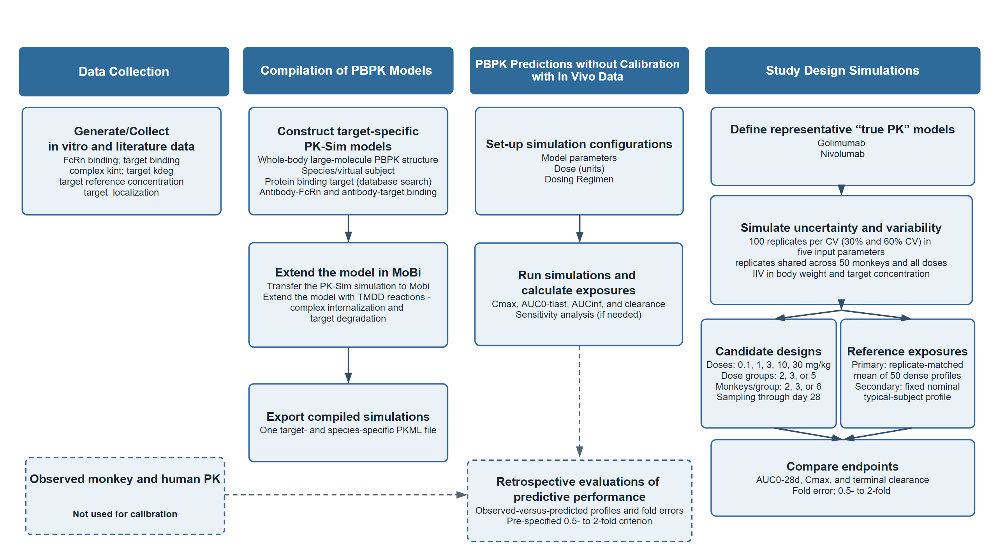
Figure 2. Observed and predicted plasma concentration-time profiles without calibration to the analyzed in vivo PK data across molecules and dose levels in (A) monkeys and (B) humans.
(A) Monkeys
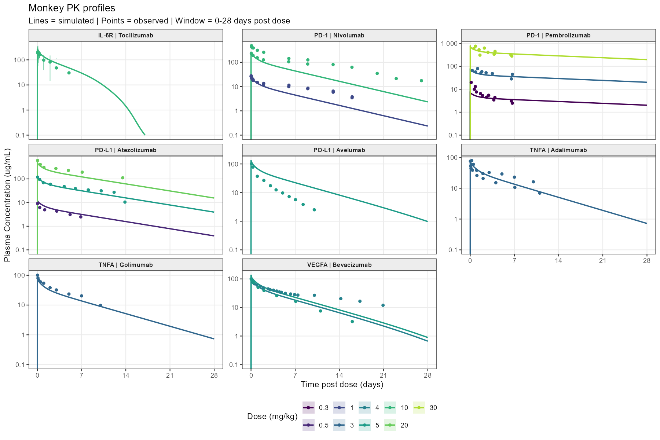

(B) Humans
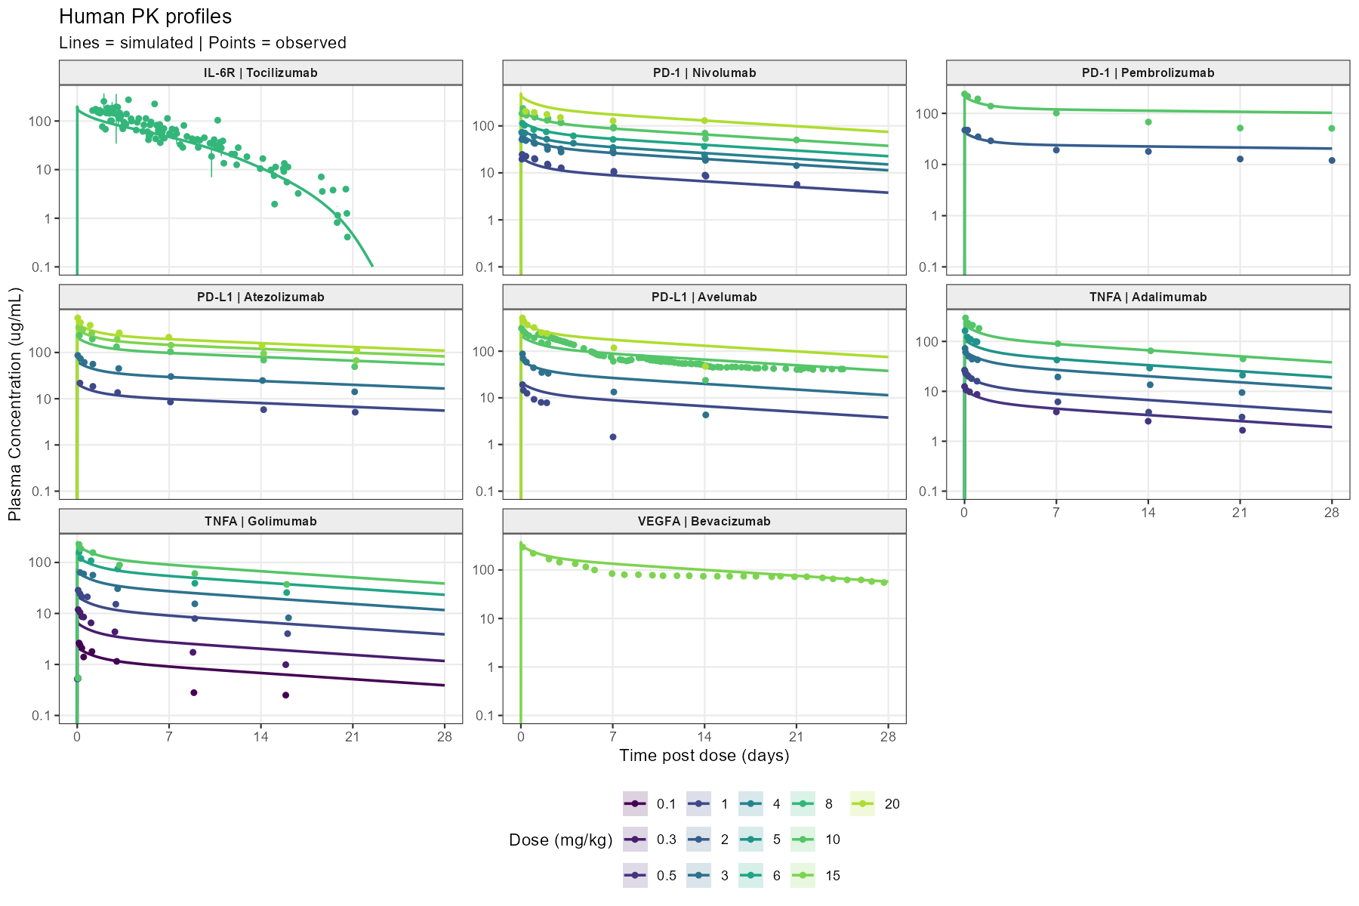

Figure 3. Illustrative PBPK-driven workflow for monoclonal antibody PK characterization with fewer animals. Molecule- and target-specific mechanistic inputs are integrated into PBPK models before in vivo PK testing. When remaining uncertainty warrants an in vivo study, PBPK predictions can inform a targeted exploratory single-dose design, and the resulting data can support model refinement and human exposure prediction. The animal counts are schematic examples rather than industry benchmarks; the modeled reduction applies to the compared single-dose PK designs, not to toxicology studies or the overall development program. FIH = first-in-human; PBPK = physiologically based pharmacokinetics.
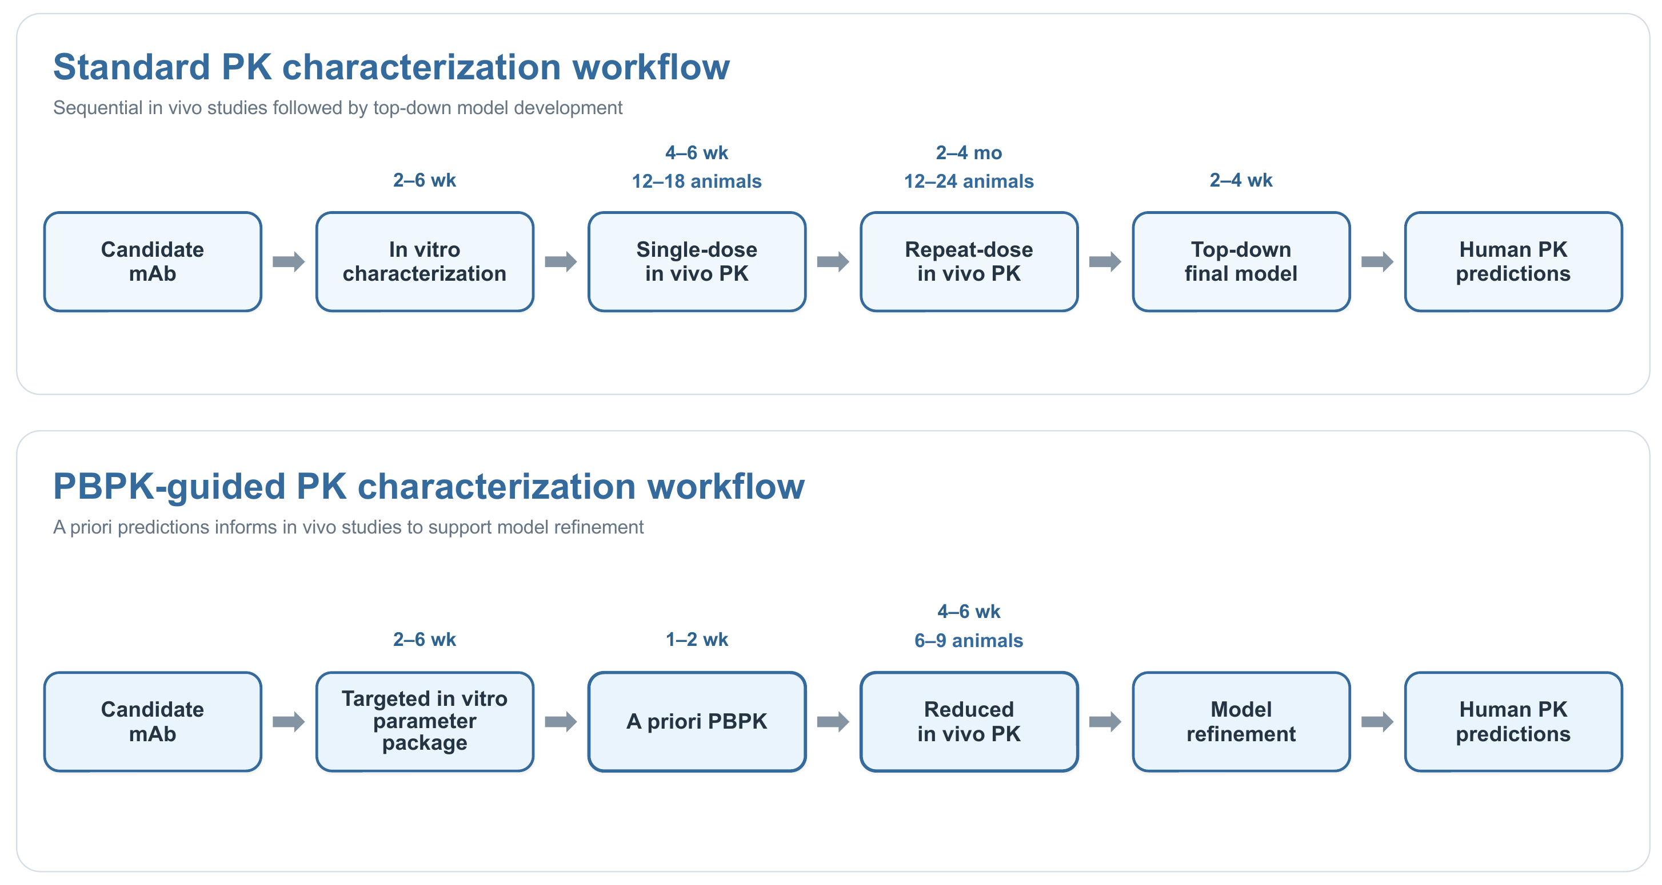

Table 1. RMSE by study design using the nominal typical subject as reference.
Dose groups | Monkeys per group | Total animals | RMSE, mean (range), %
Dose groups | Monkeys per group | Total animals | AUC0-28d | Cmax | Clearance
2 | 2 | 4 | 29.0 (19.1-36.9) | 17.4 (15.4-18.6) | 34.6 (19.3-51.0)
2 | 3 | 6 | 28.5 (16.9-37.9) | 15.5 (13.6-17.1) | 34.6 (19.3-51.1)
2 | 6 | 12 | 26.9 (16.6-37.2) | 13.1 (12.0-14.0) | 34.6 (19.3-51.1)
3 | 2 | 6 | 29.6 (19.1-41.2) | 17.5 (15.4-18.6) | 34.5 (19.2-51.0)
3 | 3 | 9 | 28.6 (16.9-37.9) | 15.6 (13.6-17.1) | 34.5 (19.2-51.1)
3 | 6 | 18 | 26.7 (16.5-37.2) | 13.2 (12.0-14.0) | 34.5 (19.2-51.1)
5 | 2 | 10 | 29.5 (19.1-41.2) | 17.6 (15.4-19.5) | 34.6 (19.2-51.6)
5 | 3 | 15 | 28.3 (16.9-37.9) | 15.4 (13.6-17.6) | 34.6 (19.2-51.7)
5 | 6 | 30 | 26.8 (16.5-39.0) | 13.2 (12.0-14.3) | 34.6 (19.2-51.5)
Note: RMSE was calculated across 100 Monte Carlo replicates within each molecule, variability, dose, design, group-size, and endpoint cell. Entries show the arithmetic mean and range across both molecules, both variability scenarios, and all included doses.
Table 2. Replicates within two-fold by study design using the nominal typical subject as reference.
Dose groups | Monkeys per group | Total animals | Replicates with all included doses within 2-fold, %
Dose groups | Monkeys per group | Total animals | AUC0-28d | Cmax | Clearance
2 | 2 | 4 | 92.3 | 100.0 | 93.5
2 | 3 | 6 | 95.3 | 100.0 | 93.8
2 | 6 | 12 | 96.5 | 100.0 | 93.8
3 | 2 | 6 | 91.0 | 100.0 | 93.5
3 | 3 | 9 | 94.5 | 100.0 | 93.8
3 | 6 | 18 | 95.8 | 100.0 | 93.8
5 | 2 | 10 | 91.3 | 100.0 | 93.0
5 | 3 | 15 | 93.0 | 100.0 | 93.5
5 | 6 | 30 | 94.0 | 100.0 | 93.5
Note: Success percentages pool 400 parameter-draw replicates per row (2 molecules x 2 variability scenarios x 100 replicates). For each endpoint, a replicate was successful only when that endpoint was within 0.5-2.0 at every included dose.

Supplementary Materials
Supplementary Material 1. GitHub repository containing the reproducible code (version tag v0.1.0):
https://github.com/namlink-org/PBPK_mAb_NAM_Tutorial
Supplementary Material 2. Additional-Figures-Tables.docx

