Physiologically-Based Pharmacokinetic Modeling to Guide Reduced Monkey PK Studies for Monoclonal Antibodies: A Tutorial

Supplementary Material S2
Additional Figures and Tables
1. Parameters Used in the A Priori Predictions
Molecule | Species | Parameter | Value | Unit | Analytical Method for deriving the parameter | Source
Adalimumab | Monkey | Kd | 0.000127 | uM | SPR/Biacore (Biacore 3000) | [1]
Adalimumab | Monkey | koff | 0.0096 | 1/min | SPR/Biacore (Biacore 3000) | [1]
Adalimumab | Monkey | kint | 0.866 | 1/h | Model fitting by the authors of [2] | [2]
Adalimumab | Monkey | Reference target concentration | 0.001 | nM | Model fitting by the authors of [3] | [3]
Adalimumab | Monkey | kdeg | 0.223 | 1/h | Model parameter from anti-TNF PBPK analysis | [4]
Adalimumab | Monkey | Kd (FcRn) in endosomal space | 1.07 | uM | Model-based meta-analysis [5] | [5]
Atezolizumab | Monkey | Kd | 0.000299 | uM | Equilibrium binding studies using human PD-L1 expressed on 293 cells | [6]
Atezolizumab | Monkey | koff | 0.00936 | 1/min | SPR/Biacore | [6]
Atezolizumab | Monkey | kint | 0.606 | 1/h | Flow cytometry internalization assay in BxPC-3 cells | [6]
Atezolizumab | Monkey | Reference target concentration | 0.609 | nM | Model fitting by the authors of [6] | [6]
Atezolizumab | Monkey | kdeg | 0.0426 | 1/h | Model fitting by the authors of [6] | [6]
Atezolizumab | Monkey | Kd (FcRn) in endosomal space | 0.65 | uM | SPR/Biacore | [6]
Avelumab | Monkey | Kd | 0.0000467 | uM | SPR assay (Biacore T200) | [7]
Avelumab | Monkey | koff | 0.00174 | 1/min | SPR assay (Biacore T200) | [8]
Avelumab | Monkey | kint | 0.25 | 1/h | pHrodo flow-cytometry internalization assay | [7]
Avelumab | Monkey | Reference target concentration | 0.609 | nM | Model fitting by the authors [6] | [6]
Avelumab | Monkey | kdeg | 0.0426 | 1/h | Model fitting by the authors [6] | [6]
Avelumab | Monkey | Kd (FcRn) in endosomal space | 1.07 | uM | Model-based meta-analysis | [5]
Bevacizumab | Monkey | Kd | 0.000058 | uM | SPR-Biacore | [9]
Bevacizumab | Monkey | koff | 0.00186 | 1/min | SPR-Biacore | [9]
Bevacizumab | Monkey | kint | 0.48 | 1/h | Assumed same as kdeg | [10]
Bevacizumab | Monkey | Reference target concentration | 0.013 | nM | quantitative fluorescence | [11]
Bevacizumab | Monkey | kdeg | 0.48 | 1/h | cycloheximide-chase protein degradation assay; western blot dosimetry | [10]
Bevacizumab | Monkey | Kd (FcRn) in endosomal space | 1.07 | uM | Model-based meta-analysis | [5]
Golimumab | Monkey | Kd | 0.000018 | uM | SPR/Biacore (Biacore 3000) | [1]
Golimumab | Monkey | koff | 0.005583 | 1/min | SPR/Biacore (Biacore 3000) | [1]
Golimumab | Monkey | kint | 0.866 | 1/h | model estimated by the authors of the source | [2]
Golimumab | Monkey | Reference target concentration | 0.001 | nM | Model-derived TNF-alpha baseline assumption (1 pM) | [3]
Golimumab | Monkey | kdeg | 0.223 | 1/h | Model parameter from anti-TNF PBPK analysis | [4]
Golimumab | Monkey | Kd (FcRn) in endosomal space | 1.07 | uM | Model-based meta-analysis | [5]
Nivolumab | Monkey | Kd | 0.00145 | uM | SPR assay (BIAcore T100) | [12]
Nivolumab | Monkey | koff | 0.114 | 1/min | SPR/Biacore | [12]
Nivolumab | Monkey | kint | 0.027 | 1/h | Model estimated by the authors | [13]
Nivolumab | Monkey | Reference target concentration | 0.0166 | nM | Model estimated by the authors | [13]
Nivolumab | Monkey | kdeg | 0.027 | 1/h | Model estimated by the authors | [13]
Nivolumab | Monkey | Kd (FcRn) in endosomal space | 1.07 | uM | Model-based meta-analysis | [5]
Pembrolizumab | Monkey | Kd | 0.00031 | uM | SPR/Biacore | [13]
Pembrolizumab | Monkey | koff | 0.0017 | 1/min | SPR/Biacore | [13]
Pembrolizumab | Monkey | kint | 0.027 |  | Model estimated by the authors | [13]
Pembrolizumab | Monkey | Reference target concentration | 0.0166 | nM | Model estimated by the authors | [13]
Pembrolizumab | Monkey | kdeg | 0.027 | 1/h | Model estimated by the authors | [13]
Pembrolizumab | Monkey | Kd (FcRn) in endosomal space | 0.081 | uM | SPR/Biacore | [13]
Tocilizumab | Monkey | Kd | 0.00134 | uM | SPR/Biacore | [14]
Tocilizumab | Monkey | koff | 0.01284 | 1/min | SPR/Biacore | [14]
Tocilizumab | Monkey | kint | 0.28 | 1/h | Assumed same as kdeg; Pulse chase experiments | [15]
Tocilizumab | Monkey | Reference target concentration | 2.2 | nM | Ligand-binding receptor assay (assumed same across species) | [16]
Tocilizumab | Monkey | kdeg | 0.28 | 1/h | Pulse chase experiments | [15]
Tocilizumab | Monkey | Kd (FcRn) in endosomal space | 1.07 | uM | Model-based meta analysis | [5]
Adalimumab | Human | Kd | 0.000127 | uM | SPR/Biacore (Biacore 3000) | [1]
Adalimumab | Human | koff | 0.0096 | 1/min | SPR/Biacore (Biacore 3000) | [1]
Adalimumab | Human | kint | 0.866 | 1/h | Estimated from minimal PBPK model by the authors | [2]
Adalimumab | Human | Reference target concentration | 0.001 | nM | Model fitting by the authors of [3] | [3]
Adalimumab | Human | kdeg | 0.223 | 1/h | Model parameter from anti-TNF PBPK analysis | [4]
Adalimumab | Human | Kd (FcRn) in endosomal space | 1.07 | uM | Model-based meta-analysis | [5]
Atezolizumab | Human | Kd | 0.000299 | uM | Equilibrium binding studies | [6]
Atezolizumab | Human | koff | 0.00936 | 1/min | SPR/Biacore | [6]
Atezolizumab | Human | kint | 0.606 | 1/h | Flow cytometry internalization assay in BxPC-3 cells | [6]
Atezolizumab | Human | Reference target concentration | 0.609 | nM | model fitting by the authors | [6]
Atezolizumab | Human | kdeg | 0.0426 | 1/h | Model estimated by the authors [6] | [6]
Atezolizumab | Human | Kd (FcRn) in endosomal space | 0.65 | uM | SPR/Biacore | [6]
Avelumab | Human | Kd | 0.0000467 | uM | SPR assay (Biacore T200) | [7]
Avelumab | Human | koff | 0.00174 | 1/min | SPR assay (Biacore T200) | [8]
Avelumab | Human | kint | 0.25 | 1/h | pHrodo flow-cytometry internalization assay | [7]
Avelumab | Human | Reference target concentration | 0.609 | nM | Model estimated by the authors [6] | [6]
Avelumab | Human | kdeg | 0.0426 | 1/h | Model estimated by the authors | [6]
Avelumab | Human | Kd (FcRn) in endosomal space | 1.07 | uM | Model-based meta-analysis | [5]
Bevacizumab | Human | Kd | 0.000058 | uM | SPR-Biacore | [9]
Bevacizumab | Human | koff | 0.00186 | 1/min | SPR-Biacore | [9]
Bevacizumab | Human | kint | 0.48 | 1/h | Assumed same as kdeg | [17]
Bevacizumab | Human | Reference target concentration | 0.013 | nM | quantitative fluorescence (assumed same across species) | [11]
Bevacizumab | Human | kdeg | 0.48 | 1/h | cycloheximide-chase protein degradation assay; western blot dosimetry | [17]
Bevacizumab | Human | Kd (FcRn) in endosomal space | 1.07 | uM | Model-based meta-analysis | [5]
Golimumab | Human | Kd | 0.000018 | uM | SPR/Biacore (Biacore 3000) | [1]
Golimumab | Human | koff | 0.005583 | 1/min | SPR/Biacore (Biacore 3000) | [1]
Golimumab | Human | kint | 0.866 | 1/h | Model estimated by the authors [2] | [2]
Golimumab | Human | Reference target concentration | 0.001 | nM | Model-derived TNF-alpha baseline assumption (1 pM) | [3]
Golimumab | Human | kdeg | 0.223 | 1/h | Model estimated by the authors [4] | [4]
Golimumab | Human | Kd (FcRn) in endosomal space | 1.07 | uM | Model-based meta-analysis | [5]
Nivolumab | Human | Kd | 0.00145 | uM | SPR assay (BIAcore T100) | [12]
Nivolumab | Human | koff | 0.114 | 1/min | SPR/Biacore | [12]
Nivolumab | Human | kint | 0.027 | 1/h | Model estimated by the authors [13] | [13]
Nivolumab | Human | Reference target concentration | 0.07138 | nM | Model estimated by the authors [13] | [13]
Nivolumab | Human | kdeg | 0.027 | 1/h | Model estimated by the authors [13] | [13]
Nivolumab | Human | Kd (FcRn) in endosomal space | 1.07 | uM | Model-based meta-analysis | [5]
Pembrolizumab | Human | Kd | 0.00031 | uM | SPR/Biacore | [13]
Pembrolizumab | Human | koff | 0.0017 | 1/min | SPR/Biacore | [13]
Pembrolizumab | Human | kint | 0.027 |  | Model estimated by the authors [13] | [13]
Pembrolizumab | Human | Reference target concentration | 0.07138 | nM | Model estimated by the authors [13] | [13]
Pembrolizumab | Human | kdeg | 0.027 | 1/h | Model estimated by the authors of the source | [13]
Pembrolizumab | Human | Kd (FcRn) in endosomal space | 0.081 | uM | SPR/Biacore | [13]
Tocilizumab | Human | Kd | 0.00134 | uM | SPR/Biacore | [14]
Tocilizumab | Human | koff | 0.01284 | 1/min | SPR/Biacore | [14]
Tocilizumab | Human | kint | 0.28 | 1/h | Pulse chase experiments | [15]
Tocilizumab | Human | Reference target concentration | 1 | nM | Ligand-binding receptor assay | [16]
Tocilizumab | Human | kdeg | 0.28 | 1/h | Pulse chase experiments | [15]
Tocilizumab | Human | Kd (FcRn) in endosomal space | 1.07 | uM | Model-based meta-analysis | [5]

2. Fold errors from PBPK model predictions without calibration with in vivo data. Directional fold errors are shown for AUC_{0-tlast}, C_{max}, and clearance across the evaluated molecule-dose scenarios. Fold error was calculated as the predicted value divided by the observed value. Horizontal bars extend from the line of unity on a base-2 logarithmic scale; values below and above 1 indicate underprediction and overprediction, respectively. The shaded region and dashed lines denote the prespecified 0.5- to 2-fold acceptance interval. Clearance scenarios were marked not evaluable when no observed profile had an AUC_{inf} extrapolated fraction of 20% or less. Models were not calibrated using in vivo pharmacokinetic data.
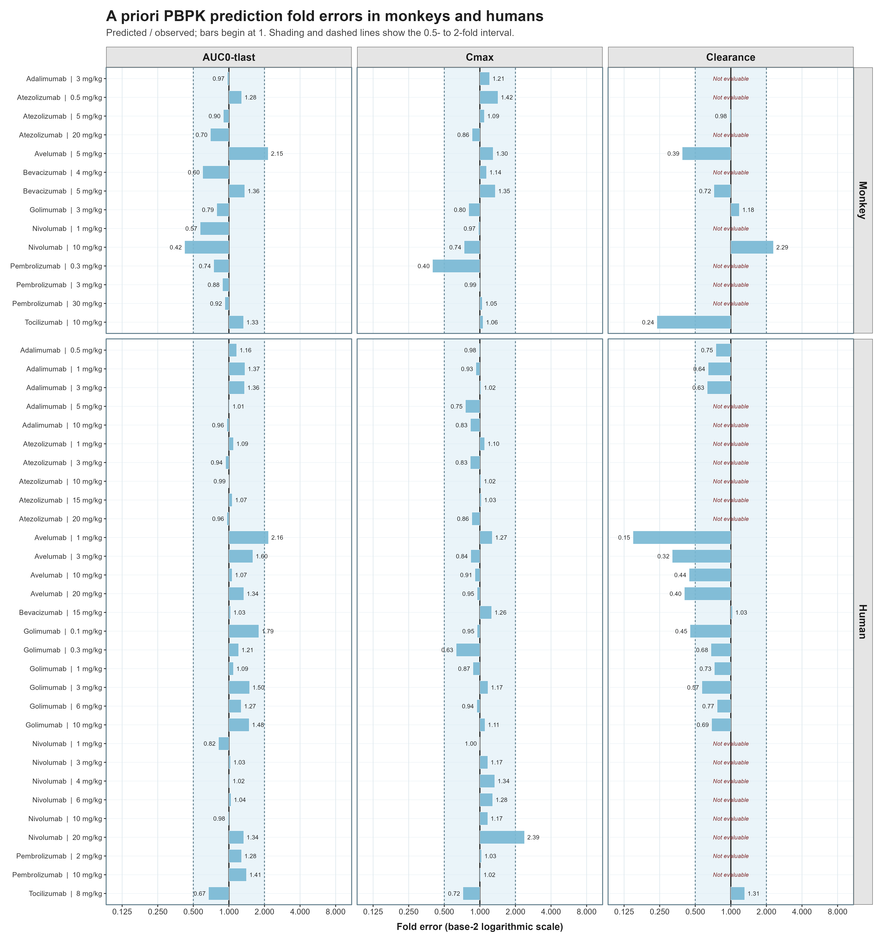
3. Local Sensitivity Analysis of Target Related Parameters on Clearance Estimate Using PBPK Model. An a priori PBPK modeling framework was used to assess parameter sensitivity by varying the target reference concentration, target degradation rate (kdeg), and internalization rate (kint) one at a time while holding all other model parameters constant. Each parameter was varied by decreasing to 0.1-fold and increasing to 10-fold of its reference value, and the resulting terminal clearance was compared with the reference simulation. The normalized sensitivity coefficient was calculated as ln(CLvaried/CLreference)/ln(Pvaried/Preference), and a sensitivity index of 1+ the normalized coefficient was reported, such that a value of 1 indicates no sensitivity. Sensitivity indices were averaged across evaluated doses for each molecule and ranked from highest to lowest in the figure.
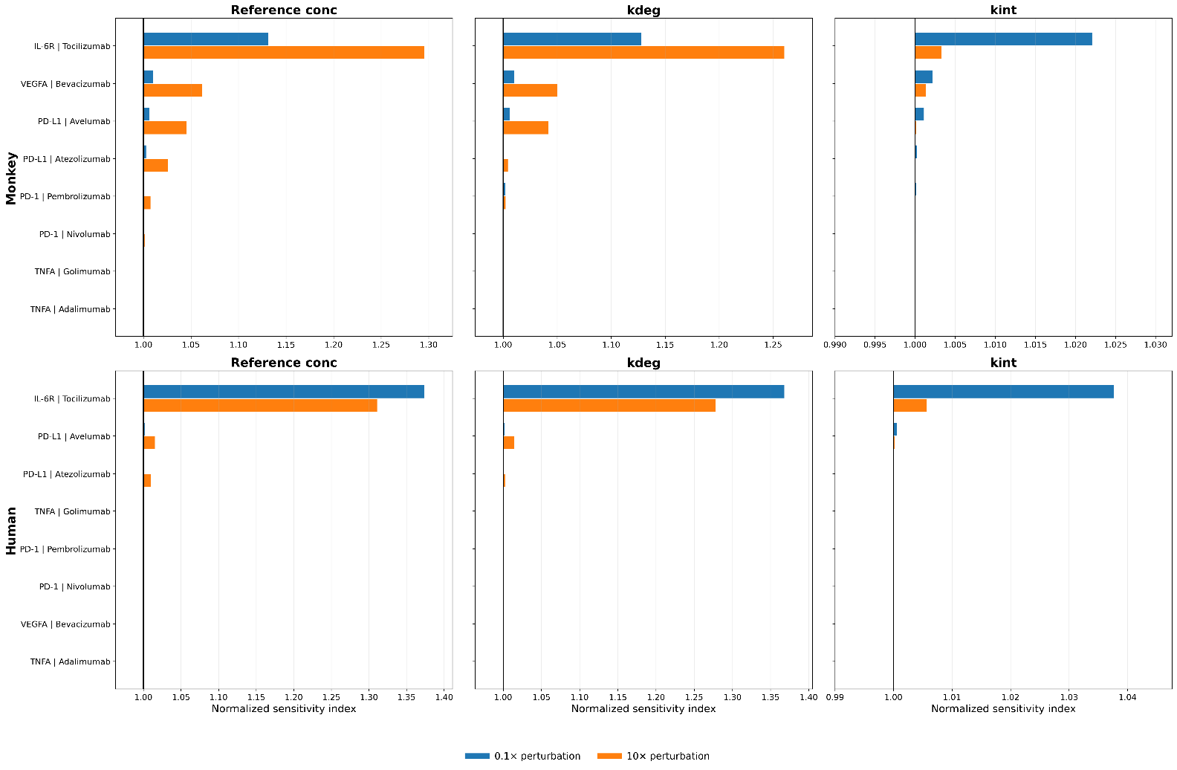

References
1. Shealy DJ, Cai A, Staquet K, Baker A, Lacy ER, Johns L, et al. Characterization of golimumab, a human monoclonal antibody specific for human tumor necrosis factor alpha. mAbs. 2010;2(4):428-439. doi:10.4161/mabs.2.4.12304.
2. Zheng S, Niu J, Geist B, Fink D, Xu Z, Zhou H, Wang W. A minimal physiologically based pharmacokinetic model to characterize colon TNF suppression and treatment effects of an anti-TNF monoclonal antibody in a mouse inflammatory bowel disease model. mAbs. 2020;12(1):1813962. doi:10.1080/19420862.2020.1813962.
3. Reig-López J, García-Otero X, Cuquerella-Gilabert M, Bandín-Vilar E, Otero-Espinar FJ, Fernández-Ferreiro A, et al. A physiologically based pharmacokinetic model to describe [89Zr]Zr-DFO-adalimumab specific activity after intravitreal administration to rats with endotoxin-induced uveitis. International Journal of Pharmaceutics. 2025;681:125845. doi:10.1016/j.ijpharm.2025.125845.
4. Chen J, Lin R, Guo G, Wu W, Ke M, Ke C, et al. Physiologically-Based Pharmacokinetic Modeling of Anti-Tumor Necrosis Factor Agents for Inflammatory Bowel Disease Patients to Predict the Withdrawal Time in Pregnancy and Vaccine Time in Infants. Clinical Pharmacology & Therapeutics. 2023;114(6):1254-1263. doi:10.1002/cpt.3031.
5. Benamara S, Sjögren E, Gattacceca F, Chenel M, Deslandes A, Nguyen L, Teutonico D. Prediction of Monoclonal Antibodies Pharmacokinetics in Human: Identification of a Reference Neonatal Fc Receptor (FcRn) Binding Affinity Using Physiologically Based Pharmacokinetic (PBPK) Modeling. ACS Pharmacology & Translational Science. 2026;9:177-190. doi:10.1021/acsptsci.5c00674.
6. Huang W, Stader F, Chan P, Shemesh CS, Chen Y, Gill KL, et al. Development of a pediatric physiologically-based pharmacokinetic model to support recommended dosing of atezolizumab in children with solid tumors. Frontiers in Pharmacology. 2022;13:974423. doi:10.3389/fphar.2022.974423.
7. Jin H, D'Urso V, Neuteboom B, McKenna SD, Schweickhardt R, Gross AW, et al. Avelumab internalization by human circulating immune cells is mediated by both Fc gamma receptor and PD-L1 binding. OncoImmunology. 2021;10(1):1958590. doi:10.1080/2162402X.2021.1958590.
8. Benicky J, Sanda M, Brnakova Kennedy Z, Grant OC, Woods RJ, Zwart A, Goldman R. PD-L1 Glycosylation and Its Impact on Binding to Clinical Antibodies. Journal of Proteome Research. 2021;20(1):485-497. doi:10.1021/acs.jproteome.0c00521.
9. Papadopoulos N, Martin J, Ruan Q, Rafique A, Rosconi MP, Shi E, et al. Binding and neutralization of vascular endothelial growth factor (VEGF) and related ligands by VEGF Trap, ranibizumab and bevacizumab. Angiogenesis. 2012;15(2):171-185. doi:10.1007/s10456-011-9249-6.
10. Calera MR, Venkatakrishnan A, Kazlauskas A. VE-cadherin increases the half-life of VEGF receptor 2. Experimental Cell Research. 2004;300(1):248-256. doi:10.1016/j.yexcr.2004.07.007.
11. Imoukhuede PI, Popel AS. Quantification and cell-to-cell variation of vascular endothelial growth factor receptors. Experimental Cell Research. 2011;317(7):955-965. doi:10.1016/j.yexcr.2010.12.014.
12. Tan S, Zhang H, Chai Y, Song H, Tong Z, Wang Q, et al. An unexpected N-terminal loop in PD-1 dominates binding by nivolumab. Nature Communications. 2017;8:14369. doi:10.1038/ncomms14369.
13. Lindauer A, Valiathan CR, Mehta K, Sriram V, de Greef R, Elassaiss-Schaap J, de Alwis DP. Translational Pharmacokinetic/Pharmacodynamic Modeling of Tumor Growth Inhibition Supports Dose-Range Selection of the Anti-PD-1 Antibody Pembrolizumab. CPT Pharmacometrics & Systems Pharmacology. 2017;6(1):11-20. doi:10.1002/psp4.12130.
14. Xu C, Rafique A, Potocky T, Paccaly A, Nolain P, Lu Q, et al. Differential Binding of Sarilumab and Tocilizumab to IL-6Rα and Effects of Receptor Occupancy on Clinical Parameters. Journal of Clinical Pharmacology. 2021;61(5):714-724. doi:10.1002/jcph.1795.
15. Gerhartz C, Dittrich E, Stoyan T, Rose-John S, Yasukawa K, Heinrich PC, Graeve L. Biosynthesis and half-life of the interleukin-6 receptor and its signal transducer gp130. European Journal of Biochemistry. 1994;223(1):265-274. doi:10.1111/j.1432-1033.1994.tb18991.x.
16. Nesbitt JE, Fuller GM. Differential regulation of interleukin-6 receptor and gp130 gene expression in rat hepatocytes. Molecular Biology of the Cell. 1992;3(1):103-112. doi:10.1091/mbc.3.1.103.
17. Sarabipour S, Kinghorn K, Quigley KM, Kovacs-Kasa A, Annex BH, Bautch VL, Mac Gabhann F. Trafficking dynamics of VEGFR1, VEGFR2, and NRP1 in human endothelial cells. PLOS Computational Biology. 2024;20(2):e1011798. doi:10.1371/journal.pcbi.1011798.

