Physiologically-based Pharmacokinetic – Informed New Approach Methodology Framework for Monoclonal Antibodies
Krina Mehta^{1,2,} Akshat Shah^{1,3}, Stephan Schaller⁴
¹ NAMLink, Cypress, CA, USA
² Enveda Therapeutics Inc., Boulder, CO, USA
³Aivaura, Bhavnagar, Gujarat, India
⁴ ESQlabs GmbH, 26683 Saterland, Germany
Funding
No funding was received for this work.
Use of Artificial Intelligence
OpenAI ChatGPT/GPT-5.5 was used to assist with language editing, manuscript organization, and generation/refinement of Figure 4. Codex/GPT-5.5 was used as a coding assistant, especially to write codes for figures and tables generation. The authors reviewed and edited all AI-assisted content. The authors take full responsibility for the accuracy, integrity, and final content of the manuscript.

Abstract
Monoclonal antibody (mAb) pharmacokinetics (PK) is governed by mechanistic processes and physiologically based pharmacokinetic (PBPK) models are well suited for mAb’s human PK prediction. We evaluated whether in vitro-informed “a priori” PBPK modeling could predict first-in-human mAb PK and support reduced monkey PK study designs as a new approach methodology (NAM). A semi-automated PK-Sim/MoBi–R workflow integrated species physiology with FcRn-binding and target-mediated disposition inputs. Intravenous single-dose PK data for eight mAbs across five targets were evaluated retrospectively. “A priori” predictions, generated without fitting to monkey PK data, were compared with observed AUC_{0–28d}, Cmax, and clearance and with predictions from monkey-fitted top-down models translated to humans. Reduced study designs were evaluated using simulations.
For human PK, 83.3%, 96.7%, and 76.7% of “a priori” AUC_{0–28d}, Cmax, and clearance predictions, respectively, were within two-fold of observed values, compared with 86.7%, 90.0%, and 93.3% for top-down translation. A two dose groups design with three animals per group (total n=6) suggested a success probability of 99.4–100% under 30% parameter variability and estimated uncertainty. The predicted success probability declined to 90.0–98.1% with 50% variability assumption.
These findings support further evaluation of “a priori” PBPK models informed NAM workflow for first-in-human mAb PK prediction. Predictive performance of the “a priori” approach was broadly comparable to monkey-to-human translation, although clearance predictions were sensitive to uncertainties in parameters and in available data. Under the stated assumptions, the reduced design required six rather than at least 15 animals, a 60% reduction at the individual PK-study level and suggests prospective validation.

Introduction
Adequate characterization of pharmacokinetics (PK) is crucial for a successful drug development program because it is the quantitative link between administered dose, systemic and tissue exposure, target engagement, pharmacodynamic (PD) response, and safety [1]. For monoclonal antibodies (mAbs) and other protein therapeutics, systemic and tissue exposures depend on target-mediated drug disposition (TMDD), neonatal Fc receptor (FcRn)-mediated recycling, and tissue distribution processes that can differ across species. Physiologically-based pharmacokinetic (PBPK) modeling is a mechanistic modeling approach that integrates species-specific physiology with drug- and target-specific parameters to simulate PK. For mAbs, PBPK models incorporate key determinants of disposition, including vascular convection, lymphatic return, tissue partitioning, pinocytosis, FcRn binding and recycling, proteolytic catabolism, target binding, target turnover, and target-receptor complex internalization, into a quantitative framework [2, 3, 4]. Overall, extensive work on PBPK models for mAbs has already established a robust scientific foundation, enabled reliable characterization of their PK, and supported their regulatory acceptance.
Momentum for new approach methodologies (NAMs) has increased exponentially since the FDA's April 2025 Roadmap to Reducing Animal Testing in Preclinical Safety Studies [5, 6, 7, 8, 9]. Within this evolving regulatory infrastructure, current NAM-focused investment has focused on establishing context-of-use (COU) frameworks, advancing complex in vitro systems (organoids, microphysiological systems, organ-on-chip platforms), and AI/ML-based computational toxicology tools. On the other hand, preclinical evaluations are increasingly being framed around whether human-relevant biological pathways are perturbed at clinically meaningful plasma and tissue exposure levels. Plasma and tissue exposures therefore provide a common quantitative measure for integrating in vitro dose-response data, in silico simulations, prior clinical knowledge, biomarkers, and safety thresholds. For example, in vitro findings from cell-based or microphysiological systems can be contextualized through predicted human concentration-time profiles, exposure margins, and time above biologically active or adverse effect thresholds [10, 11]. In this context, mechanistic PBPK models are uniquely positioned to bridge NAM-derived biological observations with quantitative predictions of human plasma and tissue exposure. A recent FDA/CDER landscape analysis of 15 years of NAM-related submissions found that 93% fell into the in vitro and in silico categories broadly, though this landscape analysis does not break out mechanistic PK/PD/safety modeling, such as PBPK, as distinct categories, leaving their specific representation within the NAM submission landscape unclear [12]. By contrast, mechanistic modeling approaches, such as, PBPK, quantitative systems pharmacology (QSP), and quantitative systems toxicology (QST), despite an established and steadily growing regulatory submission record under the parallel model-informed drug development (MIDD) paradigm and demonstrated translational utility [8, 13], have received comparatively limited dedicated attention within the emerging NAM ecosystem, representing both a gap and an opportunity. Overall, the emerging NAM ecosystem presents a significant opportunity for greater integration of mechanistic modeling approaches.
Focusing on mAb PK characterization and the role of mechanistic PK modeling, although a scientific framework for mAb PBPK exists, preclinical PK characterization mostly relies on PK studies in monkeys (often cynomolgus monkeys). A traditional mAb development program typically includes preclinical PK evaluations in at least two studies: an exploratory single-dose PK study (n =12-18 monkeys) and a definitive repeat-dose PK study (n = 12-24 monkeys). Together, these studies generally require a minimum of 24–42 monkeys per mAb development program. The scientific maturity of mAb PBPK modeling has advanced to the point where “a priori” PK predictions based on in vitro data can be considered for prospective evaluation in preclinical development workflows, as NAMs. Published examples have shown that mAb-specific in vitro measurements, together with species physiology and FcRn-mAb interaction-related parameters, can support prediction of mAb linear PK without in vivo data [14, 15]; however, these frameworks did not incorporate target-mAb interactions governing nonlinear, target-mediated clearance. Although some mAbs exhibit linear PK at dose range of interest, target-mediated drug disposition is inherent to therapeutic antibodies. For example, at high doses, even mAbs known to exhibit non-linear PK can appear linear upon target saturation, and at low doses, even mAbs known as linear may show nonlinearity. Overall, extending “a priori” PBPK frameworks to incorporate target-mediated disposition is therefore important for their broader application as NAMs with the potential to reduce preclinical monkey studies across the full range of mAb PK profiles.
While complete replacement of monkey PK studies is not yet scientifically justifiable, model-informed optimization of study design offers a pragmatic reduction strategy. Prior knowledge of the mechanistic determinants of mAb disposition, PBPK predictions, and in vitro data can inform the selection of dose groups, animals, and sampling times needed to address specific PK uncertainties, complementing approaches such as cassette dosing, microsampling, animal reuse, and integration of PK/PD endpoints into existing studies [16-18]. Because regulatory expectations and molecule-specific uncertainty vary, simulations should inform rather than independently define the minimum acceptable study size.
The objectives of the current analysis were (1) to retrospectively evaluate “a priori” PBPK modeling as a NAM for predicting human PK of intravenously administered mAbs and (2) to conduct a model-conditional precision analysis of reduced exploratory single-dose monkey PK study designs with fewer dose groups and animals per group.

Methods

Data
Pharmacokinetic profiles for eight monoclonal antibodies, spanning across 5 different targets, following intravenous dosing in monkeys and in humans were digitized from literature using webplotdigitizer tool [https://automeris.io/]. For most of the monoclonal antibodies included in the analysis, the literature sources did not specify whether the digitized concentration data represented free or total antibody. In vitro experimental parameters relevant to drug-FcRn binding, drug-target binding, drug-target complex internalization rate, and target reference concentrations were obtained through literature search. Digitized data, parameter values, measurement methods, assumptions, and source references are provided in Supplementary material 2.

“A priori” PBPK Approach
The large molecule structural model was first incorporated in PK-Sim, including its binding to FcRn and to a generic target [4]. The model was exported to MoBi and TMDD processes were added using a modular approach [19]. Next, we created target expression profiles in monkeys and humans for each of the targets including relevant localization using PK-Sim’s expression database [20, 21]. The expression database provides relative abundance of target expressions across various tissues. Absolute reference concentrations for each of the targets, i.e., concentrations of the target in the tissue with the highest expression, were set to literature derived values and are provided in S1.3. Next, PKML simulation files containing generic large molecule PK model and target expressions, one file per target and species (monkey or human), were exported [19]. Intravenous single-dose simulations were run programmatically, and Cmax, AUC_{0-28d}, clearance, and fold errors were calculated for each molecule-dose pair with observed data. Cmax and AUC_{0-28d} were used as exposure metrics. Clearance was calculated as dose divided by AUCinf and represents total systemic clearance; at target-saturating doses it is expected to be dominated by linear clearance rather than serving as a specific marker of nonlinear target-mediated elimination. The percentage of AUCinf extrapolated was calculated as 100 × (Clast/λz)/AUCinf, equivalent to 100 × (AUCinf − AUClast)/AUCinf, and values greater than 20% were flagged in the separate analysis tables. Because AUC0-28d contributes to AUCinf and clearance is calculated from AUCinf, AUC0-28d and clearance are mathematically related and were not interpreted as independent endpoints. The workflow used PK-Sim 12.2, MoBi 12.2, R 4.5.1, esqlabsR 5.6.0, and OSP Suite 12.4.2 [22-24]. Full workflow details, input files, and code are provided in Supplementary Material 2.

Top-Down TMDD Approach
In the top-down approach, a quasi-steady-state (QSS) TMDD model was fitted separately to the monkey PK profiles for each molecule in R 4.5.1 using nlmixr2 5.0.0 and rxode2 5.1.4. Clearance (CL), central volume (V1), intercompartmental clearance (Q), peripheral volume (V2), and proportional and additive residual-error terms were estimated when supported by the data. Molecule-specific TMDD parameters, including target reference concentration, binding kinetics, target degradation rate (kdeg), and internalization rate constant (kint), were fixed to literature-derived monkey inputs. The same molecule-specific inputs were used in the “a priori” monkey PBPK simulations and the top-down monkey fits.
Human PK predictions were generated by translating the final Run 4 monkey TMDD model to humans. Monkey CL and Q estimates were allometrically scaled with an exponent of 0.85, while Vc and Vp were scaled with an exponent of 1.0. All molecule-specific TMDD inputs used in the human simulations, including target reference concentration, binding affinity (KD), dissociation rate (koff), target degradation rate (kdeg), and internalization rate constant (kint)—were obtained from the human parameter dataset, and the human QSS binding constant was recalculated from the human kinetic inputs. Simulated monkey and human Cmax, AUC_{0-28d}, and clearance values were compared with observed values, and fold-errors were calculated.
Simulations-based Evaluations of Reduced Monkey PK Study Designs
For molecules with at least one “a priori” monkey exposure prediction outside the two-fold criterion, reduced-study simulations were performed as an explicitly model-conditional precision analysis. Because individual-level observed monkey PK data were unavailable, the observed-data-informed top-down model served as both the data-generating model and the retrospective reference. For each molecule, 100 virtual individuals were generated using the final Run 4 CL, V1, Q, and V2 estimates and their RSEs; 40% parameter uncertainty was assigned when a fixed structural parameter had no fitted RSE (S1.4). Independent lognormal 30% interindividual variability was applied to CL, V1, Q, and V2, while the fixed TMDD parameters were unchanged. One thousand replicate studies sampled 2-4 animals per dose group with replacement at 0.25, 1, 2, 4, and 8 hours and days 1, 2, 6, 10, 14, 21, and 28. Two-dose (0.3 and 10 mg/kg) and three-dose (0.3, 3, and 10 mg/kg) designs were evaluated. The arithmetic mean Cmax, AUC_{0-28d}, and clearance in each reduced study was divided by the corresponding arithmetic mean from the richly sampled 100-animal population. A design-level endpoint was successful only when all selected doses were within 0.5- to 2-fold of the reference. In a post hoc sensitivity analysis, additional independent lognormal variability was applied to CL, V1, Q, and V2 so that the total across-individual CV of each structural parameter was at least 50%; 10,000 reduced studies were resampled per scenario.

Results

Evaluation of “A Priori” PBPK Predictions of Monkey and Human PK
First, both “a priori” PBPK and top-down TMDD approaches were compared to evaluate how well each workflow reproduced the monkey PK data. Across the 8 drugs and 14 dose levels evaluated, the “a priori” PBPK predictions produced 8/14 AUC_{0-28d} (accuracy 0.57), 13/14 Cmax (accuracy 0.93), and 8/14 clearance (accuracy 0.57) within two-fold of the observed (S1.1A, S1.2). As a benchmark comparison, with top-down approach, as expected, fitting a quasi steady-state (QSS) TMDD model to monkey PK data while fixing molecule-specific TMDD parameters produced all AUC_{0-28d}, Cmax, and clearance values within two-fold of the observed data (accuracy 1.00 for each metric). CL and Vc were estimated for all molecules. Intercompartmental clearance was fixed to a typical cynomolgus-monkey mAb value for five molecules for which it could not be estimated with acceptable precision; peripheral volume was additionally fixed for adalimumab [25]. All remaining estimated structural parameters had RSEs <40%, and the covariance step completed successfully for all final Run 4 fits (S1.4).
Next, both “a priori” PBPK and monkey-informed top-down TMDD approaches were compared to evaluate how well each workflow predicted human PK data. Across the 8 drugs and 30 dose levels evaluated, the “a priori” PBPK predictions produced 25/30 AUC_{0-28d} (accuracy 0.83), 29/30 Cmax (accuracy 0.97), and 23/30 clearance values (accuracy 0.77) within two-fold of the observed data (Figure 1, Figure 2). With the top-down approach, translation of the monkey-fitted QSS TMDD models to humans produced 26/30 AUC_{0-28d} (accuracy 0.87), 27/30 Cmax (accuracy 0.90), and 28/30 clearance (accuracy 0.93) within two-fold (Figure 1, Figure 2).
The “a priori” PBPK framework predicted AUC_{0-28d} and Cmax for 3/8 molecules, and all three exposure markers for 4/8 molecules across all doses evaluated. Compared with the top-down approach, the “a priori” approach provided comparable accuracy for AUC_{0-28d} and Camx; but lower accuracy for clearance (0.77 versus 0.93). The molecules for which human clearance was predicted outside the two-fold criterion by the “a priori” approach were avelumab (anti-PD-L1 mAb), pembrolizumab (anti-PD-1 mAb), and golimumab (anti-TNFα mAb). For these molecules, all Cmax predictions were within two-fold of the observed values across the evaluated doses. AUC_{0–28d} predictions were also within two-fold for both pembrolizumab dose levels and five of the six golimumab dose levels, but for only one of the four avelumab dose levels. Thus, the prediction discrepancies were concentrated in clearance-related metrics rather than Cmax, with the greatest AUC_{0–28d} discrepancy observed for avelumab. For some molecules in the dataset, several key target-system parameters, including target reference concentration, internalization rate (kint), and target degradation rate (kdeg), were not available from direct in vitro measurements and were instead obtained from prior modeling studies. These inputs introduce uncertainty (S1.6) because their values may depend on the model structure, assumptions, and estimation approach used in those studies. Additionally, the observed concentration–time data through 28 days post-dose may not have adequately characterized the terminal phase, limiting the reliability of the observed clearance estimates, as the extrapolated fraction of AUC_{inf} exceeded 30% for several molecules (S1.5). Moreover, the observed human PK data for oncology mAbs, including avelumab, pembrolizumab, and nivolumab, were obtained from patients who may have substantial variability in target expression, introducing further uncertainty in PK predictions with both approaches. Overall, the “a priori” approach predicted mechanisms of mAbs distribution and elimination in humans reasonably well.

Simulations-based Evaluations of Reduced Monkey PK Study Designs
Atezolizumab, avelumab, nivolumab, and pembrolizumab were included in the reduced-study analysis because at least one “a priori” monkey exposure prediction was outside the prespecified two-fold criterion. For each molecule, the observed-data-informed top-down model generated a richly sampled reference population of 100 virtual individuals. The primary 1,000-replicate analysis incorporated fitted structural-parameter uncertainty and 30% interindividual variability in CL, V1, Q, and V2; fixed TMDD parameters were not varied.
Across the two-dose-group (0.3 and 10 mg/kg) and three-dose-group (0.3, 3, and 10 mg/kg) designs with 2-4 animals per group, reduced-study-to-reference fold errors for AUC_{0-28d}, Cmax, and clearance were centered near 1 (Figure 3). For the illustrative two-dose-group design with three animals per group (six animals total), the model-conditional probability that all three PK endpoints at both doses were within two-fold of the rich-population reference ranged from 99.4% to 100.0% across the four molecules. The 5th-95th percentile fold-error intervals also remained within the prespecified range. A fourth animal per group provided only modest additional narrowing, and adding a third dose group did not improve precision under the evaluated assumptions. The results were sensitive to greater variability: for the same six-animal design, the joint success probability decreased to 90.0–98.1% when total structural-parameter variability was increased to 50% CV. Overall, these findings support the feasibility of a reduced two-dose, total six-animal study design for collecting relevant data to support model-based characterization of IV mAbs PK in monkeys to support first-in-human PK predictions.

Discussion
In this retrospective analysis, the in vitro-informed “a priori” PBPK approach provided human PK predictions broadly comparable to monkey-informed top-down TMDD translation, particularly for AUC_{0–28d} and Cmax. Clearance accuracy was lower with the “a priori” approach, with 23/30 predictions within two-fold of observed values compared with 28/30 for the top-down approach. Notably, target concentrations, $k_{\int{ }}$, and $k_{deg}$ for pembrolizumab, nivolumab, and avelumab were obtained from prior models rather than molecule-specific in vitro measurements, suggesting that robust in vitro characterization of these parameters could further improve “a priori” predictions of clearance (S1.6). The proposed “a priori” PBPK modeling as NAM approach is feasible when robust in vitro experimental data for mechanistic parameters are available. In our retrospective analysis, in vitro parameters were derived from literature search (Supplementary material 2). Drug–target binding affinity was available from experimental binding assays for all included molecules, either from equilibrium binding or SPR/Biacore assays. FcRn binding affinity was available from SPR/Biacore for only atezolizumab and pembrolizumab while a common model-based FcRn KD estimate from a published analysis of 50 mAbs was used for several other mAbs where molecule-specific FcRn binding data were not available [27]. Drug-target complex internalization rate from flow-cytometry–based internalization assay was available for only two molecules, whereas for other molecules this parameter was assumed same as target degradation rate. Target reference concentrations represented the least standardized component of the input parameters. VEGF-A and IL-6R reference concentrations and target degradation rates were available from quantitative fluorescence or ligand-binding receptor assay data or were estimated in prior analyses. Overall, the compiled input parameters highlight the limitation of standardized in vitro experimental methods. Thus, standardization of experimental package for mAbs would further strengthen prospective PBPK-based NAM workflows.
The reduced-study simulations provide quantitative support for the feasibility of a focused two-dose, six-animal exploratory monkey PK study. Under the primary assumptions of fitted structural-parameter uncertainty and 30% interindividual variability in CL, V1, Q, and V2, a design with three animals at each of two dose levels recovered Cmax, AUC_{0–28d}, and clearance within two-fold of the rich-population reference in 99.4–100.0% of replicate studies across the four mAbs. The design remained robust when total structural-parameter variability was increased to 50% CV, with success rates of 90.0–98.1%. These findings should be interpreted as evidence of model-conditional precision rather than a validation of the reduced design. Prospective confirmation and molecule-specific assessment would therefore be needed, particularly when TMDD is pronounced or its determinants are uncertain. Overall, relative to the prespecified exploratory single-dose design of five dose groups with three animals per group, the illustrative six-animal design represents a 60% reduction in animal use (Figure 4). Importantly, this estimate applies at the individual PK-study level and should not be interpreted as a percent reduction in animal use across the overall preclinical development program or as a reduction in animals used for repeat-dose toxicology or other studies.
The analysis focused on IV single-dose mAb PK, an appropriate initial context because the principal disposition processes are comparatively well characterized. Single-dose data and mechanistic models can support projection of repeat-dose exposure and accumulation, and published examples show successful translation for selected mAbs [28, 29]. However, these examples do not establish that a dedicated repeat-dose PK study can be omitted for every molecule. When scientifically and operationally appropriate, PK/TK sampling embedded in dose-range-finding or GLP repeat-dose toxicology studies may provide repeat-dose exposure information without a separate PK study [30], but the toxicology studies and their animal use remain outside the scope of the present analysis. The framework could subsequently be extended to subcutaneous mAbs by incorporating lymphatic uptake, pre-systemic catabolism, bioavailability, and formulation- and injection-site-dependent absorption. Lessons from mAbs may also inform PBPK or hybrid PBPK-QSP workflows for more complex modalities, but each extension will require its own context-of-use definition and validation.
This study was a small retrospective proof-of-concept analysis constrained by the availability of public monkey PK, human PK, and mechanistic input data. Several target-system inputs, including target reference concentration, kint, and kdeg, were taken from prior modeling studies rather than direct in vitro measurements. Because some of those values may have been selected with knowledge of the observed PK, the inputs are not fully independent and may make retrospective performance appear optimistic. Human PK for the oncology mAbs was obtained from patients with potentially variable and high tumor-target burden rather than first-in-human healthy volunteers; disease-related target expression and patient-versus-healthy-population differences are therefore plausible contributors to prediction error. The generic target representation also did not distinguish soluble from membrane target or explicitly represent shedding, despite differences among soluble and transmembrane TNF, soluble VEGF, soluble and membrane IL-6R, and membrane PD-1/PD-L1. This level of granularity was not required for the initial context of use—evaluating exposure prediction and the conditional precision of a reduced design—but it limits mechanistic interpretation and generalizability.
Alternative empirical TMDD approximations, including a Michaelis-Menten model, were not evaluated. Estimation of Vmax and Km together with the structural PK parameters would have been poorly supported for molecules represented by only one monkey dose level. Larger retrospective datasets and prospective pilot studies should therefore generate standardized in vitro inputs, lock “a priori” models before observing in vivo PK, prespecify quantitative success criteria, include adequate individual-level data, and evaluate target representations and model structures appropriate to each molecule. Such evidence is needed to define a defensible context of use and build regulatory confidence in PBPK-informed reduction of preclinical monkey PK studies.
PK-Sim/MoBi and the R packages OSP Suite and esqlabsR provided a practical open-source framework for a reproducible, semi-automated workflow [22-24]. The platform combines physiologically structured PBPK models with curated species-specific physiology and expression databases, allowing target-expression profiles to be defined consistently across monkeys and humans [20, 21]. Export to MoBi and programmatic simulation in R also enable scalable evaluation across molecules, targets, species, and dose levels. This reproducibility is important for prospective PBPK-based NAM workflows, in which model generation, parameter updates, simulations, and exposure-metric extraction should be prespecified and independently traceable.

Conclusions
This retrospective analysis supports further evaluation of “a priori” PBPK modeling as a NAM for first-in-human mAb PK prediction. Predictive performance of “a priori” approach for human PK predictions was broadly comparable to monkey-to-human top-down translation for the evaluated dataset, although clearance-related predictions were sensitive to uncertainty in target-system inputs as well as observed data. The reduced-study simulations support an illustrative, model-informed exploratory single-dose design of two dose groups with three animals per group, corresponding to 6 rather than at least 15 animals (a 60% reduction) under the stated assumptions. This finding supports prospective validation of “a priori” PBPK modeling and reduced monkey PK study designs as a NAM for first-in-human PK predictions.

References
1. Sun D, Gao W, Hu H, Zhou S. Why 90% of clinical drug development fails and how to improve it?. Acta Pharmaceutica Sinica B. 2022;12(7):3049-3062. doi:10.1016/j.apsb.2022.02.002.
2. Garg A, Balthasar JP. Physiologically-based pharmacokinetic (PBPK) model to predict IgG tissue kinetics in wild-type and FcRn-knockout mice. Journal of Pharmacokinetics and Pharmacodynamics. 2007;34(5):687-709. doi:10.1007/s10928-007-9065-1.
3. Shah DK, Betts A. Towards a platform PBPK model to characterize the plasma and tissue disposition of monoclonal antibodies in preclinical species and human. Journal of Pharmacokinetics and Pharmacodynamics. 2011;39(1):67-86. doi:10.1007/s10928-011-9232-2.
4. Niederalt C, Kuepfer L, Solodenko J, Eißing T, Siegmund H, Block MS, et al. A generic whole body physiologically based pharmacokinetic model for therapeutic proteins in PK-Sim. Journal of Pharmacokinetics and Pharmacodynamics. 2018;45(2):235-257. doi:10.1007/s10928-017-9559-4.
5. US Food and Drug Administration. Roadmap to Reducing Animal Testing in Preclinical Safety Studies. Silver Spring, MD: FDA; April 2025. Available from: https://www.fda.gov/media/186092/download (accessed July 26, 2026).
6. US Food and Drug Administration. General Considerations for the Use of New Approach Methodologies in Drug Development. Draft Guidance for Industry. March 2026. Docket FDA-2025-D-6131. Available from: https://www.fda.gov/regulatory-information/search-fda-guidance-documents/general-considerations-use-new-approach-methodologies-drug-development (accessed July 26, 2026).
7. US Food and Drug Administration. Reducing Animal Testing in Nonclinical Studies: Year One Progress and the Path Forward. April 2026. Available from: https://www.fda.gov/media/191986/download (accessed July 26, 2026).
8. Mehta K, Maaß C, Cucurull-Sanchez L, Pichardo‐Almarza C, Subramanian K, Androulakis IP, et al. Modernizing Preclinical Drug Development: The Role of New Approach Methodologies. ACS Pharmacology & Translational Science. 2025;8(6):1513-1525. doi:10.1021/acsptsci.5c00162.
9. National Institutes of Health Common Fund. NIH invests $150 million in human-based research to reduce use of animal models. March 18, 2026. Available from: https://commonfund.nih.gov/complementarie/news/nih-invests-150-million-human-based-research-reduce-use-animal-models (accessed July 26, 2026).
10. Sillé FC, Härtung T. Metabolomics in Preclinical Drug Safety Assessment: Current Status and Future Trends. Metabolites. 2024;14(2):98. doi:10.3390/metabo14020098.
11. Kreutz A, Chang X, Högberg HT, Wetmore BA. Advancing understanding of human variability through toxicokinetic modeling, in vitro-in vivo extrapolation, and new approach methodologies. Human Genomics. 2024;18(1):129. doi:10.1186/s40246-024-00691-9.
12. Dao T, Sadrieh N. A CDER perspective: Landscape of New Approach Methodologies (NAMs) submitted in drug development programs. Regulatory Toxicology and Pharmacology. 2025;165:106007. doi:10.1016/j.yrtph.2025.106007.
13. Bai JPF, Liu G, Zhao M, Wang J, Xiong Y, Truong TM, et al. Landscape of regulatory quantitative systems pharmacology submissions to the U.S. Food and Drug Administration: An update report. CPT Pharmacometrics &amp; Systems Pharmacology. 2024;13(12):2102-2110. doi:10.1002/psp4.13208.
14. Jones HM, Zhang Z, Jasper P, Luo H, Avery LB, King LE, et al. A Physiologically‐Based Pharmacokinetic Model for the Prediction of Monoclonal Antibody Pharmacokinetics FromIn VitroData. CPT Pharmacometrics &amp; Systems Pharmacology. 2019;8(10):738-747. doi:10.1002/psp4.12461.
15. Hu S, Datta‐Mannan A, D’Argenio DZ. Physiologically Based Modeling to Predict Monoclonal Antibody Pharmacokinetics in Humans from in vitro Physiochemical Properties. mAbs. 2022;14(1):2056944. doi:10.1080/19420862.2022.2056944.
16. Germovsek E, Cheng M, Giragossian C. Allometric Scaling of Therapeutic Monoclonal Antibodies in Preclinical and Clinical Settings. mAbs. 2021;13(1):1964935. doi:10.1080/19420862.2021.1964935.
17. Ménochet K, Yu H, Wang B, Tibbitts J, Hsu CP, Kamath AV, Richter WF, Baumann A. Non-human Primates in the PKPD Evaluation of Biologics: Needs and Options to Reduce, Refine, and Replace. A BioSafe White Paper. mAbs. 2022;14(1):2145997. doi:10.1080/19420862.2022.2145997.
18. Nagayasu M, Ozeki K. Combination of Cassette-Dosing and Microsampling for Reduced Animal Usage for Antibody Pharmacokinetics in Cynomolgus Monkeys, Wild-Type Mice, and Human FcRn Transgenic Mice. Pharmaceutical Research. 2021;38(4):583–592. doi:10.1007/s11095-021-03028-6.
19. Open Systems Pharmacology. Modularization concept. Open Systems Pharmacology Suite documentation, version 12. Available from: https://docs.open-systems-pharmacology.org/v12/working-with-mobi/mobi-documentation/modularization-concept (accessed July 26, 2026).
20. Meyer M, Schneckener S, Ludewig B, Kuepfer L, Lippert J. Using Expression Data for Quantification of Active Processes in Physiologically Based Pharmacokinetic Modeling. Drug Metabolism and Disposition. 2012;40(5):892-901. doi:10.1124/dmd.111.043174.
21. Cordes H, Rapp H. Gene expression databases for physiologically based pharmacokinetic modeling of humans and animal species. CPT Pharmacometrics &amp; Systems Pharmacology. 2023;12(3):311-319. doi:10.1002/psp4.12904.
22. Lippert J, Burghaus R, Edginton AN, Frechen S, Karlsson MO, Kovar A, et al. Open Systems Pharmacology Community—An Open Access, Open Source, Open Science Approach to Modeling and Simulation in Pharmaceutical Sciences. CPT Pharmacometrics &amp; Systems Pharmacology. 2019;8(12):878-882. doi:10.1002/psp4.12473.
23. esqLABS GmbH. esqlabsR: Utility Functions for Modelling and Simulation Workflows within ESQlabs Organization. R package version 5.6.0. Released March 31, 2026. Available from: https://github.com/esqLABS/esqlabsR/releases/tag/v5.6.0 (accessed July 26, 2026).
24. Open Systems Pharmacology. OSP Suite: R Interface to the Open Systems Pharmacology Suite. R package version 12.4.2. Released April 8, 2026. Available from: https://github.com/Open-Systems-Pharmacology/OSPSuite-R/releases/tag/v12.4.2 (accessed July 26, 2026).
25. Betts A, Keunecke A, van Steeg TJ, van der Graaf PH, Avery LB, Jones H, Berkhout J. Linear pharmacokinetic parameters for monoclonal antibodies are similar within a species
26. Gosselin RD. Guidelines on statistics for researchers using laboratory animals: the essentials. Laboratory Animals. 2019;53(1):28–42. doi:10.1177/0023677218783223.
27. Benamara S, Sjögren E, Gattacceca F, Chenel M, Deslandes A, Nguyen L, Teutonico D. Prediction of Monoclonal Antibodies Pharmacokinetics in Human: Identification of a Reference Neonatal Fc Receptor (FcRn) Binding Affinity Using Physiologically Based Pharmacokinetic (PBPK) Modeling. ACS Pharmacology &amp; Translational Science. 2026;9:177-190. doi:10.1021/acsptsci.5c00674.
28. Deng R, Iyer S, Theil F, Mortensen DL, Fielder PJ, Prabhu S. Projecting human pharmacokinetics of therapeutic antibodies from nonclinical data. mAbs. 2011;3(1):61-66. doi:10.4161/mabs.3.1.13799.
29. Dong J, Salinger DH, Endres CJ, Gibbs JP, Hsu C, Stouch B, et al. Quantitative Prediction of Human Pharmacokinetics for Monoclonal Antibodies. Clinical Pharmacokinetics. 2011;50(2):131-142. doi:10.2165/11537430-000000000-00000.
30. Chapman K, Holzgrefe HH, Black LE, Brown MJ, Chellman GJ, Copeman C, et al. Pharmaceutical toxicology: Designing studies to reduce animal use, while maximizing human translation. Regulatory Toxicology and Pharmacology. 2013;66(1):88-103. doi:10.1016/j.yrtph.2013.03.001.

Figures
Figure 1. (A) Observed and “a priori” PBPK-predicted human plasma concentration-time profiles across molecules and dose levels, (B) Observed and predicted human plasma concentration-time profiles from monkey-to-human translation of the top-down QSS TMDD approach.
(A)
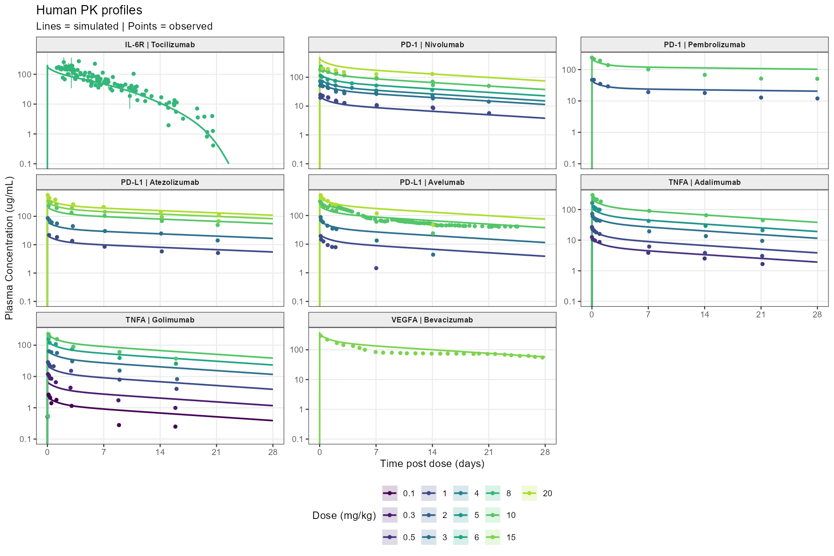

(B)
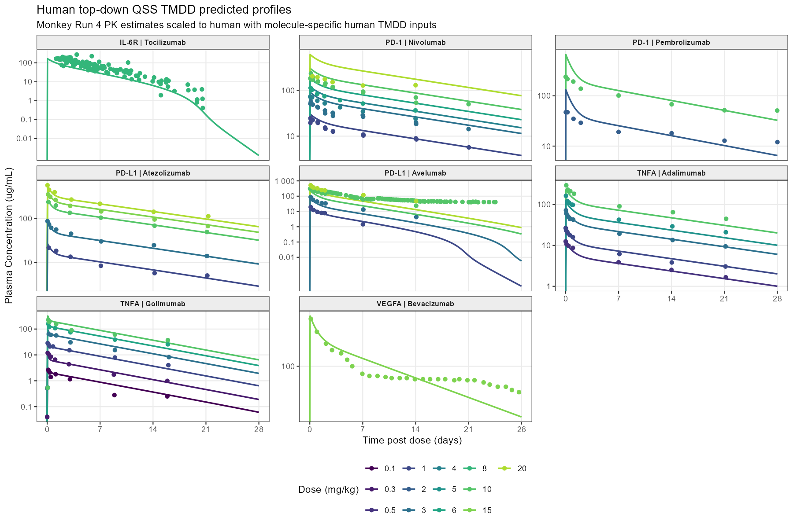

Figure 2. Fold-error comparison for human clearance, AUC0-28d, and Cmax predicted using “a priori” PBPK and monkey-fitted top-down TMDD translation. (A) AUC0-28d; (B) Cmax, and (C) Clearance, calculated as dose/AUCinf and representing total systemic clearance; At target-saturating doses, clearance is expected to be dominated by linear clearance. Fold error equals predicted divided by observed; bars extend from 1 on a base-2 logarithmic scale, and the shaded region and dashed lines indicate the 0.5- to 2-fold interval.
(A)
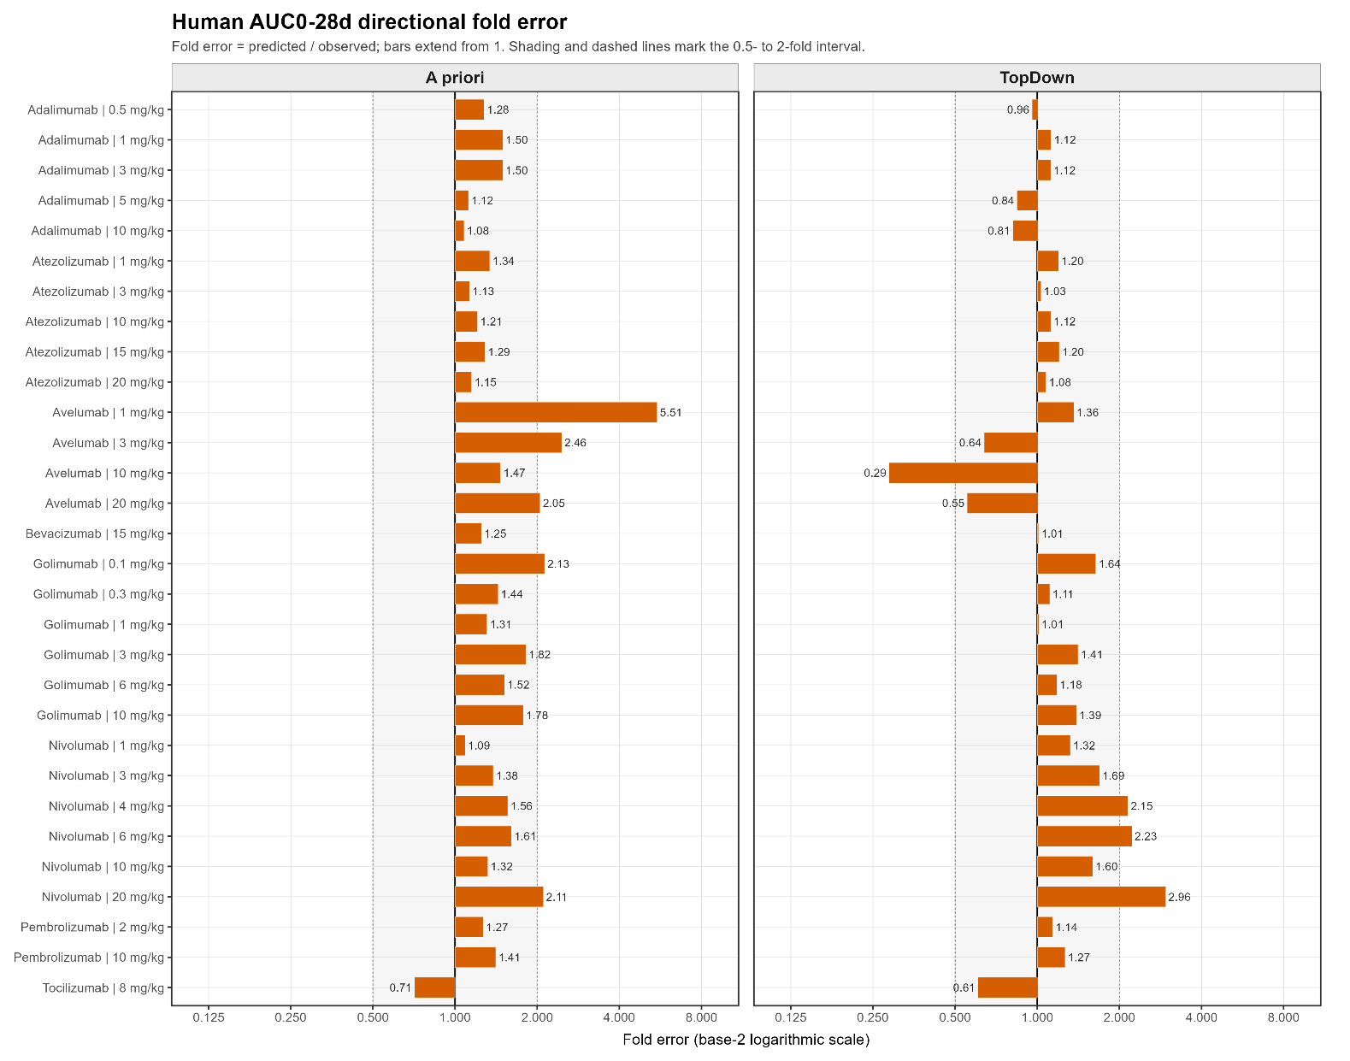

(B)
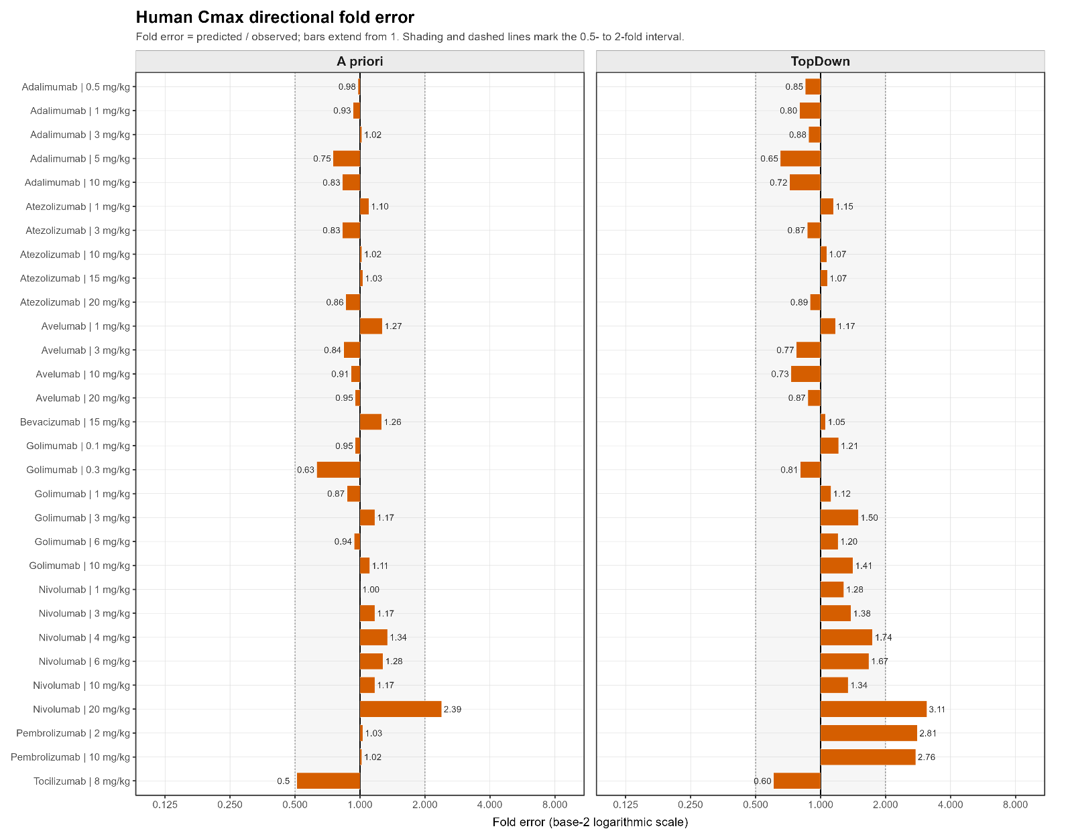

(C)
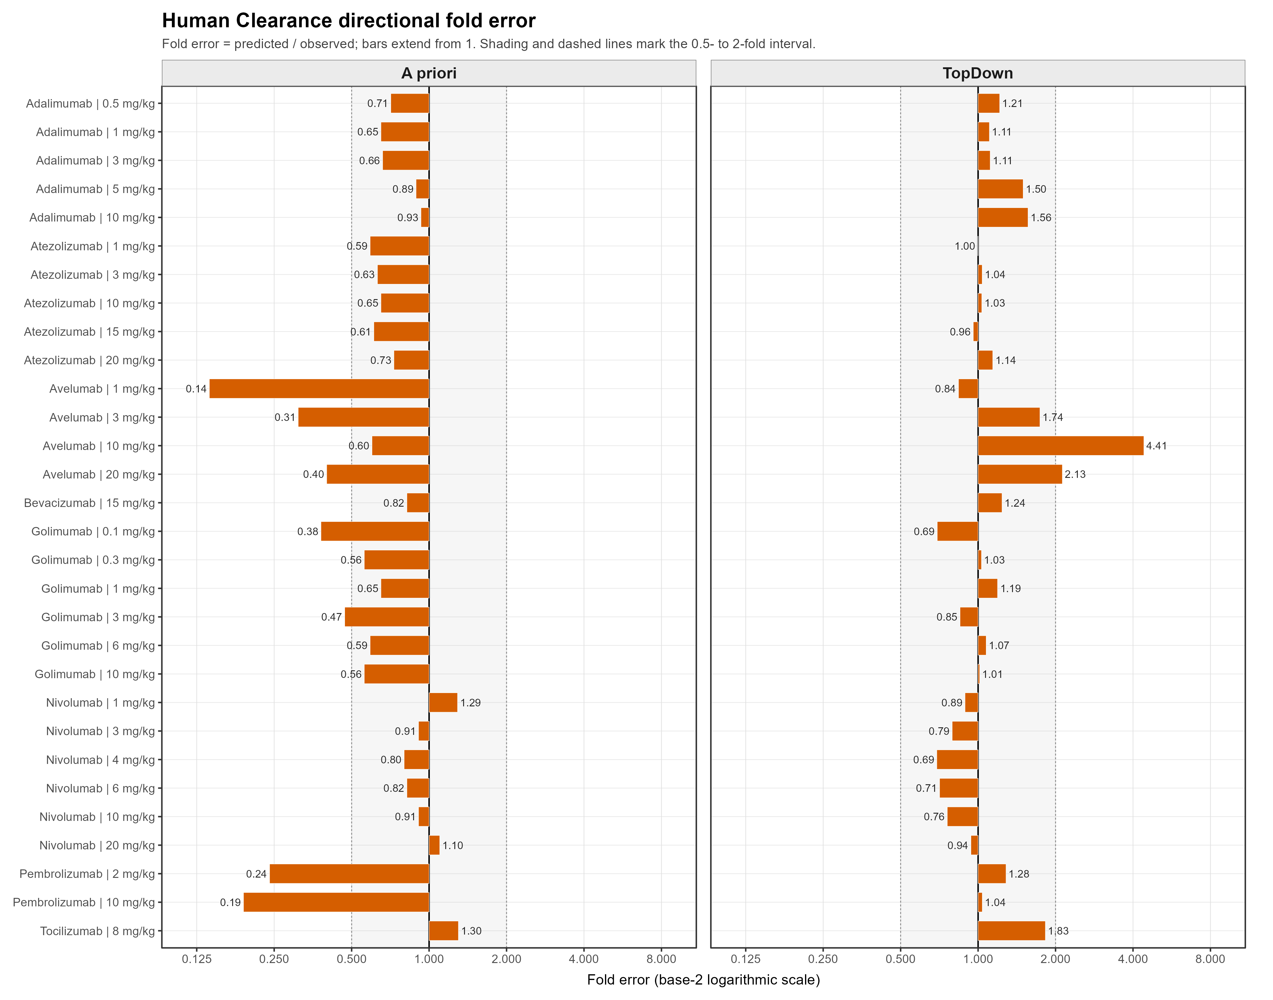

Figure 3. Model-conditional fold-error distributions for reduced monkey PK study designs. Fold error is the reduced-study arithmetic mean divided by the richly sampled top-down population arithmetic mean. The primary analysis applies 30% interindividual variability to CL, V1, Q, and V2; fixed TMDD parameters are unchanged. The shaded interval indicates the prespecified 0.5- to 2-fold criterion.
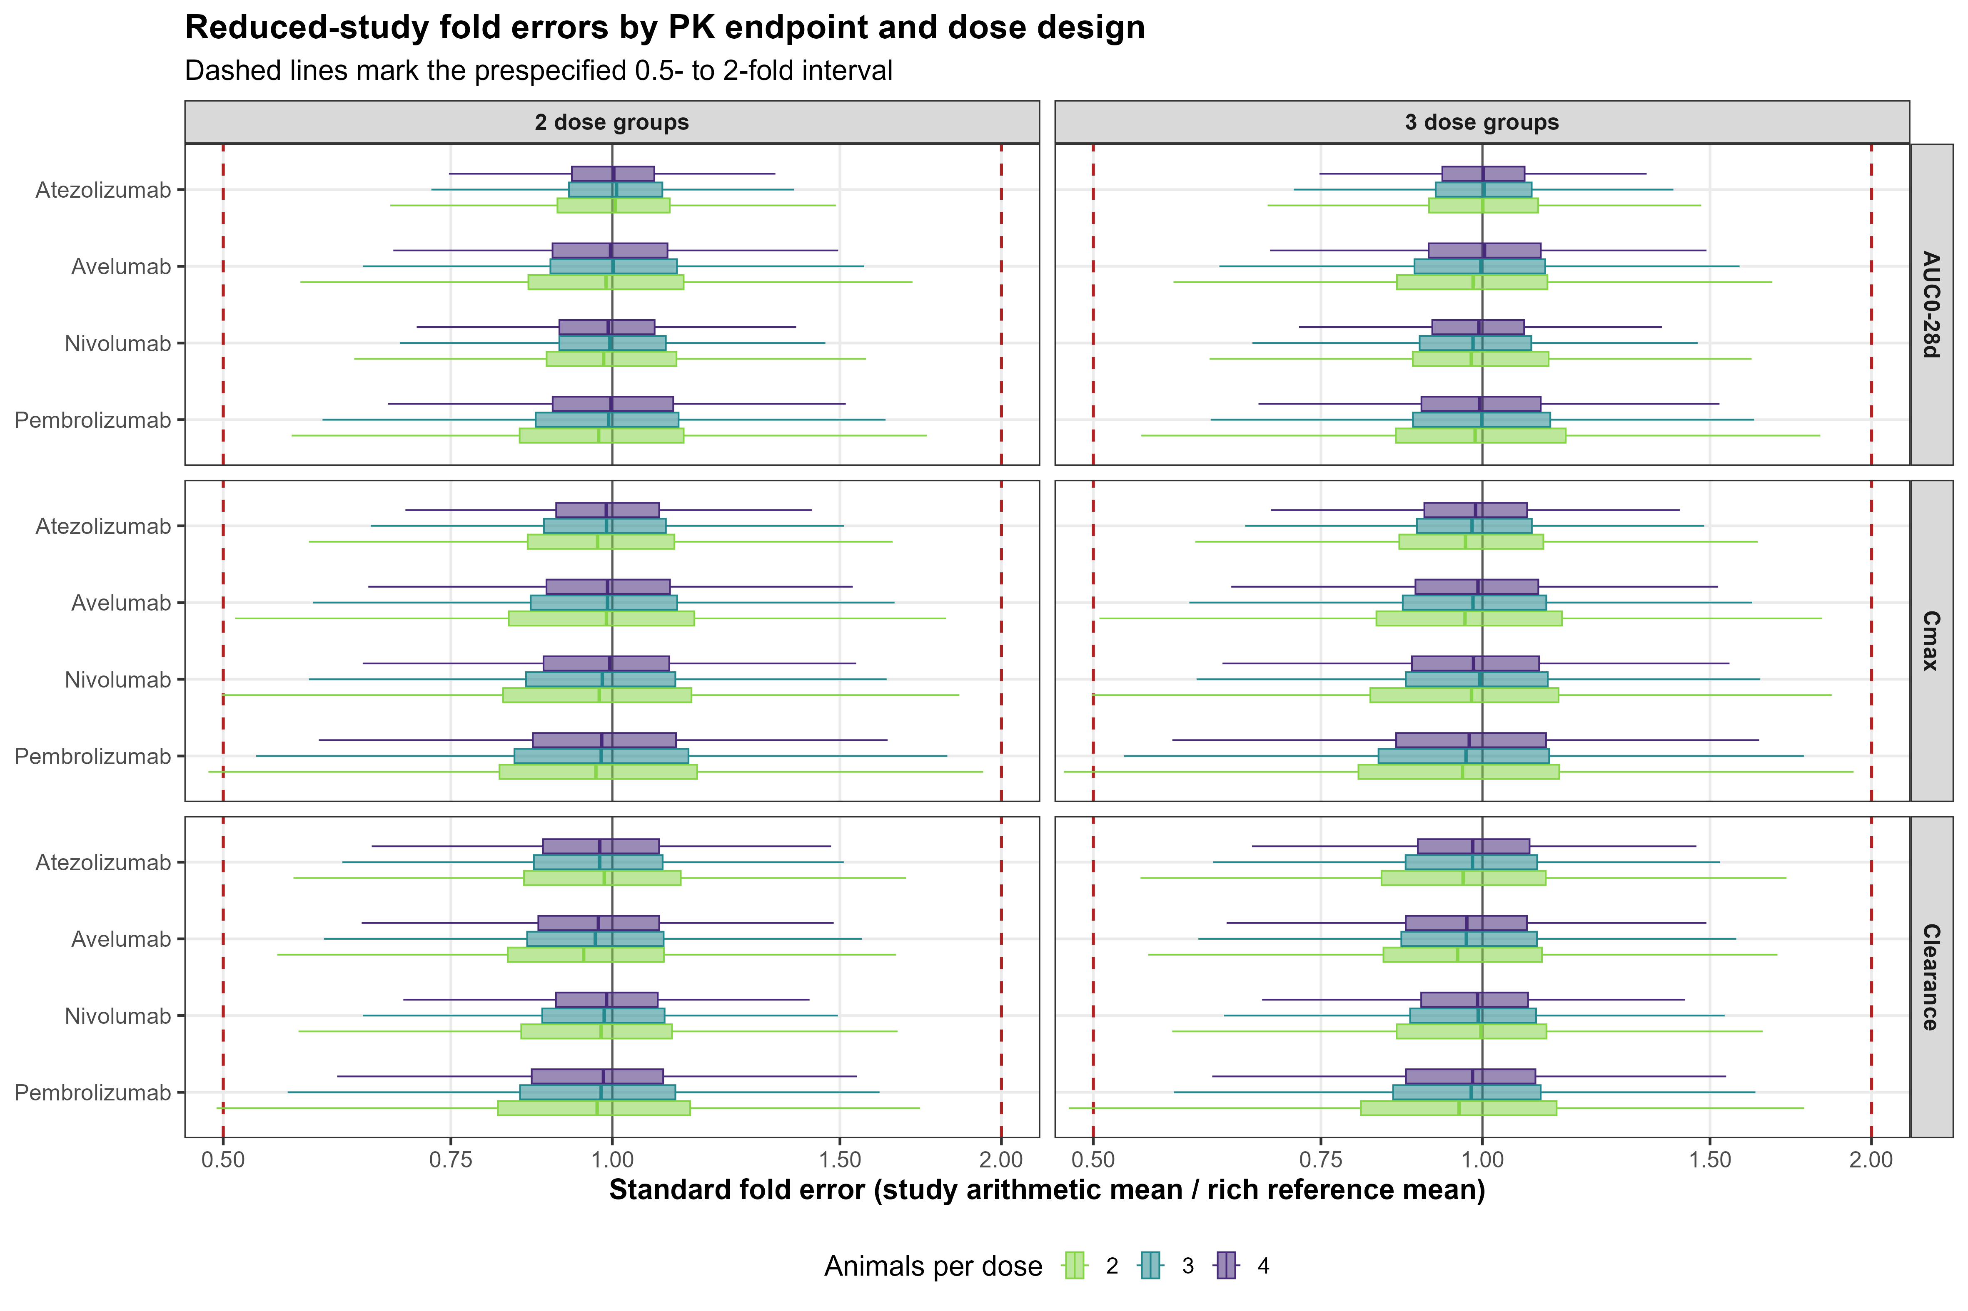
Figure 4. Proposed “a priori” PBPK workflow for monoclonal antibody PK translation as a NAM. Molecule- and target-specific in vitro data are integrated into “a priori” PBPK models before in vivo PK testing. When residual uncertainty warrants an in vivo study, PBPK predictions can inform a targeted exploratory single-dose design, and the resulting data can support model refinement and human exposure prediction. The illustrated reduction applies to single-dose PK and does not apply to toxicology studies. FIH = first-in-human; PBPK = physiologically based pharmacokinetics. Figure generated with GPT-5.5.
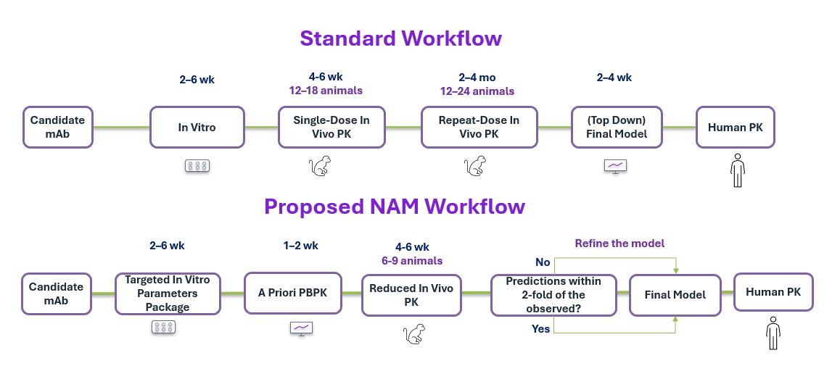

Supplementary Materials
Supplementary Material S1. (S1.1) Observed and predicted monkey plasma concentration-time profiles for the “a priori” PBPK approach, and (B) the top-down QSS TMDD approach, (S1.2) Fold-error comparison for monkey clearance, AUC0-28d, and Cmax predicted using “a priori” PBPK and monkey-fitted top-down TMDD translation, (S1.3) Parameters Used in A Priori and Top-Down Simulations
S1.1. Observed and model-predicted monkey plasma concentration-time profiles across molecules and dose levels. (A) A priori PBPK simulations generated without fitting to monkey PK data. (B) Top-down QSS TMDD Run 4 fits with CL, Vc, Q, and Vp estimated and molecule-specific TMDD inputs fixed. Points represent observed data and lines represent model predictions.
(A) A priori PBPK monkey profiles
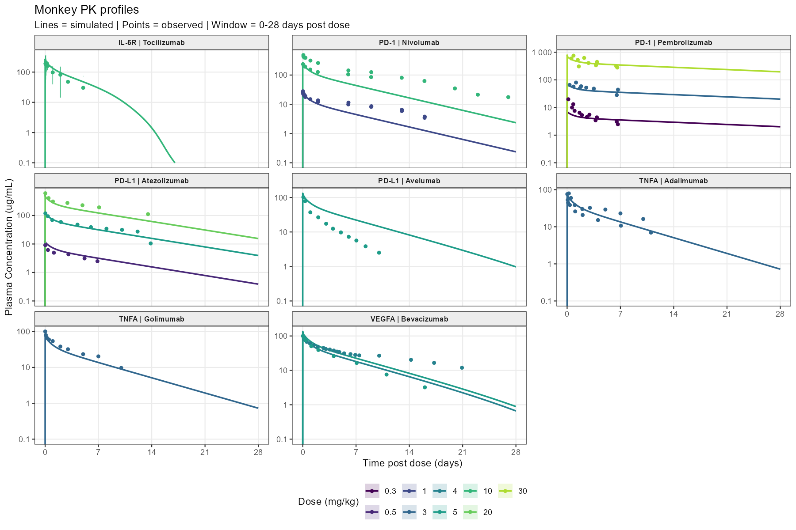

(B) Top-down QSS TMDD monkey fitted profiles
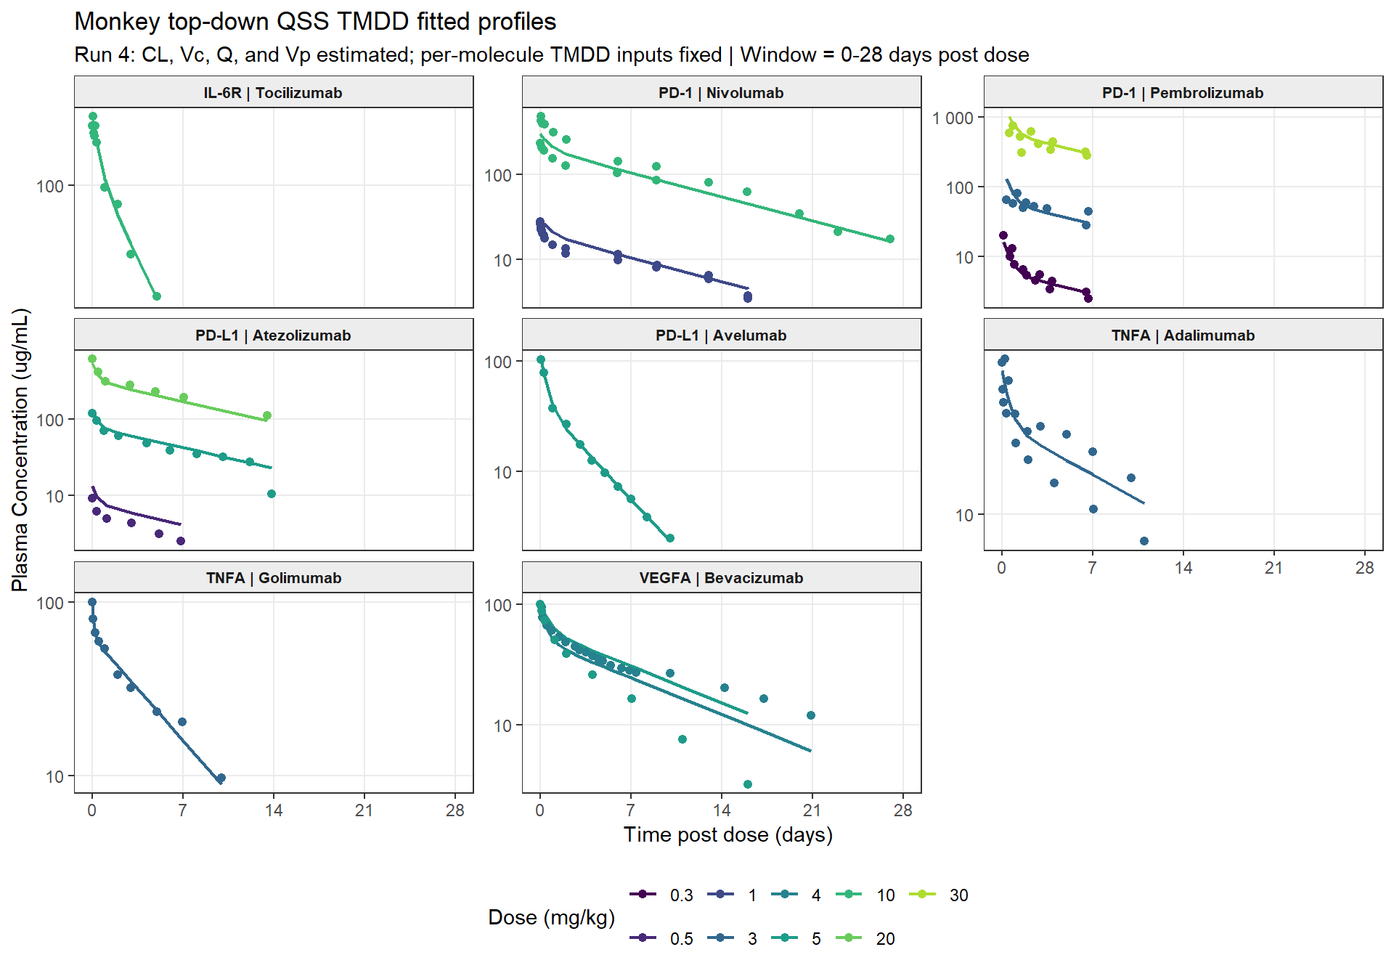

S1.2. Fold-error comparison for monkey clearance, AUC0-28d, and Cmax predicted using “a priori” PBPK and monkey-fitted top-down TMDD translation. (A) Clearance, calculated as dose/AUCinf and representing total systemic clearance; (B) AUC0-28d; and (C) Cmax. At target-saturating doses, clearance is expected to be dominated by linear clearance. Fold error equals predicted divided by observed; bars extend from 1 on a base-2 logarithmic scale, and the shaded region and dashed lines indicate the 0.5- to 2-fold interval.
(A) Monkey clearance
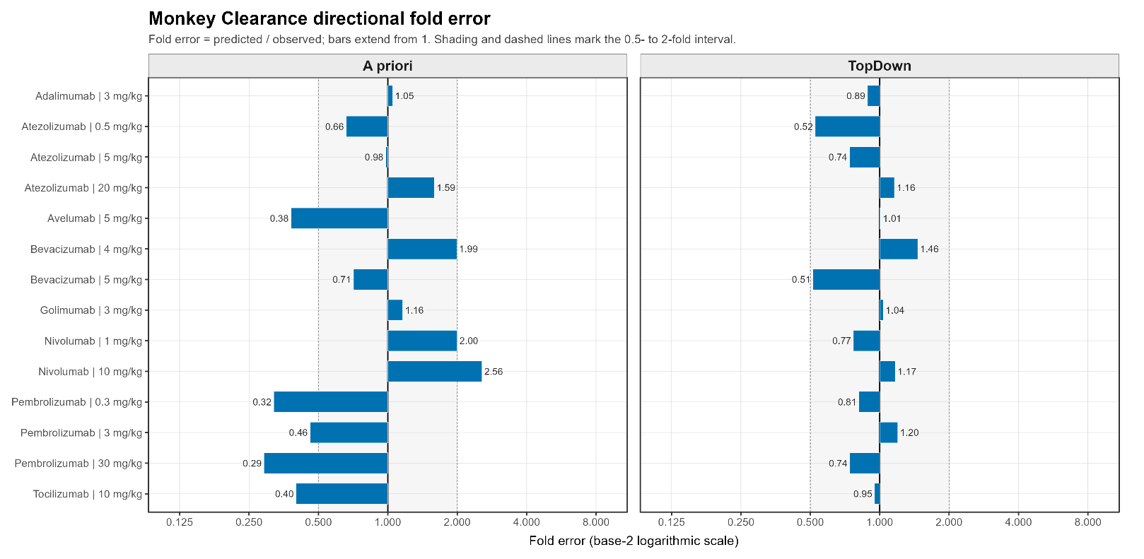

(B) Monkey AUC0-28d
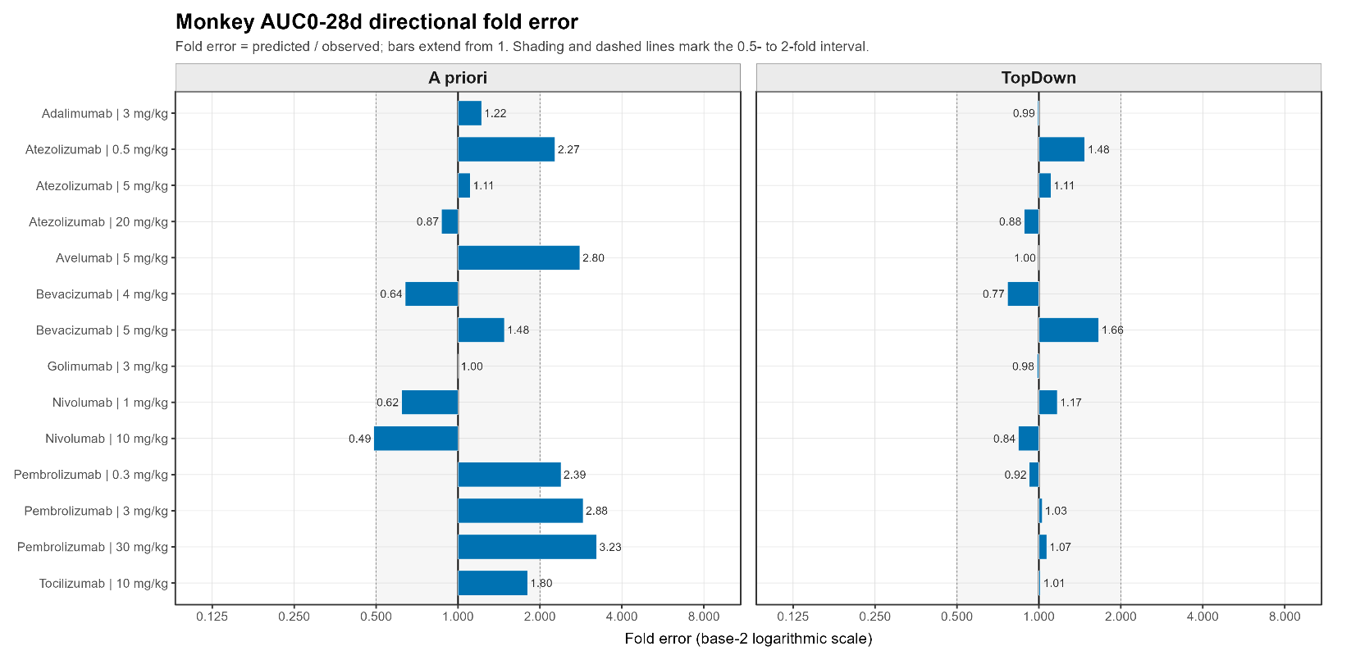

(C) Monkey Cmax
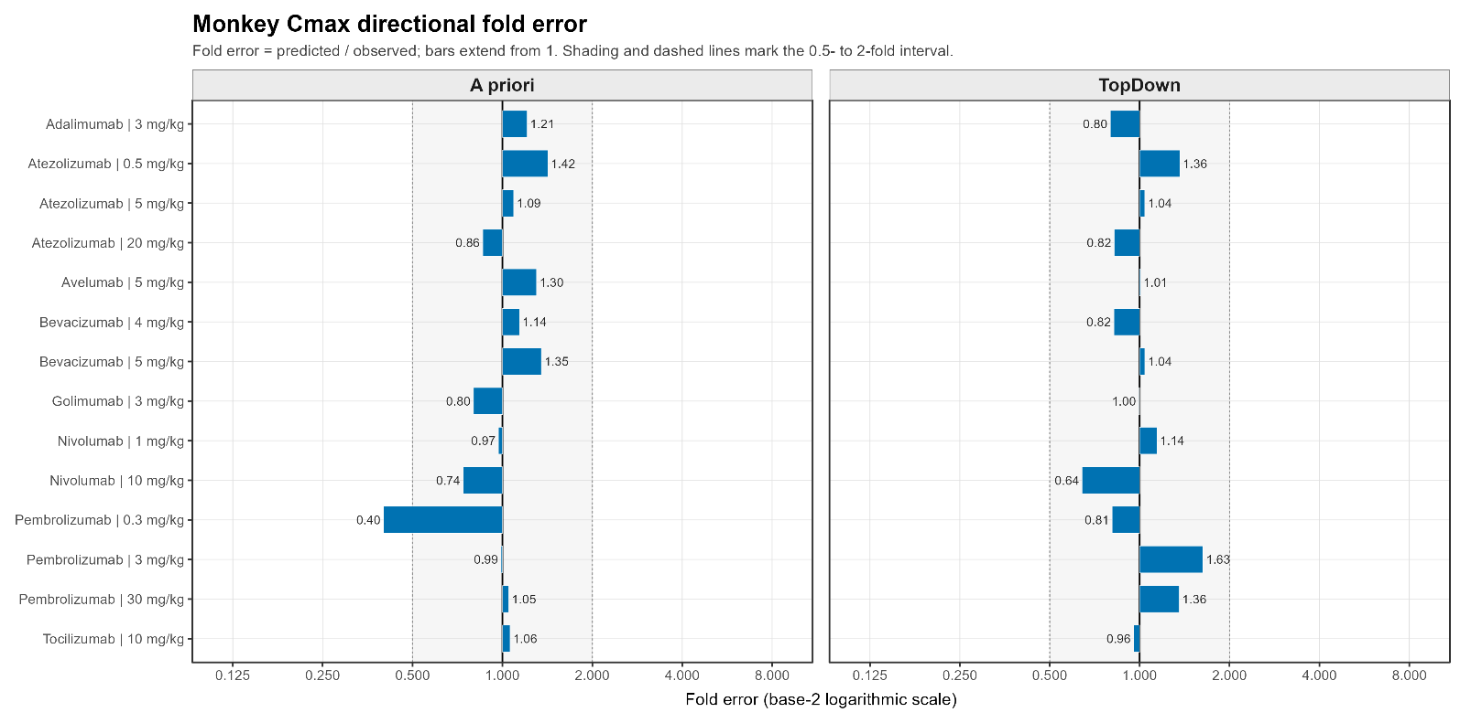
S1.3. Parameters Used in A Priori and Top-Down Simulations
Molecule | Species | Parameter | Value | Unit | Analytical Method for deriving the parameter | Parameter Group | Source
Adalimumab | Monkey | Kd | 0.000127 | uM | SPR/Biacore (Biacore 3000) | A Priori and Top Down | [1]
Adalimumab | Monkey | koff | 0.0096 | 1/min | SPR/Biacore (Biacore 3000) | A Priori and Top Down | [1]
Adalimumab | Monkey | kint | 0.866 | 1/h | Model fitting by the authors of [2] | A Priori and Top Down | [2]
Adalimumab | Monkey | Reference target concentration | 0.001 | nM | Model fitting by the authors of [3] | A Priori and Top Down | [3]
Adalimumab | Monkey | kdeg | 0.223 | 1/h | Model parameter from anti-TNF PBPK analysis | A Priori and Top Down | [4]
Adalimumab | Monkey | Kd (FcRn) in endosomal space | 1.07 | uM | Model-based meta-analysis [5] | A Priori | [5]
Atezolizumab | Monkey | Kd | 0.299 | uM | Equilibrium binding studies using human PD-L1 expressed on 293 cells | A Priori and Top Down | [6]
Atezolizumab | Monkey | koff | 0.00936 | 1/min | SPR/Biacore | A Priori and Top Down | [6]
Atezolizumab | Monkey | kint | 0.606 | 1/h | Flow cytometry internalization assay in BxPC-3 cells | A Priori and Top Down | [6]
Atezolizumab | Monkey | Reference target concentration | 0.609 | nM | Model fitting by the authors of [6] | A Priori and Top Down | [6]
Atezolizumab | Monkey | kdeg | 0.0426 | 1/h | Model fitting by the authors of [6] | A Priori and Top Down | [6]
Atezolizumab | Monkey | Kd (FcRn) in endosomal space | 0.65 | uM | SPR/Biacore | A Priori | [6]
Avelumab | Monkey | Kd | 0.0000467 | uM | SPR assay (Biacore T200) | A Priori and Top Down | [7]
Avelumab | Monkey | koff | 0.00174 | 1/min | SPR assay (Biacore T200) | A Priori and Top Down | [8]
Avelumab | Monkey | kint | 0.25 | 1/h | pHrodo flow-cytometry internalization assay | A Priori and Top Down | [7]
Avelumab | Monkey | Reference target concentration | 0.609 | nM | Model fitting by the authors [6] | A Priori and Top Down | [6]
Avelumab | Monkey | kdeg | 0.0426 | 1/h | Model fitting by the authors [6] | A Priori and Top Down | [6]
Avelumab | Monkey | Kd (FcRn) in endosomal space | 1.07 | uM | Model-based meta-analysis | A Priori | [5]
Bevacizumab | Monkey | Kd | 0.000058 | uM | SPR-Biacore | A Priori and Top Down | [9]
Bevacizumab | Monkey | koff | 0.00186 | 1/min | SPR-Biacore | A Priori and Top Down | [9]
Bevacizumab | Monkey | kint | 0.48 | 1/h | Assumed same as kdeg | A Priori and Top Down | [10]
Bevacizumab | Monkey | Reference target concentration | 0.013 | nM | quantitative fluorescence | A Priori and Top Down | [11]
Bevacizumab | Monkey | kdeg | 0.48 | 1/h | cycloheximide-chase protein degradation assay; western blot dosimetry | A Priori and Top Down | [10]
Bevacizumab | Monkey | Kd (FcRn) in endosomal space | 1.07 | uM | Model-based meta-analysis | A Priori | [5]
Golimumab | Monkey | Kd | 0.000018 | uM | SPR/Biacore (Biacore 3000) | A Priori and Top Down | [1]
Golimumab | Monkey | koff | 0.005583 | 1/min | SPR/Biacore (Biacore 3000) | A Priori and Top Down | [1]
Golimumab | Monkey | kint | 0.866 | 1/h | model estimated by the authors of the source | A Priori and Top Down | [2]
Golimumab | Monkey | Reference target concentration | 0.001 | nM | Model-derived TNF-alpha baseline assumption (1 pM) | A Priori and Top Down | [3]
Golimumab | Monkey | kdeg | 0.223 | 1/h | Model parameter from anti-TNF PBPK analysis | A Priori and Top Down | [4]
Golimumab | Monkey | Kd (FcRn) in endosomal space | 1.07 | uM | Model-based meta-analysis | A Priori | [5]
Nivolumab | Monkey | Kd | 0.00145 | uM | SPR assay (BIAcore T100) | A Priori and Top Down | [12]
Nivolumab | Monkey | koff | 0.114 | uM | SPR/Biacore | A Priori and Top Down | [12]
Nivolumab | Monkey | kint | 0.027 | 1/h | Model estimated by the authors | A Priori and Top Down | [13]
Nivolumab | Monkey | Reference target concentration | 0.0166 | nM | Model estimated by the authors | A Priori and Top Down | [13]
Nivolumab | Monkey | kdeg | 0.027 | 1/h | Model estimated by the authors | A Priori and Top Down | [13]
Nivolumab | Monkey | Kd (FcRn) in endosomal space | 1.07 | uM | Model-based meta-analysis | A Priori | [5]
Pembrolizumab | Monkey | Kd | 0.00031 | uM | SPR/Biacore | A Priori and Top Down | [13]
Pembrolizumab | Monkey | koff | 0.0017 | 1/min | SPR/Biacore | A Priori and Top Down | [13]
Pembrolizumab | Monkey | kint | 0.027 |  | Model estimated by the authors | A Priori and Top Down | [13]
Pembrolizumab | Monkey | Reference target concentration | 0.0166 | nM | Model estimated by the authors | A Priori and Top Down | [13]
Pembrolizumab | Monkey | kdeg | 0.027 | 1/h | Model estimated by the authors | A Priori and Top Down | [13]
Pembrolizumab | Monkey | Kd (FcRn) in endosomal space | 0.081 | uM | SPR/Biacore | A Priori | [13]
Tocilizumab | Monkey | Kd | 0.00134 | uM | SPR/Biacore | A Priori and Top Down | [14]
Tocilizumab | Monkey | koff | 0.01284 | 1/min | SPR/Biacore | A Priori and Top Down | [14]
Tocilizumab | Monkey | kint | 0.28 | 1/h | Assumed same as kdeg; Pulse chase experiments | A Priori and Top Down | [15]
Tocilizumab | Monkey | Reference target concentration | 2.2 | nM | Ligand-binding receptor assay (assumed same across species) | A Priori and Top Down | [16]
Tocilizumab | Monkey | kdeg | 0.28 | 1/h | Pulse chase experiments | A Priori and Top Down | [15]
Tocilizumab | Monkey | Kd (FcRn) in endosomal space | 1.07 | uM | Model-based meta analysis | A Priori | [5]
Adalimumab | Human | Kd | 0.000127 | uM | SPR/Biacore (Biacore 3000) | A Priori and Top Down | [1]
Adalimumab | Human | koff | 0.0096 | 1/min | SPR/Biacore (Biacore 3000) | A Priori and Top Down | [1]
Adalimumab | Human | kint | 0.866 | 1/h | Estimated from minimal PBPK model by the authors | A Priori and Top Down | [2]
Adalimumab | Human | Reference target concentration | 0.001 | nM | Model fitting by the authors of [3] | A Priori and Top Down | [3]
Adalimumab | Human | kdeg | 0.223 | 1/h | Model parameter from anti-TNF PBPK analysis | A Priori and Top Down | [4]
Adalimumab | Human | Kd (FcRn) in endosomal space | 1.07 | uM | Model-based meta-analysis | A Priori | [5]
Atezolizumab | Human | Kd | 0.299 | uM | Equilibrium binding studies | A Priori and Top Down | [6]
Atezolizumab | Human | koff | 0.00936 | 1/min | SPR/Biacore | A Priori and Top Down | [6]
Atezolizumab | Human | kint | 0.606 | 1/h | Flow cytometry internalization assay in BxPC-3 cells | A Priori and Top Down | [6]
Atezolizumab | Human | Reference target concentration | 0.609 | nM | model fitting by the authors | A Priori and Top Down | [6]
Atezolizumab | Human | kdeg | 0.0426 | 1/h | Model estimated by the authors [6] | A Priori and Top Down | [6]
Atezolizumab | Human | Kd (FcRn) in endosomal space | 0.65 | uM | SPR/Biacore | A Priori | [6]
Avelumab | Human | Kd | 0.0000467 | uM | SPR assay (Biacore T200) | A Priori and Top Down | [7]
Avelumab | Human | koff | 0.00174 | 1/min | SPR assay (Biacore T200) | A Priori and Top Down | [8]
Avelumab | Human | kint | 0.25 | 1/h | pHrodo flow-cytometry internalization assay | A Priori and Top Down | [7]
Avelumab | Human | Reference target concentration | 0.609 | nM | Model estimated by the authors [6] | A Priori and Top Down | [6]
Avelumab | Human | kdeg | 0.0426 | 1/h | Model estimated by the authors | A Priori and Top Down | [6]
Avelumab | Human | Kd (FcRn) in endosomal space | 1.07 | uM | Model-based meta-analysis | A Priori | [5]
Bevacizumab | Human | Kd | 0.000058 | uM | SPR-Biacore | A Priori and Top Down | [9]
Bevacizumab | Human | koff | 0.00186 | 1/min | SPR-Biacore | A Priori and Top Down | [9]
Bevacizumab | Human | kint | 0.48 | 1/h | Assumed same as kdeg | A Priori and Top Down | [17]
Bevacizumab | Human | Reference target concentration | 0.013 | nM | quantitative fluorescence (assumed same across species) | A Priori and Top Down | [11]
Bevacizumab | Human | kdeg | 0.48 | 1/h | cycloheximide-chase protein degradation assay; western blot dosimetry | A Priori and Top Down | [17]
Bevacizumab | Human | Kd (FcRn) in endosomal space | 1.07 | uM | Model-based meta-analysis | A Priori | [5]
Golimumab | Human | Kd | 0.000018 | uM | SPR/Biacore (Biacore 3000) | A Priori and Top Down | [1]
Golimumab | Human | koff | 0.005583 | 1/min | SPR/Biacore (Biacore 3000) | A Priori and Top Down | [1]
Golimumab | Human | kint | 0.866 | 1/h | Model estimated by the authors [2] | A Priori and Top Down | [2]
Golimumab | Human | Reference target concentration | 0.001 | nM | Model-derived TNF-alpha baseline assumption (1 pM) | A Priori and Top Down | [3]
Golimumab | Human | kdeg | 0.223 | 1/h | Model estimated by the authors [4] | A Priori and Top Down | [4]
Golimumab | Human | Kd (FcRn) in endosomal space | 1.07 | uM | Model-based meta-analysis | A Priori | [5]
Nivolumab | Human | Kd | 0.00145 | uM | SPR assay (BIAcore T100) | A Priori and Top Down | [12]
Nivolumab | Human | koff | 0.114 | uM | SPR/Biacore | A Priori and Top Down | [12]
Nivolumab | Human | kint | 0.027 | 1/h | Model estimated by the authors [13] | A Priori and Top Down | [13]
Nivolumab | Human | Reference target concentration | 0.07138 | nM | Model estimated by the authors [13] | A Priori and Top Down | [13]
Nivolumab | Human | kdeg | 0.027 | 1/h | Model estimated by the authors [13] | A Priori and Top Down | [13]
Nivolumab | Human | Kd (FcRn) in endosomal space | 1.07 | uM | Model-based meta-analysis | A Priori | [5]
Pembrolizumab | Human | Kd | 0.00031 | uM | SPR/Biacore | A Priori and Top Down | [13]
Pembrolizumab | Human | koff | 0.0017 | 1/min | SPR/Biacore | A Priori and Top Down | [13]
Pembrolizumab | Human | kint | 0.027 |  | Model estimated by the authors [13] | A Priori and Top Down | [13]
Pembrolizumab | Human | Reference target concentration | 0.07138 | nM | Model estimated by the authors [13] | A Priori and Top Down | [13]
Pembrolizumab | Human | kdeg | 0.027 | 1/h | Model estimated by the authors of the source | A Priori and Top Down | [13]
Pembrolizumab | Human | Kd (FcRn) in endosomal space | 0.081 | uM | SPR/Biacore | A Priori | [13]
Tocilizumab | Human | Kd | 0.00134 | uM | SPR/Biacore | A Priori and Top Down | [14]
Tocilizumab | Human | koff | 0.01284 | 1/min | SPR/Biacore | A Priori and Top Down | [14]
Tocilizumab | Human | kint | 0.28 | 1/h | Pulse chase experiments | A Priori and Top Down | [15]
Tocilizumab | Human | Reference target concentration | 1 | nM | Ligand-binding receptor assay | A Priori and Top Down | [16]
Tocilizumab | Human | kdeg | 0.28 | 1/h | Pulse chase experiments | A Priori and Top Down | [15]
Tocilizumab | Human | Kd (FcRn) in endosomal space | 1.07 | uM | Model-based meta-analysis | A Priori | [5]

S1.4. Top-down Linear Clearance Estimates for Monkey
Molecule | CL (L/h/kg)  [RSE %] | V1 (L/kg) [RSE %] | Q (L/h/kg) [RSE %] | V2 (L/kg) [RSE %]
Adalimumab | 0.0004 [14.9] | 0.0467 [11.1] | 0.0010 [Fixed] | 0.0276 [Fixed]
Atezolizumab | 0.0002 [8.1] | 0.0396 [8.5] | 0.0010 [Fixed] | 0.0221 [23.4]
Avelumab | 0.0012 [1.8] | 0.0435 [6.2] | 0.0015 [21.8] | 0.0394 [8.6]
Bevacizumab | 0.0003 [14.5] | 0.0474 [5.6] | 0.0010 [Fixed] | 0.0270 [31.2]
Golimumab | 0.0004 [5.9] | 0.0288 [3.2] | 0.0038 [24.4] | 0.0171 [9.8]
Nivolumab | 0.0002 [5.4] | 0.0312 [8.5] | 0.0010 [Fixed] | 0.0149 [32.8]
Pembrolizumab | 0.0002 [18.6] | 0.0150 [23.8] | 0.0007 [23.5] | 0.0254 [22.5]
Tocilizumab | 0.0008 [5.2] | 0.0477 [3.8] | 0.0010 [Fixed] | 0.0206 [28.6]

S1.5. Percent Extrapolated in AUCinf Calculations in Observed Data.
Species | Molecule | Dose (mg/kg) | % Extrapolated in AUC_{inf}
Monkey | Adalimumab | 3 | 29
Monkey | Atezolizumab | 0.5 | 37
Monkey | Atezolizumab | 5 | 13
Monkey | Atezolizumab | 20 | 31
Monkey | Avelumab | 5 | 5
Monkey | Bevacizumab | 4 | 22
Monkey | Bevacizumab | 5 | 5
Monkey | Golimumab | 3 | 16
Monkey | Nivolumab | 1 | 21
Monkey | Nivolumab | 10 | 20
Monkey | Pembrolizumab | 0.3 | 28
Monkey | Pembrolizumab | 3 | 59
Monkey | Pembrolizumab | 30 | 38
Monkey | Tocilizumab | 10 | 15
Human | Adalimumab | 0.5 | 25
Human | Adalimumab | 1 | 30
Human | Adalimumab | 3 | 30
Human | Adalimumab | 5 | 31
Human | Adalimumab | 10 | 32
Human | Atezolizumab | 1 | 31
Human | Atezolizumab | 3 | 25
Human | Atezolizumab | 10 | 31
Human | Atezolizumab | 15 | 31
Human | Atezolizumab | 20 | 35
Human | Avelumab | 1 | 11
Human | Avelumab | 3 | 9
Human | Avelumab | 10 | 24
Human | Avelumab | 20 | 15
Human | Bevacizumab | 15 | 33
Human | Golimumab | 0.1 | 14
Human | Golimumab | 0.3 | 15
Human | Golimumab | 1 | 19
Human | Golimumab | 3 | 19
Human | Golimumab | 6 | 23
Human | Golimumab | 10 | 31
Human | Nivolumab | 1 | 50
Human | Nivolumab | 3 | 45
Human | Nivolumab | 4 | 45
Human | Nivolumab | 6 | 48
Human | Nivolumab | 10 | 42
Human | Nivolumab | 20 | 70
Human | Pembrolizumab | 2 | 42
Human | Pembrolizumab | 10 | 35
Human | Tocilizumab | 8 | 0

S1.6. Local Sensitivity Analysis of Target Related Parameters on Clearance Estimate Using PBPK Model. An a priori PBPK modeling framework was used to assess parameter sensitivity by varying the target reference concentration, target degradation rate (kdeg), and internalization rate (kint) one at a time while holding all other model parameters constant. Each parameter was varied by decreasing to 0.1-fold and increasing to 10-fold of its reference value, and the resulting terminal clearance was compared with the reference simulation. The normalized sensitivity coefficient was calculated as ln(CLvaried/CLreference)/ln(Pvaried/Preference), and a sensitivity index of 1+ the normalized coefficient was reported, such that a value of 1 indicates no sensitivity. Sensitivity indices were averaged across evaluated doses for each molecule and ranked from highest to lowest in the figure.
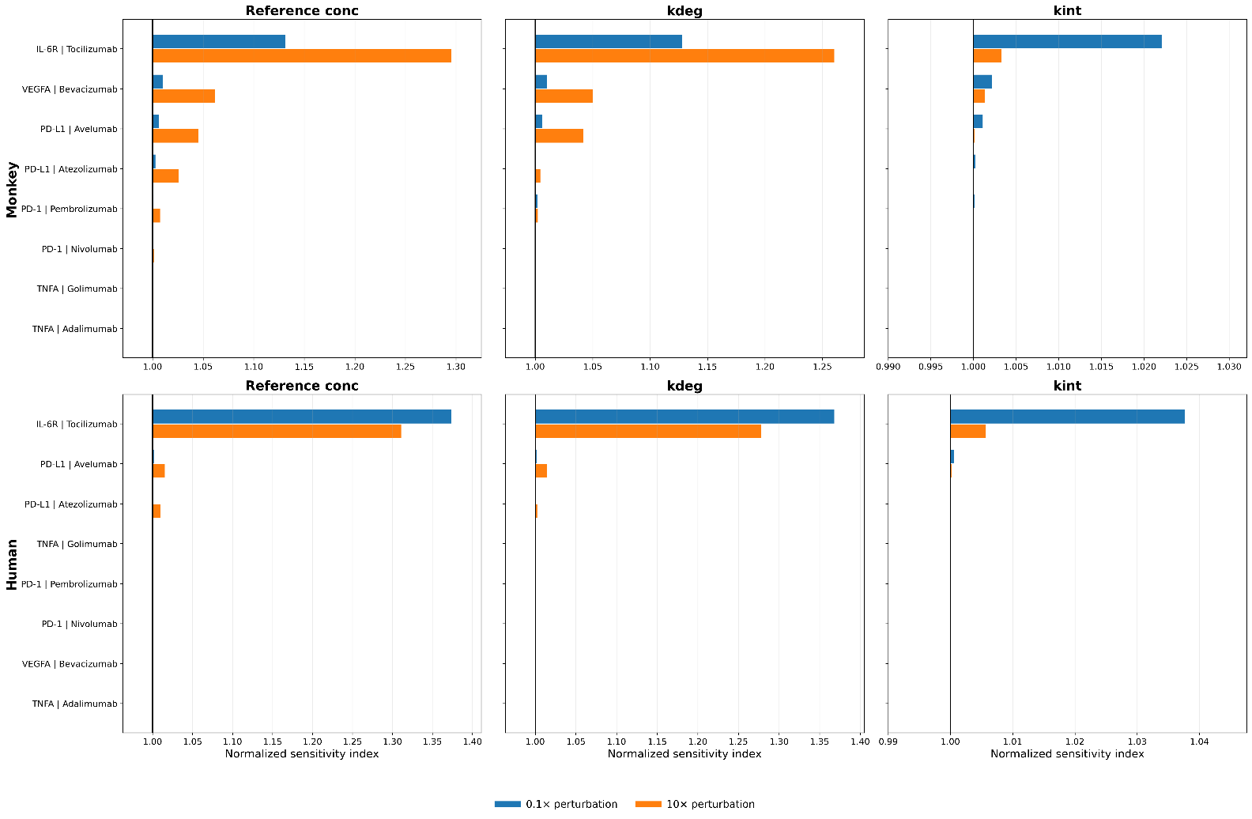

References
1. Shealy DJ, Cai A, Staquet K, Baker A, Lacy ER, Johns L, et al. Characterization of golimumab, a human monoclonal antibody specific for human tumor necrosis factor alpha. mAbs. 2010;2(4):428-439. doi:10.4161/mabs.2.4.12304.
2. Zheng S, Niu J, Geist B, Fink D, Xu Z, Zhou H, Wang W. A minimal physiologically based pharmacokinetic model to characterize colon TNF suppression and treatment effects of an anti-TNF monoclonal antibody in a mouse inflammatory bowel disease model. mAbs. 2020;12(1):1813962. doi:10.1080/19420862.2020.1813962.
3. Reig-López J, García-Otero X, Cuquerella-Gilabert M, Bandín-Vilar E, Otero-Espinar FJ, Fernández-Ferreiro A, et al. A physiologically based pharmacokinetic model to describe [89Zr]Zr-DFO-adalimumab specific activity after intravitreal administration to rats with endotoxin-induced uveitis. International Journal of Pharmaceutics. 2025;681:125845. doi:10.1016/j.ijpharm.2025.125845.
4. Chen J, Lin R, Guo G, Wu W, Ke M, Ke C, et al. Physiologically-Based Pharmacokinetic Modeling of Anti-Tumor Necrosis Factor Agents for Inflammatory Bowel Disease Patients to Predict the Withdrawal Time in Pregnancy and Vaccine Time in Infants. Clinical Pharmacology & Therapeutics. 2023;114(6):1254-1263. doi:10.1002/cpt.3031.
5. Benamara S, Sjögren E, Gattacceca F, Chenel M, Deslandes A, Nguyen L, Teutonico D. Prediction of Monoclonal Antibodies Pharmacokinetics in Human: Identification of a Reference Neonatal Fc Receptor (FcRn) Binding Affinity Using Physiologically Based Pharmacokinetic (PBPK) Modeling. ACS Pharmacology & Translational Science. 2026;9:177-190. doi:10.1021/acsptsci.5c00674.
6. Huang W, Stader F, Chan P, Shemesh CS, Chen Y, Gill KL, et al. Development of a pediatric physiologically-based pharmacokinetic model to support recommended dosing of atezolizumab in children with solid tumors. Frontiers in Pharmacology. 2022;13:974423. doi:10.3389/fphar.2022.974423.
7. Jin H, D'Urso V, Neuteboom B, McKenna SD, Schweickhardt R, Gross AW, et al. Avelumab internalization by human circulating immune cells is mediated by both Fc gamma receptor and PD-L1 binding. OncoImmunology. 2021;10(1):1958590. doi:10.1080/2162402X.2021.1958590.
8. Benicky J, Sanda M, Brnakova Kennedy Z, Grant OC, Woods RJ, Zwart A, Goldman R. PD-L1 Glycosylation and Its Impact on Binding to Clinical Antibodies. Journal of Proteome Research. 2021;20(1):485-497. doi:10.1021/acs.jproteome.0c00521.
9. Papadopoulos N, Martin J, Ruan Q, Rafique A, Rosconi MP, Shi E, et al. Binding and neutralization of vascular endothelial growth factor (VEGF) and related ligands by VEGF Trap, ranibizumab and bevacizumab. Angiogenesis. 2012;15(2):171-185. doi:10.1007/s10456-011-9249-6.
10. Calera MR, Venkatakrishnan A, Kazlauskas A. VE-cadherin increases the half-life of VEGF receptor 2. Experimental Cell Research. 2004;300(1):248-256. doi:10.1016/j.yexcr.2004.07.007.
11. Imoukhuede PI, Popel AS. Quantification and cell-to-cell variation of vascular endothelial growth factor receptors. Experimental Cell Research. 2011;317(7):955-965. doi:10.1016/j.yexcr.2010.12.014.
12. Tan S, Zhang H, Chai Y, Song H, Tong Z, Wang Q, et al. An unexpected N-terminal loop in PD-1 dominates binding by nivolumab. Nature Communications. 2017;8:14369. doi:10.1038/ncomms14369.
13. Lindauer A, Valiathan CR, Mehta K, Sriram V, de Greef R, Elassaiss-Schaap J, de Alwis DP. Translational Pharmacokinetic/Pharmacodynamic Modeling of Tumor Growth Inhibition Supports Dose-Range Selection of the Anti-PD-1 Antibody Pembrolizumab. CPT Pharmacometrics & Systems Pharmacology. 2017;6(1):11-20. doi:10.1002/psp4.12130.
14. Xu C, Rafique A, Potocky T, Paccaly A, Nolain P, Lu Q, et al. Differential Binding of Sarilumab and Tocilizumab to IL-6Rα and Effects of Receptor Occupancy on Clinical Parameters. Journal of Clinical Pharmacology. 2021;61(5):714-724. doi:10.1002/jcph.1795.
15. Gerhartz C, Dittrich E, Stoyan T, Rose-John S, Yasukawa K, Heinrich PC, Graeve L. Biosynthesis and half-life of the interleukin-6 receptor and its signal transducer gp130. European Journal of Biochemistry. 1994;223(1):265-274. doi:10.1111/j.1432-1033.1994.tb18991.x.
16. Nesbitt JE, Fuller GM. Differential regulation of interleukin-6 receptor and gp130 gene expression in rat hepatocytes. Molecular Biology of the Cell. 1992;3(1):103-112. doi:10.1091/mbc.3.1.103.
17. Sarabipour S, Kinghorn K, Quigley KM, Kovacs-Kasa A, Annex BH, Bautch VL, Mac Gabhann F. Trafficking dynamics of VEGFR1, VEGFR2, and NRP1 in human endothelial cells. PLOS Computational Biology. 2024;20(2):e1011798. doi:10.1371/journal.pcbi.1011798.

Supplementary Material 2. Github link to full project codes: https://github.com/namlink-org/APriori_PBPK_mAb

