Physiologically-Based Pharmacokinetic Modeling to Guide Reduced Monkey PK Studies for Monoclonal Antibodies: A Tutorial
Krina Mehta^{1,} Akshat Shah^{1,2}, Stephan Schaller³
¹ NAMLink, Cypress, CA, USA
²Aivaura, Bhavnagar, Gujarat, India
³ ESQlabs GmbH, 26683 Saterland, Germany
Funding
No funding was received for this work.
Use of Artificial Intelligence
OpenAI GPT-5.5/5.6 was used to assist with language editing, manuscript organization, and generation/refinement of Figures 1 and 5. Codex GPT-5.5/5.6 was used as a coding assistant. The authors reviewed and edited all AI-assisted content. The authors take full responsibility for the accuracy, integrity, and final content of the manuscript.

Abstract
Physiologically based pharmacokinetic (PBPK) models for predicting monoclonal antibody (mAb) pharmacokinetics are well established. This tutorial presents a reproducible PK-Sim/MoBi-R workflow for generating monkey and human mAb PK predictions without calibration with in vivo PK profiles and for using simulations to explore reduced monkey PK study designs within a new approach methodology (NAM) decision framework. The workflow integrates species physiology with FcRn-binding and target-mediated disposition inputs. Intravenous single-dose PK data for eight mAbs across five targets were evaluated retrospectively. Predicted AUC_{0-28d,} C_{max}, and clearance were compared with observed values. Candidate monkey study designs were evaluated for a mAb, golimumab, under 30% and 50% variability in mechanistic inputs combined with virtual-monkey physiological variability.
For human PK, 86.7%, 96.7%, and 80.0% of AUC_{0-28d}, C_{max}, and clearance predictions, respectively, were within two-fold of observed values; the corresponding proportions for monkey PK were 57.1%, 92.9%, and 42.9%. The PBPK framework predicted both AUC_{0-28d} and C_{max} within two-fold across all evaluated doses for six of the eight molecules. In the golimumab study-design exercise, a two-dose design with three animals per group (total n=6) met the two-fold criterion for all three PK endpoints at both doses in 99.7% and 97.6% of replicate studies under 30% and 50% input variability, respectively.
These findings illustrate how PBPK models can connect mechanistic inputs and exposure prediction to design fit-for-purpose preclinical studies. Further evaluations using larger datasets, incorporating experimentally measured mechanistic inputs, pre-specified decision criteria, and explicit assessment of study objectives, uncertainties, and model and study-design assumptions. This tutorial provides a reproducible framework for conducting such systematic evaluations.

Introduction
Adequate characterization of pharmacokinetics (PK) is crucial for a successful drug development program because it is the quantitative link between administered dose, systemic and tissue exposure, target engagement, pharmacodynamic (PD) response, and safety [1]. For monoclonal antibodies (mAbs) and other protein therapeutics, systemic and tissue exposures depend on target-mediated drug disposition (TMDD), neonatal Fc receptor (FcRn)-mediated recycling, and tissue distribution processes that can differ across species. Physiologically-based pharmacokinetic (PBPK) modeling is a mechanistic modeling approach that integrates species-specific physiology with drug- and target-specific parameters to simulate PK. For mAbs, PBPK models incorporate key determinants of disposition, including vascular convection, lymphatic return, tissue partitioning, pinocytosis, FcRn binding and recycling, proteolytic catabolism, target binding, target turnover, and target-receptor complex internalization, into a quantitative framework [2, 3, 4]. Extensive work on PBPK models for mAbs has established a robust scientific foundation for characterizing their PK [31]. For mAb PK characterization, published examples have shown that in vitro measurements, together with species physiology and FcRn-mAb interaction-related parameters, can support prediction of mAb linear PK without in vivo data [14, 15]; although these frameworks did not incorporate target-mAb interactions governing nonlinear, target-mediated clearance. Chen et al. compared approaches for translating PD-1/PD-L1 antibody PK from cynomolgus monkeys to humans, including the generic macromolecule PBPK model in PK-Sim [32]. This foundation provides an opportunity to incorporate established PBPK and TMDD methods within a new approach methodologies (NAMs) decision framework.
Interest in NAMs has increased substantially following the FDA’s April 2025 Roadmap to Reducing Animal Testing in Preclinical Safety Studies [5-9]. Current NAM efforts encompass context-of-use (COU) frameworks, complex in vitro systems, including organoids, microphysiological systems, and organ-on-chip platforms, and AI/ML-enabled computational toxicology. These approaches increasingly evaluate whether human-relevant biological pathways are perturbed at clinically meaningful plasma or tissue exposures. Exposure therefore provides a common quantitative basis for integrating in vitro concentration-response data, in silico predictions, prior clinical knowledge, biomarkers, and safety thresholds. For example, findings from cell-based or microphysiological systems can be interpreted in the context of predicted human concentration-time profiles, exposure margins, and the duration for which concentrations exceed biologically active or adverse-effect thresholds [10, 11].
Despite the growing interest, the role of quantitative pharmacology within the NAM landscape remains insufficiently delineated. A recent FDA/CDER analysis of 15 years of NAM-related submissions reported that 93% involved broadly defined in vitro or in silico approaches, but did not clearly identify examples of mechanistic quantitative pharmacology approaches, such as physiologically based pharmacokinetic (PBPK), quantitative systems pharmacology (QSP), or quantitative systems toxicology (QST) modeling [12]. Consequently, the extent to which these model-informed drug development (MIDD) approaches are being applied specifically as NAMs remains unclear, despite their established and growing use in regulatory submissions [8, 13]. Mechanistic quantitative pharmacology can play an important role at the interface between preclinical evidence and clinical translation by connecting NAM-derived biological observations to predictions of clinically relevant plasma and tissue exposures.
Here, we illustrate this role through a practical workflow that applies in vitro data, PBPK modeling, TMDD principles, and study simulations to inform the design of mAb PK studies. The example focuses on optimizing monkey PK studies, including dose groups and animal numbers to address defined uncertainty while reducing animal use. The same workflow can be adapted to other types of preclinical studies and can complement strategies such as cassette dosing, microsampling, animal reuse, and integration of PK/PD or toxicology endpoints into existing studies [16-18]. It can also support the evaluation of alternatives to nonhuman primates, including hybrid approaches that scale human PK from transgenic human FcRn mice using allometric or PBPK methods. This article presents a reproducible, tutorial-oriented workflow for applying established PBPK and TMDD methods within a NAM decision framework for mAb development. The emphasis is on practical implementation and interpretation. The primary objectives are (1) to demonstrate how to generate PBPK prediction without in vivo PK data of monkey and human PK using PK-Sim/MoBi; and (2) to explore animal number reduction opportunities for monkey PK studies for mAbs using the developed PBPK models. A secondary objective is to evaluate the workflow retrospectively using eight intravenously administered mAbs across five targets. The analysis assesses predictive performance and uses simulation-based visualizations to show how uncertainty in in vitro inputs and interindividual variability affect confidence that data generated by candidate study designs can recover molecule’s “true” PK characteristics. These examples are intended to help preclinical pharmacology and modeling teams to walk through model development, interpret model outputs, and design fit-for-purpose PK studies with fewer dose groups and animals, while identifying the additional evidence needed for prospective application to human PK prediction and study-design decisions.

Overview
The workflow presented here contains four main parts: (1) in vitro input parameters collection, (2) structural models set-up, (3) typical subject PBPK simulations without calibration with any in vivo data, (4) study simulations accounting for population variability and parameter uncertainty (Figure 1). The fully reproducible workflow and instructions are provided in Supplementary Material 1. The workflow began with the generation or collection of six drug- and target-specific input parameters for each molecule and species: antibody-FcRn binding affinity, antibody-target binding affinity and dissociation rate, target-antibody complex internalization rate, target degradation rate, and target reference concentration. Species- and target-specific structural PBPK models were then constructed in PK-Sim. Each PK-Sim simulation was transferred to MoBi, extended with TMDD reactions describing antibody-target complex internalization and target degradation, and exported as a compiled PKML file. Simulation configuration files were subsequently generated using R scripts and were used to apply the appropriate molecule-, species-, dose-, and administration-specific inputs to produce monkey and human PK predictions. Observed PK data were not used to calibrate the models. After the predictions had been generated and saved, predicted concentration-time profiles and PK endpoints, including C_{max}, AUC_{0-28d}, AUC_{inf}, and clearance, were compared retrospectively with observed data using predicted-to-observed fold errors and a prespecified two-fold criterion.
Study simulations were subsequently performed for one molecule to demonstrate whether exploratory monkey PK studies with fewer animals could reproduce prespecified model-defined PK characteristics, i.e., reference model, while accounting for physiological variability and uncertainty in the mechanistic input parameters. Golimumab was selected from the eight evaluated molecules because its monkey predictions without calibration to the analyzed in vivo data demonstrated the best overall predictive performance in the retrospective comparison. For this model-conditional exercise, the nominal, uncalibrated Golimumab monkey model was designated as the reference model. At each of two input-variability levels, 30% and 50% coefficient of variation, 100 sets of the six molecule-specific PBPK inputs were generated and crossed with the same population of 50 virtual monkeys. This procedure produced 5,000 unique physiology-parameter combinations per variability level and 50,000 concentration-time profiles across the five evaluated doses before sparse sampling. Candidate studies with two, three, or five dose groups; two, three, or six animals per group; and a fixed sparse sampling schedule were repeatedly sampled from these profiles. For each candidate design, 1,000 replicate studies were compared with a densely sampled, typical-subject reference generated using the nominal Golimumab model. The resulting fold-error distributions and two-fold coverage probabilities were used to assess how reliably each candidate design recovered AUC_{0-28d}, C_{max}, and terminal clearance. This comparison is informative about precision under the assumed model and uncertainty distributions.
Observed In Vivo PK Data: To illustrate and evaluate the workflow, we digitized literature-based plasma PK profiles for eight mAbs directed against five targets after intravenous administration to monkeys and humans using WebPlotDigitizer (https://automeris.io/). For most mAbs, the source publications did not state whether the reported concentrations represented free or total antibody.
In Vitro Experimental Data: Literature-based target- and molecule-specific data were used to compile drug-FcRn binding, drug-target binding, drug-target complex internalization, target degradation, and target reference concentration inputs. The same target reference and degradation rates were used for each target-specific molecule. Some values came from prior modeling analyses rather than independent in vitro measurements; their provenance is identified in Supplementary Material 2 and considered when interpreting prediction performance.
Software: PK-Sim/MoBi and the R packages OSP Suite and esqlabsR provide a practical open-source framework for a reproducible, semi-automated workflow [22-24]. The platform combines physiologically structured PBPK models with curated species-specific physiology and expression databases, allowing target-expression profiles to be defined consistently across monkeys and humans [20, 21]. Export to MoBi and programmatic simulation in R also enable scalable evaluation across molecules, targets, species, and dose levels. This reproducibility is important for prospective PBPK-based NAM workflows, in which model generation, parameter updates, simulations, and exposure-metric extraction should be pre-specified and independently traceable. The example workflow was implemented with PK-Sim 12.2 and MoBi 12.2 for model construction, R 4.5.1 for programmatic execution and analysis, esqlabsR 5.6.0 and ospsuite 12.4.2 for the R interface to the Open Systems Pharmacology (OSP) Suite, and Quarto for the executable tutorial documents [22-24, 33].

Generating PBPK Predictions Without In Vivo PK Calibration

Configuring Target-Specific PBPK Models
In this tutorial, we began with the generic large-molecule structural model in PK-Sim, including its binding to FcRn and to a generic target [4]. The model was exported to MoBi and TMDD processes were added using a modular approach [19]. Next, we created target expression profiles in monkeys and humans for each of the targets, including relevant localization, using PK-Sim's expression database [20, 21]. The expression database provides relative abundance of target expression across tissues. Absolute reference concentrations for each target, that is, the concentration in the tissue with the highest expression, were set to literature-derived values and are provided in Supplementary Material 2. PKML simulation files containing the generic large-molecule PK model and target expression, one file per target and species, were then exported [19]. The 01_Models folder in Supplementary Material 1 documents the model-building steps and supplies the files used in the executable workflow.

Running Simulations
Intravenous single-dose simulations for each of the eight molecules were run programmatically for both monkeys and humans. C_{max}, AUC_{0-28d}, clearance, and fold errors were calculated for each molecule-dose pair with observed digitized data. C_{max} and AUC_{0-28d} were used as exposure metrics. AUC_{0-28d} was calculated through 672 hours by the linear-up/log-down trapezoidal method; for observed profiles ending earlier, the estimate was limited to the available samples. Clearance was calculated as dose divided by AUC_{inf} and reflects total systemic elimination, including any target-mediated contribution. Because AUC_{inf} depends on terminal-phase estimation, clearance comparisons also depend on adequate late sampling. The 02_APriori_PBPK_Workflow folder in Supplementary Material 1 provides the detailed steps and executable code for the predictions and endpoint calculations.

Predictive Performance
Figures 2 and 3 compare PBPK predictions generated without calibration to the analyzed in vivo PK data with observed monkey and human data. For monkeys, across the 8 drugs and 14 dose levels evaluated, the PBPK predictions produced 8/14 AUC_{0-28d} values (57% accuracy), 13/14 C_{max} values (93% accuracy), and 6/14 clearance values (43% accuracy) within two-fold of the observed data. For humans, across the 8 drugs and 30 dose levels evaluated, the PBPK predictions produced 26/30 AUC_{0-28d} values (87% accuracy), 29/30 C_{max} values (97% accuracy), and 24/30 clearance values (80% accuracy) within two-fold of the observed data.
The PBPK framework predicted both AUC₀–₂₈d and C_{max} within two-fold of the observed values across all evaluated doses for six of the eight molecules. For four of these molecules, terminal clearance was also predicted within two-fold across all doses. The molecules with one or more human clearance predictions outside the two-fold criterion using the PBPK approach without in vivo PK data were avelumab (anti-PD-L1 mAb), pembrolizumab (anti-PD-1 mAb), and golimumab (anti-TNFα mAb). For these molecules, all C_{max} predictions were within two-fold of the observed values across the evaluated doses. AUC₀–₂₈d predictions were also within two-fold for both pembrolizumab dose levels and all six golimumab dose levels, but for only one of the four avelumab dose levels. Among the remaining molecules, the C_{max} and AUC₀–₂₈d predictions for nivolumab were outside the two-fold criterion only at the highest evaluated dose, whereas its clearance predictions remained within two-fold across all doses. Thus, the prediction discrepancies were concentrated primarily in clearance-related metrics, with the largest AUC₀–₂₈d discrepancy observed for avelumab. Within the shared PD-L1 target, all five evaluated human atezolizumab doses met the AUC₀–₂₈d and clearance criteria, compared with one of four avelumab doses; this contrast is descriptive and does not isolate its cause. For some molecules in the dataset, several key target-system parameters, including target reference concentration, internalization rate (k_{int}), and target degradation rate (k_{deg}), were unavailable from direct in vitro measurements and were instead obtained from prior modeling studies. These inputs introduce uncertainty because their values may depend on the model structure, assumptions, and estimation approach used in those studies. Additionally, the observed concentration–time data may not have adequately characterized the terminal phase, limiting the reliability of the observed clearance estimates, as the extrapolated fraction of AUC_{inf} exceeded 30% for several molecules. Moreover, the observed human PK data for oncology mAbs, including avelumab, pembrolizumab, and nivolumab, were obtained from patients who may exhibit substantial variability in target expression, introducing further uncertainty in the PK predictions. Overall, the PBPK approach presented herein reasonably predicted observed PK data in monkey and human for IV mAbs. Simulation-Based Evaluation of Reduced Monkey PK Study Designs
Golimumab was selected as the example for this objective because the monkey PBPK model without calibration to the analyzed in vivo data predicted C_{max}, AUC_{0-28d}, and clearance within two-fold of the observed values and had the smallest mean absolute log-fold error across these endpoints among the eight evaluated molecules. A population of 50 virtual monkeys was combined with uncertainty in six molecule-specific inputs governing FcRn binding and TMDD, including FcRn binding affinity, target binding affinity, target dissociation rate, drug-target complex internalization rate, target degradation rate, and target reference concentration. For each of two uncertainty scenarios (30% and 50% coefficient of variation), 100 independent parameter sets were drawn from lognormal distributions whose arithmetic means equaled the configured nominal values. Crossing each parameter set with the same 50-monkey physiology population generated 5,000 profiles per uncertainty level and dose across 0.1, 1, 3, 10, and 30 mg/kg. A total of 49,998 of the 50,000 requested profiles were successfully simulated; two profiles had numerical issues.
Candidate studies included two dose groups (1 and 10 mg/kg), three dose groups (0.1, 1, and 10 mg/kg), or five dose groups (0.1, 1, 3, 10, and 30 mg/kg), with 2, 3, or 6 animals per group. One thousand replicate studies were sampled with replacement at 0.25, 1, 2, 4, 8, 24, 48, 144, 240, 336, 504, and 672 hours. Within each dose group, the same sampled animals were used to calculate C_{max}, AUC_{0-28d}, and terminal clearance from AUC_{inf}. The reference Golimumab model with a typical monkey individual, typical mechanistic inputs, and dense sampling through 28 days served as the rich reference model. For each dose and endpoint, fold error was calculated as the replicate study-group arithmetic mean divided by the corresponding rich-reference value. Overall design success required all three endpoints at every selected dose to be within 0.5- to 2-fold of the reference. The 03_Study_Simulations folder in Supplementary Material 1 provides the detailed steps and executable code for this exercise.

Interpretation
For the two-dose design with three animals per group (n=6 total), 99.7% of replicate studies met the overall two-fold criterion under 30% input uncertainty and 97.6% met it under 50% input uncertainty (Figure 4). Adding dose groups did not improve performance with three animals per group: overall success was 99.8% and 97.1% for the three-dose design and 99.7% and 94.7% for the five-dose design at 30% and 50% uncertainty, respectively. Under these model-based assumptions, two dose groups with three animals per group met the pre-specified precision criterion for Golimumab at both evaluated uncertainty levels.

Application and Key Considerations
This tutorial illustrates how an established computational framework, i.e., PBPK/TMDD models, can be used as a NAM to connect mechanistic input data withto support reduction in number of animals needed for preclinical assessments.
In this retrospective example analysis, the in vitro-informed PBPK approach without using in vivo PK data for model calibration provided human and monkey PK predictions that were reasonably in alignment with the observed data, particularly for AUC_{0–28d} and Cmax. The model deviated from pre-defined two-fold criteria for avelumab (anti-PD-L1), nivolumab (anti-PD1), and pembrolizumab (anti-PD1). Target reference concentrations, target degradation rate, and complex internalization rate for these targets/molecules were derived from prior modeling exercise in literature rather than molecule-specific in vitro measurements. This could mean that robust in vitro characterization of these parameters may further improve “a priori” predictions of clearance.

The value of this approach depends on the quality and provenance of the mechanistic inputs. In the present retrospective analysis, antibody-target binding affinity was available from experimental assays for all eight molecules, but the remaining inputs were less consistently measured (Supplementary Material 2). Molecule-specific FcRn binding affinity from SPR/Biacore was available for atezolizumab and pembrolizumab; for several other mAbs, we used a common model-based FcRn affinity estimate derived from a published analysis of 50 mAbs [27]. A measured complex internalization rate was available for only two molecules, while for others it was assumed to equal the target degradation rate. Target reference concentration was particularly difficult to standardize across targets and tissues. These substitutions are useful for demonstrating the workflow, but parameters estimated in earlier PK analyses may carry information from prior in vivo studies. Accordingly, prediction without calibration to the profilesa evaluated here should not be interpreted as prediction from independent in vitro evidence alone. A prospective evaluation would benefit from a defined experimental package for binding, target abundance and localization, turnover, and internalization, with uncertainty ranges attached to each input.
In this example analysis, the study-design exercise addressed a narrower question: under specified levels of population variability and uncertainty in mechanistic in vitro inputs, could a smaller exploratory study recover the PK characteristics generated by the reference model? In the evaluated golimumab case study, the two-dose design with three monkeys per group met the joint two-fold performance criterion in 99.7% of simulated replicate studies at 30% input variability plus uncertainty and in 97.6% at 50% variability and uncertainty. Any comparison of animal use must also be interpreted within the appropriate context. In this exercise, using six rather than 15 animals represents a 60% reduction relative to the modeled five-dose design with three animals per group. It does not represent a universal comparison with current industry practice or a reduction across an entire development program. Figure 5 shows how this decision could fit within a broader workflow, but the animal-number ranges are schematic. In practice, a sponsor may already use fewer dose groups, microsampling, cassette dosing, animal reuse, or PK/TK measurements incorporated into another study [17, 18, 30]. Anti-drug antibodies may also eliminate late PK observations, while biological variability or additional pharmacodynamic and safety endpoints may require more animals. The model-informed design should therefore be compared with the program’s actual feasible alternatives, including the use of data from an existing safety study or a suitable alternative model. The most defensible outcome is not a fixed animal count, but a fit-for-purpose design supported by explicit evidence and pre-specified decision criteria.
The model is most useful for reducing study size when the intended decision is defined before the design is selected. The team should specify which exposure or PK features must be estimated, the required precision, and whether the study must also evaluate immunogenicity, target engagement, pharmacodynamics, or toxicity. PBPK simulations can then inform the selection of dose levels, dose groups, animal numbers, and sampling times needed to distinguish among plausible parameter sets. For a poorly characterized target, this process may indicate that a targeted in vitro measurement or a small pilot PK study would be more informative than proceeding directly to a larger, fixed design. Performance criteria should be defined in advance, and model inputs, data sources, and assumptions should be documented to support traceability and future refinement.
Our analysis focused on IV single-dose mAb PK, an appropriate initial context because the principal disposition processes are comparatively well characterized. Single-dose data and mechanistic models can support projection of repeat-dose exposure and accumulation, and published examples show successful translation for selected mAbs [28, 29]. However, these examples do not establish that a dedicated repeat-dose PK study can be omitted for every molecule. When scientifically and operationally appropriate, PK/TK sampling embedded in dose-range-finding or GLP repeat-dose toxicology studies may provide repeat-dose exposure information without a separate PK study [30], but the toxicology studies and their animal use remain outside the scope of the present analysis. The framework could subsequently be extended to subcutaneous mAbs by incorporating lymphatic uptake, pre-systemic catabolism, bioavailability, and formulation- and injection-site-dependent absorption. Hybrid approaches using human FcRn transgenic mice are another potential comparator for human PK projection, but were not tested here. Lessons from mAbs may also inform PBPK or hybrid PBPK-QSP workflows for more complex modalities; each extension will require its own context-of-use definition and validation.
This study was a small retrospective proof-of-concept analysis constrained by the availability of public monkey PK, human PK, and mechanistic input data. All eight antibodies were marketed products against comparatively well-studied targets, so the results may not transfer to a first-in-class antibody for which target abundance, turnover, shedding, or localization is poorly characterized. Several target-system inputs, including target reference concentration, k_{int}, and k_{deg}, were taken from prior modeling studies rather than direct in vitro measurements. Because some values may have been selected with knowledge of observed PK, the inputs are not fully independent and may make retrospective performance appear optimistic. Human PK for the oncology mAbs was obtained from patients with potentially variable and high tumor-target burden rather than first-in-human healthy volunteers; disease-related target expression and population differences are plausible contributors to prediction error. For most source profiles, it was also unclear whether the assay measured free or total antibody, and some observed clearance estimates relied on substantial terminal extrapolation. Finally, the generic target representation did not distinguish soluble from membrane target or explicitly represent shedding, despite differences among TNF, VEGF, IL-6R, and PD-1/PD-L1 systems. These limitations restrict mechanistic interpretation and generalization of both the predictive results and the conditional study-design finding.
The next step is prospective testing with a clearly defined context of use. Such studies should obtain standardized mechanistic inputs where feasible, lock the PBPK model before examining new PK data, prespecify success criteria, and retain individual-level profiles, late samples, and immunogenicity information. A larger retrospective set, including multiple antibodies per target and less characterized targets, would help distinguish molecule effects from target assumptions. Together, those data would show when PBPK can support a reduced exploratory study, when a different design is warranted, and how much confidence can be placed in human exposure projections.

Conclusions
This tutorial provides a reproducible method for using PBPK models to predict monkey and human mAb PK without calibration with vivo PK profiles and to explore a smaller monkey PK study design. In the eight-antibody retrospective example, the PBPK framework predicted both AUC₀–₂₈d and C_{max} within two-fold of the observed values across all evaluated doses for six of the eight molecules. In a simulations-based study sample size evaluation exercise for golimumab case study, a two-dose design with three animals per group met the joint two-fold criterion in 99.7% and 97.6% of replicate studies at 30% and 50% input variability, respectively. The result supports a model-informed question to ask whether a focused PK study could answer a defined question with fewer animals. Further evaluations using larger datasets, incorporating experimentally measured mechanistic inputs, pre-specified decision criteria, and explicit assessment of study objectives, uncertainties, and model and study-design assumptions. This tutorial provides a reproducible framework for conducting such systematic evaluations.

References
1. Sun D, Gao W, Hu H, Zhou S. Why 90% of clinical drug development fails and how to improve it?. Acta Pharmaceutica Sinica B. 2022;12(7):3049-3062. doi:10.1016/j.apsb.2022.02.002.
2. Garg A, Balthasar JP. Physiologically-based pharmacokinetic (PBPK) model to predict IgG tissue kinetics in wild-type and FcRn-knockout mice. Journal of Pharmacokinetics and Pharmacodynamics. 2007;34(5):687-709. doi:10.1007/s10928-007-9065-1.
3. Shah DK, Betts A. Towards a platform PBPK model to characterize the plasma and tissue disposition of monoclonal antibodies in preclinical species and human. Journal of Pharmacokinetics and Pharmacodynamics. 2011;39(1):67-86. doi:10.1007/s10928-011-9232-2.
4. Niederalt C, Kuepfer L, Solodenko J, Eißing T, Siegmund H, Block MS, et al. A generic whole body physiologically based pharmacokinetic model for therapeutic proteins in PK-Sim. Journal of Pharmacokinetics and Pharmacodynamics. 2018;45(2):235-257. doi:10.1007/s10928-017-9559-4.
5. US Food and Drug Administration. Roadmap to Reducing Animal Testing in Preclinical Safety Studies. Silver Spring, MD: FDA; April 2025. Available from: https://www.fda.gov/media/186092/download (accessed July 26, 2026).
6. US Food and Drug Administration. General Considerations for the Use of New Approach Methodologies in Drug Development. Draft Guidance for Industry. March 2026. Docket FDA-2025-D-6131. Available from: https://www.fda.gov/regulatory-information/search-fda-guidance-documents/general-considerations-use-new-approach-methodologies-drug-development (accessed July 26, 2026).
7. US Food and Drug Administration. Reducing Animal Testing in Nonclinical Studies: Year One Progress and the Path Forward. April 2026. Available from: https://www.fda.gov/media/191986/download (accessed July 26, 2026).
8. Mehta K, Maaß C, Cucurull-Sanchez L, Pichardo‐Almarza C, Subramanian K, Androulakis IP, et al. Modernizing Preclinical Drug Development: The Role of New Approach Methodologies. ACS Pharmacology & Translational Science. 2025;8(6):1513-1525. doi:10.1021/acsptsci.5c00162.
9. National Institutes of Health Common Fund. NIH invests $150 million in human-based research to reduce use of animal models. March 18, 2026. Available from: https://commonfund.nih.gov/complementarie/news/nih-invests-150-million-human-based-research-reduce-use-animal-models (accessed July 26, 2026).
10. Sillé FC, Härtung T. Metabolomics in Preclinical Drug Safety Assessment: Current Status and Future Trends. Metabolites. 2024;14(2):98. doi:10.3390/metabo14020098.
11. Kreutz A, Chang X, Högberg HT, Wetmore BA. Advancing understanding of human variability through toxicokinetic modeling, in vitro-in vivo extrapolation, and new approach methodologies. Human Genomics. 2024;18(1):129. doi:10.1186/s40246-024-00691-9.
12. Dao T, Sadrieh N. A CDER perspective: Landscape of New Approach Methodologies (NAMs) submitted in drug development programs. Regulatory Toxicology and Pharmacology. 2025;165:106007. doi:10.1016/j.yrtph.2025.106007.
13. Bai JPF, Liu G, Zhao M, Wang J, Xiong Y, Truong TM, et al. Landscape of regulatory quantitative systems pharmacology submissions to the U.S. Food and Drug Administration: An update report. CPT Pharmacometrics &amp; Systems Pharmacology. 2024;13(12):2102-2110. doi:10.1002/psp4.13208.
14. Jones HM, Zhang Z, Jasper P, Luo H, Avery LB, King LE, et al. A Physiologically‐Based Pharmacokinetic Model for the Prediction of Monoclonal Antibody Pharmacokinetics FromIn VitroData. CPT Pharmacometrics &amp; Systems Pharmacology. 2019;8(10):738-747. doi:10.1002/psp4.12461.
15. Hu S, Datta‐Mannan A, D’Argenio DZ. Physiologically Based Modeling to Predict Monoclonal Antibody Pharmacokinetics in Humans from in vitro Physiochemical Properties. mAbs. 2022;14(1):2056944. doi:10.1080/19420862.2022.2056944.
16. Germovsek E, Cheng M, Giragossian C. Allometric Scaling of Therapeutic Monoclonal Antibodies in Preclinical and Clinical Settings. mAbs. 2021;13(1):1964935. doi:10.1080/19420862.2021.1964935.
17. Ménochet K, Yu H, Wang B, Tibbitts J, Hsu CP, Kamath AV, Richter WF, Baumann A. Non-human Primates in the PKPD Evaluation of Biologics: Needs and Options to Reduce, Refine, and Replace. A BioSafe White Paper. mAbs. 2022;14(1):2145997. doi:10.1080/19420862.2022.2145997.
18. Nagayasu M, Ozeki K. Combination of Cassette-Dosing and Microsampling for Reduced Animal Usage for Antibody Pharmacokinetics in Cynomolgus Monkeys, Wild-Type Mice, and Human FcRn Transgenic Mice. Pharmaceutical Research. 2021;38(4):583–592. doi:10.1007/s11095-021-03028-6.
19. Open Systems Pharmacology. Modularization concept. Open Systems Pharmacology Suite documentation, version 12. Available from: https://docs.open-systems-pharmacology.org/v12/working-with-mobi/mobi-documentation/modularization-concept (accessed July 26, 2026).
20. Meyer M, Schneckener S, Ludewig B, Kuepfer L, Lippert J. Using Expression Data for Quantification of Active Processes in Physiologically Based Pharmacokinetic Modeling. Drug Metabolism and Disposition. 2012;40(5):892-901. doi:10.1124/dmd.111.043174.
21. Cordes H, Rapp H. Gene expression databases for physiologically based pharmacokinetic modeling of humans and animal species. CPT Pharmacometrics &amp; Systems Pharmacology. 2023;12(3):311-319. doi:10.1002/psp4.12904.
22. Lippert J, Burghaus R, Edginton AN, Frechen S, Karlsson MO, Kovar A, et al. Open Systems Pharmacology Community—An Open Access, Open Source, Open Science Approach to Modeling and Simulation in Pharmaceutical Sciences. CPT Pharmacometrics &amp; Systems Pharmacology. 2019;8(12):878-882. doi:10.1002/psp4.12473.
23. esqLABS GmbH. esqlabsR: Utility Functions for Modelling and Simulation Workflows within ESQlabs Organization. R package version 5.6.0. Released March 31, 2026. Available from: https://github.com/esqLABS/esqlabsR/releases/tag/v5.6.0 (accessed July 26, 2026).
24. Open Systems Pharmacology. OSP Suite: R Interface to the Open Systems Pharmacology Suite. R package version 12.4.2. Released April 8, 2026. Available from: https://github.com/Open-Systems-Pharmacology/OSPSuite-R/releases/tag/v12.4.2 (accessed July 26, 2026).
25. Betts A, Keunecke A, van Steeg TJ, van der Graaf PH, Avery LB, Jones H, Berkhout J. Linear pharmacokinetic parameters for monoclonal antibodies are similar within a species
26. Gosselin RD. Guidelines on statistics for researchers using laboratory animals: the essentials. Laboratory Animals. 2019;53(1):28–42. doi:10.1177/0023677218783223.
27. Benamara S, Sjögren E, Gattacceca F, Chenel M, Deslandes A, Nguyen L, Teutonico D. Prediction of Monoclonal Antibodies Pharmacokinetics in Human: Identification of a Reference Neonatal Fc Receptor (FcRn) Binding Affinity Using Physiologically Based Pharmacokinetic (PBPK) Modeling. ACS Pharmacology &amp; Translational Science. 2026;9:177-190. doi:10.1021/acsptsci.5c00674.
28. Deng R, Iyer S, Theil F, Mortensen DL, Fielder PJ, Prabhu S. Projecting human pharmacokinetics of therapeutic antibodies from nonclinical data. mAbs. 2011;3(1):61-66. doi:10.4161/mabs.3.1.13799.
29. Dong J, Salinger DH, Endres CJ, Gibbs JP, Hsu C, Stouch B, et al. Quantitative Prediction of Human Pharmacokinetics for Monoclonal Antibodies. Clinical Pharmacokinetics. 2011;50(2):131-142. doi:10.2165/11537430-000000000-00000.
30. Chapman K, Holzgrefe HH, Black LE, Brown MJ, Chellman GJ, Copeman C, et al. Pharmaceutical toxicology: Designing studies to reduce animal use, while maximizing human translation. Regulatory Toxicology and Pharmacology. 2013;66(1):88-103. doi:10.1016/j.yrtph.2013.03.001.
31. Glassman PM, Balthasar JP. Physiologically-based modeling of monoclonal antibody pharmacokinetics in drug discovery and development. Drug Metabolism and Pharmacokinetics. 2019;34(1):3-13. doi:10.1016/j.dmpk.2018.11.002.
32. Chen W, Wang L, Ruan Z, Lou H, Jiang B. Translate Pharmacokinetics of PD-1/PD-L1 Monoclonal Antibodies from Cynomolgus Monkey to Human: Comparison of Different Approaches. Journal of Pharmaceutical Sciences. 2024;113(9):2915-2921. doi:10.1016/j.xphs.2024.07.003.
33. Geci R, Gadaleta D, García de Lomana M, Ortega-Vallbona R, Colombo E, Serrano-Candelas E, et al. Systematic evaluation of high-throughput PBK modelling strategies for the prediction of intravenous and oral pharmacokinetics in humans. Archives of Toxicology. 2024;98(8):2659-2676. doi:10.1007/s00204-024-03764-9.

Figures
Figure 1. Overview of the tutorial workflow.
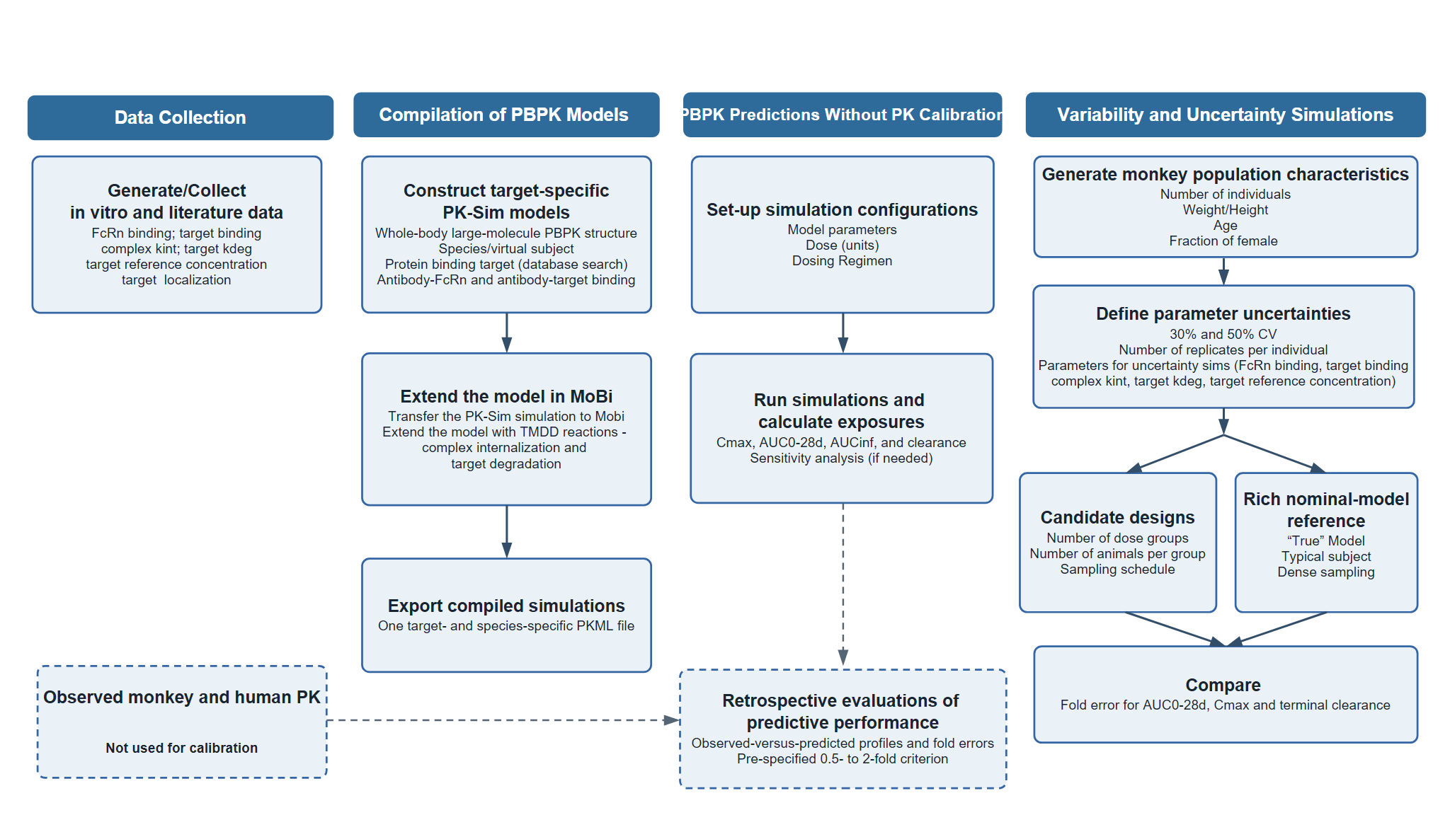

Figure 2. Observed and predicted plasma concentration-time profiles without calibration to the analyzed in vivo PK data across molecules and dose levels in (A) monkeys and (B) humans.
(A) Monkeys
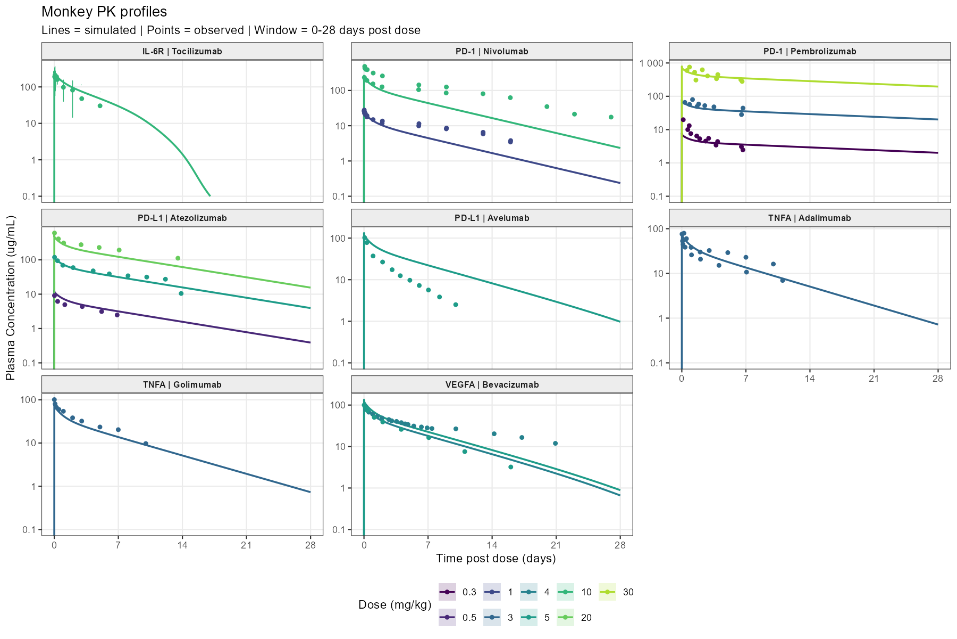

(B) Humans
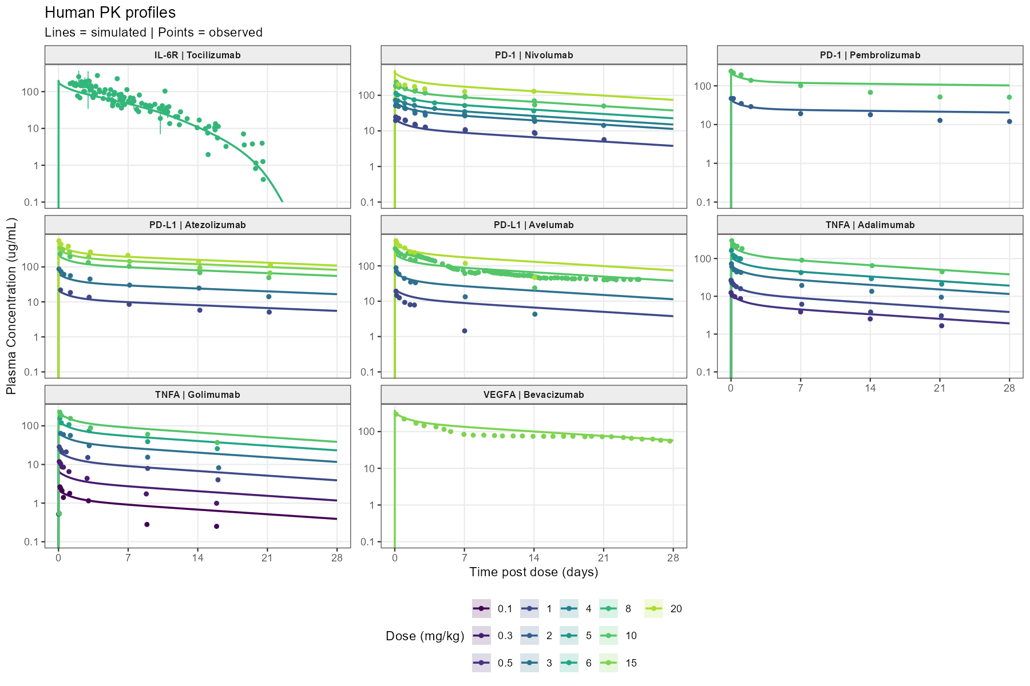

Figure 3. Fold errors from PBPK model predictions without calibrations with in vivo data. Directional fold errors are shown for AUC0–28d, Cmax, and clearance across the evaluated molecule–dose scenarios. Fold error was calculated as the predicted value divided by the observed value. Horizontal bars extend from the line of unity on a base-2 logarithmic scale; values below and above 1 indicate underprediction and overprediction, respectively. The shaded region and dashed lines denote the prespecified 0.5- to 2-fold acceptance interval. Models were not calibrated using in vivo pharmacokinetic data.
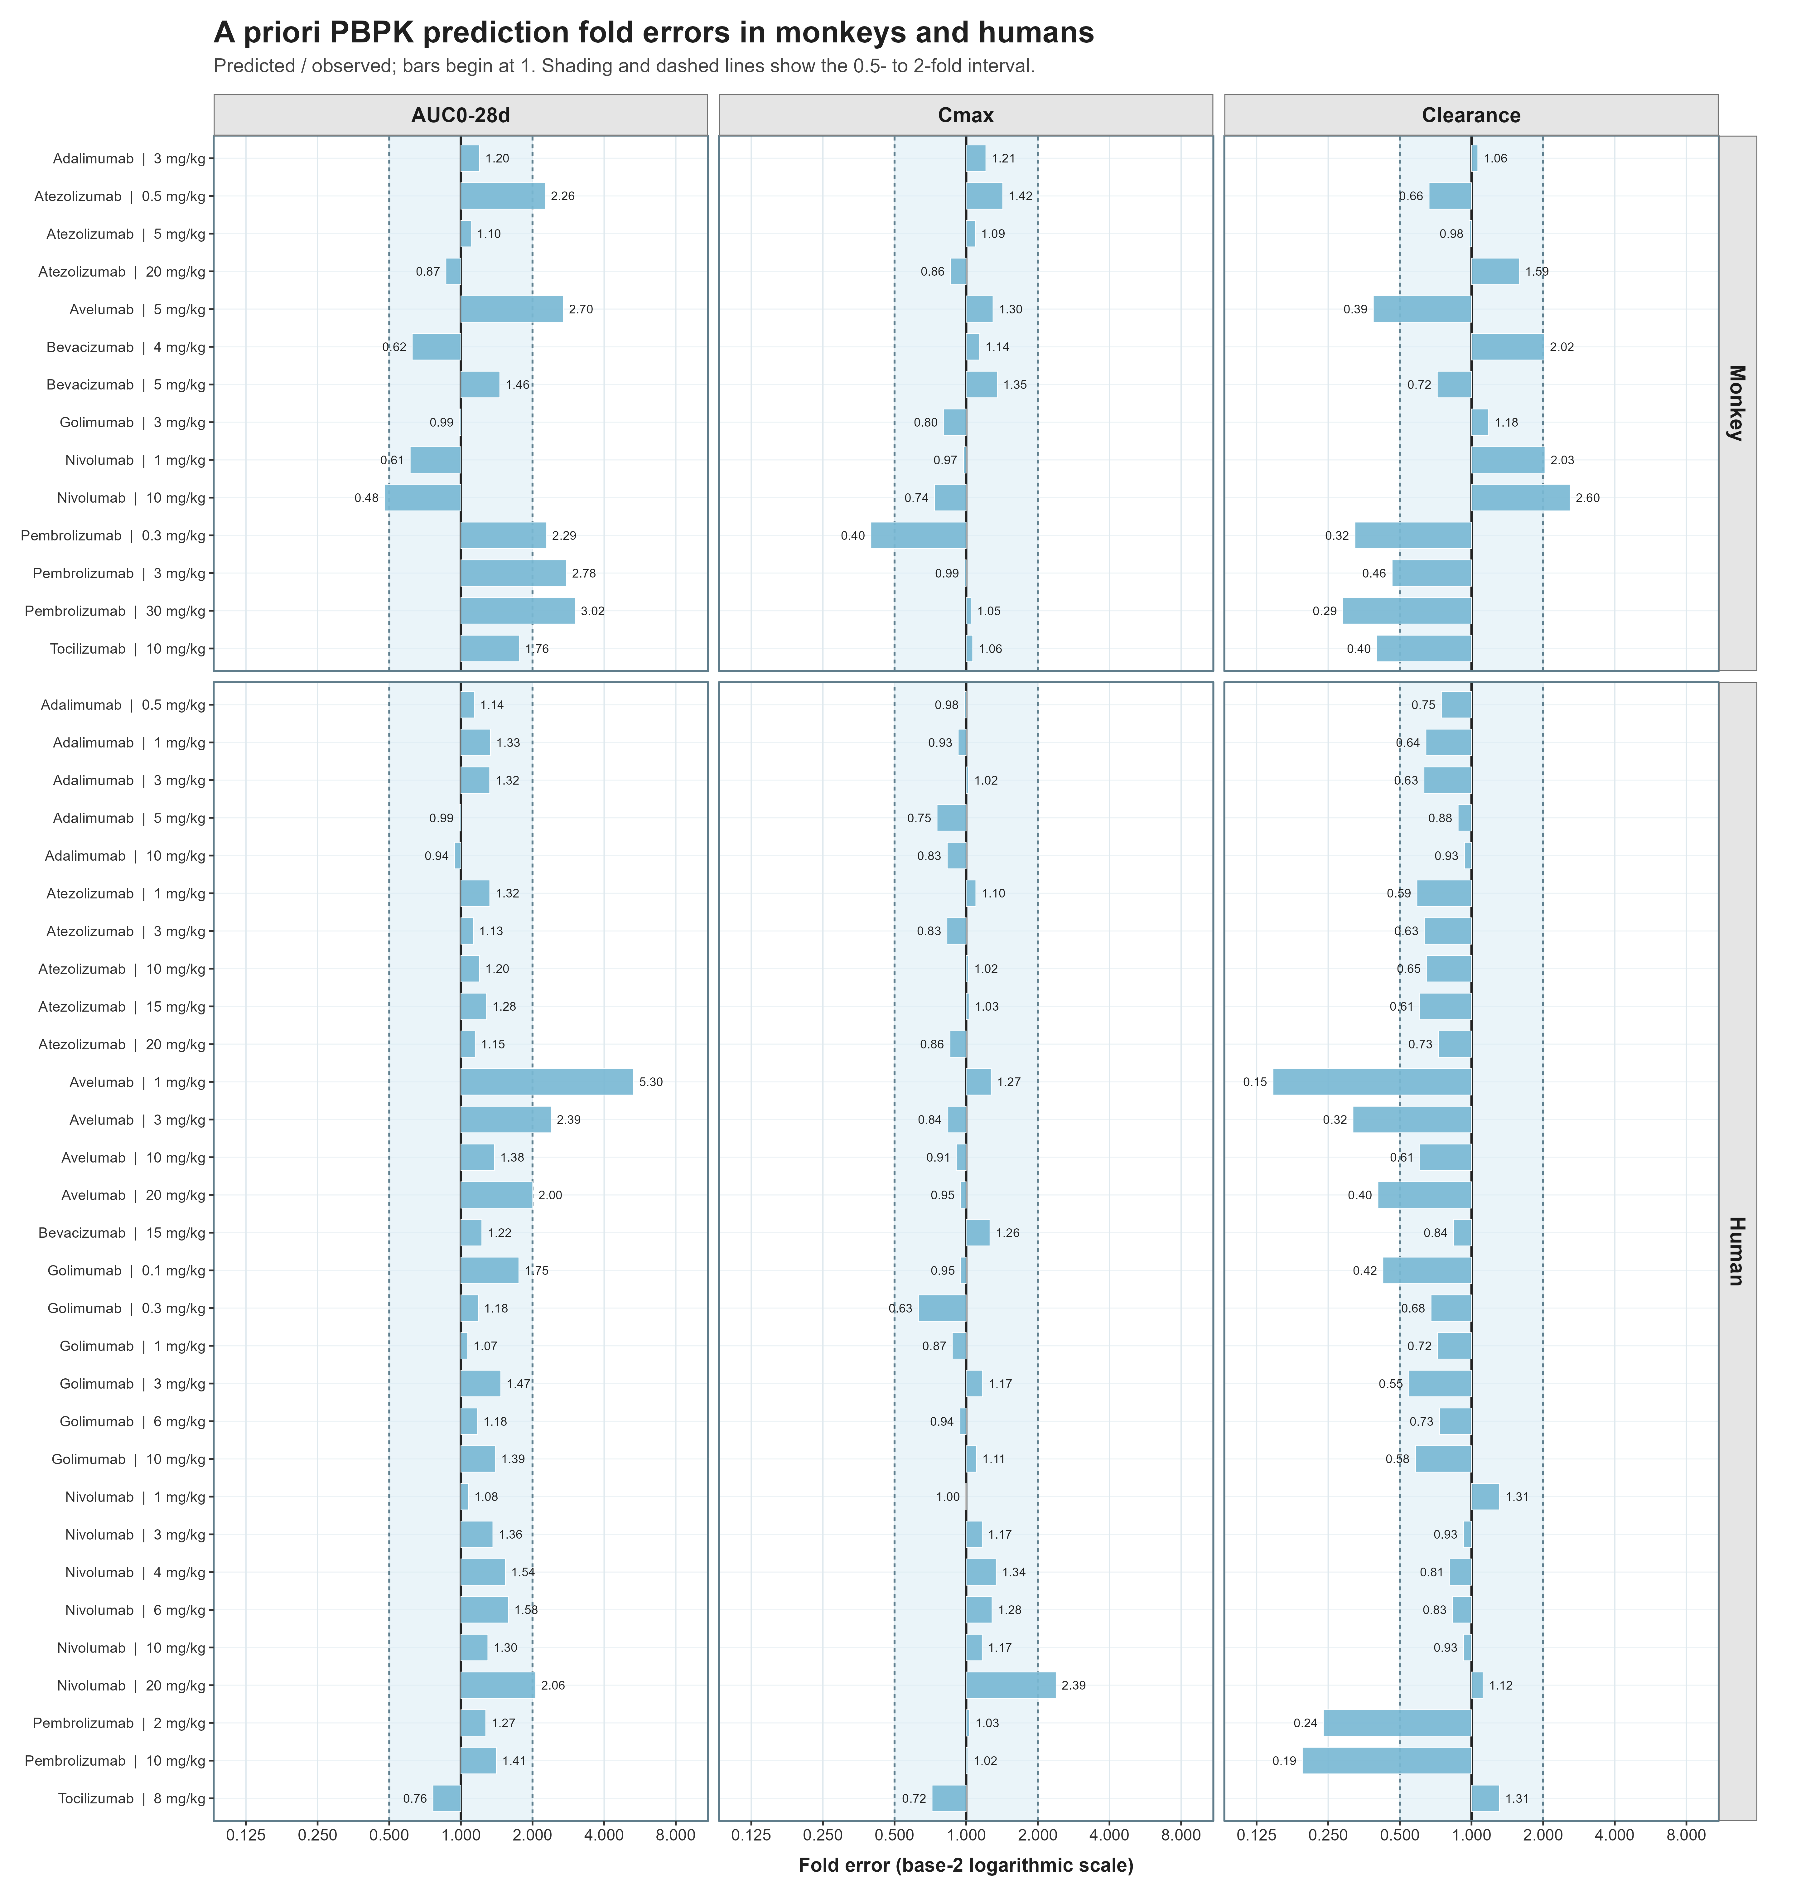

Figure 4. Fold errors for PK endpoints by number of dose groups and animals per group in the Golimumab study simulations. Dashed red lines mark the prespecified 0.5- to 2-fold interval.
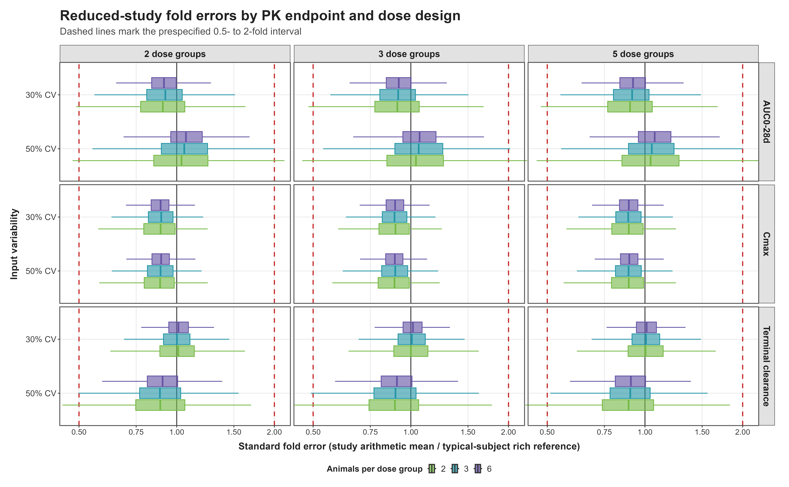

Figure 5. Illustrative PBPK-driven workflow for monoclonal antibody PK characterization with fewer animals. Molecule- and target-specific mechanistic inputs are integrated into PBPK models before in vivo PK testing. When remaining uncertainty warrants an in vivo study, PBPK predictions can inform a targeted exploratory single-dose design, and the resulting data can support model refinement and human exposure prediction. The animal counts are schematic examples rather than industry benchmarks; the modeled reduction applies to the compared single-dose PK designs, not to toxicology studies or the overall development program. FIH = first-in-human; PBPK = physiologically based pharmacokinetics.
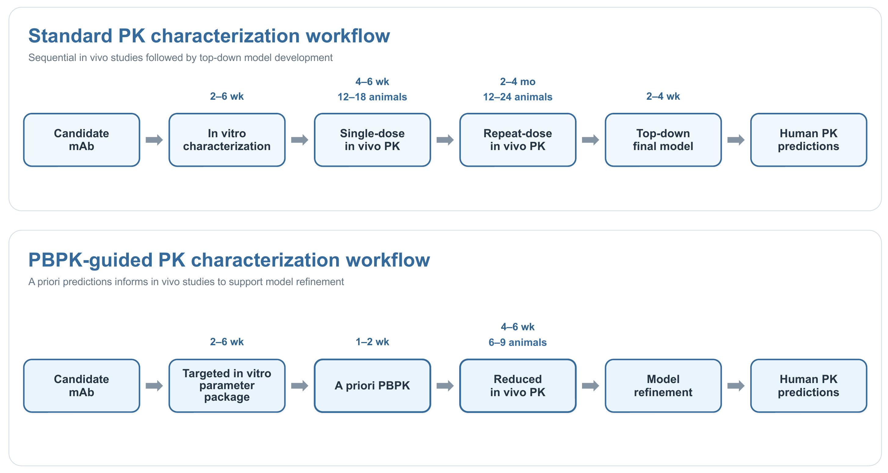

Supplementary Materials
Supplementary Material 1. Github link to fully reproducible project codes:
https://github.com/namlink-org/PBPK_mAb_NAM_Tutorial

Supplementary Material 2. Additional-Figures-Tables.docx

