**Bài thực hành 02 – Tuần 6, ngày 02/11/2021**

***Note:*** *Phần BTVN thiết kế Interface cho Usecase Rush Order em đã có làm và lồng ghép luôn vào các mục, chứ không tách riêng ra ạ.*

**Mục lục:**

I. Tạo các ảnh màn hình**:** 2

1. Splash screen: 2

2. Home screen: 3

3. View cart screen: 3

4. Delivery form: 4

5. Rush information form: 4

6. Invoice screen: 5

7. Payment form: 5

8. Result screen: 6

II. Tạo các dịch chuyển màn hình: 6

III. Mô tả các màn hình: 7

1. Splash screen: 7

2. Home screen: 7

3. View cart screen: 8

4. Delivery form: 9

5. Rush information form: 10

6. Invoice screen: 11

7. Payment form: 12

8. Result screen: 13

IV. Thiết kế giao diện hệ thống: 14

1. Tìm ra các subsystem: 14

2. Thiết kế interface cho subsystem: 15

3. Thiết kế Subsystem: 15

3.1. Sequence Diagram - UC: Pay Order 15

3.2. Sequence Diagram - UC: Refund 16

3.3. Sequence Diagram - UC: Get Balance 16

3.4. Document Subsystem Element 17

3.5. Describe Subsystem Dependencies 17

3.6. Checkpoints 18

# Tạo các ảnh màn hình**:**

## Splash screen:

## A screenshot of a computer Description automatically generated with medium confidenceHome screen:

## View cart screen:

## Delivery form:

## Rush information form:

## Invoice screen:

## Payment form:

## Result screen:

# Graphical user interface Description automatically generated with low confidenceTạo các dịch chuyển màn hình:

# Mô tả các màn hình:

## Splash screen:

|  |  |  |  |  |  |
| --- | --- | --- | --- | --- | --- |
| **AIMS Software** | | **Date of creation** | **Approved by** | **Reviewed by** | **Person in charge** |
| **Screen specification** | Splash screen | 04/11/2020 |  |  | Lê Nhật Nam |
|  | | **Control** | **Operation** | **Function** | |
| Area for display logo | Initial | Display the logo | |

## Home screen:

|  |  |  |  |  |  |
| --- | --- | --- | --- | --- | --- |
| **AIMS Software** | | **Date of creation** | **Approved by** | **Reviewed by** | **Person in charge** |
| **Screen specification** | Home screen | 02/11/2020 |  |  | Lê Nhật Nam |
|  | | **Control** | **Operation** | **Function** | |
| Search Box | Input | Display the text field for user to search | |
| Button Search | Click | Search for items by keywords and display them | |
| Icon Cart | Click | Display the number of items in cart, click to display cart | |
| Button Add to cart | Click | Add item to cart | |
| Area for display Avail | Initial | Display available quantity of each item | |
| Area for display Price | Initial | Display price of each item | |
| Spinner Quantity | Select | Enable user to select number of items to add | |
| Area for display Items | Initial | Display available items | |

***Định nghĩa các trường thuộc tính:***

|  |  |  |  |  |
| --- | --- | --- | --- | --- |
| **Item name** | **Number of bytes** | **Type** | **Field attribute** | **Remarks** |
| Search Box | 50 | String | Black | Left |
| Icon Cart | 4 | Number | Blue | Center |
| Spinner Quantity | 4 | Number | Black | Left |

## View cart screen:

|  |  |  |  |  |  |
| --- | --- | --- | --- | --- | --- |
| **AIMS Software** | | **Date of creation** | **Approved by** | **Reviewed by** | **Person in charge** |
| **Screen specification** | Home screen | 02/11/2020 |  |  | Lê Nhật Nam |
|  | | **Control** | **Operation** | **Function** | |
| Button Delete | Click | Delete item from cart | |
| Spinner Quantity | Select | Define the number of this item in cart | |
| Area for display Price | Initial | Display the price of this item | |
| Area for display Subtotal and amount | Initial | Display the subtotal and total amount of cart | |
| Button Place order | Click | Confirm to process place order | |

***Định nghĩa các trường thuộc tính:***

|  |  |  |  |  |
| --- | --- | --- | --- | --- |
| **Item name** | **Number of bytes** | **Type** | **Field attribute** | **Remarks** |
| Media Name | 50 | String | Blue | Left |
| Price | 20 | Number | Blue | Right |
| Subtotal and Amount | 20 | Number | Black | Left |
| Button Place order |  | Button | Red background, White text | Text center |

## Delivery form:

|  |  |  |  |  |  |
| --- | --- | --- | --- | --- | --- |
| **AIMS Software** | | **Date of creation** | **Approved by** | **Reviewed by** | **Person in charge** |
| **Screen specification** | Home screen | 02/11/2020 |  |  | Lê Nhật Nam |
|  | | **Control** | **Operation** | **Function** | |
| Textfield Name | Input | Enter user’s name | |
| Textfield Phone | Input | Enter user’s phone number | |
| Combobox Province/City | Select | Let user select the city/province they live in | |
| Textfield Address | Input | Enter user’s detailed address | |
| Textfield Shipping instructions | Input | Let user give notes or add requirements to the order | |
| Button Place rush order | Click | Process to Rush order form | |
| Button Confirm delivery | Click | Process to Invoice screen | |

***Định nghĩa các trường thuộc tính:***

|  |  |  |  |  |
| --- | --- | --- | --- | --- |
| **Item name** | **Number of bytes** | **Type** | **Field attribute** | **Remarks** |
| Textfields | 150 | String | Black | Left |
| Combobox Province/City | 50 | String | Black | Left |
| Button Place rush order |  | Button | Blue background, white text | Text center |
| Button Confirm delivery |  | Button | Red background, White text | Text center |

## Rush information form:

|  |  |  |  |  |  |
| --- | --- | --- | --- | --- | --- |
| **AIMS Software** | | **Date of creation** | **Approved by** | **Reviewed by** | **Person in charge** |
| **Screen specification** | Home screen | 02/11/2020 |  |  | Lê Nhật Nam |
|  | | **Control** | **Operation** | **Function** | |
| Area for display Items for rush order | Initial | Display items that are available for rush order | |
| Area for display Items not for rush order | Initial | Display items that are not available for rush order | |
| Combobox rush delivery time | Select | Let user select time in a day for rush order | |
| Textarea Rush instruction | Input | Let user note down additional rush instruction | |
| Button Submit | Click | Submit rush information | |

***Định nghĩa các trường thuộc tính:***

|  |  |  |  |  |
| --- | --- | --- | --- | --- |
| **Item name** | **Number of bytes** | **Type** | **Field attribute** | **Remarks** |
| Combobox rush delivery time | 50 | Number | Black | Left |
| Textarea Rush instruction | 500 | String | Black | Left |
| Button Submit | 50 | Button | Red background, white text | Text center |

## Invoice screen:

|  |  |  |  |  |  |
| --- | --- | --- | --- | --- | --- |
| **AIMS Software** | | **Date of creation** | **Approved by** | **Reviewed by** | **Person in charge** |
| **Screen specification** | Home screen | 02/11/2020 |  |  | Lê Nhật Nam |
|  | | **Control** | **Operation** | **Function** | |
| Area for display Name | Initial | Display user’s name | |
| Area for display Phone | Initial | Display user’s phone number | |
| Area for display Province/City | Initial | Display the city/province user lives in | |
| Area for display Address | Initial | Display user’s detailed address | |
| Area for display summary | Initial | Display final summary of the invoice | |
| Button Confirm order | Click | Confirm the invoice information | |
| Area for display Shipping instructions | Initial | Display additional shipping instructions | |

***Định nghĩa các trường thuộc tính:***

|  |  |  |  |  |
| --- | --- | --- | --- | --- |
| **Item name** | **Number of bytes** | **Type** | **Field attribute** | **Remarks** |
| Text labels | 150 | String | Black | Left |
| Subtotal and Shipping fee | 50 | String | Black | Right |
| Total | 50 | String | Red | Right |
| Button Submit |  | Button | Red background, White text | Text center |

## Payment form:

|  |  |  |  |  |  |
| --- | --- | --- | --- | --- | --- |
| **AIMS Software** | | **Date of creation** | **Approved by** | **Reviewed by** | **Person in charge** |
| **Screen specification** | Home screen | 02/11/2020 |  |  | Lê Nhật Nam |
|  | | **Control** | **Operation** | **Function** | |
| Radio button Payment method | Select | Let user select payment method | |
| Textfield Card number | Input | Enter user’s card number | |
| Textfield Card holder name | Input | Enter card’s holder name | |
| Textfield expiration date | Input | Enter card’s expiration date | |
| Textfield Card security code | Input | Enter card’s security code | |
| Button Confirm payment | Click | Confirm to process payment | |

***Định nghĩa các trường thuộc tính:***

|  |  |  |  |  |
| --- | --- | --- | --- | --- |
| **Item name** | **Number of bytes** | **Type** | **Field attribute** | **Remarks** |
| Radio button Payment method |  | Radio | Black |  |
| Textfields | 150 | String | Black | Left |
| Button Confirm payment |  | Button | Red background, White text | Text center |

## Result screen:

|  |  |  |  |  |  |
| --- | --- | --- | --- | --- | --- |
| **AIMS Software** | | **Date of creation** | **Approved by** | **Reviewed by** | **Person in charge** |
| **Screen specification** | Home screen | 02/11/2020 |  |  | Lê Nhật Nam |
|  | | **Control** | **Operation** | **Function** | |
| Area for display Payment result | Initial | Display payment result (Success or Fail) | |
| Area for display Message | Initial | Display additional payment message | |
| Button OK | Click | Click to confirm that payment is done | |

***Định nghĩa các trường thuộc tính:***

|  |  |  |  |  |
| --- | --- | --- | --- | --- |
| **Item name** | **Number of bytes** | **Type** | **Field attribute** | **Remarks** |
| Payment result | 50 | String | Green | Center |
| Message | 150 | String | Black | Left |
| Button OK |  | Button | Red background, White text | Text center |

# Thiết kế giao diện hệ thống:

## Tìm ra các subsystem:

## Thiết kế interface cho subsystem:

## Thiết kế Subsystem:

### Sequence Diagram - UC: Pay Order

### Sequence Diagram - UC: Refund

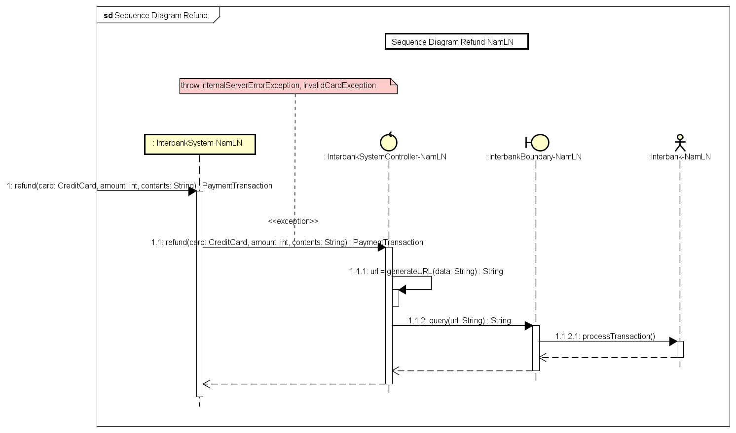

### Sequence Diagram - UC: Get Balance

### Document Subsystem Element

### Describe Subsystem Dependencies

### Checkpoints