Design UI

S

Data: <http://www.onthitoeic.vn/bai-2-hi%E1%BB%87n-t%E1%BA%A1i-d%C6%A1n-hi%E1%BB%87n-t%E1%BA%A1i-ti%E1%BA%BFp-di%E1%BB%85n/>

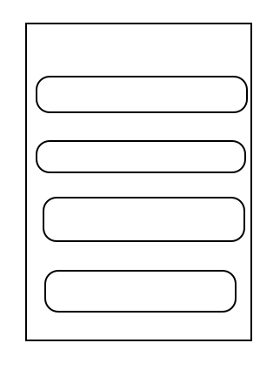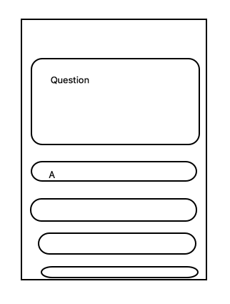

Design Data + Database

|  |
| --- |
| Lession 1 : Class for Learning part |
| - Id: Determy which lession it is  - Title: of the lession  - Content: html format |
|  |

🡺 Proplem : Show to show content

|  |
| --- |
| Question |
| Id Lession |
| QuestionContent |
| Id Question |

|  |
| --- |
| Answer |
| Id Question |
| Content |
| IsCorrect |
| Explant |