Qt Quick

* UI: qml/js
* Code behind: C++

Loại project sử dụng: Qt Quick Controls 2 Application

(Loại project được xây dựng sẵn một số control cơ bản, sẽ giúp cho quá trình xây dựng ứng dụng nhanh hơn!)

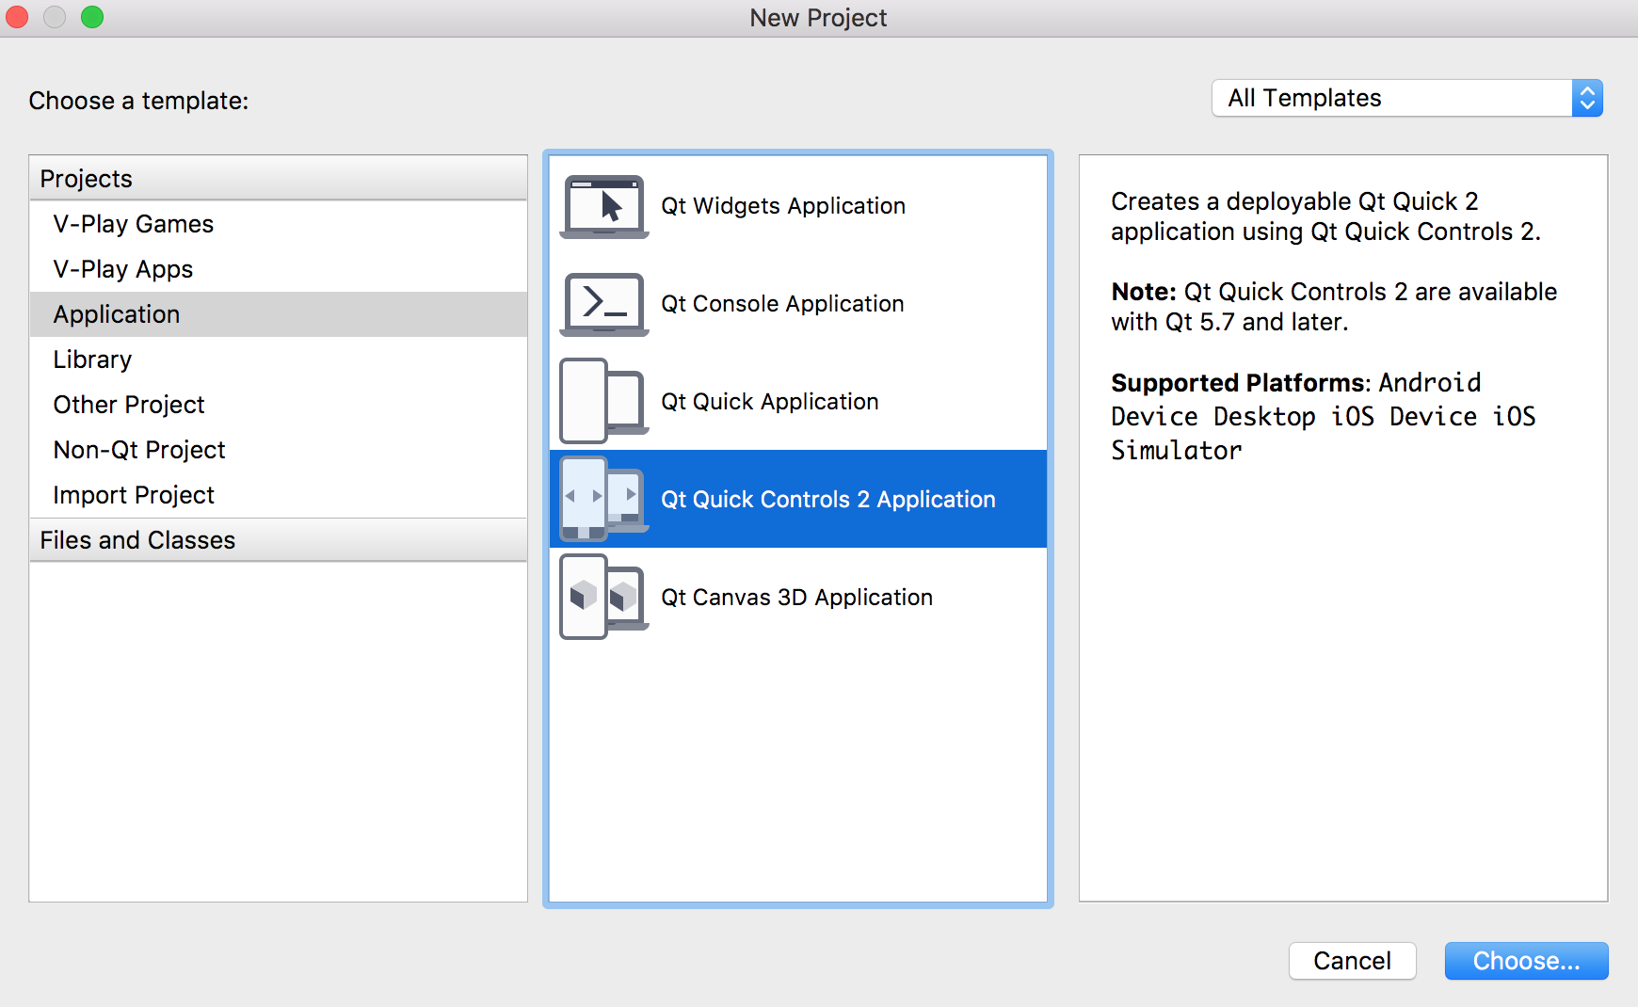

Phần 1: QML

Phần nhiều UI và các logic đơn giản sẽ được hoàn thiện bằng các file .qml

|  |
| --- |
| **//main.qml**  import QtQuick 2.7  import QtQuick.Controls 2.0  import QtQuick.Layouts 1.3  ApplicationWindow {  visible: true  width: 640  height: 480  title: *qsTr*("Hello World")  SwipeView {  id: *swipeView*  anchors.fill: *parent*  currentIndex: *tabBar*.currentIndex  Page1 {  }  Page {  Label {  text: *qsTr*("Second page")  anchors.centerIn: *parent*  }  }  }  footer: TabBar {  id: *tabBar*  currentIndex: *swipeView*.currentIndex  TabButton {  text: *qsTr*("First")  }  TabButton {  text: *qsTr*("Second")  }  }  } |

Cấu trúc của qml cũng gần giống json

|  |
| --- |
| TenControl {  TenThuocTinh: value  TenThuocTinh.SubThuocTinh: value  OtherControl {  }  }  TenThuocTinh: TenControl {  id: *tabBar*  } |

Tạo một button

|  |
| --- |
| Button{  id: *myFirstButton*  text: *qsTr*("Click Me")  } |

Main.qml

|  |
| --- |
| import QtQuick 2.7  import QtQuick.Controls 2.0  import QtQuick.Layouts 1.3  ApplicationWindow {  visible: true  width: 640/2  height: 1136/2  title: *qsTr*("Hello World")  Button{  id: *myFirstButton*  text: *qsTr*("Click Me")  }  } |

Result:

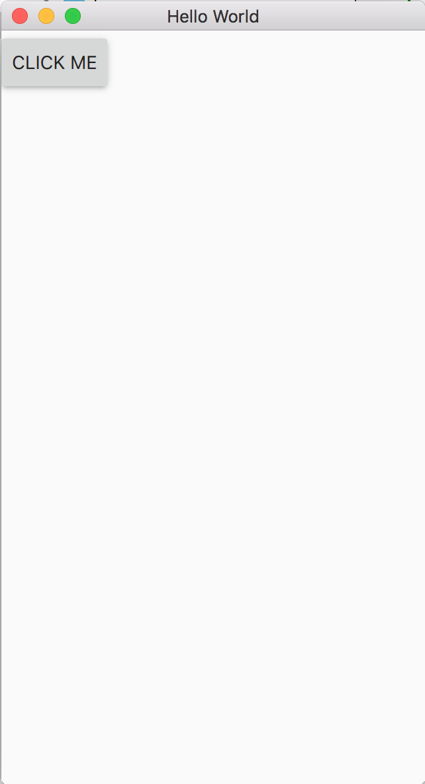

Ref

1. Các control có

|  |  |  |  |  |  |  |  |  |  |  |  |  |  |  |  |  |  |  |  |  |  |  |  |  |  |  |  |  |  |  |  |  |  |  |  |  |  |  |  |  |  |  |  |  |  |  |  |  |  |  |  |  |  |  |  |  |  |  |  |  |  |  |  |  |  |  |  |  |  |  |  |  |  |  |  |  |  |  |  |  |  |  |  |  |  |  |  |  |  |  |  |  |  |  |  |  |  |  |  |  |
| --- | --- | --- | --- | --- | --- | --- | --- | --- | --- | --- | --- | --- | --- | --- | --- | --- | --- | --- | --- | --- | --- | --- | --- | --- | --- | --- | --- | --- | --- | --- | --- | --- | --- | --- | --- | --- | --- | --- | --- | --- | --- | --- | --- | --- | --- | --- | --- | --- | --- | --- | --- | --- | --- | --- | --- | --- | --- | --- | --- | --- | --- | --- | --- | --- | --- | --- | --- | --- | --- | --- | --- | --- | --- | --- | --- | --- | --- | --- | --- | --- | --- | --- | --- | --- | --- | --- | --- | --- | --- | --- | --- | --- | --- | --- | --- | --- | --- | --- | --- | --- |
| QML Types   |  |  | | --- | --- | | [AbstractButton](https://doc.qt.io/qt-5/qml-qtquick-controls2-abstractbutton.html) | Abstract base type providing functionality common to buttons | | [ApplicationWindow](https://doc.qt.io/qt-5/qml-qtquick-controls2-applicationwindow.html) | Styled top-level window with support for a header and footer | | [BusyIndicator](https://doc.qt.io/qt-5/qml-qtquick-controls2-busyindicator.html) | Indicates background activity, for example, while content is being loaded | | [Button](https://doc.qt.io/qt-5/qml-qtquick-controls2-button.html) | Push-button that can be clicked to perform a command or answer a question | | [ButtonGroup](https://doc.qt.io/qt-5/qml-qtquick-controls2-buttongroup.html) | Mutually-exclusive group of checkable buttons | | [CheckBox](https://doc.qt.io/qt-5/qml-qtquick-controls2-checkbox.html) | Check button that can be toggled on or off | | [CheckDelegate](https://doc.qt.io/qt-5/qml-qtquick-controls2-checkdelegate.html) | Item delegate with a check indicator that can be toggled on or off | | [ComboBox](https://doc.qt.io/qt-5/qml-qtquick-controls2-combobox.html) | Combined button and popup list for selecting options | | [Container](https://doc.qt.io/qt-5/qml-qtquick-controls2-container.html) | Abstract base type providing functionality common to containers | | [Control](https://doc.qt.io/qt-5/qml-qtquick-controls2-control.html) | Abstract base type providing functionality common to all controls | | [DelayButton](https://doc.qt.io/qt-5/qml-qtquick-controls2-delaybutton.html) | Check button that triggers when held down long enough | | [Dial](https://doc.qt.io/qt-5/qml-qtquick-controls2-dial.html) | Circular dial that is rotated to set a value | | [Dialog](https://doc.qt.io/qt-5/qml-qtquick-controls2-dialog.html) | Popup dialog with standard buttons and a title, used for short-term interaction with the user | | [DialogButtonBox](https://doc.qt.io/qt-5/qml-qtquick-controls2-dialogbuttonbox.html) | A button box used in dialogs | | [Drawer](https://doc.qt.io/qt-5/qml-qtquick-controls2-drawer.html) | Side panel that can be opened and closed using a swipe gesture | | [Frame](https://doc.qt.io/qt-5/qml-qtquick-controls2-frame.html) | Visual frame for a logical group of controls | | [GroupBox](https://doc.qt.io/qt-5/qml-qtquick-controls2-groupbox.html) | Visual frame and title for a logical group of controls | | [ItemDelegate](https://doc.qt.io/qt-5/qml-qtquick-controls2-itemdelegate.html) | Basic item delegate that can be used in various views and controls | | [Label](https://doc.qt.io/qt-5/qml-qtquick-controls2-label.html) | Styled text label with inherited font | | [Menu](https://doc.qt.io/qt-5/qml-qtquick-controls2-menu.html) | Popup that can be used as a context menu or popup menu | | [MenuItem](https://doc.qt.io/qt-5/qml-qtquick-controls2-menuitem.html) | Presents an item within a Menu | | [MenuSeparator](https://doc.qt.io/qt-5/qml-qtquick-controls2-menuseparator.html) | Separates a group of items in a menu from adjacent items | | [Page](https://doc.qt.io/qt-5/qml-qtquick-controls2-page.html) | Styled page control with support for a header and footer | | [PageIndicator](https://doc.qt.io/qt-5/qml-qtquick-controls2-pageindicator.html) | Indicates the currently active page | | [Pane](https://doc.qt.io/qt-5/qml-qtquick-controls2-pane.html) | Provides a background matching with the application style and theme | | [Popup](https://doc.qt.io/qt-5/qml-qtquick-controls2-popup.html) | Base type of popup-like user interface controls | | [ProgressBar](https://doc.qt.io/qt-5/qml-qtquick-controls2-progressbar.html) | Indicates the progress of an operation | | [RadioButton](https://doc.qt.io/qt-5/qml-qtquick-controls2-radiobutton.html) | Exclusive radio button that can be toggled on or off | | [RadioDelegate](https://doc.qt.io/qt-5/qml-qtquick-controls2-radiodelegate.html) | Exclusive item delegate with a radio indicator that can be toggled on or off | | [RangeSlider](https://doc.qt.io/qt-5/qml-qtquick-controls2-rangeslider.html) | Used to select a range of values by sliding two handles along a track | | [RoundButton](https://doc.qt.io/qt-5/qml-qtquick-controls2-roundbutton.html) | A push-button control with rounded corners that can be clicked by the user | | [ScrollBar](https://doc.qt.io/qt-5/qml-qtquick-controls2-scrollbar.html) | Vertical or horizontal interactive scroll bar | | [ScrollIndicator](https://doc.qt.io/qt-5/qml-qtquick-controls2-scrollindicator.html) | Vertical or horizontal non-interactive scroll indicator | | [ScrollView](https://doc.qt.io/qt-5/qml-qtquick-controls2-scrollview.html) | Scrollable view | | [Slider](https://doc.qt.io/qt-5/qml-qtquick-controls2-slider.html) | Used to select a value by sliding a handle along a track | | [SpinBox](https://doc.qt.io/qt-5/qml-qtquick-controls2-spinbox.html) | Allows the user to select from a set of preset values | | [StackView](https://doc.qt.io/qt-5/qml-qtquick-controls2-stackview.html) | Provides a stack-based navigation model | | [SwipeDelegate](https://doc.qt.io/qt-5/qml-qtquick-controls2-swipedelegate.html) | Swipable item delegate | | [SwipeView](https://doc.qt.io/qt-5/qml-qtquick-controls2-swipeview.html) | Enables the user to navigate pages by swiping sideways | | [Switch](https://doc.qt.io/qt-5/qml-qtquick-controls2-switch.html) | Button that can be toggled on or off | | [SwitchDelegate](https://doc.qt.io/qt-5/qml-qtquick-controls2-switchdelegate.html) | Item delegate with a switch indicator that can be toggled on or off | | [TabBar](https://doc.qt.io/qt-5/qml-qtquick-controls2-tabbar.html) | Allows the user to switch between different views or subtasks | | [TabButton](https://doc.qt.io/qt-5/qml-qtquick-controls2-tabbutton.html) | Button with a look suitable for a TabBar | | [TextArea](https://doc.qt.io/qt-5/qml-qtquick-controls2-textarea.html) | Multi-line text input area | | [TextField](https://doc.qt.io/qt-5/qml-qtquick-controls2-textfield.html) | Single-line text input field | | [ToolBar](https://doc.qt.io/qt-5/qml-qtquick-controls2-toolbar.html) | Container for context-sensitive controls | | [ToolButton](https://doc.qt.io/qt-5/qml-qtquick-controls2-toolbutton.html) | Button with a look suitable for a ToolBar | | [ToolSeparator](https://doc.qt.io/qt-5/qml-qtquick-controls2-toolseparator.html) | Separates a group of items in a toolbar from adjacent items | | [ToolTip](https://doc.qt.io/qt-5/qml-qtquick-controls2-tooltip.html) | Provides tool tips for any control | | [Tumbler](https://doc.qt.io/qt-5/qml-qtquick-controls2-tumbler.html) | Spinnable wheel of items that can be selected | |