
Cloud Based Attendance And Leave Management System
(CBAMLS)

Sem End Project Report

Cloud Infrastructure Design-23SDCS16A
Department of Computer Science and Engineering
By
2300033899 – Kurapati Raja Sai Nammalwar
2300031093 – Kedarisetti Krishna Chaitanya
2300031717 – Pinnaka Lakshmi Sandeep

under the supervision of
Suneetha Bandeela
Assistant Professor

Koneru Lakshmaiah Education Foundation
(Deemed to be University estd., u/s 3 of UGC Act 1956)
Green Fields, Vaddeswaram, Guntur (Dist.), Andhra Pradesh – 522302
March, 2026

Koneru Lakshmaiah Education Foundation
(Deemed to be University estd., u/s 3 of UGC Act 1956)
Green Fields, Vaddeswaram, Guntur (Dist.), Andhra Pradesh – 522302

CONTENTS
I. Abstract 4
II. Introduction 5
III. Literature Review 6
Project Objectives
The CBALMS project encompasses several strategic objectives designed to deliver comprehensive workforce management capabilities:
4.1 Problem Statement 7
V. Technical Implementation 8
5.1 AWS Services Used 8
5.2 System Architecture
CBALMS implements a well-structured client-server architecture that promotes scalability, maintainability, and clear separation of concerns. This architectural pattern has been proven effective for modern web applications and provides a solid foundation for the system's current functionality and future enhancements.
VI. Analysis & Problem-Solving 10
6.1 Setup Procedures
The implementation of CBALMS required careful configuration of cloud infrastructure components and application services.
6.2 Simulation and Testing
Comprehensive testing procedures were executed to validate system functionality, performance characteristics, and reliability under various conditions:
VII. Discussions & Results 15
7.1 Use Cases and Application Scenarios
CBALMS is designed to address diverse workforce management needs across various organizational contexts. The following use cases illustrate the system's applicability in real-world scenarios:
VIII. Conclusion 16
IX. Future Work 16

LIST OF FIGURES
Figure No | Title of the image
1 | System Architecture of CBALMS
2 | EC2 Instance for Backend
3 | Supabase Database table for CBALMS
4 | S3 Bucket for Storing the images of the users

I.Abstract

The cloud-Based Attendance and Leave Management System (CBALMS) represents a comprehensive full-stack web application meticulously designed to digitize, streamline, and modernize employee attendance and leave management processes within organizational environments. In today's rapidly evolving corporate landscape, traditional systems that rely on manual spreadsheets, paper-based records, or fragmented digital tools have become increasingly inefficient, error-prone, and incapable of providing real-time visibility into workforce operations. These conventional approaches often result in data inconsistencies, delayed approvals, and significant administrative overhead that can impede organizational productivity and employee satisfaction.

CBALMS provides a robust, centralized platform that serves as a single source of truth for all attendance and leave-related activities. Through this intuitive system, employees can effortlessly mark their attendance, submit leave applications with detailed justifications, track their attendance history, and manage their personal profiles with ease. Simultaneously, administrators and human resources personnel gain powerful tools to monitor attendance patterns across the organization, review and approve leave requests through streamlined workflows, generate comprehensive analytical reports, and maintain compliance with organizational policies.

II. Introduction
In contemporary organizational environments, effective workforce management has emerged as a critical determinant of sustained productivity, regulatory compliance, and overall business success. As organizations scale and workforce dynamics become increasingly complex, the ability to accurately track employee attendance, manage leave entitlements, and maintain comprehensive records has taken on heightened strategic importance. Traditional attendance and leave management systems, which frequently depend on manual data entry, spreadsheet-based tracking, or disjointed software tools, inherently suffer from numerous limitations that can severely impact organizational efficiency.

CBALMS directly addresses these pervasive challenges by delivering a unified, fully automated, and intuitively designed system specifically engineered for managing attendance and leave workflows with unprecedented efficiency. The platform empowers employees with self-service capabilities, enabling them to easily check in and out through multiple interfaces, apply for various types of leave with automated eligibility checking, and maintain comprehensive visibility into their attendance records and leave balances. Concurrently, administrators benefit from powerful dashboard interfaces that facilitate efficient monitoring of workforce data, rapid decision-making through automated approval workflows, and access to rich analytical insights that support strategic workforce planning initiatives.

The system fundamentally eliminates the need for manual intervention in routine attendance and leave processes, dramatically reducing administrative overhead while ensuring real-time data accuracy and consistency. By leveraging secure, scalable cloud-based infrastructure and modern web technologies, CBALMS provides organizations with a reliable platform that grows with their needs. The architecture ensures high availability, data integrity, and seamless user experiences across diverse devices and locations, making it particularly well-suited for today's distributed and hybrid work environments.

III. Literature Review
Workforce management systems have undergone substantial transformation over the past decade, driven largely by the widespread adoption of cloud computing paradigms and advanced web technologies. Contemporary solutions in this domain increasingly emphasize automation capabilities, real-time data processing, and centralized control mechanisms that enable organizations to manage their human resources more effectively. The evolution from standalone, on-premise installations to cloud-native architectures has democratized access to sophisticated workforce management capabilities, allowing organizations of all sizes to benefit from enterprise-grade features without prohibitive infrastructure investments.

Frontend Technology Stack
The presentation layer of CBALMS is implemented using a carefully selected set of modern frontend technologies:

CBALMS strategically builds upon these established technological principles by synthesizing modern frontend frameworks, well-architected backend APIs, and cloud-based database services into a cohesive, scalable workforce management solution. The system's design reflects contemporary best practices in web application development, incorporating principles of separation of concerns, state management, and API-driven architecture. By leveraging these proven technologies and patterns, CBALMS delivers a solution that is not only functionally comprehensive but also technically robust, maintainable, and positioned for future enhancement and scaling.

Project Scope

The CBALMS system is architected to support two primary user roles, each with carefully designed functionality sets that address their specific operational needs:
The primary objective of this project is to design, develop, and implement a comprehensive, serverless, event-driven system capable of automatically detecting and remediating infrastructure failures within AWS cloud environments. While the core focus remains on attendance and leave management functionality, the technical implementation explores advanced cloud-native patterns that ensure high availability, fault tolerance, and operational resilience. The system aims to substantially reduce manual intervention requirements, minimize potential downtime through proactive monitoring and automated responses, and provide stakeholders with real-time visibility into infrastructure health through sophisticated notification mechanisms. This dual-focus approach ensures that the application layer delivers excellent user experiences while the underlying infrastructure maintains enterprise-grade reliability.

4.1 Problem Statement
Manual attendance and leave management systems inherently suffer from a multitude of inefficiencies that can significantly impact organizational operations. These include persistent data inconsistency issues arising from multiple data entry points, substantial delays in approval workflows due to manual routing and dependency on individual availability, and a general lack of transparency that can lead to employee dissatisfaction and disputes. Additionally, paper-based or spreadsheet-dependent systems are vulnerable to data loss, difficult to audit, and incapable of providing the analytical insights necessary for strategic decision-making. These issues collectively contribute to productivity losses, increased administrative burden on HR personnel, and potential compliance risks.
CBALMS comprehensively solves these pervasive problems by offering a fully digital, highly automated, and inherently scalable solution that ensures exceptional accuracy, complete transparency, and remarkable efficiency in workforce management operations. The system replaces fragmented manual processes with integrated digital workflows, establishes a single source of truth for all attendance and leave data, and provides stakeholders with real-time visibility into process status. By automating routine tasks and enforcing consistent business rules, CBALMS eliminates the errors and delays associated with manual processing while creating an audit trail that supports compliance requirements.

Objectives
- Develop a centralized attendance and leave management system
- Automate employee attendance tracking and leave workflows
- Provide role-based access for employees and administrators
- Ensure secure authentication and data handling
- Enable real-time notifications and reporting
Scope
The system supports two main roles:
- Employees: The employee role provides comprehensive self-service capabilities including intuitive attendance marking through multiple interfaces (web dashboard, mobile-responsive design), streamlined leave application processes with automated eligibility validation and attachment support, and complete profile management functionality allowing users to maintain their personal information, contact details, and preferences. Employees can view their attendance history, track leave balances, monitor application status in real-time, and receive automated notifications regarding approvals or requests for additional information.
- Administrators and HR Personnel: The administrative role provides powerful oversight and management capabilities including comprehensive leave approval workflows with configurable multi-level approval chains, real-time attendance monitoring across individuals, teams, or entire departments through intuitive dashboard interfaces, and sophisticated report generation tools that support various export formats and scheduling options. Administrators can configure system policies, manage user accounts, handle exception cases, generate compliance reports, and access analytical insights that support strategic workforce planning decisions.

V. Technical Implementation

The CBALMS system is built upon a modern, layered architecture that leverages industry-standard technologies and best practices to deliver a robust, scalable, and maintainable solution. The technical implementation encompasses three primary layers: the presentation layer (frontend), the application layer (backend), and the data layer (database and authentication services). Each layer is designed with specific responsibilities, ensuring clear separation of concerns and facilitating independent evolution of system components.
Frontend
- React (SPA architecture)
- React Router (navigation)
- Bootstrap (UI design)
- Axios (API communication)
Backend Technology Stack
The application layer provides robust API services and business logic processing:
- Node.js + Express (REST API)
- Middleware: Helmet, CORS, rate limiting, Joi validation
Database and Authentication Infrastructure
The data layer ensures secure, reliable persistence and identity management:
- Supabase (PostgreSQL + Auth)
- JWT-based authentication

5.2 System Architecture

The CBALMS architecture comprises three primary components that work in concert to deliver seamless user experiences:

Frontend Layer (React-based Single Page Application): The frontend component is responsible for rendering intuitive user interfaces, managing application state, handling user interactions, and communicating with backend services through well-defined APIs. The React-based implementation enables component reusability, efficient rendering through virtual DOM, and a responsive user experience that adapts to various device form factors.

Backend Layer (Express.js REST API): The backend component encapsulates all business logic, request validation, authentication verification, and database operations. Implemented as a stateless REST API, this layer processes incoming requests, enforces business rules, ensures data integrity, and returns appropriate responses to frontend consumers. The middleware architecture enables cross-cutting concerns such as security, logging, and error handling to be implemented consistently.

Data Layer (Supabase Platform): The data layer leverages Supabase's integrated platform capabilities, combining PostgreSQL's powerful relational database features with comprehensive authentication and authorization services. This layer ensures data persistence, maintains referential integrity, manages user identities, and enforces access controls at the database level.

Illustrative Data Flow: Leave Request Processing

To illustrate how these architectural components interact, consider the following typical leave request workflow:

Step 1 - Request Initiation: The employee accesses the CBALMS interface through their web browser, navigates to the leave application section, completes the required fields (leave type, date range, reason), and submits the request. The frontend validates the input format and completeness before proceeding.

Step 2 - Authenticated API Communication: The frontend application constructs an HTTP POST request containing the leave request data and includes a JSON Web Token (JWT) in the Authorization header. This token, obtained during authentication, enables the backend to verify the user's identity and permissions.

Step 3 - Server-Side Processing: Upon receiving the request, the backend middleware validates the JWT signature and expiration, extracts user claims, and routes the request to the appropriate handler. The business logic layer validates the request against organizational policies (leave balance verification, blackout date checks, approval hierarchy requirements), prepares the data for persistence, and executes the database transaction.

Step 4 - Data Persistence: The backend service interacts with the Supabase database to insert the leave request record, update related tables (such as leave balance tracking), and ensure all changes are committed atomically. Database triggers may automatically populate audit fields and initiate notification workflows.

Step 5 - Notification and Response: Upon successful database commit, the backend triggers notification services to alert relevant administrators of the pending approval request. A success response, including the generated request identifier and status, is returned to the frontend, which updates the user interface to reflect the submitted status and provides confirmation to the employee.

AWS Cloud Architecture of CBALMS

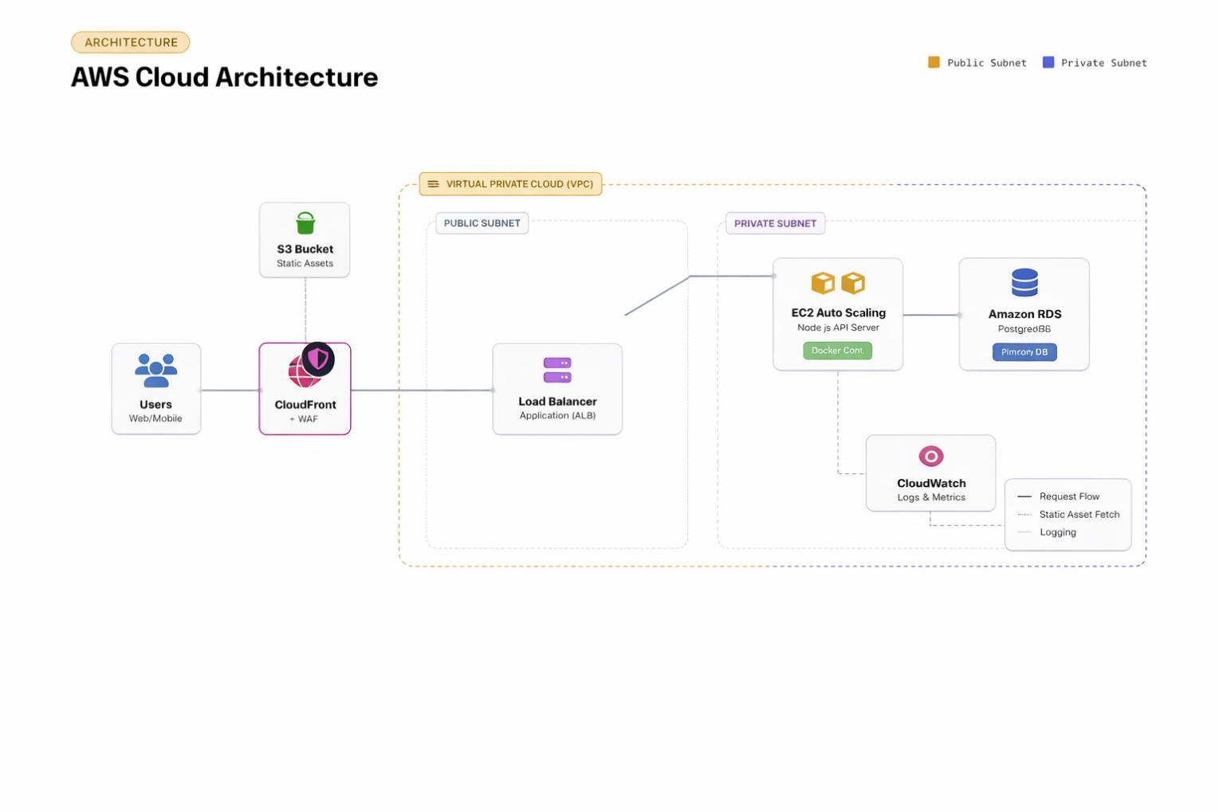

VI. Analysis & Problem-Solving

This section details the systematic approach undertaken to implement, configure, and validate the CBALMS infrastructure and application components. The analysis and problem-solving methodology encompassed environment setup, service configuration, integration testing, and performance validation to ensure the system meets functional requirements and operational standards.

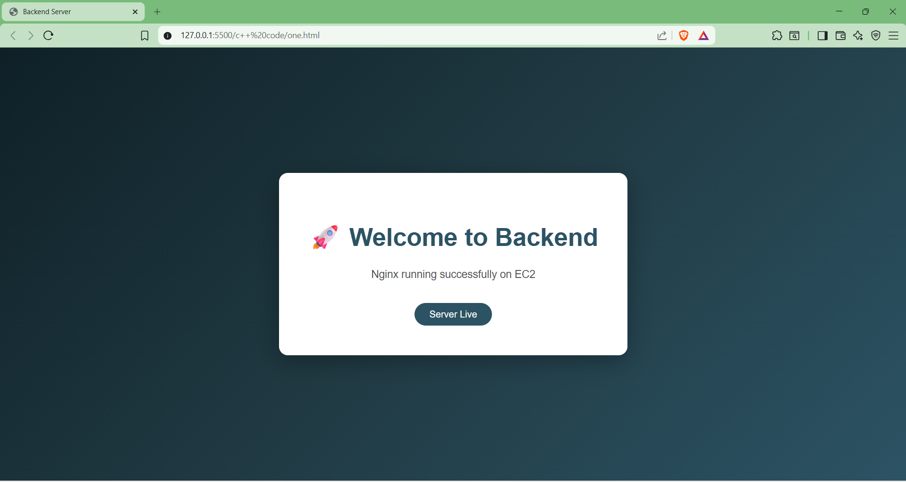

This is the backend file for the EC-2 instance that is running in the AWS which has the node js backend running.

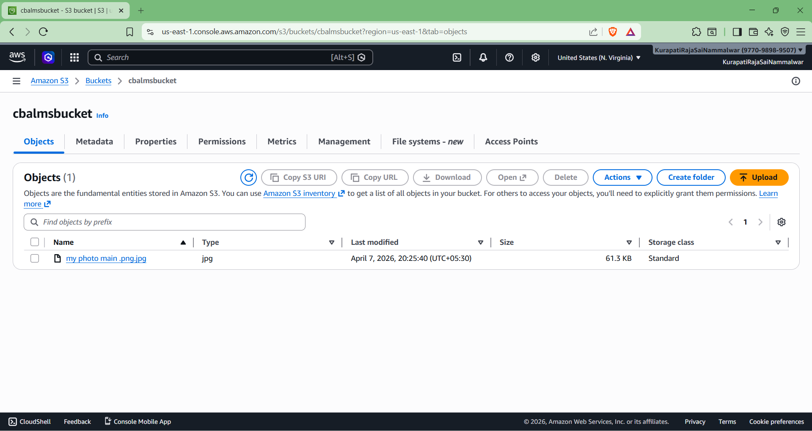

This is the Bucket that the users will upload their profile photos and other static data.

DB table schema

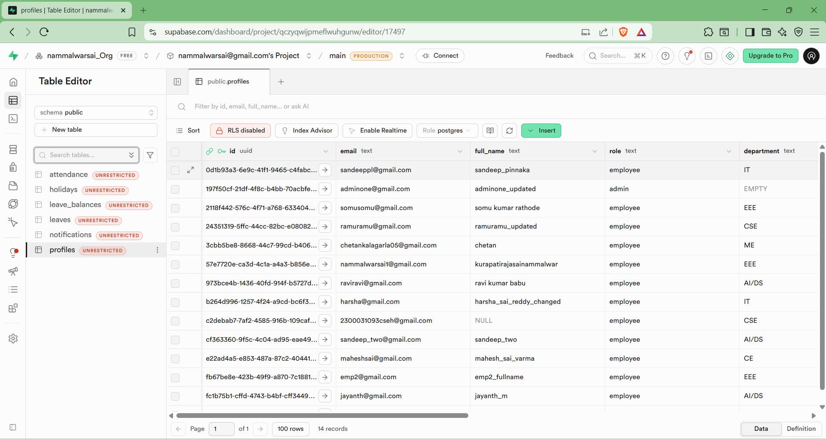

This is the List of tables of the CBALMS in Supabase Database

6.2 Simulation and Testing
- API Endpoint Validation: All REST API endpoints were subjected to rigorous testing using representative sample requests covering normal operations, edge cases, and error conditions. Test scenarios included valid and invalid authentication tokens, malformed request payloads, boundary value testing for date ranges and numeric fields, and concurrent request handling to verify thread safety and data consistency.
- Authentication and Authorization Testing: The JWT-based authentication mechanism underwent thorough validation including token generation, signature verification, expiration handling, and role-based access control enforcement. Tests verified that protected endpoints correctly reject unauthenticated requests, validate token integrity, and enforce permission boundaries based on user roles.
- Business Workflow Verification: End-to-end testing of attendance marking and leave management workflows confirmed that all business rules are correctly implemented. Test cases covered complete workflow lifecycles from initial submission through approval or rejection, ensuring proper state transitions, notification delivery, and data consistency throughout the process.
- Access Control Validation: The role-based access control system was validated to ensure that employees can only access their own data and permitted functions, while administrators have appropriate oversight capabilities. Tests confirmed proper isolation between user contexts and enforcement of permission constraints.
- Performance and Scalability Testing: System performance was evaluated under load conditions with large datasets to verify pagination functionality, query optimization, and response time consistency. Tests confirmed that the system maintains acceptable performance characteristics even as data volumes grow.

VII. Discussions & Results

The CBALMS system was successfully implemented, deployed, and subjected to comprehensive testing protocols. The evaluation results demonstrate that the system achieves its design objectives and delivers significant value across multiple dimensions of workforce management.
The CBALMS system was successfully implemented and subjected to rigorous testing protocols. The evaluation results demonstrate the following key achievements:
- Accurate and Reliable Attendance Tracking: The system consistently records attendance events with high precision, eliminating the data entry errors common in manual systems. Real-time synchronization ensures that attendance data is immediately available for reporting and analysis, while audit trails maintain complete historical records for compliance purposes.
- Streamlined Leave Management Workflows: The automated leave application and approval process has significantly reduced processing times from days to hours. Configurable approval hierarchies adapt to organizational structures, while automated notifications keep all stakeholders informed of status changes without manual intervention.
- Robust Security Implementation: The authentication and authorization mechanisms provide enterprise-grade security without compromising user experience. JWT-based session management ensures stateless, scalable authentication, while role-based access controls enforce appropriate data visibility and functional permissions.
- Real-Time Communication Capabilities: The notification system delivers timely updates to users through multiple channels, ensuring that important events (approvals, rejections, policy reminders) are communicated promptly. This real-time capability enhances user engagement and reduces uncertainty in workflow processes.

7.1 Use Cases
- Human Resources Department Optimization: HR teams leverage CBALMS to transform their attendance management operations from administrative burden to strategic function. The system automates routine tracking tasks, provides analytical insights into attendance patterns, facilitates compliance reporting, and enables HR professionals to focus on employee engagement and development initiatives rather than paperwork processing.
- Digital Transformation for Traditional Organizations: Organizations currently dependent on spreadsheet-based tracking or paper records can implement CBALMS to achieve immediate operational improvements. The transition eliminates version control issues, reduces data entry duplication, prevents loss of historical records, and establishes a foundation for data-driven workforce decisions.
- Distributed and Remote Workforce Management: For organizations with remote employees, distributed teams, or multiple office locations, CBALMS provides a centralized platform that ensures consistent attendance policies across all work arrangements. The web-based interface enables access from any location, while the underlying infrastructure supports concurrent usage across geographic boundaries.
- Regulatory Compliance and Audit Support: Organizations subject to labor regulations or internal audit requirements benefit from CBALMS's comprehensive reporting capabilities. The system maintains detailed audit trails, supports custom report generation for specific compliance frameworks, and provides historical data retention that satisfies regulatory requirements.

VIII. Conclusion

The Cloud-Based Attendance and Leave Management System represents a significant advancement in workforce management technology, successfully addressing the limitations of traditional approaches while leveraging modern cloud-native architectures and development practices.

CBALMS stands as a scalable, efficient, and feature-complete workforce management solution that successfully digitizes attendance and leave processes from end to end. By thoughtfully integrating modern web technologies—including React for the frontend, Node.js/Express for backend services, and Supabase for data persistence—the system provides a secure, reliable, and intuitively user-friendly platform that meets the needs of both employees and administrators. The architecture's modular design ensures that the system can evolve with changing requirements while maintaining operational stability.

The implementation of CBALMS delivers measurable benefits across multiple organizational dimensions. Manual effort associated with attendance tracking and leave processing is dramatically reduced through workflow automation. Data accuracy improves through elimination of transcription errors and enforcement of validation rules. Organizational productivity enhances as employees and administrators redirect time from administrative tasks to value-creating activities. The system's modular architecture, with clear separation between presentation, application, and data layers, facilitates both horizontal scalability to support growing user bases and vertical extensibility to incorporate new features and integrations.

IX. Future Work and Enhancement Opportunities

While CBALMS successfully delivers core workforce management functionality, several enhancement opportunities have been identified for future development iterations. These potential improvements would extend the system's capabilities and address emerging organizational needs:
- Enhanced Authentication and Security Features: Future development will implement self-service password reset functionality to reduce administrative support burden. Additional authentication options, including multi-factor authentication (MFA), social login integration, and single sign-on (SSO) capabilities, will provide organizations with flexible security configurations that align with their existing identity management infrastructure.
- Comprehensive Test Automation: Investment in automated testing infrastructure, including unit tests for individual components, integration tests for API endpoints and service interactions, and end-to-end tests for critical user workflows, will improve code quality, accelerate development cycles, and reduce regression risks during future enhancements.
- Administrative Audit Logging: Implementation of comprehensive audit logging for all administrative actions will provide organizations with visibility into system configuration changes, policy modifications, and sensitive data access. This capability supports compliance requirements and enables forensic analysis when needed.
- Advanced Reporting and Analytics: Expansion of reporting capabilities to include predictive analytics, trend identification, and customizable dashboard widgets will transform raw attendance data into actionable business intelligence. Integration with business intelligence tools and support for automated report scheduling will further enhance the system's analytical value.
- Containerization and DevOps Integration: Migration to containerized deployment using Docker and orchestration platforms will improve deployment consistency and scalability. Implementation of continuous integration and continuous deployment (CI/CD) pipelines will automate testing, building, and deployment processes, accelerating feature delivery while maintaining quality standards.

