PLACEMENT TEST – SPEAKING
GRADE 3 – GRADE 4 (15 minutes)
Part I. Introduction (3 points)
1. What do you like to do in your free time? (1 point)
2. Do you have any hobbies? Can you tell me about one of them? (1 point)
3. What do you usually do after school? (1 point)

Part II. Ask and aswer about the pictures. (7 points)
Picture 1. Find the differences (4 points)
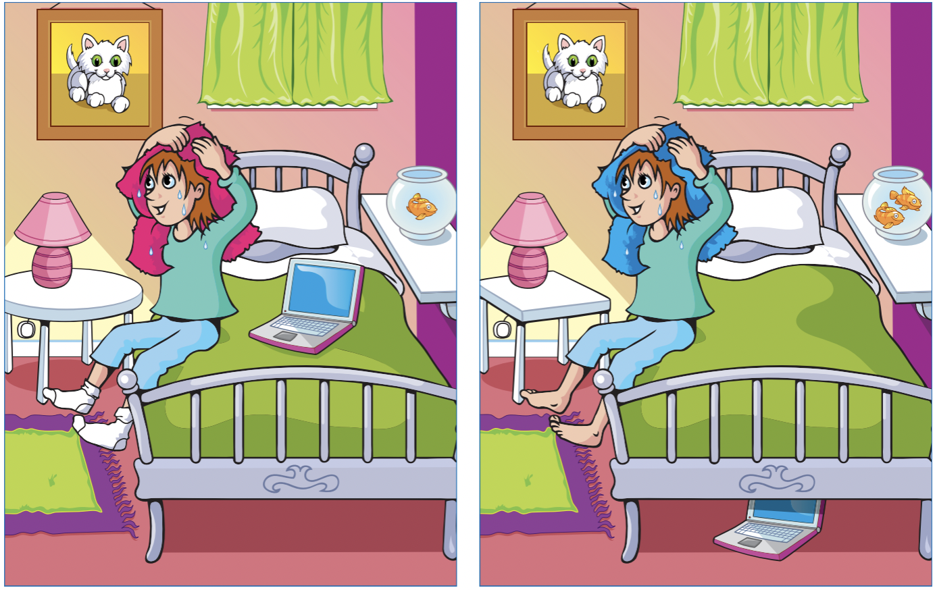
Suggested questions:
1. Can you find any differences between the two pictures?
2. How many differences can you see? (Students point to the diffrences)
3. Can you see anything different on the bed? Where is the laptop?
4. What color is the girl’s towel in each picture? Is it the same or different?
5. Are her socks and feet the same in both pictures?

Picture 2. Picture Story (3 points)
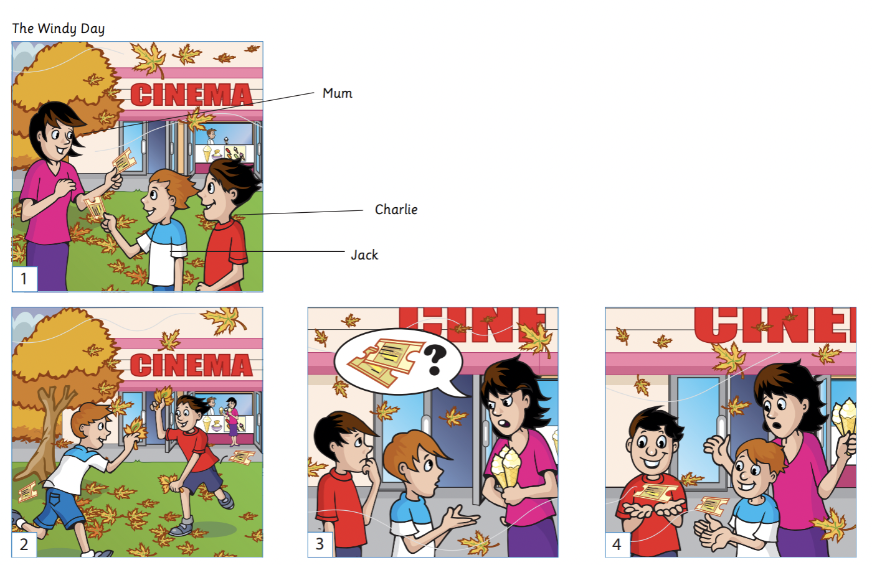

Suggested questions:
Picture 1:
1. Where are the family members? What place is this?
2. What is Mum giving to Charlie and Jack?
3. What is the weather like? Can you see anything special in the background?
4. How do Charlie and Jack look? Are they happy?

Picture 2:
1. What are Charlie and Jack doing now?
2. What happened to one of the tickets?

Picture 3:
1. How does Mum feel? Can you guess from her face?
2. What do you think happened to the ticket?
3. Why are they worried?

Picture 4:
1. What are Charlie and Jack holding in their hands now?
2. How does Mum feel now? How about the boys?
3. What do you think happened in the end? Can they go to the cinema?

