PLACEMENT TEST – SPEAKING
GRADE 4 – GRADE 6 (15 minutes)
Part I. Introduction (3 points)
1. Can you introduce yourself? Your name, your age, and your address. (0.5 points)
2. Can you tell me about your school? What grade are you in, and what do you like about your school? (0.5 points)
3. What is your favorite subject in school? Why do you like it? (1 point)
4. Can you describe a typical day in your life? What time do you wake up, and what do you usually do? (1 point)

Part II. Ask and aswer about the pictures.
Picture 1. Find the differences (5 points)



Suggested questions:
1. How many differences can you see? (Students point to the diffrences)
2. Look at the cake on the table. Is it the same in both pictures?
3. Can you check the man holding the tray? What is he carrying in each picture?
4. Look at the TV host. What is different about his shirt?
5. What do you notice about the picture on the wall? Is the weather the same?
6. Look at the boxes. Can you find something different in the boxes?
7. Look at the woman at the door. What is she holding in each picture?
8. What is the woman at the desk doing in each picture?

Picture 2. Picture story (2 points)
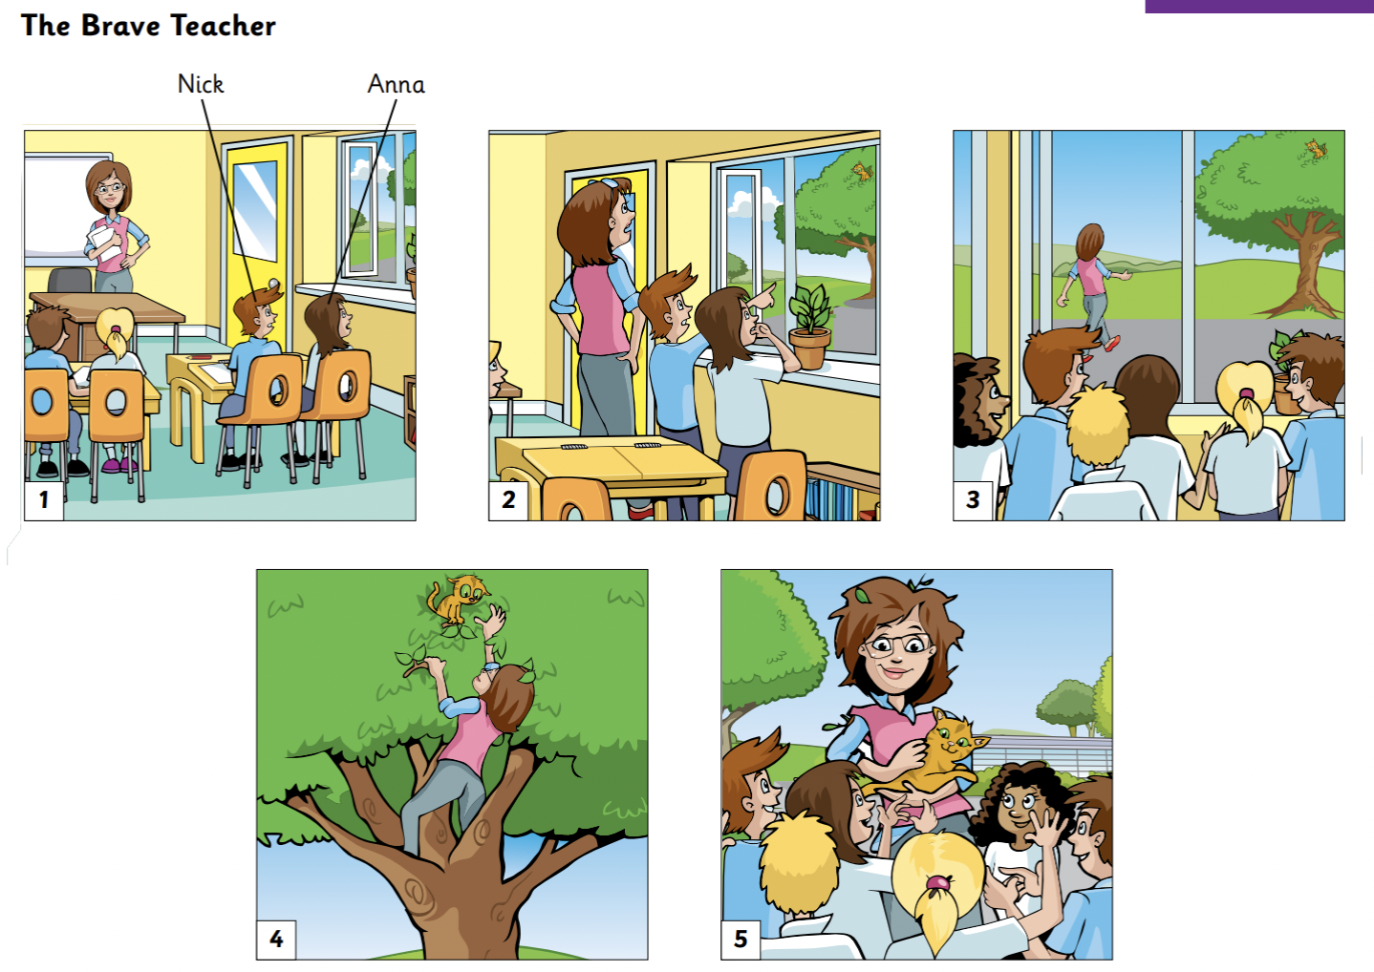
Suggested questions:
Picture 1:
1. Where are the teacher and the students?
2. What are Nick and Anna doing?
3. How do the students look? Are they paying attention?

Picture 2:
1. What are they looking at through the window?
2. How does they feel?
Picture 3:
1. Where is the teacher going?
2. What do the students do when the teacher leaves the classroom?
3. Can you guess why the teacher is leaving?

Picture 4:
1. What is the teacher doing now?
2. Where is the cat, and how does the teacher try to help?

Picture 5:
1. What is the teacher holding in her hands now?
2. How do the students feel when the teacher returns?
3. What do you think about the teacher?

