ENTRANCE TEST
Time: 35 minutes
Student’s name: _______________________ | Listening: ______________________________
Class: _________________________________ | Reading and Writing: ___________________

A. LISTENING PART
Exercise 1. Listen and draw lines. (Track 1)
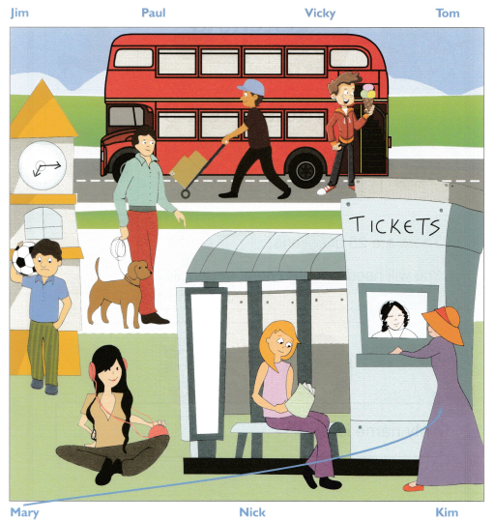

Exercise 2. Listen and write number or name. (Track 2)
Examples
Girl’s name …………Ann Moon………..
Questions
1. Doctor’s name …………Smith………………
2. Problem with …………………stomach……………………
3. Breakfast ……………lemon cake ………….
4. Anna’s age ……………………8…………………

Exercise 3. Listen and circle the correct picture. (Track 3)
 | Which woman is Jane’s aunt? | 3. | What is May painting?
 | 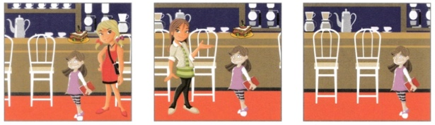 |  | 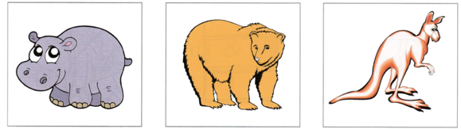
 | A B C |  | A B C
1. | What present did Paul’s father give him? | 4. | What must Alex bring to school?
 | 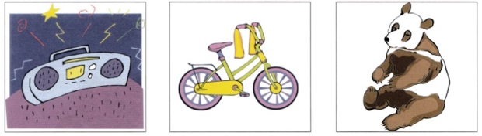 |  | 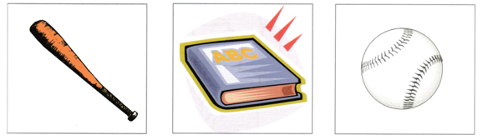
 | A B C |  | A B C
2. | 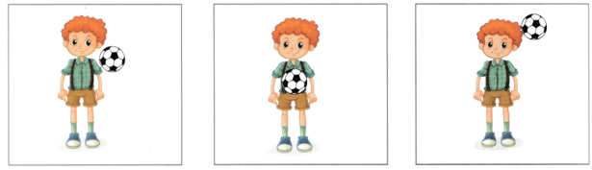  Where did the ball hit Tom? | 5. | Which vegetable does Jill choose?
 |  |  | 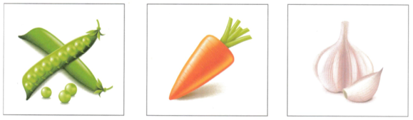
 | A B C |  | A B C

B. READING & WRITING
Exercise 1. Read and write the words in the box.
a zoo snow a city a park a shark

Example
This is white. You see outside when it is very cold. | ………………….snow………………………
Questions
1. You go there to have a picnic. | ……………………a park ……
2. A place where many kids of animals live. They are there for people to see. | ……………a zoo …..………
3. This animal lives in the sea. It is grey and it has very big teeth. | …………a shark………

Exercise 2. Read and choose the correct words.
Islands
There are islands in the sea. There is water all around ….(0) them …
People like to go to islands because they’ve got nice beaches (1) …………………………….……… people like to sit on. People sit there and read their book and drink lemonade. They don’t have to go to work (2) …………………………….……… they are on holiday. Some islands have got jungles and some have got mountains, but (3) …………………………….……… have towns with shops and cafes. From the beach you can look at the sea, and sometimes you can see whales and dolphins. People like to have parties on islands where they play music and see (4) …………………………….……… friends. When the weather is very hot and sunny, people (5) …………………………….……… to islands to walk on the beach and swim in the sea.

Example | - it | - them | - those
1. | - Who | - what | - which
2. | - because | - but | - after
3. | - many | - lot | - more
4. | - them | - their | - them
5. | - going | - go | - goes

Exercise 3. Look at the picture, read and write.
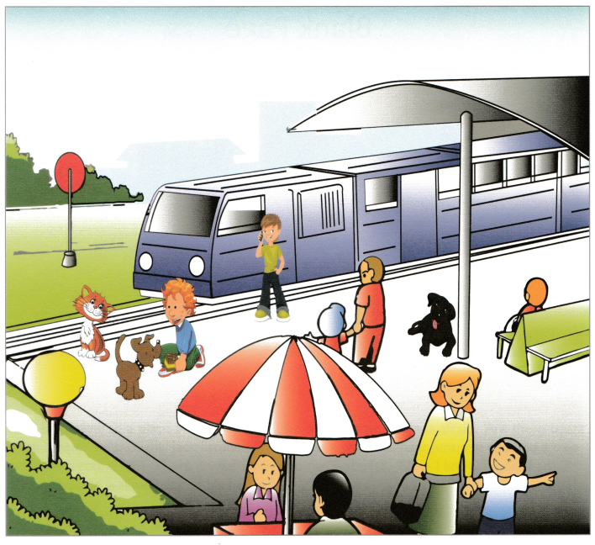

Examples
Two people are sitting at ………a table…..
What’s the colour of the train ? …..blue….
Questions
1. The woman with the boy is holding ………………a bag ……………..
2. One dog is brown and one dog is ………………………black …………….

3. What is the boy near the dog doing ?
………The boy is playing/Smiling …………………….
4. How many dogs are there?
……………………two (2)……………………………………………………….

Exercise 4. Order the words to complete the sentences.
1. the / like / What / today / weather / is?
__What is the weather like today? ______________
2. go / by / bike / school / to / I.
__I go to school by bike ____________________________
3. book / , / the / Close / please.
__Close the book, please ______________________________________

