ENTRANCE TEST
Time: 35 minutes
Student’s name: _______________________ | Listening: ______________________________
Class: _________________________________ | Reading and Writing: ___________________

A. LISTENING PART
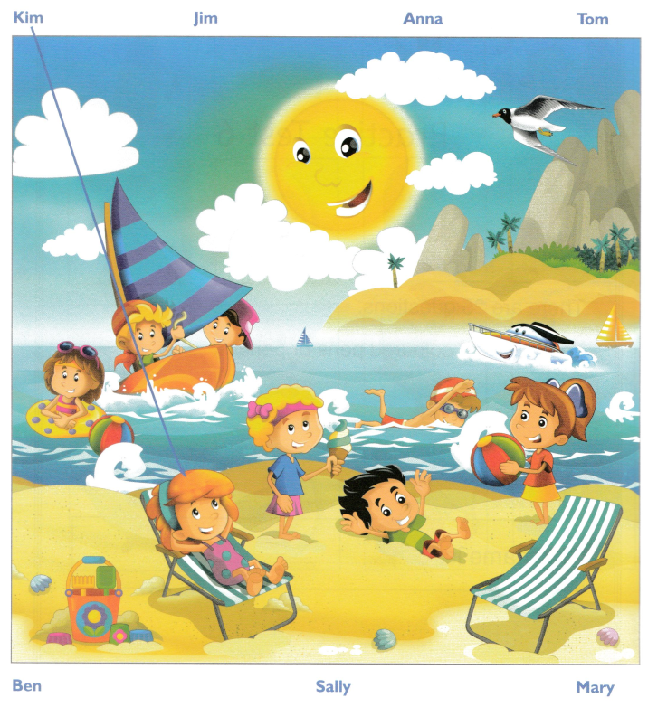
Exercise 1. Listen and draw lines. (Track 1)

Exercise 2. Listen and write number or name. (Track 2)
Examples
Meeting at …………bus station………..
Questions
1. On Friday afternoon they will go to ………………………………………
2. On Saturday afternoon they will go to ………………………………………
3. They will go to the theater on ……………………………………..
4. Students are going to swim with .…..……………………………………

Exercise 3. Listen and circle the correct picture. (Track 3)
 | 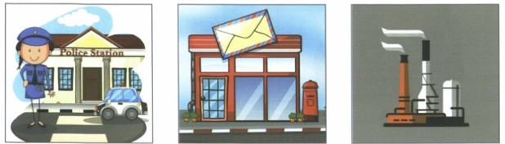  What is next to the museum? | 3. | What did the airport give the museum?
 |  |  | 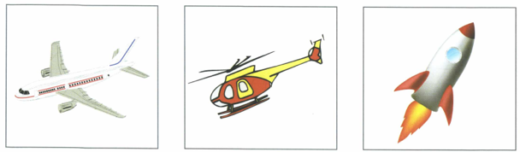
 | A B C |  | A B C
1. | 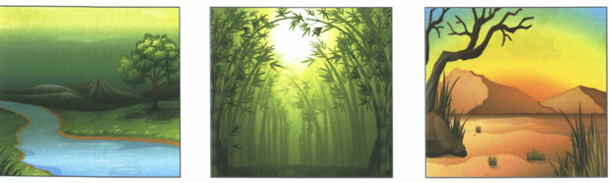  Which was Harry’s favourite environment? | 4. | Which ring did Harry see?
 |  |  | 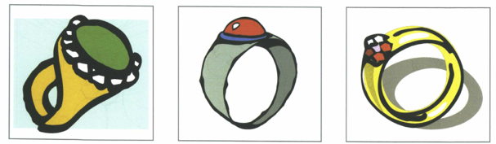
 | A B C |  | A B C
2. | 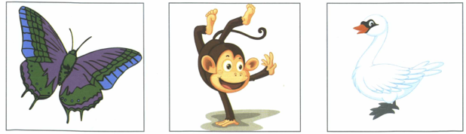  Which animal did Harry see there? | 5. | Which is Harry’s teacher?
 |  |  | 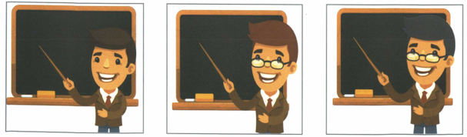
 | A B C |  | A B C

B. READING & WRITING
Exercise 1. Read and write the words in the box.
a doctor a pool coffee a bag a village

Example
You carry your things in this when you go school or work. |  | ………………….a bag………………………
Questions
1. This is a small. There aren’t a lot of houses in it. | ………………………………..………………………
2. You drink this hot in the morning. | ………………………………..………………………
3. This person helps people who aren’t well. | ………………………………..………………………

Exercise 2. Read and choose the correct answer.
Lorries are bigger than cars and (0) ...….smaller……… than trains . People drive them on the roads from cities (1) ………………………………….. towns and in the countryside. Sometimes you can see lorries with tomatoes or apples in them moving down the road.
Lorries (2) ………………………………….. to supermarkets and clothes to shops. When you come to the road with many lorries on it, you (3) ………………………………….. to be very careful when you cross the road. Some lorries have a small bed behind the part (4) ………………………………….. the driver sits. When driver is tired, (5) ………………………………….. can stop and sleep in the small bed.
Example | - small | - smaller | - smallest
1. | - to | - with | - on
2. | - carrying | - carries | - carry
3. | - have | - must | - could
4. | - where | - when | - what
5. | - him | - his | - he
Exercise 3. Look at the picture, read and write.
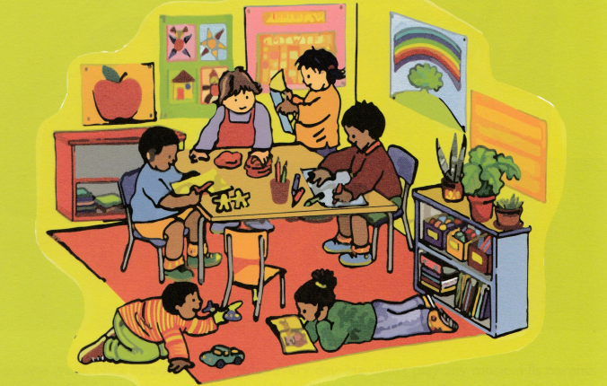

Examples
The boy in the red sweater is drawing ……..a picture …….
What colour is the table ? ………brown ……..
Questions:
1. The boy on the floor is holding a ……………………………
2. The girl in the green sweater is reading …………………………………
3. Where is the boy in the blue T-shirt sitting ?
………………………………………………………………………………………………………………

Exercise 4. Order the words to complete the sentences.
1. There/ music/ be / weekend / next / a / festival / will / .
______________________________________________________
2. you / What / day / going / sports / to / do / are / on / ?
______________________________________________________
3. event / going / the / to / She / table / play / in / is / tennis /.
______________________________________________________
4. notebooks / are / many / there / How / the / table / on / ?
______________________________________________________

