ENTRANCE TEST
Time: 45 minutes
Student’s name: _______________________ | Listening: ______________________________
Class: _________________________________ | Vocabulary and Grammar: _____________

A. LISTENING
Exercise 1. Listen and decide if each statement is True or False. (Track 1)
1. There are more and more people on the earth.
2. The author thinks that it is totally bad for the population to continue to increase.
3. When the world’s population increases too much, there will be food wars but water wars.
4. Natural disaster is one of the factors controlling population.
5. Although we are rich, we cannot control the length of time we live.
1. ______________ | 2. ______________ | 3. ______________
4. ______________ | 5. ______________

Exercise 2. Listen and choose the correct picture. (Track 2)
1. What is John going to do tonight?
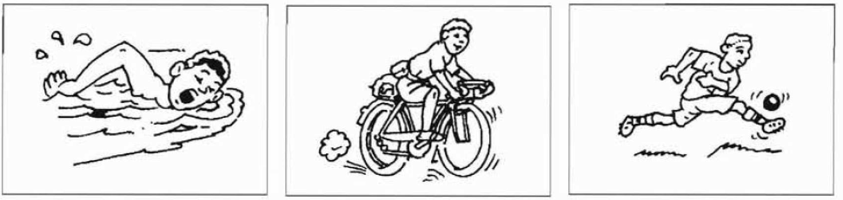

A B C

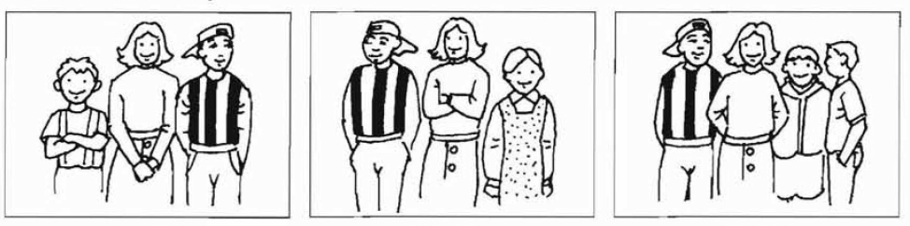
2. Which is Ben’s family?

A B C
3. Which bag does the woman buy?
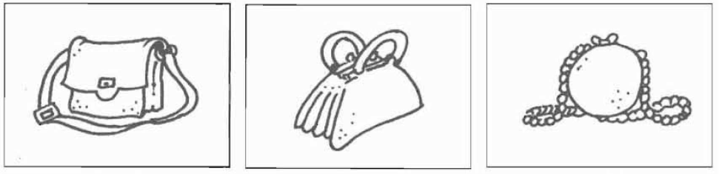

A B C
4. How much did the woman pay for the apples?
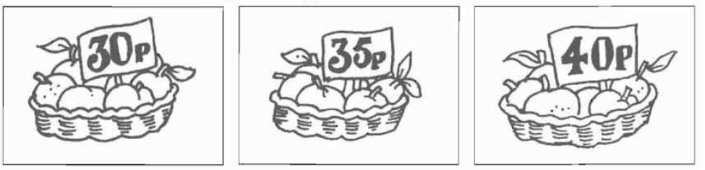

A B C
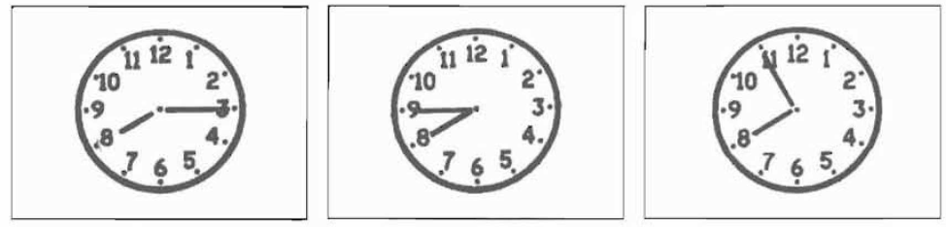
5. What time does the film start?

A B C

B. VOCABULARY AND GRAMMAR
Exercise 1. Choose the word whose underlined part is pronounced differently.
1. A. thousand B. healthy C. weather D. thirsty
2. A. crowded B. polluted C. wanted D. caused
3. A. umbrella B. focus C. under D. mushroom
4. A. cough B. enough C. through D. laugh
5. A. started B. washed C. wanted D. visited

Exercise 2. Choose the best option to complete each sentence.
1. _______ person suffering from ______ shock should not be given anything to drink.
A. An – the B. A – Ø C. A – the D. A – any
2. You can see ____ people in many places in big cities. They have no place to live.
A. homeless B. old C. poor D. wealthy
3. ______ cat is adorable. ______is adorable, too.
A. Your - Mine B. Yours - Mine C. Yours - My D. Your - My
4. It’s ________ to fly and more convenient than a helicopter.
A. fast B. cheap C. easier D. expensive
5. They _____ solar panels on the roof of the house to catch the energy from the sun.
A. have B. get C. install D. put
6. The boys __________ their homework at the moment. They __________ TV instead.
A. aren’t doing – watches B. doesn’t do – is watching
C. aren’t doing – are watching D. doesn’t do - watches
7. People ________ the festival by throwing water to wish everyone happiness.
A. celebrate B. have C. organize D. complete
8. _______ they hold the festival in Ha Noi every year?
A. Does B. Do C. Will D. Are
9. _________ the fact that he is 23 years old, he is so childish.
A. in spite B. despite C. however D. but
10. The films was so ________ that we almost fell asleep.
A. interesting B. gripping C. boring D. violent
11. The traffic_ tell people to do, warns people about possible dangers in the street.
A. jams B. signs C. lights D. rules
12. People in the countryside have less stress, _______ they usually live longer.
A. so B. and C. but D. or

Exercise 4. Read the passage and choose the best option to answer the questions.
Wind is a form of solar energy. Winds are caused by the uneven heating of the atmosphere by the sun. Wind flow patterns are changed by the earth’s terrain, bodies of water, and vegetative cover. This wind flow, or motion energy, when “harvested” by modern wind turbines, can be used to generate electricity.
Wind turbines are available in a variety of sizes, and therefore power ratings. The largest machine has blades that span more than the length of a football field, stands 20 building stories high, and produces enough electricity to power 1,400 homes. A small home-sized wind machine has rotors between 8 and 25 feet in diameter and stands upwards of 30 feet and can supply the power needs of an all-electric home or small business, utility scale turbines range in size from 50 to 750 kilowatts. Single small turbines, below 50 kilowatts, are used for homes, telecommunications dishes, or water pumping.
1. What is the reason for the existence of wind?
A. atmosphere heated unevenly B. wind flow
C. motion energy D. wind turbines
2. Which of the following is NOT mentioned as a factor affecting the wind direction?
A. earth’s terrain B. bodies of water C. vegetative cover D. the Sun
3. What is the height of the largest wind turbines?
A. as tall as a 20 story building B. between 8 and 25 feet
C. 30 feet D. 50 feet
4. A small home-sized wind machine can produce enough power for_________.
A. 20 buildings B. a small business
C. 400 homes D. a football field
5. How much power do single small turbines generate?
A. about 30 kilowatts B. more than 50 kilowatts
C. about 750 kilowatts D. less than 50 kilowatts

Exercise 5. Read the passage and choose the correct answer A, B, or C to fill each blank.
A hoverboard can bring (1) ________ a lot of benefits. It is self-balancing so it is safe for (2) ________. It is also fun because it connects to a music speaker with a phone, so riders can enjoy music while (3) _______ on the road. It can also give riders a smooth (4) ________. It runs on electric battery. Its run time is 30 minutes but you may have to wait 2-3 hours for the battery to (5) ________. Because hoverboards are safe, easy to use, and inexpensive, they will be around for long for the children to enjoy.
1. A. owners B. riders C. players
2. A. beginners B. professionals C. adults
3. A. hovering B. running C. driving
4. A. drive B. ride C. fly
5. A. change B. replace C. charge

Exercise 6. Rewrite the following sentences without changing their meaning.
1. I’m going to buy a hybrid car because it doesn’t use as much gas as other cars. (LESS)
⇨=> I’m going to buy a hybrid car because it uses _______________________.
2. My sightseeing tour in Melbourne lasted two hours. (GOING)
=> I spent ___________________________________________________________.
3. China is the largest producer of wind power in the world.
=> China produces ___________________________________________________.

