ENTRANCE TEST
Time: 35 minutes
Student’s name: _______________________ | Listening: ______________________________
Class: _________________________________ | Vocabulary and Grammar: _____________

A. LISTENING PART
Exercise 1. Listen and write the words. (Track 1)
 | Example  0. He goes to the sports center …….every Saturday……..  1. His name …….Peter Moon  2. His age ………………10…………….  3. Sport he wants to play ………………baseball ………  4. He needs this to play a……………bat…………………………...  5. Mrs River is …the teacher ……….

Exercise 2. Listen and circle the correct picture. (Track 2)
0. | Where will Helen’s club meet on Saturday? | 2. | What mus Helen take to the club this week?
 | 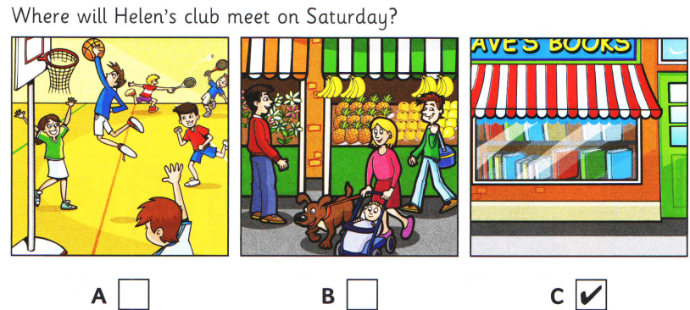 |  | 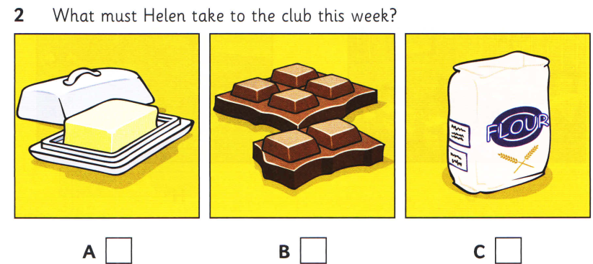
 | A B C |  | A B C
1. | What doest Helen play at the club? | 3. | Who’s going to visit the club next month?
 | 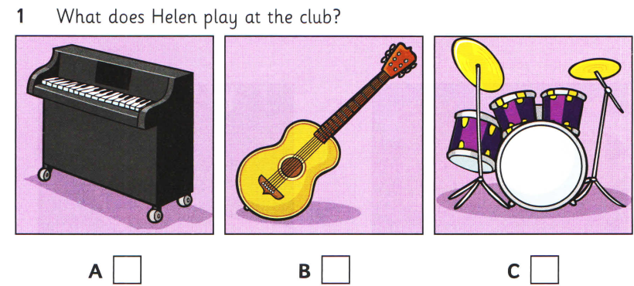 |  | 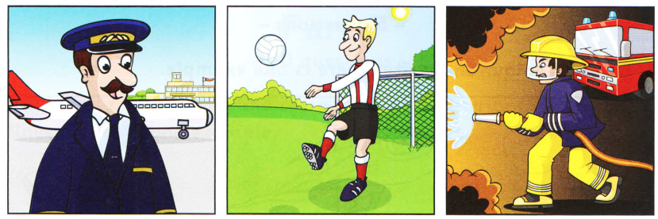
 | A B C |  | A B C
4. | Which film was the most interesting? | 5. | What is the club going to do on holiday year?
 | 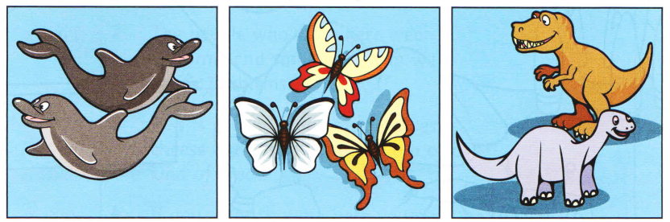 |  | 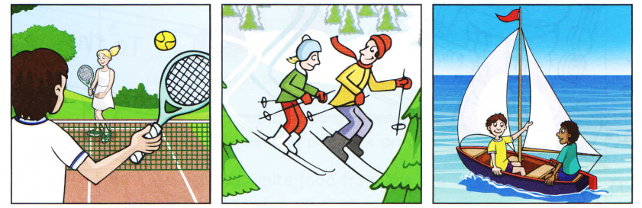
 | A B C |  | A B C

B. VOCABULARY & GRAMMAR
Exercise 1. Find the word which has a different sound in the part underlined.
1. A. study B. bus C. up D. surf
2. A. Monday B. some C. come D. home
3. A. goes B. washes C. boxes D. classes

Exercise 2. Choose the best answer A, B, C or D.
1. Go along the street. It's_________to the post office.
A. at B. in C. on D. next
2. We ___________ kites in the park.
A. take B. fly C. go D. read
3. He doesn’t want ___________ a movie.
A. see B. sees C. seeing D. to see

4. My brother __________ brown boots.
A. goes B. puts C. wears D. plays
5. Can __________ use chopsticks? Yes, she can.
A. I B. he C. she D. they

Exercise 3. Choose the correct option ( A,B,C or D) to complete the following passage.
This summer holiday my parents are ………(1)…………. to take me to Hanoi. We are going to travel …………(2)…………… car. We are going to stay in my uncle’s house for two weeks. We are going to ………(3)……………. President Ho Chi Minh Mausoleum, Hoan Kiem Lake, Temple of Literature, and Lenin Park. We are going to go shopping in Dong Xuan…………(4)………., and I’m going to buy some souvernirs …………(5)………………….. my friends.
1. A. going B. goes C. to going D. went
2. A. with B. by C. for D.on
3. A. come B. look C. visit D. fly
4. A. temple B. lake C. zoo D. market
5. A. with B. from C. for D. to

Exercise 4. Read the conversation and answer the questions.
Nam is a student. He's in grade six. Every morning, he gets up at half past five. He brushes his teeth at five forty-five, washes his face and gets dressed, and then he has his big breakfast at six o'clock. He goes to school at six thirty. Nam's school is small. It has two floors and Nam's classroom is on the second floor.
1. What does Nam do?
...Nam is a student ...................................................................................................

2. Which grade is he in?
......He’s in grade six ..............................................................................................
3. What time does Nam brush his teeth?
............... He brushes his teeth at five forty-five....................................................
4. Is Nam's school big?
......No, it isnt................................................................................................
5. How many floors does his school have?
............It has two floors / 2 floors .......................................................................................

Exercise 5. Rewrite the sentences using the given words.
1. There are three floors in my new house. (has)
.......The new house has three floors....................................
2. I cycle to school every day. (by)
...I go to school by bike everyday ................................

