ENTRANCE TEST
Time: 35 minutes
Student’s name: _______________________ | Listening: ______________________________
Class: _________________________________ | Reading and Writing: ___________________

A. LISTENING PART
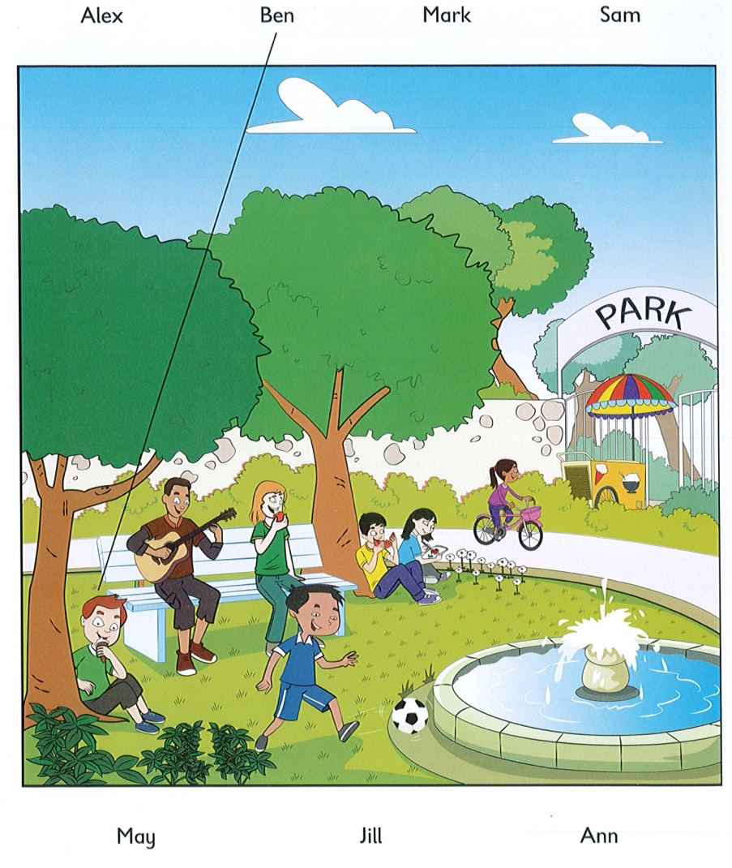
Exercise 1. Listen and draw lines. (Track 1)

Exercise 2. Listen and write number or name. (Track 2)
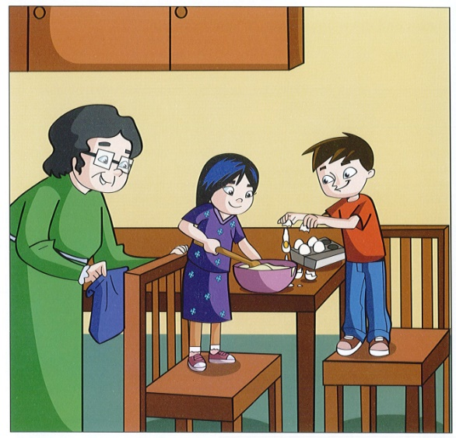 | Examples :  How old is May ? …………7………  What’s May’s grandma’s name ? …….Anna……  Questions  1. How old is Nick ? …8……………..  2. What’s Nick’s sister’s name ? ……Kim………..  3. How old is Nick’s sister ? ……9……………  4. How many eggs are in the box ? .………4…………
Exercise 3. Listen and circle the correct picture. (Track 3)
 | What’s Lucy eating? | 3. | What can Ben see?
 | 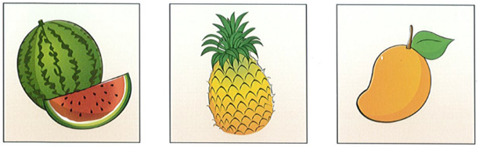 |  | 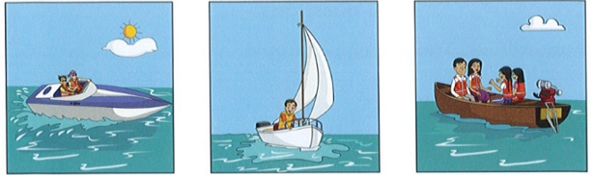
 | A B C |  | A B C
1. | Which is Bill’s house? | 4. | What colour are Ann’s eyes?
 | 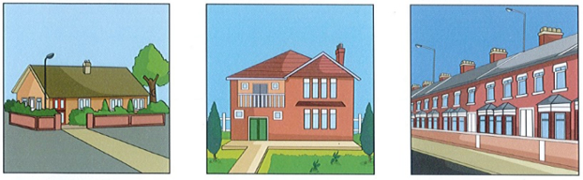 |  | 
 | A B C |  | A B C
2. | How is Sue getting to school today? | 5. | What sport is Mark playing?
 | 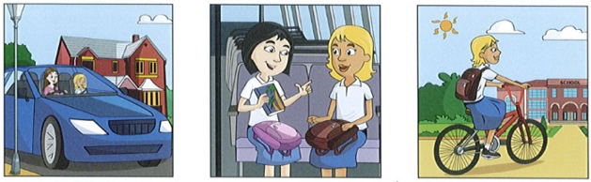 |  | 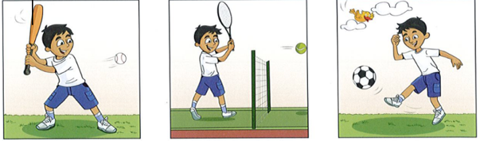
 | A B C |  | A B C

B. READING & WRITING
Exercise 1. Read and tick or cross.
 | 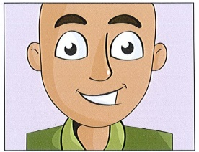 |  | 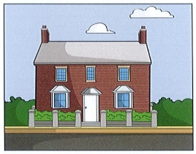
 | This is a face.  V |  | This is a flat.  X
1. |  | 2. | 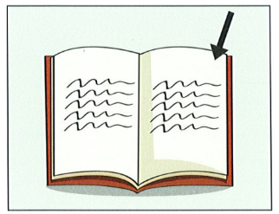  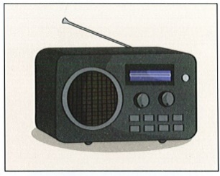
 | This is a page.  V |  | This is a radio.  V
3. | 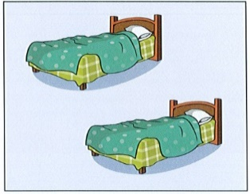 | 4. | 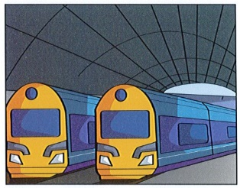
 | These are baths.  X |  | These are trains.  V
5. | 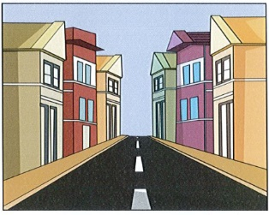
This is a beach.
X

Exercise 2. Look, read and write Yes or No.
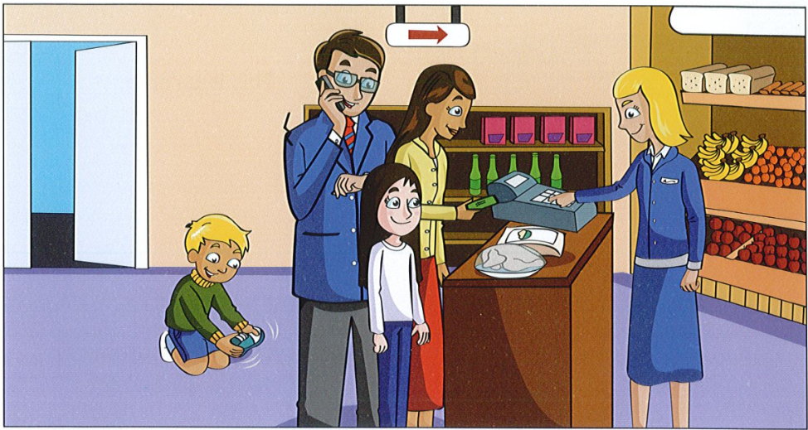

Examples:
The woman with brown hair has got some rice and chicken. …….yes…
The girl is wearing black shorts. …….no…..

Questions
1. The man is talking on the phone. …yes………….
2. The shop door is closed. ……no………….
3. There is some bread and fruit behind the woman with .……………yes…….
blonde hair.

Exercise 3. Choose the words in the box to fill in the blanks.
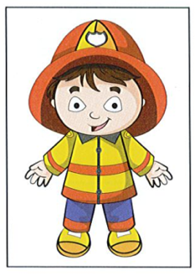
A doll

This doll has got a …..face…. , two eyes, a nose and a (1) ……………mouth……………………….
He has got two arms but he cannot throw a (2) ……………ball………………………. He has got two (3) ………………………legs……………. but he can not run or jump. He lives in a (4) ……………bedroom………………………. in a house. Young (5) …………………children…………………. play with him.
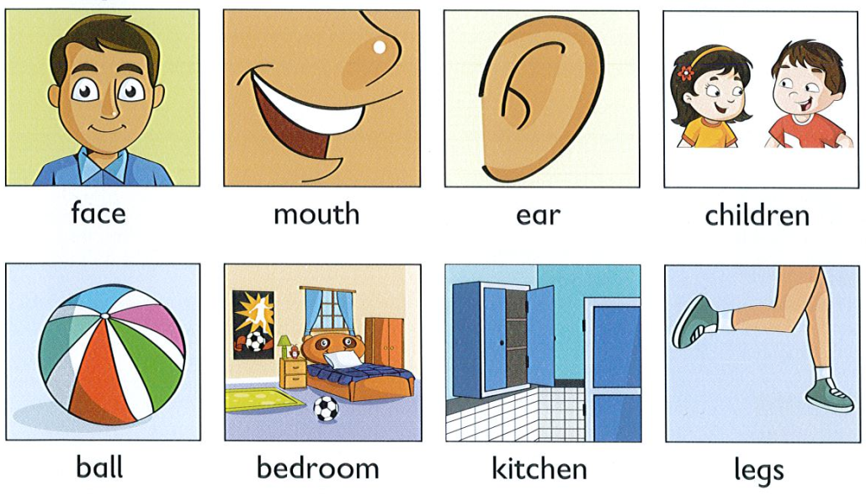

Exercise 4. Order the words to complete the sentences.
1. a / frog / green / It is / .
=> ……………It is a green frog…………………………………………………………
2. square / are / They / windows / .
=> …………………They are square windows……………………………………………………………

