ENTRANCE TEST
Time: 35 minutes
Student’s name: _______________________ | Listening: ______________________________
Class: _________________________________ | Reading and Writing: ___________________

A. LISTENING
Exercise 1. Listen and tick the correct picture. (Track 1)
1. |  |  | 
 |  |  | V
2. |  | 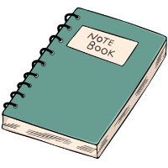 | 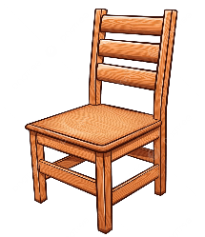
 |  | V
3. |  |  | 
 | V
4. |  |  | 
 |  | V
5. |  |  | 
 |  |  | V

Exercise 2. Listen and write. (Track 2)
Example
What’s the boy’s name ? ……….TOM………
How many photos has he got ? …..10/ten….
Questions
1. Who is Tom’s friend ? ………KIM……………
2. How old is Tom’s friend ? ………7…………..
3. Where does Tome live ? in ……BEAN……Street
4. What number is his house ? ………20…………….
5. What’s the name of Tom’s sister ? …………PAT………….

B. READING & WRITING
Exercise 1. Look, circle the correct words.
1. |  | 2. |  | 3. | 
 | jumper/ shoes |  | pencil / crayon |  | teacher / doctor
4. |  | 5. |  | 6. | 
 | tiger / hippo |  | ballon / teddy |  | duck / desk

Exercise 2. Unscramble the words.
1. | 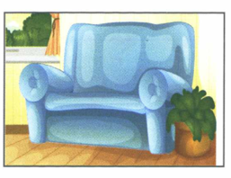 | A S F O | SOFA
2. | 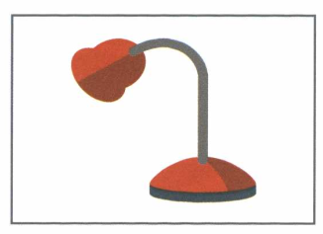 | M P A L | LAMP
3. | 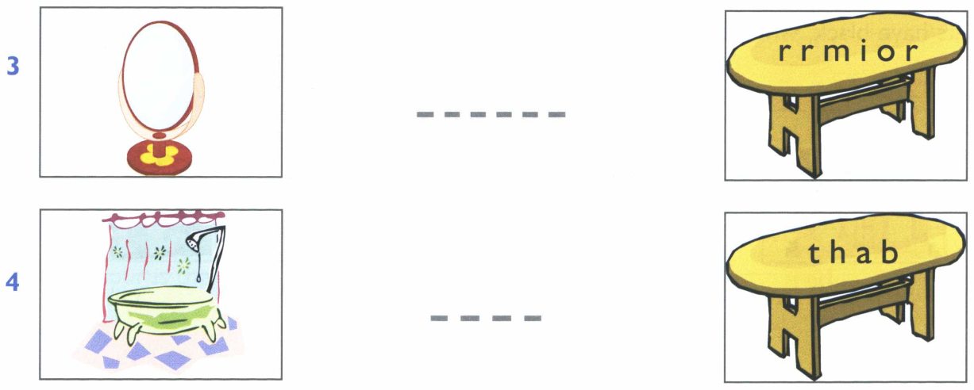 | R R M I O R | MIRROR
4. |  | T H A B | BATH

Exercise 3. Look, read and write Yes/ No.
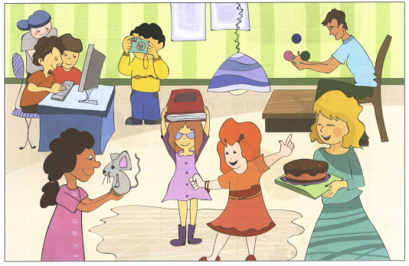
Example
The woman is giving the children. ……….yes………
The boys are playing tennis. ………...no……….
Questions
1. There are two boys in the room. ………no……………
2. The boy with the black hair is taking a photo. ………yes…………..
3. The man is playing with a dog. ………...no………
4. There are three lamps in the room. …………no………….
5. The girl in the pink dress is holding a mouse. …………yes………….

