INSTRUCTIONS
Please read the instructions carefully before doing the questions.
- You can use materials in your computer, notebook and text book.
- You are NOT allowed to use any device to share data with others.
Beside the above conditions, students must follow the following requirements:
1. The work must complete by using Visual Studio 2022++
2. The Framework must be .NET 8.0
3. THIS PART IS VERY IMPORTANT, PLEASE READ IT CAREFULLY AND FOLLOW THE INSTRUCTIONS.
- You are given a database script (.sql file) in Zip file. Execute the script before doing questions.
- You must use the given solution.
- You are not allowed to add any more libraries via NuGet Package Manager into given solution.
- Submission Guideline:
Submit your work for each question separately. For each question, please:
- Publish your project using the command:
dotnet publish -c Release -o ./[QuestionNumber_StudentAccount]
Example:
dotnet publish -c Release -o ./Q1_trungnthe123432
- Submit the root folder of the project into the PEA_Client application.
- If the root folder of the project is too large, you may delete the following subfolders to reduce its size before submitting: /bin, /obj
Just one of above requirements is violated, your work will be considered as invalid.

Question 1
You are provided with a database as following diagram
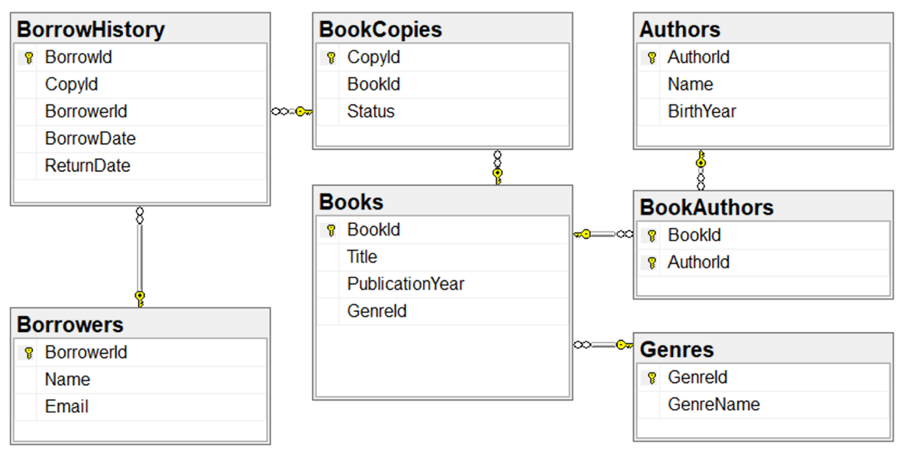
Ensure that the database connection string is adjustable through appsettings.json (otherwise your post will get 0 point) as pattern:
{
"ConnectionStrings":
{
"MyCnn": ""
}
}

Your task is to implement the following APIs using NET8 and Entity Framework Core:
Method | URL | Description
GET | /api/books | Retrieve a list of all books
GET | /api/paginationbooks | Retrieve a list of books with enhanced pagination features
POST | /api/copies | Add a new copy for a book.
DELETE | /api/copies/{copyId} | Delete a copy of a book.

1. GET /api/books

Retrieve a list of all books, supporting both JSON and XML formats, and include the number of available copies.
- Return a list of books with the following information: BookId, Title, PublicationYear, and the number of available copies.
- The number of available copies is calculated based on the copies in the Copies table that are not currently borrowed (i.e., copies in BorrowHistory where ReturnDate is null indicate they are borrowed).
- Support response formats in both JSON and XML using media formatters.
- Example:
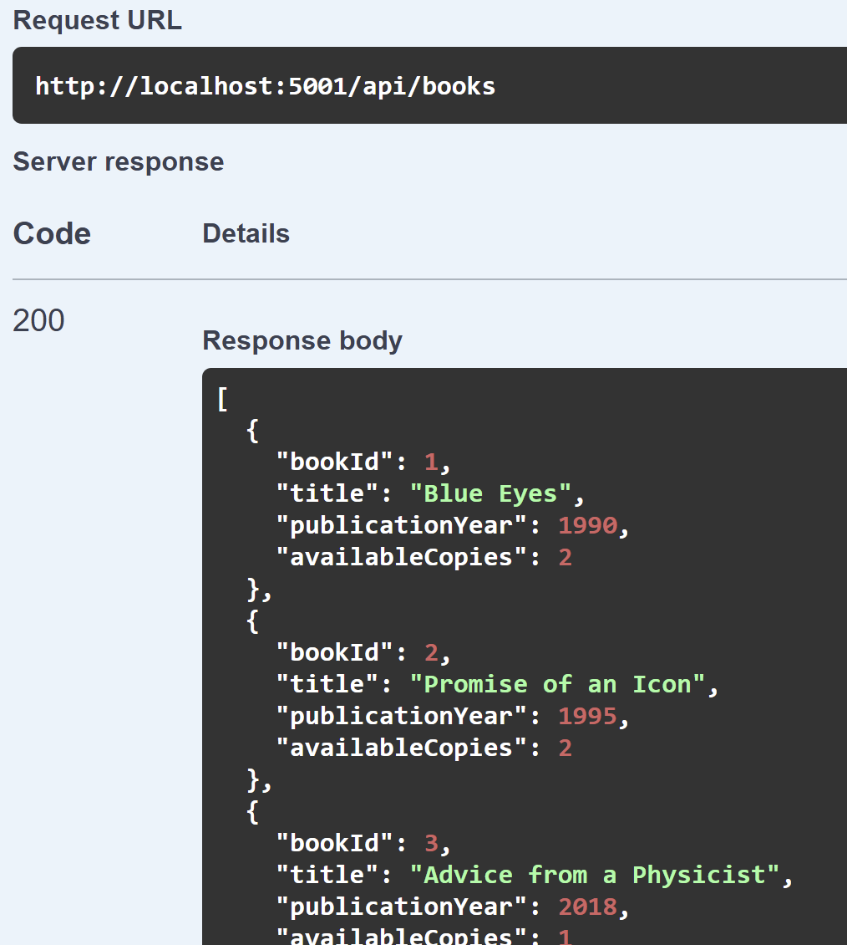

2. GET /api/paginationbooks

Retrieve a list of books similar to /api/books but with enhanced pagination features.
- Return a list of books with the following information: BookId, Title, PublicationYear, and the number of available copies.
- Support both JSON and XML response formats.
- Detailed pagination:
Use query parameters:
page: Current page (starting from 1, default is 1).
pageSize: Number of books per page (default is 10).
Return the list of books for the requested page, along with pagination metadata:
TotalBooks: Total number of books in the database.
TotalPages: Total number of pages, calculated based on pageSize (e.g., 25 books with pageSize=10 results in TotalPages=3).
CurrentPage: The current page.
PageSize: Number of books per page.
- Error handling:
If page or pageSize is negative or invalid, return a 400 Bad Request error.
If page exceeds TotalPages, return an empty list with pagination metadata.
- Examples:
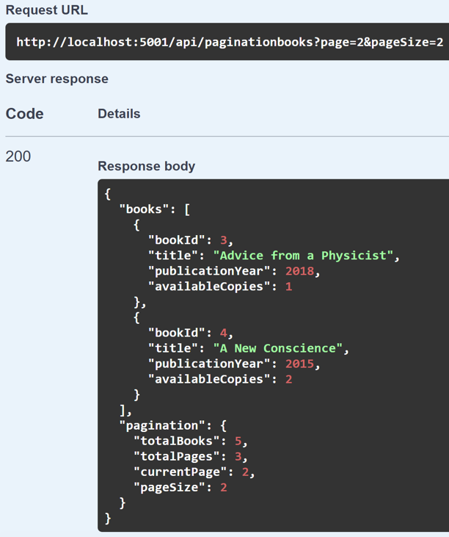
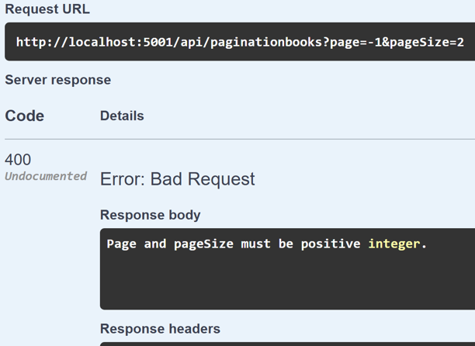

3. POST /api/copies

Add a new copy for a book.
- Accept BookId from the request body and add a new copy to the Copies table.
- Return the details of the newly added copy, including CopyId and BookId.
- Error handling:
If the BookId does not exist, return a 404 Not Found error.
- Example:

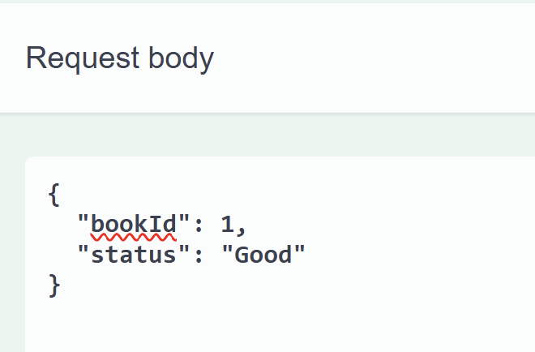

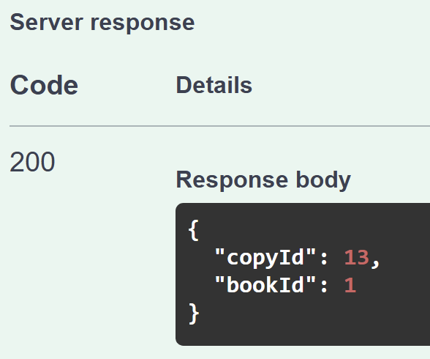

4. DELETE /api/copies/{copyId}

Delete a copy of a book.
- Delete the copy with the specified CopyId from the URL and return 204 Undocumented if success.
- Error handling:
If the copy is currently borrowed (exists in BorrowHistory with ReturnDate as null), return a 400 Bad Request error with the message "Cannot delete a copy that is currently borrowed."
If the CopyId does not exist, return a 404 Not Found error with the message "No copy found with provided CopyId".
- Example:
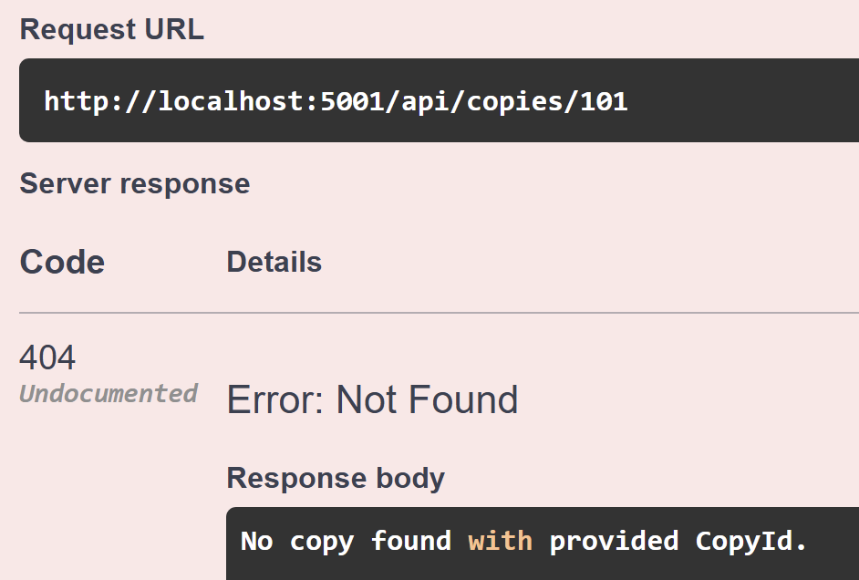
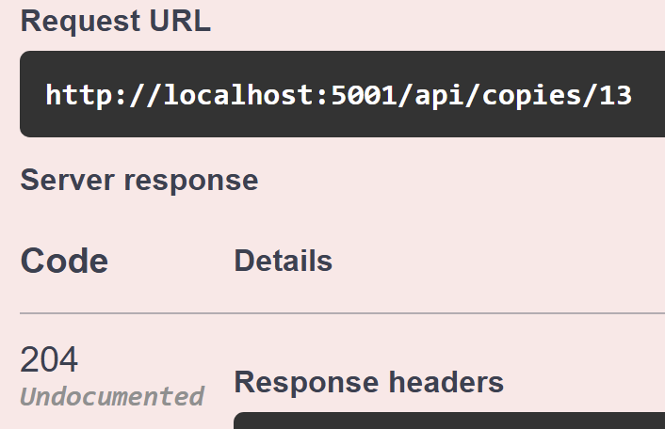

Question 2
In this question, you are asked to write an MVC/Razor Pages application. The application fetch data by calling pre-existing RESTful API hosted at GivenAPIBaseUrl. The API are provided in a separate project named GivenAPIs, which students must run locally to start the API server

1. Important Notes
- Students MUST use HttpClient to make calls to the API.
- The value of GivenAPIBaseUrl must be written in appsettings.json as following format:
{
“GivenAPIBaseUrl”: “http://localhost:5100”
}
"GivenAPIBaseUrl" is a provided key, and students are not allowed to modify it.
Students get the GivenAPIBaseUrl value from appsettings.json, combine it with the endpoint to call the API.
When concatenating the base URL with the endpoint, students must explicitly use string concatenation (e.g., "baseUrl" + "/endpoint"), rather than implicit or framework-specific alternatives.
- All input and output elements in the HTML source must have an ‘id’ attribute to ensure accessibility and traceability (Students can refer to the list.html and detail.html files in given materials, which provides code snippets for the assignment).

2. The provided API is
GET /api/books/author/{authorId?}: Returns a list of books of the author has AuthorId equal {authorId}. In case, {authorId} is missing, return all books.
GET /api/authors: Returns a list of all authors.
GET /api/books/{bookId}: Returns detailed information about a specific book, including its list of authors (e.g., /api/books/1).

3. Requirements

3.1. Book List Page (see Figure 1)

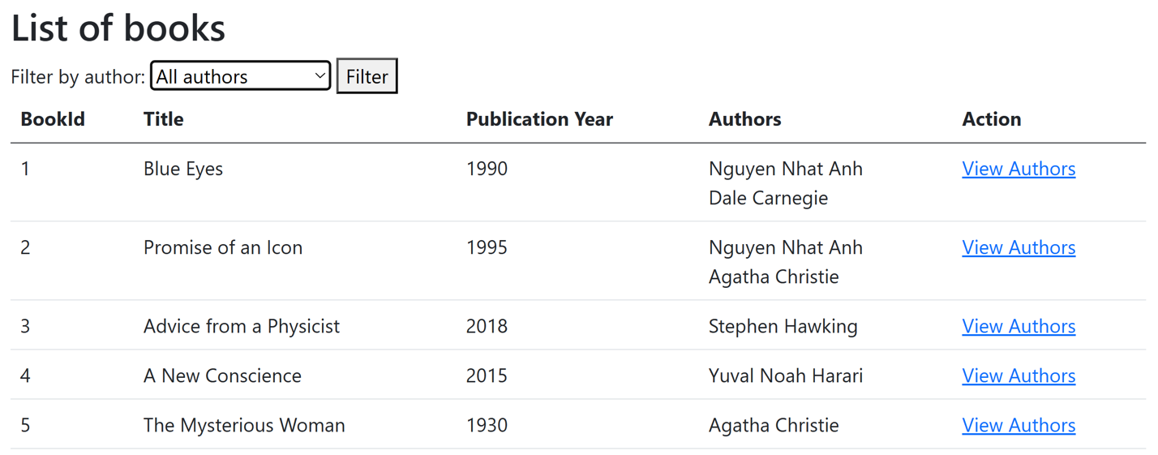
Figure 1. The Book List page.
URL: /Book
- Display all books from the Books table in a tabular format with the following columns:
- BookId.
- The book's title (e.g., "Programming in C#").
- PublicationYear.
- Authors: The list of the book's authors (retrieved from the Authors table via BookAuthors). Each author's name is placed on a separate line.
- Each row in the table should have a "View Details" link redirecting to the detail page with the URL /Book/{BookId}.
- Include a dropdown list that displays all authors from the database (from the Authors table). Add into dropdownlist the item "All authors".
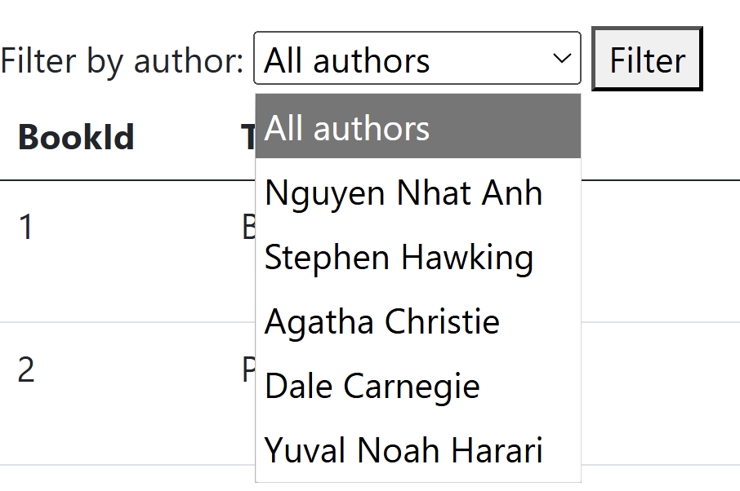
Figure 2. List of options in Author DropDownList.
ID Requirements:
- Each <td> tag in the table that lists books will have an id in the form td_{columnName}_{bookId} (where bookId is the id in database of the book and columnName written in camelCase format): td_bookId_1, td_title_1, td_publicationYear_1, td_authors_1, td_action_1
- Each author's name in column Authors, must be placed in an <div> tag with id div_{bookId}_{authorId} (where bookId and authorId are the id in database of book and author). Example: div_1_1
- Each "View Authors" link must be placed in an <a> tag with id a_{bookId}. Example a_1
- The Dropdownlist using <select> tag that has id sl_authors
- The option "All authors" is set by default, using <option> tag with id op_0
- Each option tag in Dropdownlist has an id in the form op_{authorId} (where authorId is the id in database of author). Example: op_1, op_2

3.2. Filter books by author (see Figure 1)
- When a user selects an author from the dropdown and clicks the "Filter" button, the book list should only show books associated with the selected author. Note that, if the user selects "All authors" list all the books.
- The [Filter] button using <input> tag that has id bt_filter

3.3. Book Authors Detail Page (see Figure 2)

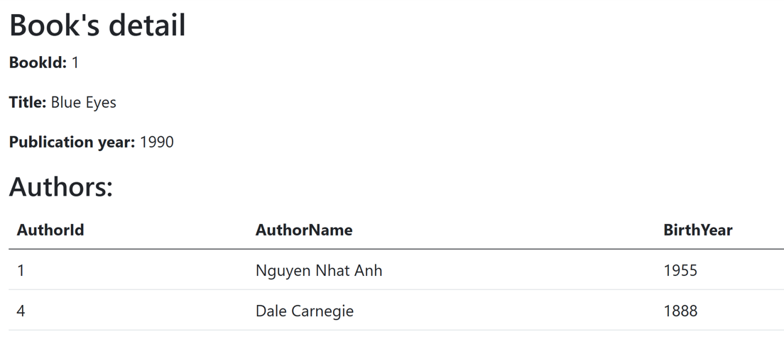
Figure 3. The Book Authors Detail page.
- URL: /Book/{BookId} (e.g., /Book/1)
- Display basic information of the book:
BookId: The book's ID.
Title: The book's title.
PublicationYear: The publication year.
- Display a list of all authors associated with the book in a table with the following columns:
AuthorId: The author's ID
Name: The author's name
BirthYear: The author's birth year
ID Requirement:
- Each piece of basic information in the book (BookId, Title, Publication Year) is placed within a <span> tag, with the IDs being as folows span_bookId, span_title, span_publicationYear.
- Each <td> tag in the table that lists authors will have an id in the form td_{columnName}_{authorId} (where authorId is the id in database of the author and columnName written in camelCase format). Example: td_authorId_1, td_authorName_1, td_birthYear_1

4. Summary of HTML Elements ID
The HTML id requirements are summarized in the table below:
Page | Element | Element Tag | Id
/Book/ | Each cell in the table that lists books | <td> | td_{columnName}_{bookId}
 | Each author in list of authors of one book (in table) | <div> | div_{bookId}_{authorId}
 | Each ViewAuthors link | <a> | a_{bookId}
 | DropdownList Authors (Filter) | <select> | sl_authors
 | Option "All Authors" (Filter) | <option> | op_0
 | Each author option in DropdownList | <option> | op_{authorId}
 | Button Filter | <input> | bt_filter
/Book/{BookId} | Field BookId | <span> | span_{bookId}
 | Field Title of book | <span> | span_{title}
 | Field PublicationYear | <span> | span_{publicationYear}
 | Each cell in the table that lists authors | <td> | td_{columnName}_{authorId}
See list.html and detail.html in the Given Materials
Note: Ensure all ID requirements are strictly followed so that the examiner can automatically verify your work.

5. Summary of Required URLs
Function | URL
List and filter books | /Book
Details of the book with id {BookId} | /Book/{BookId}

