1.(1.sql) . Write a query to display all products that have price is maximum price in the same category as below. /

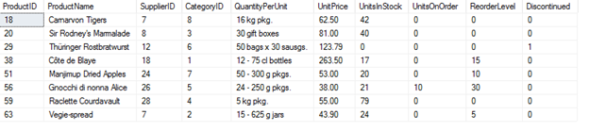

2.(2.sql) .An order will be taxed 20% if its freight cost is larger than or equal to $100. Otherwise, an order will be taxed 10% if its freight cost is smaller than $100. Write a query to show the freight with taxes of orders placed between 1/5/1997 and 15/5/1997 as follows, by ascending order of order ID as follows /

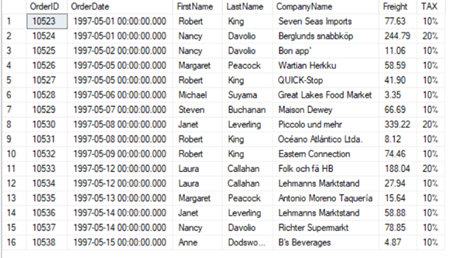

3.(3.sql) .Write a query to display all employees that have first name starting with A, by their ID order. /



4.(4.sql) . Write a query to display 3 youngest employees and 3 oldest employees as follows. /

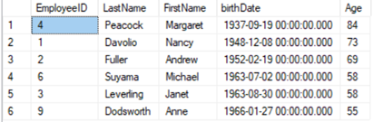

5.(5.sql) . Write a query to display employees whose hire later is later than hire date of employee ‘Peacock Margaret’ as follows /

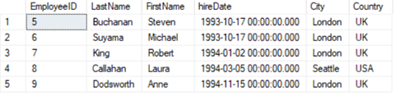

6.(6.sql) .Write a query to display total value of each order from 1/12/1996 to 31/12/1996 as follows / Note: Total value = sum of all (UnitPrice \* Quantity).

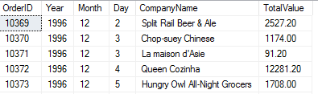

7.(7.sql) . Write a query to display number of orders shipped by shippers as follows /

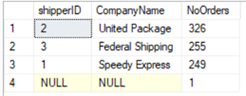

8.(8.sql) . Write a query to display all products that have price is maximum price in the same supplier as below /

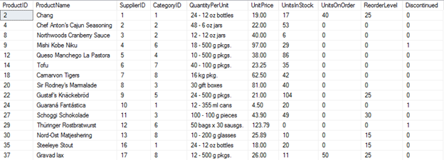

9.(9.sql) .Write a query to display all customers that have the second character of ContactName is O, by their ID order. /

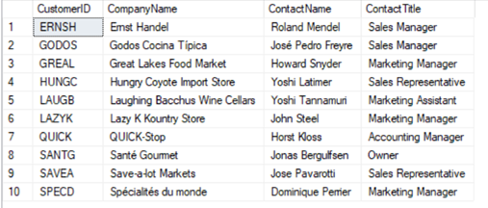

10.(10.sql) . Write a query to display the list of young employees ranks from 4th to 8th as follows /

