**BÁO CÁO THỰC HÀNH KIẾN TRÚC MÁY TÍNH TUẦN 5**

**Assignment 1**

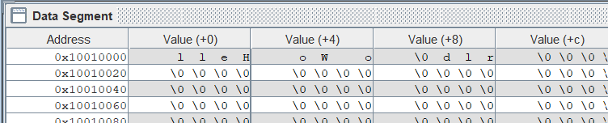

* Test string “Hello World” được lưu ở các địa chỉ 0x10010000, 0x10010004, 0x10010008
* Được lưu bằng cách gán service number =4 cho $v0 và tải địa chỉ chuỗi test vào biến $a0

**Assignment 2**

.data

Xuat1: .asciiz "Nhap so thu 1 "

Xuat2: .asciiz "Nhap so thu 2 "

Xuat3: .asciiz "Result: "

.text

la $a0, Xuat1 # print string Xuat1

li $v0, 4

syscall

li $v0, 5 # nhap so nguyen

syscall

add $t1,$zero,$v0

la $a0, Xuat2 # print string Xuat2

li $v0, 4

syscall

li $v0, 5 # nhap so nguyen

syscall

add $t2,$zero,$v0

add $t3,$t1,$t2

la $a0, Xuat3 # print string Xuat3

li $v0, 4

syscall

li $v0, 1 # In ra tong 2 so

add $a0,$zero,$t3

syscall

**Assignment 3**

#Laboratory Exercise 5, Home Assignment 2

.data

x: .space 32 # destination string x, empty

y: .asciiz "Hello World"

.text

strcpy:

add $s0,$zero,$zero # $s0 = i = 0

la $a0, x #load address x

la $a1, y #load address y

L1:

add $t1,$s0,$a1 # $t1 = $s0 + $a1 = i + y[0]

# = address of y[i]

lb $t2,0($t1) # $t2 = value at $t1 = y[i]

add $t3,$s0,$a0 # $t3 = $s0 + $a0 = i + x[0]

# = address of x[i]

sb $t2,0($t3) # x[i]= $t2 = y[i]

beq $t2,$zero,end_of_strcpy # if y[i] == 0, exit

nop

addi $s0,$s0,1 # $s0 = $s0 + 1 <-> i = i + 1

j L1 # next character

nop

end_of_strcpy:

* Bộ nhớ lúc đầu:

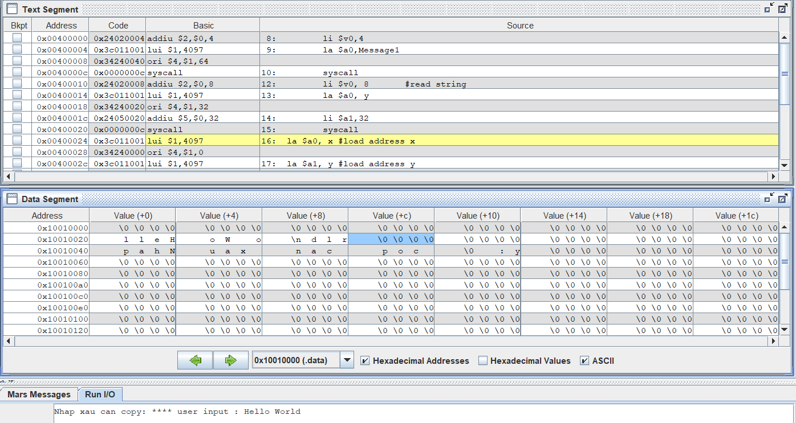

* Bộ nhớ lúc sau khi kết thúc chương trình:

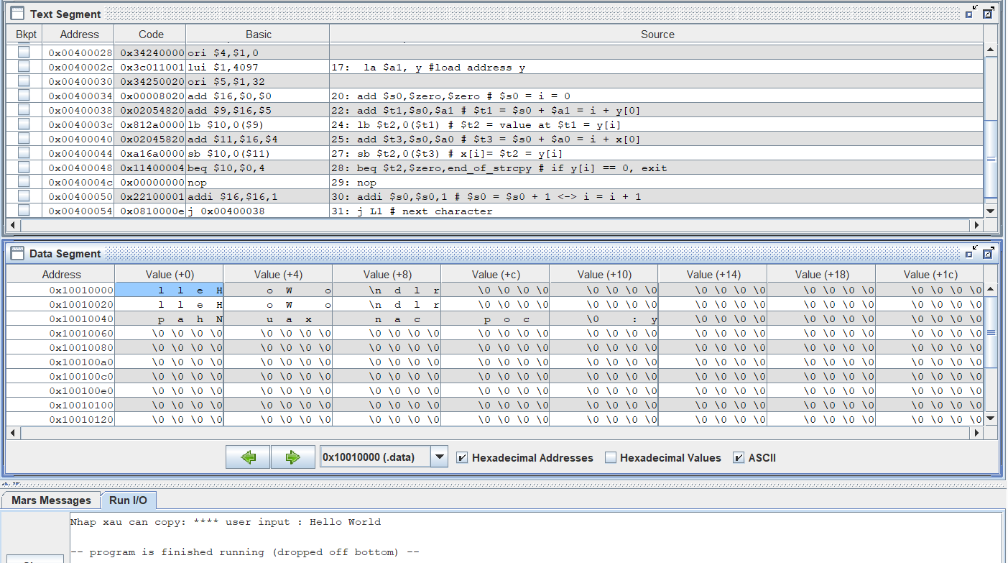

**Assignment 4**

#Laboratory Exercise 5, Home Assignment 3

.data

string: .space 50

Message1: .asciiz "Nhap xau: "

Message2: .asciiz "Do dai xau la: "

.text

main:

get_string: li $v0,4

la $a0,Message1

syscall

li $v0, 8 #read string

la $a0, string

li $a1,50

syscall

get_length: la $a0,string # $a0 = address(string[0])

add $t0,$zero,$zero # $t0 = i = 0

check_char: add $t1,$a0,$t0 # $t1 = $a0 + $t0

# = address(string[i])

lb $t2, 0($t1) # $t2 = string[i]

beq $t2, $zero, end_of_str # is null char?

addi $t0, $t0, 1 # $t0 = $t0 + 1 -> i = i + 1

j check_char

end_of_str:

end_of_get_length:

print_length: li $v0,56 # Intenger Message Dialog

la $a0,Message2

add $a1,$zero,$t0

syscall

**Assignment 5**

.data

string: .space 21

.text

la $a0, string # a0 chua dia chi cua string

li $s0, -1 # s0 la i

loop:

add $s0, $s0, 1 #s0 = s0 + 1

addi $s3, $s0, -19 #s3 = s1 -20 = count - 20

beq $s3, $zero, endloop#neu so luong qua 20, thoat

nop

li $v0, 12 #doc vao v0

syscall

add $s4, $v0, -10 # Kiem tra v0 co phai Enter?

beq $s4, $zero, endloop# Neu co thoat

add $s1, $s0, $a0 #s1 = dia chi cua a[i]

sb $v0, 0($s1) #Luu vao a[i]

j loop

nop

endloop:

print_loop:

li $v0, 11 # Ham 11 in character

la $a2, string

lb $a0, 0($s1) # In s1

syscall

beq $s1, $a2, end_print_loop # Neu den a[0], thoat

nop

addi $s1, $s1, -1 # s1= s1-1

j print_loop

nop

end_print_loop: