**BÁO CÁO THỰC HÀNH KIẾN TRÚC MÁY TÍNH TUẦN 6**

**Assignment 1**

* Code:

.data

A: .word -2, 6, -1, 3, -2

.text

main: la $a0,A

li $a1,5

j mspfx

nop

continue:

lock: j lock

nop

end_of_main:

#-----------------------------------------------------------------

#Procedure mspfx

# @brief find the maximum-sum prefix in a list of integers

# @param[in] a0 the base address of this list(A) need to be processed

# @param[in] a1 the number of elements in list(A)

# @param[out] v0 the length of sub-array of A in which max sum reachs.

# @param[out] v1 the max sum of a certain sub-array

#-----------------------------------------------------------------

#Procedure mspfx

#function: find the maximum-sum prefix in a list of integers

#the base address of this list(A) in $a0 and the number of

#elements is stored in a1

mspfx: addi $v0,$zero,0 #initialize length in $v0 to 0

addi $v1,$zero,0 #initialize max sum in $v1to 0

addi $t0,$zero,0 #initialize index i in $t0 to 0

addi $t1,$zero,0 #initialize running sum in $t1 to 0

loop: add $t2,$t0,$t0 #put 2i in $t2

add $t2,$t2,$t2 #put 4i in $t2

add $t3,$t2,$a0 #put 4i+A (address of A[i]) in $t3

lw $t4,0($t3) #load A[i] from mem(t3) into $t4

add $t1,$t1,$t4 #add A[i] to running sum in $t1

slt $t5,$v1,$t1 #set $t5 to 1 if max sum < new sum

bne $t5,$zero,mdfy #if max sum is less, modify results

j test #done?

mdfy: addi $v0,$t0,1 #new max-sum prefix has length i+1

addi $v1,$t1,0 #new max sum is the running sum

test: addi $t0,$t0,1 #advance the index i

slt $t5,$t0,$a1 #set $t5 to 1 if i<n

bne $t5,$zero,loop #repeat if i<n

done: j continue

mspfx_end:

* Kết quả chạy chương trình:

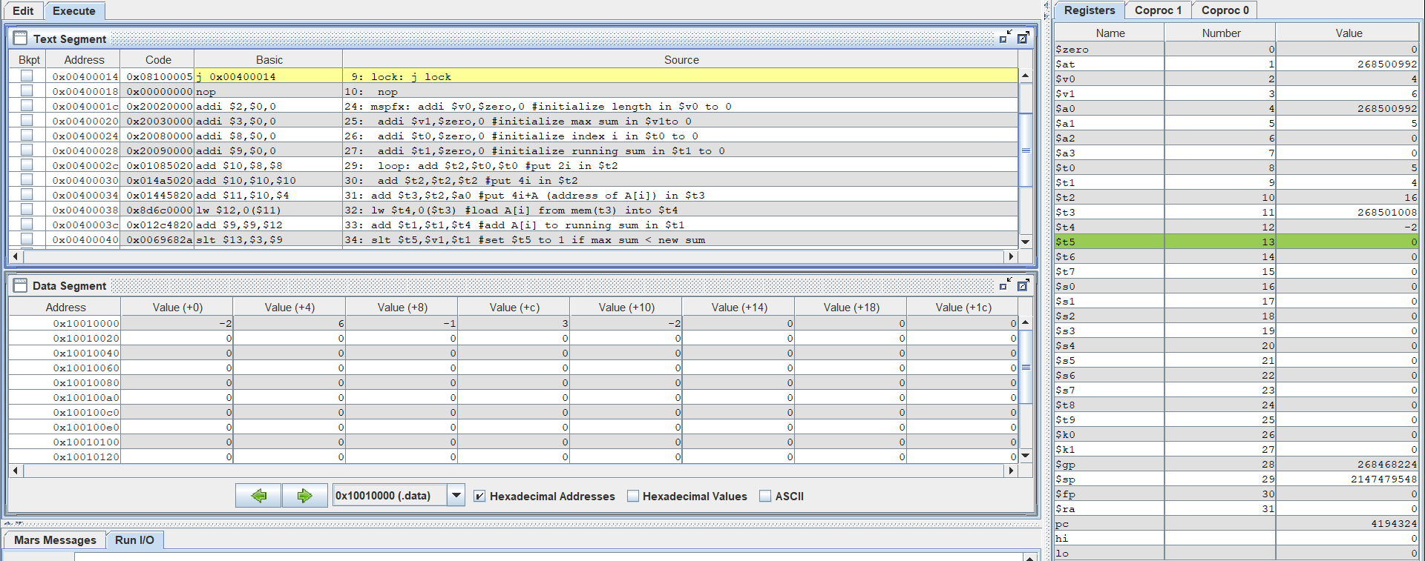

**Nhận xét:**

Chương trình load địa chỉ phần tử đầu tiên của mảng vào a0, rồi sau đó chạy vòng lặp từ đầu array đến cuối và tính tổng prefix vào running sum, lấy phần lớn nhất trong các tổng đã tính vào max sum, nếu running sum hiện tại lớn hơn max sum thì sẽ nhảy đến nhãn mdfy để thay thế max sum bằng running sum.

**Assignment 2**

* Code:

.data

A: .word 7, -2, 5, 1, 5,6,7,3,6,8,8,59,5

Aend: .word

.text

main: la $a0,A #$a0 = Address(A[0])

la $a1,Aend

addi $a1,$a1,-4 #$a1 = Address(A[n-1])

j sort #sort

after_sort: li $v0, 10 #exit

syscall

end_main:

#--------------------------------------------------------------

#procedure sort (ascending selection sort using pointer)

#register usage in sort program

#$a0 pointer to the first element in unsorted part

#$a1 pointer to the last element in unsorted part

#$t0 temporary place for value of last element

#$v0 pointer to max element in unsorted part

#$v1 value of max element in unsorted part

#--------------------------------------------------------------

sort: beq $a0,$a1,done #single element list is sorted

j max #call the max procedure

after_max: lw $t0,0($a1) #load last element into $t0

sw $t0,0($v0) #copy last element to max location

sw $v1,0($a1) #copy max value to last element

addi $a1,$a1,-4 #decrement pointer to last element

j sort #repeat sort for smaller list

done: j after_sort

#------------------------------------------------------------------------

#Procedure max

#function: fax the value and address of max element in the list

#$a0 pointer to first element

#$a1 pointer to last element

#------------------------------------------------------------------------

max:

addi $v0,$a0,0 #init max pointer to first element

lw $v1,0($v0) #init max value to first value

addi $t0,$a0,0 #init next pointer to first

loop:

beq $t0,$a1,ret #if next=last, return

addi $t0,$t0,4 #advance to next element

lw $t1,0($t0) #load next element into $t1

slt $t2,$t1,$v1 #(next)<(max) ?

bne $t2,$zero,loop #if (next)<(max), repeat

addi $v0,$t0,0 #next element is new max element

addi $v1,$t1,0 #next value is new max value

j loop #change completed; now repeat

ret:

j after_max

* Kết quả chạy chương trình:

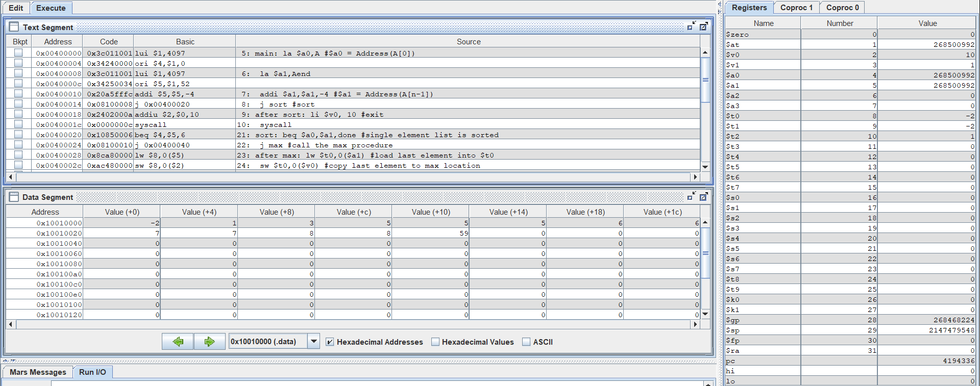

* SORT TỪ LỚN HƠN ĐẾN NHỎ HƠN

.data

A: .word 7, -2, 5, 1, 5,6,7,3,6,8,8,59,5

Aend: .word

.text

main: la $a0,A #$a0 = Address(A[0])

la $a1,Aend

addi $a1,$a1,-4 #$a1 = Address(A[n-1])

j sort #sort

after_sort: li $v0, 10 #exit

syscall

end_main:

#--------------------------------------------------------------

#procedure sort (ascending selection sort using pointer)

#register usage in sort program

#$a0 pointer to the first element in unsorted part

#$a1 pointer to the last element in unsorted part

#$t0 temporary place for value of last element

#$v0 pointer to max element in unsorted part

#$v1 value of max element in unsorted part

#--------------------------------------------------------------

sort: beq $a0,$a1,done #single element list is sorted

j max #call the max procedure

after_max: lw $t0,0($a1) #load last element into $t0

sw $t0,0($v0) #copy last element to max location

sw $v1,0($a1) #copy max value to last element

addi $a1,$a1,-4 #decrement pointer to last element

j sort #repeat sort for smaller list

done: j after_sort

#------------------------------------------------------------------------

#Procedure max

#function: fax the value and address of max element in the list

#$a0 pointer to first element

#$a1 pointer to last element

#------------------------------------------------------------------------

max:

addi $v0,$a0,0 #init max pointer to first element

lw $v1,0($v0) #init max value to first value

addi $t0,$a0,0 #init next pointer to first

loop:

beq $t0,$a1,ret #if next=last, return

addi $t0,$t0,4 #advance to next element

lw $t1,0($t0) #load next element into $t1

slt $t2,$v1,$t1 #(next)<(max) ?

bne $t2,$zero,loop #if (next)<(max), repeat

addi $v0,$t0,0 #next element is new max element

addi $v1,$t1,0 #next value is new max value

j loop #change completed; now repeat

ret:

j after_max

**Assignment 3**

# bubble sort

.data

Arr: .word 1,2,3,4,5,6,7,8,9

.text

.globl main

main:

li $t1,6 # lay so phan tu cua mang

# main_loop -- di vong qua array nhieu lan

main_loop:

subi $a1,$t1,1

blez $a1,main_done

la $a0,Arr

li $t2,0

jal pass_loop

beqz $t2,main_done # trong vong lap hien tai k co swap la xong

subi $t1,$t1,1 # tru di so lan lap con lai

b main_loop

main_done:

j end # end ctr

pass_loop:

lw $s1,0($a0) # load phan tu dau tien vao s1

lw $s2,4($a0) # load phan tu 2 vao s2

bgt $s1,$s2,pass_swap # if (s1 > s2) swap

pass_next:

addiu $a0,$a0,4 # di chuyen toi phan tu tiep theo

subiu $a1,$a1,1

bgtz $a1,pass_loop # kiem tra xem swap chua, neu khong se loop

jr $ra

pass_swap:

sw $s1,4($a0) # cho gia tri cua [i+1] vao s1

sw $s2,0($a0) # cho gia tri cua [i] vao s2

li $t2,1 # da swap

j pass_next

# End the program

end:

li $v0,10

syscall

**Assignment 4**

.data

A: .word

.text

# ---------------------------------------------------------------------

# $a0 store base address of A

# $s1 store value of n

# $s3 store value of i

# ---------------------------------------------------------------------

main:

la $a0, A # $a0 = Address(A[0])

add $s2, $a0, $0 # $s2 -> add(A)

addi $s1, $0, 5 # n = 5

add $s3, $0, $0 # i = 0

generate_arr:

beq $s1, $s3, end_generate # i == n end

li $v0, 5 # read integer

syscall

sw $v0, 0($s2) # A[i] = integer

addi $s2, $s2, 4 # next to A{i+1]

addi $s3, $s3, 1 # i++

j generate_arr

end_generate:

addi $s3, $0, 1 # set i = 1

j sort

# ---------------------------------------------------------------------

# $s2 store value of j

# $t0 is tmp

# $t1 is address of A[i]

# $t2 is address of A[j]

# $t3 to compare A[i] and A[j]

# $t4 is value of key

# $t5 is value of A[j]

# $s0 is address of A[j+1]

# $s4 is value of A[j+1]

# ---------------------------------------------------------------------

after_sort:

li $v0, 10 # exit

syscall

end_main:

sort:

loop_1:

beq $s3, $s1, after_sort # if i == n end sort

addi $s2, $s3, -1 # set j = i - 1

sll $t1, $s3, 2 # $t1 = i*4

add $t1, $a0, $t1 # $t1 -> A[i]

lw $t4, 0($t1) # key = A[i]

j loop_2

after_loop_2:

addi $s3, $s3, 1 # i++

sll $s6, $s2, 2

addi $s6, $s6, 4

add $s0, $s6, $a0

sw $t4, 0($s0) # A[j+1] = key

j loop_1

loop_2:

sll $t2, $s2, 2 # $t2 = j*4

add $t2, $a0, $t2 # $t2 -> A[j]

lw $t5, 0($t2) # $t5 = A[j]

addi $s0, $t2, 4 # $s0 -> A[j+1]

lw $s4, 0($s0) # $s4 = A[j+1]

sgt $t6, $s2, $0 # j >= 0

beq $s2, $0, setequal

next:

sgt $t7, $t5, $t4 # A[j] > key

and $t8, $t6, $t7 # if(j>=n && A[j] > key)

beq $t8, $0, after_loop_2

sw $t5, 0($s0) # A[j+1] = A[j]

addi $s2, $s2, -1 # j--

j loop_2

setequal:

seq $t6, $s2, $0

j next