Screen Spec: SC-06 Forgot password
DBIZ3 Session 4 template — one file per screen. The Screen ID is kept from the DBIZ2 Screen List. The mockup image stays an image; everything around it is text. Each orange numbered badge on the mockup is the row with the same number in section 3 (Element inventory).
Field | Value
Screen ID | SC-06
Screen name | Forgot password
Actor | Guest
Priority | Must
Belongs to module | docs/spec/spec-SYS.md
Mockup image | img/SC-06.png
Status | Draft
Route: /forgot-password · Screen list file: SYS, item #21 (Added 30/09/2026 — Must) · Design note from the screen list file: Send a reset link.
Notes against Screen List v2.0
- New Screen Spec written 30/09/2026; the screen existed in Screen List v2.0 without a mockup.

1. Purpose
Shown when: A guest clicks Forgot password? on the Log in tab of SC-04 (SC-05), or Send a new link on an expired link in SC-07.
The user leaves this screen when: The guest opens the reset link from the email (SC-07), goes back to SC-04, or asks VFDA for help on SC-33.

2. Mockup
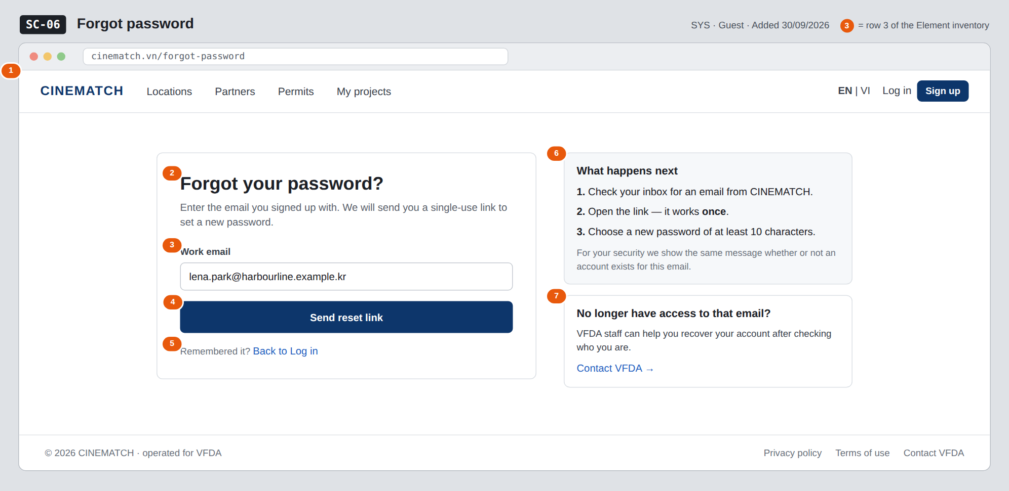
The image is the visual contract (layout, grouping, hierarchy); the tables below are the behavioural contract. All data in the mockup is sample data for one fictional project (The Last Ferry, Harbour Line Films); organisation names, people and phone numbers are examples, not real records.

3. Element inventory
# | Element | Type | Content / data source | Required | Validation
1 | Navigation bar (logged out) | Header | static; EN | VI switch and Log in / Sign up | — | —
2 | Title + explanation | Header | static (bilingual dictionary, F-SYS-06) | — | —
3 | Work email | Input (email) | FR-003 email | Yes | email format; ≤ 254 characters
4 | Send reset link button | Button | static | — | disabled while the email is empty or invalid
5 | Back to Log in link | Link | static | — | —
6 | What happens next block | Text | static | — | —
7 | No longer have access to that email? help | Text + link | static | — | —

4. States
State | What the user sees | Trigger
Default | Empty email field, Send reset link disabled until a valid email is typed (the mockup is pre-filled for illustration). | Open /forgot-password
Empty (no data) | Not applicable — a one-field form with no data list. | —
Loading | The button changes to Sending… and is disabled; the field is locked to prevent a second request. | Click Send reset link
Error | Invalid format: Enter a valid email address under the field. Email provider down: We couldn't send the email right now — try again in a minute; the request is queued and retried (FR-008). | Zod validation fails / email delivery fails
Success / confirmation | The form is replaced by If an account exists for lena.park@harbourline.example.kr, we've sent a reset link (reset_status = sent), with Resend locked for 60 seconds and Back to Log in. | Request accepted by Supabase Auth

5. Interactions and navigation
# | Element | User action | System response | Goes to screen
1 | Email field | type | Validates format on blur | stays
2 | Send reset link | tap | Calls Supabase Auth password reset for email; sends the reset email (F-SYS-08) | stays (confirmation message)
3 | Reset link in the email | tap | Opens the reset page with reset_token | SC-07
4 | Back to Log in | tap | — | SC-05
5 | Contact VFDA | tap | Opens the booking form | SC-33
6 | EN | VI switch | tap | Switches all interface text, keeps the typed email (F-SYS-05) | stays

6. Screen-level rules
Rule ID | Rule | Source
SR-211 | The confirmation message is the same whether or not an account exists for the email, so the page cannot be used to find out who has an account. | Security
SR-212 | The reset link is single-use; tokens and password handling are done by Supabase Auth only. | SYS BR-004; FR-003
SR-213 | A deactivated account (account_status = deactivated) gets the same neutral message but no reset email — a reset never reactivates it. | SYS BR-005
SR-214 | Resend is locked for 60 seconds after each send, as for the verification email. | SYS §3 edge cases

7. Linked requirements
FR ID (from the module spec) | What this screen does for it
FR-003 · spec-SYS.md (F-SYS-03) | Request a single-use password reset link
FR-008 · spec-SYS.md (F-SYS-08) | Reset email from the authenticated domain
FR-005 · spec-SYS.md (F-SYS-05) | Language switch keeps the form

8. Responsive and accessibility notes
- Minimum supported width: 360px.
- Narrow screens: the help blocks move below the form card.
- Every field has a real <label>; errors are linked with aria-describedby and announced when they appear.
- The email field uses type=email and autocomplete=email.

9. Open questions
# | Question | Blocking? | Status
1 | [NEEDS CLARIFICATION: How long is a password reset link valid before it expires (e.g. 1 hour)?] | No | Open

Completion checklist
- ☒ The mockup is a separate cropped image file, named with the Screen ID (img/SC-06.png).
- ☒ Every visible element in the mockup appears in the element inventory — machine-checked: badge numbers on the image = row numbers in section 3.
- ☒ Every input element has a validation rule or an explicit "—".
- ☒ All five states are filled in, or marked "Not applicable" with a reason.
- ☒ Every navigation target is a Screen ID that exists in docs/screen-list.md — machine-checked.
- ☒ Every element that displays data names the field it displays, matching docs/spec/spec-SYS.md section 5.1.
- ☐ Checked by a person: (not signed — a Group C member compares the image with the tables and signs here)

DBIZ3 Session 4 · Group C · CINEMATCH. Built on the DBIZ2 Screen Design (Screen List and Screen Layout).

