Screen Spec: SC-09 Notification centre
DBIZ3 Session 4 template — one file per screen. The Screen ID is kept from the DBIZ2 Screen List. The mockup image stays an image; everything around it is text. Each orange numbered badge on the mockup is the row with the same number in section 3 (Element inventory).
Field | Value
Screen ID | SC-09
Screen name | Notification centre
Actor | Member
Priority | Must
Belongs to module | docs/spec/spec-SYS.md
Mockup image | img/SC-09.png
Status | Draft
Route: /notifications · Screen list file: SYS, item #24 (Added 30/09/2026 — Must) · Design note from the screen list file: List of notifications.
Notes against Screen List v2.0
- New Screen Spec written 30/09/2026. Partner and VFDA roles use the same screen for their own notifications.

1. Purpose
Shown when: A signed-in user opens Notifications from the avatar menu, follows the link in a notification email, or clicks Open the notification centre on SC-08.
The user leaves this screen when: The user opens a notification and goes to the screen it is about (e.g. SC-25, SC-32, SC-33), or stays after marking notifications as read.

2. Mockup
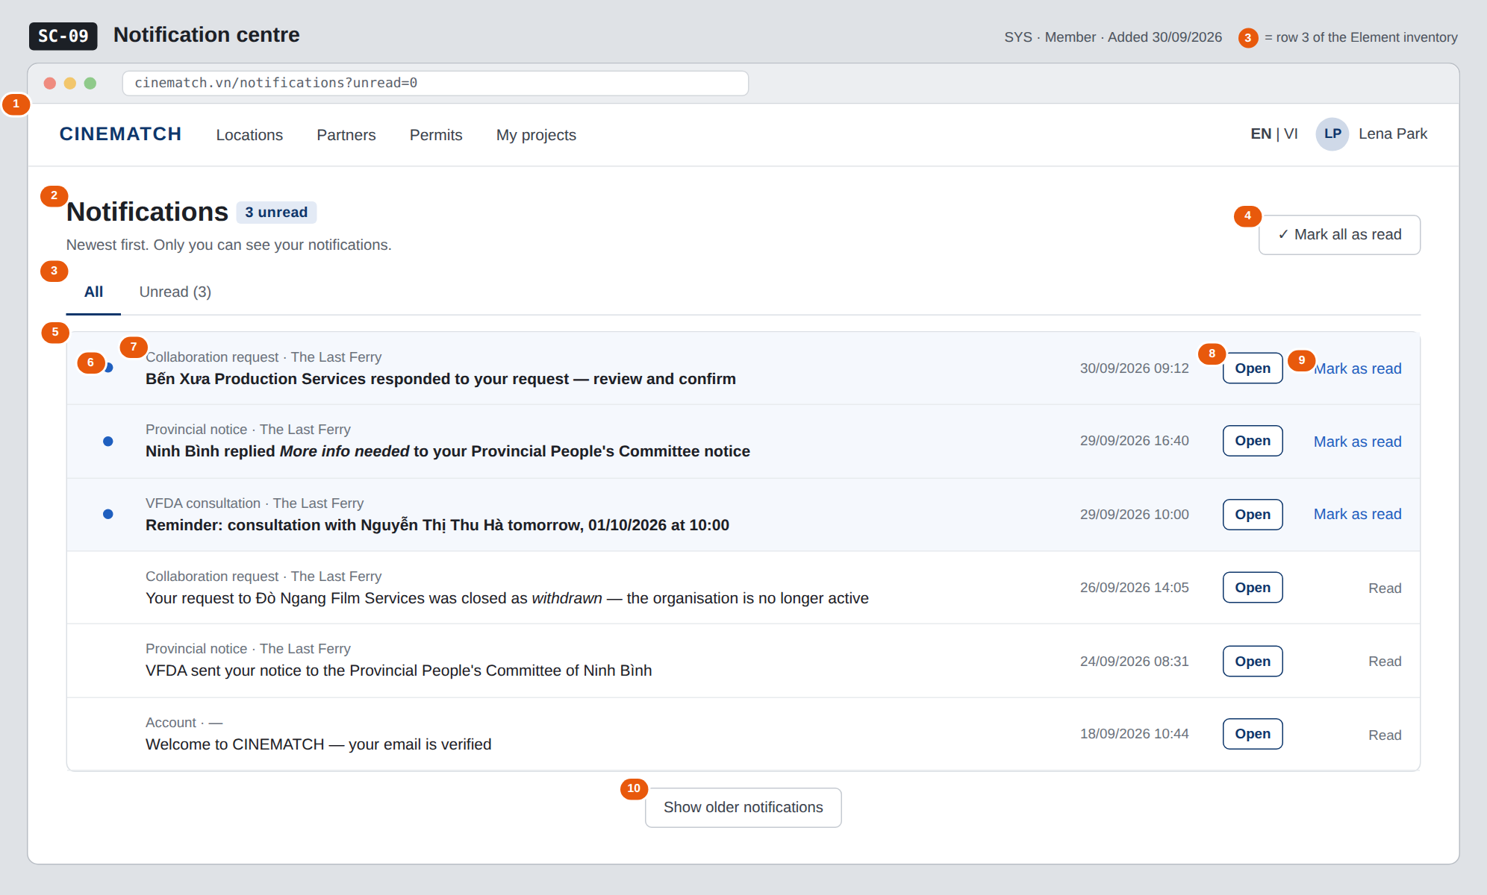
The image is the visual contract (layout, grouping, hierarchy); the tables below are the behavioural contract. All data in the mockup is sample data for one fictional project (The Last Ferry, Harbour Line Films); organisation names, people and phone numbers are examples, not real records.

3. Element inventory
# | Element | Type | Content / data source | Required | Validation
1 | Navigation bar | Header | static | — | —
2 | Title + unread count | Header | FR-009 unread_count | Yes | —
3 | All / Unread filter | Toggle | FR-009 unread_only | No | boolean; kept in the URL
4 | Mark all as read button | Button | sets read_at on every unread notification of the user | — | hidden when unread_count = 0
5 | Notification row | List | FR-009 notifications, newest first by created_at | Yes | only the user's own (recipient_id)
6 | Unread marker | Icon | read_at is empty | — | text alternative Unread
7 | Event label + project | Text | event_type (readable label) + project name from payload | Yes | —
8 | Open button | Button | target screen from payload | — | —
9 | Mark as read link | Link | sets read_at | — | shown on unread rows only
10 | Show older notifications | Button | next page of FR-009 notifications | — | hidden when no older rows

4. States
State | What the user sees | Trigger
Default | Up to 20 notifications, newest first; unread rows tinted and bold with a blue marker; unread count in the title. | Open /notifications
Empty (no data) | No notifications yet — we'll tell you when a partner, a province or VFDA replies. With the Unread filter and nothing unread: You're all caught up. | No notifications / no unread ones
Loading | Six grey skeleton rows; Show older notifications shows a spinner while loading. | Page opens / next page
Error | We couldn't load your notifications — try again with a Retry button; marking as read fails: the row returns to unread with a short message. | Query or update fails
Success / confirmation | After Mark all as read: every row turns to Read, the count disappears, and a short strip reads All notifications marked as read. | Update succeeded

5. Interactions and navigation
# | Element | User action | System response | Goes to screen
1 | Unread tab | tap | Reloads with unread_only = true | stays
2 | Mark all as read | tap | Sets read_at for all unread; count goes to 0 | stays
3 | Open on a collaboration-request row | tap | Marks as read, opens the request | SC-25
4 | Open on a provincial-notice row | tap | Marks as read, opens the project's provinces page | SC-32
5 | Open on a consultation row | tap | Marks as read, opens the booking | SC-33
6 | Mark as read | tap | Sets read_at for that row | stays
7 | Show older notifications | tap | Loads the next 20 | stays

6. Screen-level rules
Rule ID | Rule | Source
SR-241 | A user reads only their own notifications; enforced by Row Level Security on recipient_id. | SYS BR-001; FR-009
SR-242 | Notifications are listed newest first with an unread count. | SYS §3 US-4
SR-243 | Every event addressed to a user creates exactly one in-app notification; the matching email is sent separately and may be retried. | SYS FR-007; FR-008
SR-244 | A notification about an archived project opens it read-only; one about a deactivated organisation still opens the closed request. | M0 BR-005; M4 BR-008

7. Linked requirements
FR ID (from the module spec) | What this screen does for it
FR-007 · spec-SYS.md (F-SYS-07) | Show the in-app notifications created for the user
FR-009 · spec-SYS.md (F-SYS-09) | List newest first, unread filter, mark as read

8. Responsive and accessibility notes
- Minimum supported width: 360px.
- Narrow screens: date moves under the text; Open becomes a tap on the whole row; Mark as read moves into a row menu.
- The unread marker has a text alternative; the unread count is announced when it changes (aria-live=polite).
- The list is a real <ul>; each row is reachable with the keyboard.

9. Open questions
# | Question | Blocking? | Status
1 | [NEEDS CLARIFICATION: Which event_type values exist in the MVP and what readable label does each get? SYS §5.1 declares the field but not its values.] | No | Open

Completion checklist
- ☒ The mockup is a separate cropped image file, named with the Screen ID (img/SC-09.png).
- ☒ Every visible element in the mockup appears in the element inventory — machine-checked: badge numbers on the image = row numbers in section 3.
- ☒ Every input element has a validation rule or an explicit "—".
- ☒ All five states are filled in, or marked "Not applicable" with a reason.
- ☒ Every navigation target is a Screen ID that exists in docs/screen-list.md — machine-checked.
- ☒ Every element that displays data names the field it displays, matching docs/spec/spec-SYS.md section 5.1.
- ☐ Checked by a person: (not signed — a Group C member compares the image with the tables and signs here)

DBIZ3 Session 4 · Group C · CINEMATCH. Built on the DBIZ2 Screen Design (Screen List and Screen Layout).

