Screen Spec: SC-12 Readiness dashboard (5 gauges)
DBIZ3 Session 4 template — one file per screen. The Screen ID is kept from the DBIZ2 Screen List. The mockup image stays an image; everything around it is text. Each orange numbered badge on the mockup is the row with the same number in section 3 (Element inventory).
Field | Value
Screen ID | SC-12
Screen name | Readiness dashboard (5 gauges)
Actor | Member
Priority | Must
Belongs to module | docs/spec/spec-M0.md
Mockup image | img/SC-12.png
Status | Draft
Route: /projects/[id] · Screen list file: M0, item #5 (Tier 1 — Must) · Design note from the screen list file: The central screen; every module writes data here.

1. Purpose
Shown when: A member opens a project from SC-10, has just created a project, or returns from any screen within the project.
The user leaves this screen when: The member clicks a gauge button, the deadline strip, an activity item, or an item in the project sidebar.

2. Mockup
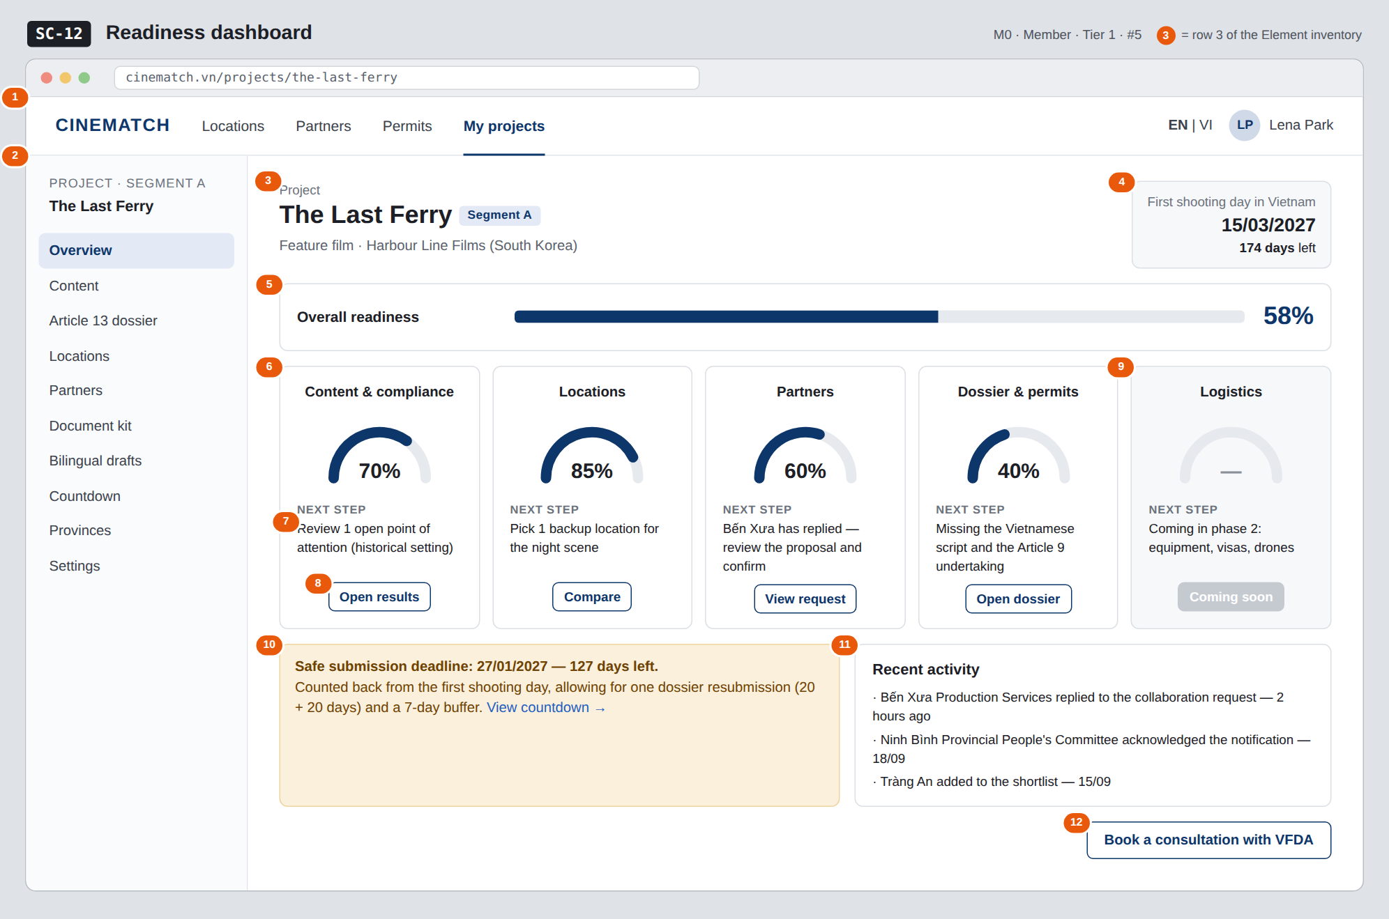
The image is the visual contract (layout, grouping, hierarchy); the tables below are the behavioural contract. All data in the mockup is sample data for one fictional project (The Last Ferry, Harbour Line Films); organisation names, people and phone numbers are examples, not real records.

3. Element inventory
# | Element | Type | Content / data source | Required | Validation
1 | Navigation bar | Header | static | — | —
2 | Project sidebar | List | static: 10 items; Overview selected | — | —
3 | Project name + segment + organisation | Header | projects.name, projects.segment, organizations_producer.name | Yes | —
4 | First shooting day + countdown | Text | projects.shooting_start_date | No | none → not set and a Set date button
5 | Overall readiness | Text + bar | v_project_readiness.overall_score | Yes | 0–100, integer
6 | Gauges (5) | Chart (gauge) | v_project_readiness — one *_score column per gauge | Yes | number of gauges shown depends on the segment — see SR
7 | Next step sentence | Text | F-M0-07 — rule-generated, no language model | Yes | always present; when done, shows Complete
8 | Gauge action button | Button | static; target per gauge | — | —
9 | Logistics gauge (not yet available) | Chart (gauge) | static | — | shows —, not 0%
10 | Safe submission deadline strip | Text | F-M5-08 — safe submission date and days remaining | No | hidden when there is no first shooting day or for segment C
11 | Recent activity | List | project activity_log, 3 latest items | No | —
12 | Book a consultation with VFDA button | Button | static | — | —

4. States
State | What the user sees | Trigger
Default | Project name, countdown, overall bar, 5 gauges with next steps, deadline strip, recent activity. | Open a project with data
Empty (no data) | Newly created project: all gauges at 0%, the first gauge's next step is Start with a content pre-check; activity shows No activity yet; the deadline strip is replaced by Set a first shooting day to calculate the deadline. | Project just created
Loading | Project name appears immediately; grey skeletons for the overall bar and the 5 gauges. | Loading the score view
Error | Scores can't be calculated: each gauge shows — with the line Couldn't calculate readiness. Your project data is safe. plus Try again. Never show a fake 0%. | View error / timeout
Success / confirmation | Returning after completing a task on another screen: the corresponding gauge rises with a short animation, green strip Readiness updated. | Score changes

5. Interactions and navigation
# | Element | User action | System response | Goes to screen
1 | Content & compliance gauge / button | tap | — | SC-48
2 | Locations gauge / button | tap | — | SC-17
3 | Partners gauge / button | tap | — | SC-25
4 | Dossier & permits gauge / button | tap | — | SC-27
5 | Logistics gauge | tap | Not clickable; caption Phase 2 | stays
6 | Deadline strip | tap | — | SC-29
7 | Activity item | tap | Opens the related object | SC-25 / SC-32 / SC-17
8 | Book a consultation with VFDA button | tap | — | SC-33
9 | Sidebar item | tap | — | corresponding screen

6. Screen-level rules
Rule ID | Rule | Source
SR-051 | The Next step sentence is the primary information; the percentage is secondary. This sentence is never empty. | TL4 §4
SR-052 | Scores are computed by the DB view v_project_readiness, not in the browser — every place shows the same number. | TL5 §M0
SR-053 | Number of gauges by segment: segment C has no Dossier & permits gauge; weights are read from segment_requirements. | TL4 §2
SR-054 | A gauge that doesn't apply shows —, not 0% — these are two different things. | No-guessing principle
SR-055 | Every module writes to the dashboard via the readiness_changed event; the dashboard never reads other modules' tables directly. | Screen list file — note #5
SR-056 | The deadline strip uses the same calculation function as SC-29; the two screens must never show different dates. | Consistency principle

7. Linked requirements
FR ID (from the module spec) | What this screen does for it
FR-005 · spec-M0.md (F-M0-05) | Calculate the five gauge scores
FR-006 · spec-M0.md (F-M0-06) | Display the dashboard
FR-007 · spec-M0.md (F-M0-07) | Suggest the next step
FR-008 · spec-M0.md (F-M0-08) | Periodic readiness snapshots
FR-008 · spec-M5.md (F-M5-08) | Deadline from the countdown

8. Responsive and accessibility notes
- Minimum supported width: 360px.
- Narrow screens: the sidebar becomes a dropdown menu at the top of the page; the 5 gauges become a vertical list, one per row (small gauge on the left, next step on the right).
- The Next step sentence must never be truncated with an ellipsis.
- Each gauge has role="meter" with aria-valuenow and a full text label.

9. Open questions
# | Question | Blocking? | Status
1 | [NEEDS CLARIFICATION: weights of the five gauges in the overall score per segment — VFDA to approve before they are written to segment_requirements] | Yes | Open
2 | [NEEDS CLARIFICATION: the 7-day buffer before the first shooting day is a proposed figure — can users change it themselves] | No | Open

Completion checklist
- ☒ The mockup is a separate cropped image file, named with the Screen ID (img/SC-12.png).
- ☒ Every visible element in the mockup appears in the element inventory — machine-checked: badge numbers on the image = row numbers in section 3.
- ☒ Every input element has a validation rule or an explicit "—".
- ☒ All five states are filled in, or marked "Not applicable" with a reason.
- ☒ Every navigation target is a Screen ID that exists in docs/screen-list.md — machine-checked.
- ☒ Every element that displays data names the field it displays, matching docs/spec/spec-M0.md section 5.1.
- ☐ Checked by a person: (not signed — a Group C member compares the image with the tables and signs here)

DBIZ3 Session 4 · Group C · CINEMATCH. Built on the DBIZ2 Screen Design (Screen List and Screen Layout).

