Screen Spec: SC-14 Location suggestions (list + map)
DBIZ3 Session 4 template — one file per screen. The Screen ID is kept from the DBIZ2 Screen List. The mockup image stays an image; everything around it is text. Each orange numbered badge on the mockup is the row with the same number in section 3 (Element inventory).
Field | Value
Screen ID | SC-14
Screen name | Location suggestions (list + map)
Actor | Guest / Member
Priority | Must
Belongs to module | docs/spec/spec-M3.md
Mockup image | img/SC-14.png
Status | Draft
Route: /locations · Screen list file: M3, item #10 (Tier 1 — Must) · Design note from the screen list file: Shows match score and why it matches.
Notes against Screen List v2.0
- SC-14 was previously called Location search (filters + grid + map). It is now the shared results screen for two entry points: from a description (SC-15) or from filters. The list + map structure is unchanged.

1. Purpose
Shown when: The user clicks Find matching locations on SC-15, picks the By filters tab, or opens a shared results link.
The user leaves this screen when: The user opens a location (SC-16) or opens the comparison (SC-17).

2. Mockup
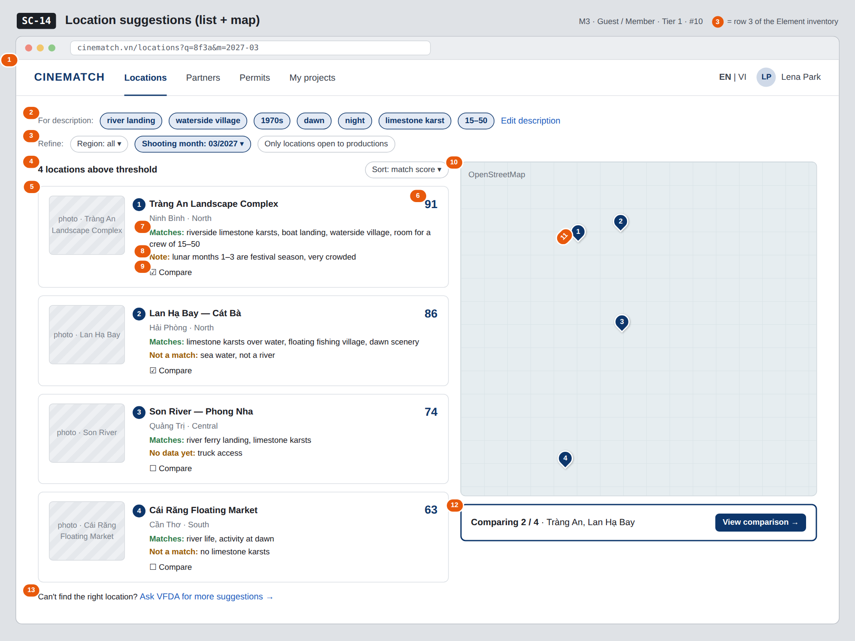
The image is the visual contract (layout, grouping, hierarchy); the tables below are the behavioural contract. All data in the mockup is sample data for one fictional project (The Last Ferry, Harbour Line Films); organisation names, people and phone numbers are examples, not real records.

3. Element inventory
# | Element | Type | Content / data source | Required | Validation
1 | Navigation bar | Header | static | — | —
2 | Query summary + Edit description | List (chip) + Link | location_queries.attributes | — | —
3 | Additional filters | Toggle | region, shooting month, only locations open to productions | No | written to the URL (nuqs)
4 | Result count + sort | Text + Toggle | count of results above threshold; sort by score / name / distance | — | —
5 | Result card | List | locations.name, provinces.name, provinces.region, locations.cover_image | — | published locations only
6 | Match score | Text | F-M3-08 — 0–100 score computed in the database | — | only cards scoring ≥ 40 are shown
7 | Why it matches | Text | generated from the matched criteria — not written by a language model | Yes | at least one reason; no reason, no card
8 | Not a match / notes | Text | unmatched criteria, missing data, seasonal warnings for the shooting month | No | No data yet is distinct from Not a match
9 | Compare checkbox | Toggle (checkbox) | session comparison basket | — | max 4
10 | Map | Map | Leaflet + OpenStreetMap; coordinates locations.geom | — | —
11 | Numbered pin | Map marker | one pin per card, same number as the card | — | pin number = card number
12 | Comparison tray | Container | comparison basket | — | hidden when the basket is empty
13 | Ask VFDA for more suggestions link | Link | static | — | —

4. States
State | What the user sees | Trigger
Default | Query summary, additional filters, numbered card list on the left, map with matching numbered pins on the right, comparison tray. | Results ≥ 40 points
Empty (no data) | No card ≥ 40 points: show the 3 closest locations under the heading No locations reach the threshold — here are the 3 closest, each card stating the unmatched criteria; Ask VFDA for suggestions button. Never a blank page. | 0 results above threshold
Loading | Grey placeholders the size of the cards; the map keeps the old pins until new data arrives. | Scoring
Error | Couldn't load results. Your description and filters have been kept. + Try again. | Query error
Success / confirmation | Ticking Compare → tray updates to Comparing n / 4. Ticking a 5th: Maximum 4 locations — remove one to add another. | Added to basket

5. Interactions and navigation
# | Element | User action | System response | Goes to screen
1 | Edit description | tap | Carries the current query | SC-15
2 | Additional filters | tap | Re-scores immediately, no Search button; written to the URL | stays
3 | Result card | tap | — | SC-16
4 | Map pin | tap | Scrolls to and highlights the card with the same number | stays
5 | Compare checkbox | tap | Adds to / removes from the basket | stays
6 | View comparison | tap | — | SC-17
7 | Ask VFDA for more suggestions | tap | Books a session, attaching the query | SC-33

6. Screen-level rules
Rule ID | Rule | Source
SR-101 | Every card must show a match score and why it matches; reasons are generated from criteria, not written by a language model. | Screen list file — note #10; anti-black-box
SR-102 | Three kinds of information are kept apart: Matches / Not a match / No data yet. Missing data is never counted as a match or a mismatch. | No-guessing principle
SR-103 | Map pins carry the same number as the cards — users can link a card to its location without hovering. | Fixes old mockup: unnumbered pins
SR-104 | Display threshold is 40 points; below it, switch to a guided empty state. | TL5 §M3
SR-105 | Seasonal warnings are computed from the project's shooting month, not shown generically. | TL5 §M3
SR-106 | Province names follow the list of 34 units after the 2025 reorganisation (e.g. Phong Nha is in Quảng Trị, no longer Quảng Bình). | 2025 administrative reorganisation resolution

7. Linked requirements
FR ID (from the module spec) | What this screen does for it
FR-007 · spec-M3.md (F-M3-07) | Multi-criteria filters
FR-008 · spec-M3.md (F-M3-08) | Scoring and ranking
FR-009 · spec-M3.md (F-M3-09) | Results grid with why it matches
FR-014 · spec-M3.md (F-M3-14) | Map
FR-016 · spec-M3.md (F-M3-16) | Select up to four locations

8. Responsive and accessibility notes
- Minimum supported width: 360px.
- Narrow screens: the map becomes a List | Map toggle; the comparison tray sticks to the bottom of the screen.
- The match score is always a number, never colour alone.
- The card list is a full alternative to the map for non-mouse users.

9. Open questions
# | Question | Blocking? | Status
1 | [NEEDS CLARIFICATION: criterion weights in the scoring formula — VFDA to approve before configuring scoring_weights] | Yes | Open
2 | [NEEDS CLARIFICATION: the 40-point threshold is a proposal and needs tuning once real data is available] | No | Open

Completion checklist
- ☒ The mockup is a separate cropped image file, named with the Screen ID (img/SC-14.png).
- ☒ Every visible element in the mockup appears in the element inventory — machine-checked: badge numbers on the image = row numbers in section 3.
- ☒ Every input element has a validation rule or an explicit "—".
- ☒ All five states are filled in, or marked "Not applicable" with a reason.
- ☒ Every navigation target is a Screen ID that exists in docs/screen-list.md — machine-checked.
- ☒ Every element that displays data names the field it displays, matching docs/spec/spec-M3.md section 5.1.
- ☐ Checked by a person: (not signed — a Group C member compares the image with the tables and signs here)

DBIZ3 Session 4 · Group C · CINEMATCH. Built on the DBIZ2 Screen Design (Screen List and Screen Layout).

