Screen Spec: SC-15 Scene description (AI Matching input)
DBIZ3 Session 4 template — one file per screen. The Screen ID is kept from the DBIZ2 Screen List. The mockup image stays an image; everything around it is text. Each orange numbered badge on the mockup is the row with the same number in section 3 (Element inventory).
Field | Value
Screen ID | SC-15
Screen name | Scene description (AI Matching input)
Actor | Guest / Member
Priority | Must
Belongs to module | docs/spec/spec-M3.md
Mockup image | img/SC-15.png
Status | Draft
Route: /locations/describe · Screen list file: M3, item #9 (Tier 1 — Must) · Design note from the screen list file: Free-text input with structure hints.

1. Purpose
Shown when: The user clicks Where should we shoot each scene? on SC-01, Locations in the navigation bar, or Edit description on SC-14.
The user leaves this screen when: The user clicks Find matching locations (to SC-14) or switches to the By filters tab.

2. Mockup
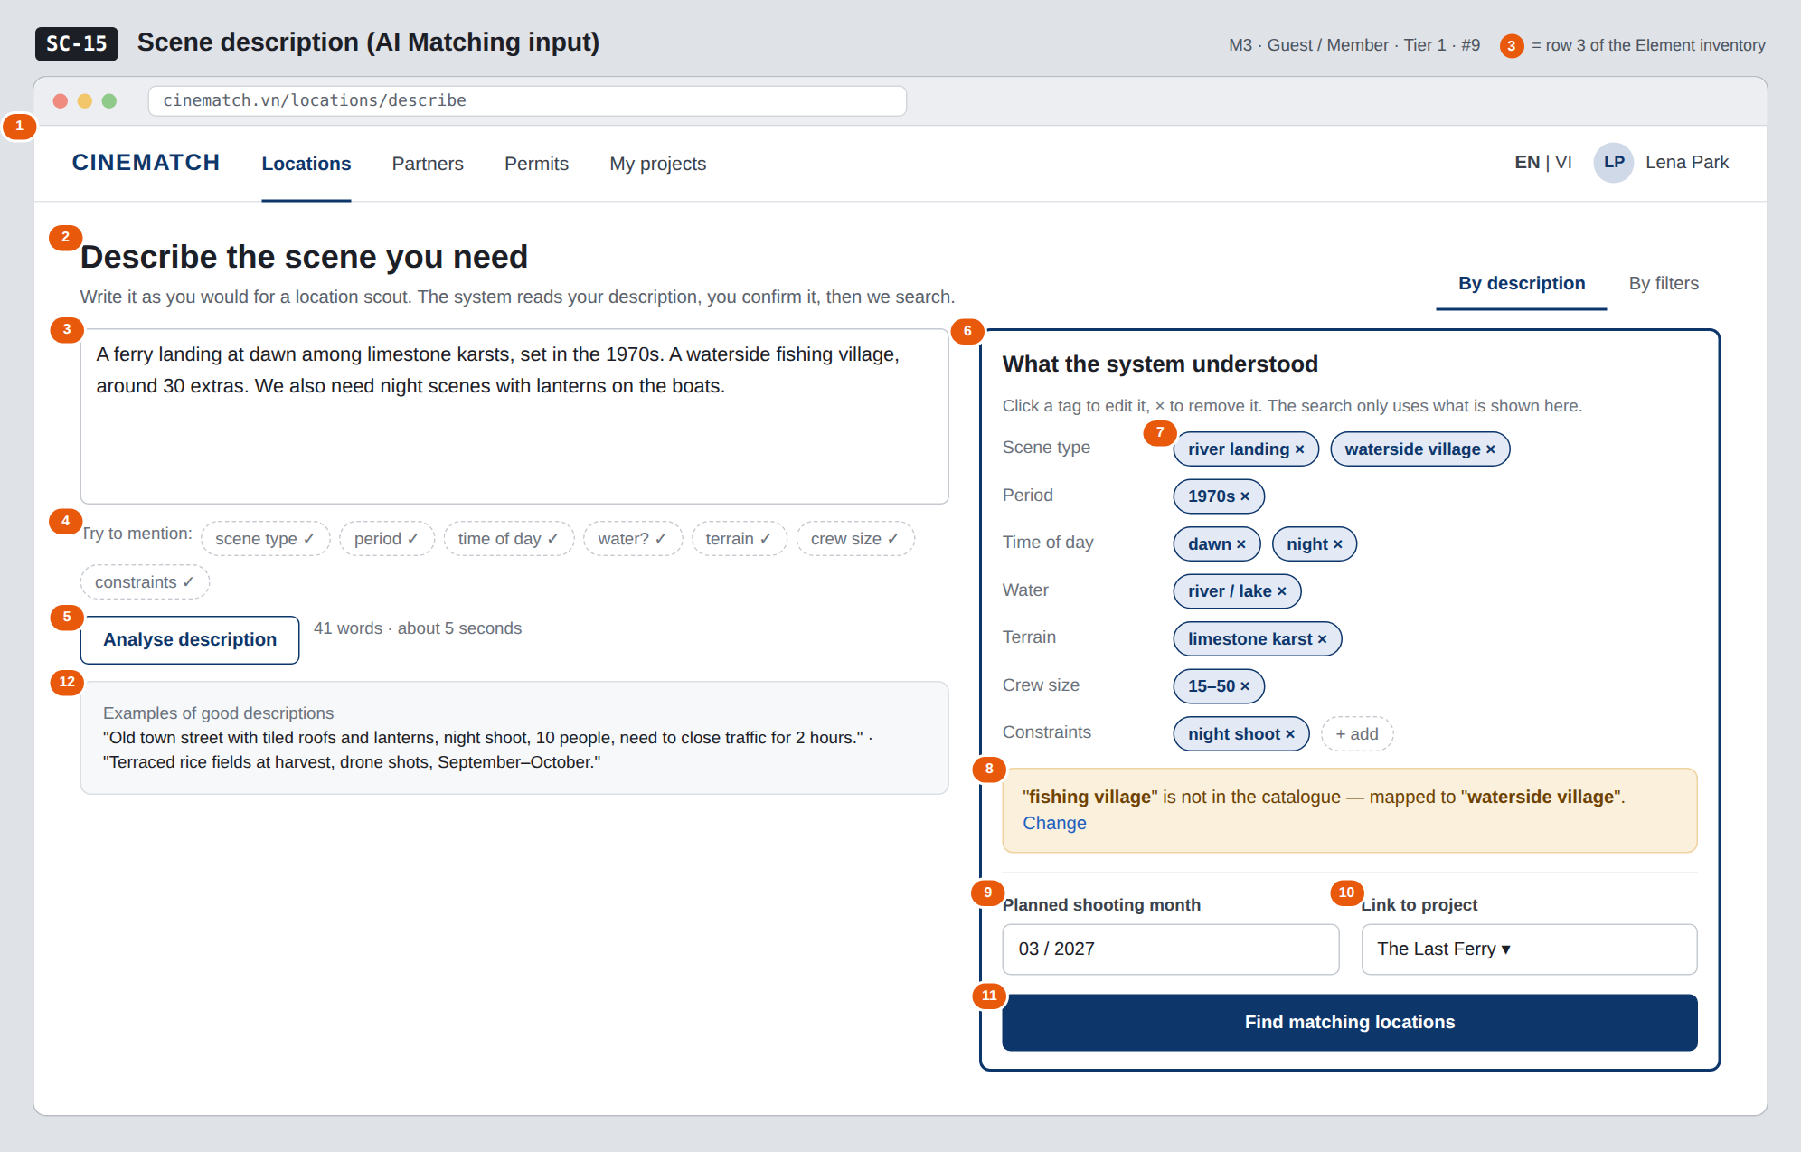
The image is the visual contract (layout, grouping, hierarchy); the tables below are the behavioural contract. All data in the mockup is sample data for one fictional project (The Last Ferry, Harbour Line Films); organisation names, people and phone numbers are examples, not real records.

3. Element inventory
# | Element | Type | Content / data source | Required | Validation
1 | Navigation bar | Header | static | — | —
2 | Title + mode switch | Header + Toggle | static: By description / By filters | — | —
3 | Scene description box | Input (textarea) | location_queries.description | Yes | 10–1000 characters (Function List F-M3-10)
4 | Structure hints (chips) | List | 7 attribute groups; a chip ticks ✓ automatically once the description covers it | — | hints only, never blocking
5 | Analyse description button | Button | calls F-M3-11 | — | disabled under 10 characters
6 | What the system understood block | Container | location_queries.attributes (JSONB) | Yes | only values from the catalogue (F-M3-12)
7 | Attribute tag | Toggle (edit / remove chip) | one value in attributes | — | accepts catalogue values only
8 | Mapping warning | Text | term not in the catalogue and the value it was mapped to | — | always shown when a mapping occurs; has a Change button
9 | Planned shooting month | Input (month/year) | location_queries.month; prefilled from projects.shooting_start_date | No | valid month, not in the past
10 | Link to project | Toggle (dropdown) | location_queries.project_id | No | user's own projects only; hidden for guests
11 | Find matching locations button | Button | static | — | disabled when the attribute block is empty
12 | Examples of good descriptions | Text | static | — | —

4. States
State | What the user sees | Trigger
Default | Empty description box with examples; What the system understood block greyed out with the line Analyse your description to see what the system understood. The mockup shows the state after analysis. | Page opens
Empty (no data) | Analysis finished but no attributes extracted: We couldn't understand the description — try stating the scene type and terrain + switch to By filters. | Empty extraction result
Loading | Analyse description button shows a spinner; the attribute block shows 7 grey placeholder rows. | Calling F-M3-11
Error | Couldn't analyse right now. + Try again + a Search by filters option. The typed description is kept. | Model error / timeout
Success / confirmation | Attribute block filled, Find matching locations enabled. Clicking search → SC-14. | Extraction succeeded

5. Interactions and navigation
# | Element | User action | System response | Goes to screen
1 | Description box | type | Ticks ✓ the matching hint chips | stays
2 | Analyse description button | tap | Calls F-M3-11, validates against the F-M3-12 catalogue | stays
3 | Attribute tag | tap | Opens the list of values in the same group to change it | stays
4 | × on a tag | tap | Removes the attribute from the query | stays
5 | Change in the mapping warning | tap | Pick another catalogue value | stays
6 | By filters tab | tap | Opens results with the filter panel | SC-14
7 | Find matching locations button | tap | Saves the query, runs F-M3-08 scoring | SC-14

6. Screen-level rules
Rule ID | Rule | Source
SR-091 | Two separate steps: the language model only extracts attributes; ranking is done by the deterministic scorer in the database. The model never proposes location names itself. | TL4 — hybrid M3 design
SR-092 | Users can see and edit every attribute before searching. The search only uses the attributes shown in the block. | Anti-black-box principle
SR-093 | Every attribute must come from the fixed catalogue; unknown terms are mapped to the nearest value and flagged clearly, never silently dropped. | F-M3-12
SR-094 | Guests can use it too; the Link to project field is shown to members only. | TL4 §3

7. Linked requirements
FR ID (from the module spec) | What this screen does for it
FR-010 · spec-M3.md (F-M3-10) | Scene description input
FR-011 · spec-M3.md (F-M3-11) | Extract structured attributes
FR-012 · spec-M3.md (F-M3-12) | Validate attributes against the catalogue

8. Responsive and accessibility notes
- Minimum supported width: 360px.
- Narrow screens: the What the system understood block moves below the description box; the Find button sticks to the bottom of the screen.
- Attribute tags are <button> elements with full labels (Remove attribute: river landing).
- The mapping warning is announced via aria-live.

9. Open questions
# | Question | Blocking? | Status
1 | [NEEDS CLARIFICATION: fixed attribute catalogue (scene type, terrain, period…) — who approves and maintains it] | Yes | Open

Completion checklist
- ☒ The mockup is a separate cropped image file, named with the Screen ID (img/SC-15.png).
- ☒ Every visible element in the mockup appears in the element inventory — machine-checked: badge numbers on the image = row numbers in section 3.
- ☒ Every input element has a validation rule or an explicit "—".
- ☒ All five states are filled in, or marked "Not applicable" with a reason.
- ☒ Every navigation target is a Screen ID that exists in docs/screen-list.md — machine-checked.
- ☒ Every element that displays data names the field it displays, matching docs/spec/spec-M3.md section 5.1.
- ☐ Checked by a person: (not signed — a Group C member compares the image with the tables and signs here)

DBIZ3 Session 4 · Group C · CINEMATCH. Built on the DBIZ2 Screen Design (Screen List and Screen Layout).

