Screen Spec: SC-20 Partner profile
DBIZ3 Session 4 template — one file per screen. The Screen ID is kept from the DBIZ2 Screen List. The mockup image stays an image; everything around it is text. Each orange numbered badge on the mockup is the row with the same number in section 3 (Element inventory).
Field | Value
Screen ID | SC-20
Screen name | Partner profile
Actor | Guest / Member
Priority | Must
Belongs to module | docs/spec/spec-M4.md
Mockup image | img/SC-20.png
Status | Draft
Route: /partners/[slug] · Screen list file: M4, item #13 (Tier 1 — Must) · Design note from the screen list file: Organisation profile with three permission-based visibility layers.
Notes against Screen List v2.0
- In the old mockup set, the organisation profile was drawn inside the SC-19 image. SC-20 now has its own mockup.

1. Purpose
Shown when: The user clicks an organisation card on SC-19, or the partner name in a request on SC-25.
The user leaves this screen when: The user clicks Send collaboration request (SC-23) or returns to the directory.

2. Mockup
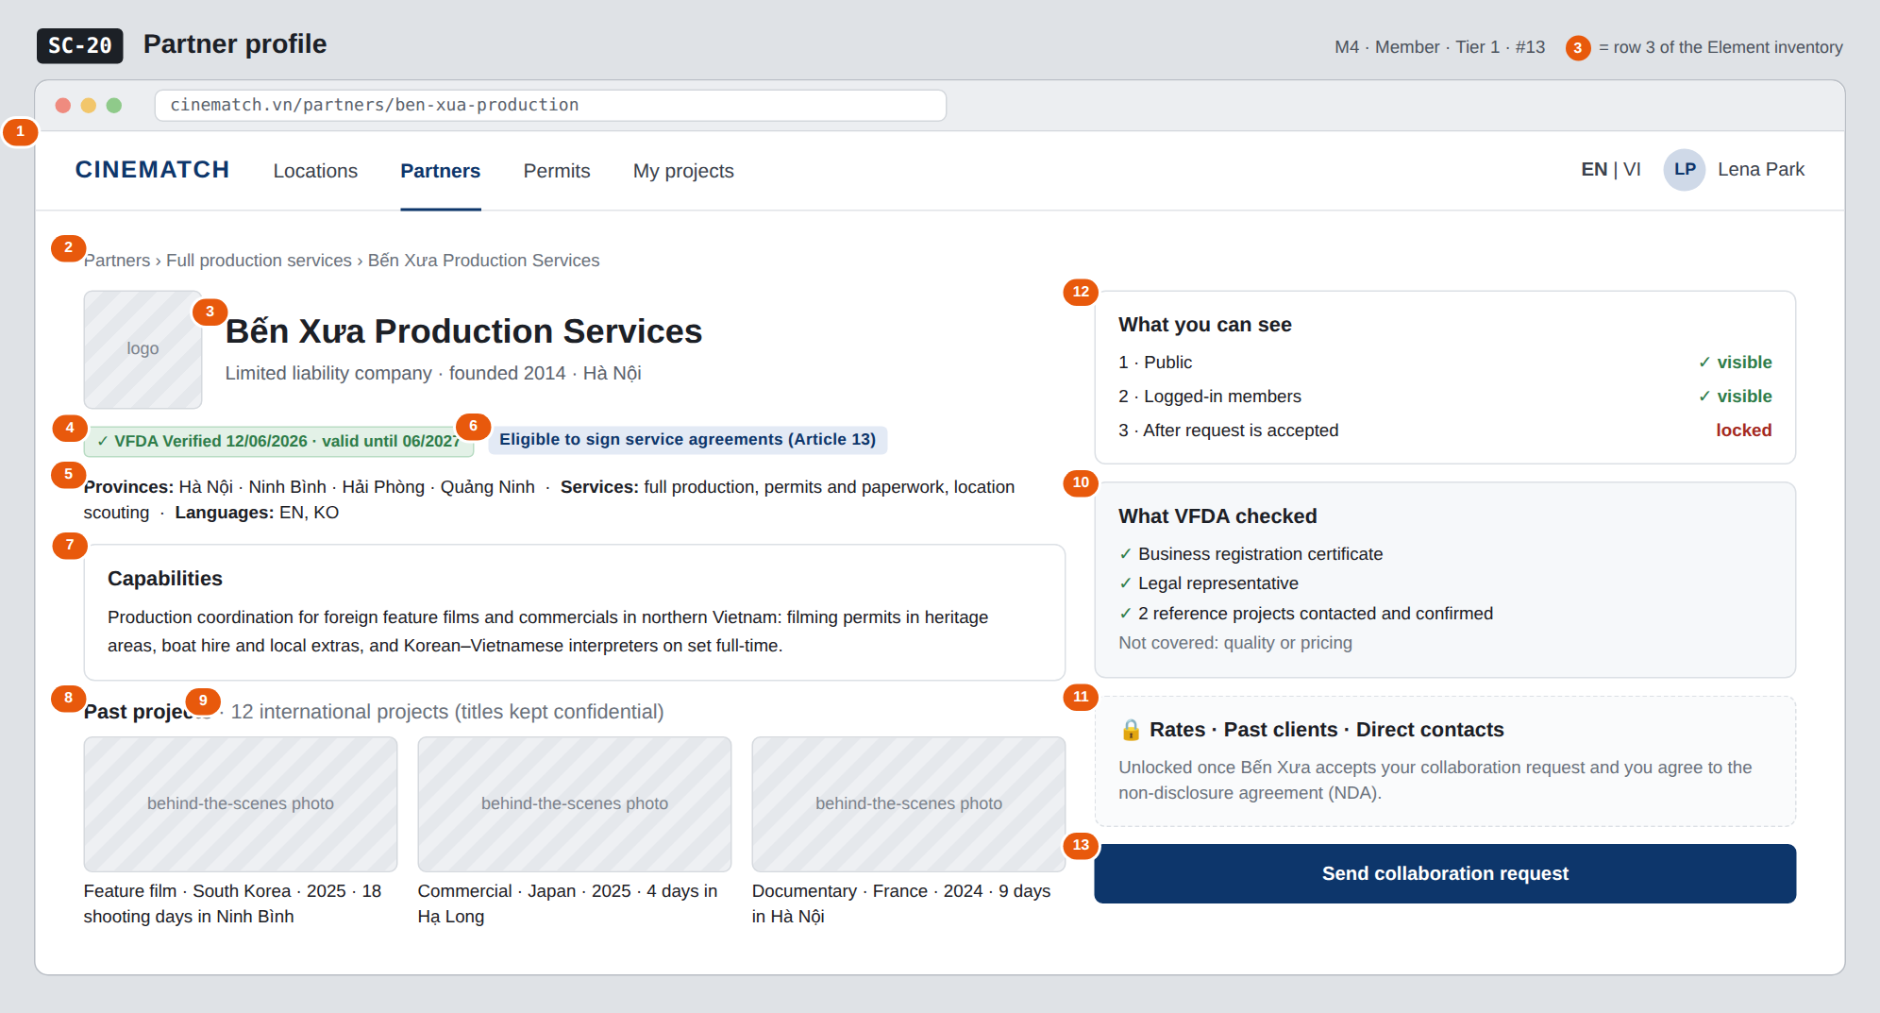
The image is the visual contract (layout, grouping, hierarchy); the tables below are the behavioural contract. All data in the mockup is sample data for one fictional project (The Last Ferry, Harbour Line Films); organisation names, people and phone numbers are examples, not real records.

3. Element inventory
# | Element | Type | Content / data source | Required | Validation
1 | Navigation bar | Header | static | — | —
2 | Breadcrumb | Text | Partners › service group › organisation name | — | —
3 | Logo + organisation name + legal entity | Header | organizations.name, legal_form, founded_year, hq_province | Yes | public layer
4 | VFDA Verified badge + validity | Text | organizations.verified_at, verified_until | — | hidden once expired
5 | Provinces, services, languages | Text | organization_provinces, organization_services, working_languages | Yes | public layer
6 | Eligible to sign service agreements (Article 13) badge | Text | organizations.art13_eligible — confirmed by VFDA | — | only VFDA can switch it on
7 | Capabilities block | Text | organization_profiles_member.capability | — | member layer
8 | Past projects (portfolio) | List + Image | organization_portfolio — type, country, year, days, filming place | — | member layer; no project titles
9 | International project count | Text | organizations.intl_project_count | — | member layer
10 | What VFDA checked block | List | verification_checks from the latest verification | Yes | also states what was not checked
11 | Locked layer 3 block | Container | organization_profiles_accepted — rates, past clients, contacts | — | RLS: only unlocked with an accepted request and an agreed NDA
12 | Three-layer indicator | List | computed from the viewer's permissions | Yes | reflects actual permissions
13 | Send collaboration request button | Button | static | — | hidden when a request is already open — replaced by View request

4. States
State | What the user sees | Trigger
Default | The mockup shows the member view (layers 1 and 2 open, layer 3 locked). For guests: blocks 7, 8, 9 are replaced by a box Log in to see capabilities and past projects. | Open an organisation profile
Empty (no data) | Organisation has no portfolio: This organisation hasn't added reference projects yet. Empty capabilities block: hide the block, no empty box. | Missing layer 2 data
Loading | Grey placeholders for the capabilities and portfolio blocks; the public layer is pre-rendered. | Loading
Error | Organisation hidden or not found → dedicated 404 with a button back to SC-19. | Not found
Success / confirmation | Once the request is accepted and the NDA agreed: block 11 reveals rates, past clients and contacts; the layer 3 indicator switches to ✓ visible. | Request accepted + NDA

5. Interactions and navigation
# | Element | User action | System response | Goes to screen
1 | Send collaboration request button | tap | Not logged in → SC-04; logged in → compose request | SC-23
2 | Portfolio photo | tap | Opens a large view | stays
3 | Service group in breadcrumb | tap | — | SC-19
4 | Locked layer 3 block | tap | Explains how to unlock it | stays

6. Screen-level rules
Rule ID | Rule | Source
SR-131 | The three information layers are enforced by RLS on three tables, not by hiding columns in the UI. | Database-layer security principle
SR-132 | The portfolio does not name projects at the member layer — many production contracts contain confidentiality clauses. | TL5 §M4
SR-133 | The Eligible to sign service agreements (Article 13) badge can only be switched on by VFDA, and is decisive for segment A productions. | Cinema Law 2022, Article 13 cl.3
SR-134 | The What VFDA checked block also states what was not checked (quality, pricing) to avoid it being read as a guarantee. | Accountability principle
SR-135 | Two-way reviews belong to phase 2 (M8) — not on this screen in the MVP. | MVP scope

7. Linked requirements
FR ID (from the module spec) | What this screen does for it
FR-002 · spec-M4.md (F-M4-02) | Public-level profile
FR-003 · spec-M4.md (F-M4-03) | Member-level profile
FR-004 · spec-M4.md (F-M4-04) | Accepted-level profile
FR-012 · spec-M4.md (F-M4-12) | Send request entry point

8. Responsive and accessibility notes
- Minimum supported width: 360px.
- Narrow screens: the right column moves below the introduction; the Send request button sticks to the bottom of the screen.
- The lock icon is accompanied by explanatory text.
- The three-layer indicator is a list with text statuses, not colour alone.

9. Open questions
# | Question | Blocking? | Status
1 | [NEEDS CLARIFICATION: criteria for VFDA to grant the Eligible to sign service agreements badge — which registered business lines qualify] | Yes | Open
2 | [NEEDS CLARIFICATION: can an organisation choose to hide its international project count] | No | Open

Completion checklist
- ☒ The mockup is a separate cropped image file, named with the Screen ID (img/SC-20.png).
- ☒ Every visible element in the mockup appears in the element inventory — machine-checked: badge numbers on the image = row numbers in section 3.
- ☒ Every input element has a validation rule or an explicit "—".
- ☒ All five states are filled in, or marked "Not applicable" with a reason.
- ☒ Every navigation target is a Screen ID that exists in docs/screen-list.md — machine-checked.
- ☒ Every element that displays data names the field it displays, matching docs/spec/spec-M4.md section 5.1.
- ☐ Checked by a person: (not signed — a Group C member compares the image with the tables and signs here)

DBIZ3 Session 4 · Group C · CINEMATCH. Built on the DBIZ2 Screen Design (Screen List and Screen Layout).

