Screen Spec: SC-27 Article 13 dossier completeness check
DBIZ3 Session 4 template — one file per screen. The Screen ID is kept from the DBIZ2 Screen List. The mockup image stays an image; everything around it is text. Each orange numbered badge on the mockup is the row with the same number in section 3 (Element inventory).
Field | Value
Screen ID | SC-27
Screen name | Article 13 dossier completeness check
Actor | Member
Priority | Must
Belongs to module | docs/spec/spec-M2.md
Mockup image | img/SC-27.png
Status | Draft
Route: /projects/[id]/dossier-check · Screen list file: M2, item #8 (Tier 1 — Must) · Design note from the screen list file: Checklist with a status for each item.
Notes against Screen List v2.0
- In the previous Screen List, SC-27 covered both dossier completeness and content review. Content review has moved to SC-48. SC-27 now only checks the 4 components under Article 13 clause 3.

1. Purpose
Shown when: The member clicks the Dossier & permits gauge on SC-12, the Article 13 dossier item in the sidebar, or has just uploaded a document on SC-26.
The user leaves this screen when: The member clicks a component's action (draft the Vietnamese version, view the collaboration request, upload) or opens the countdown.

2. Mockup
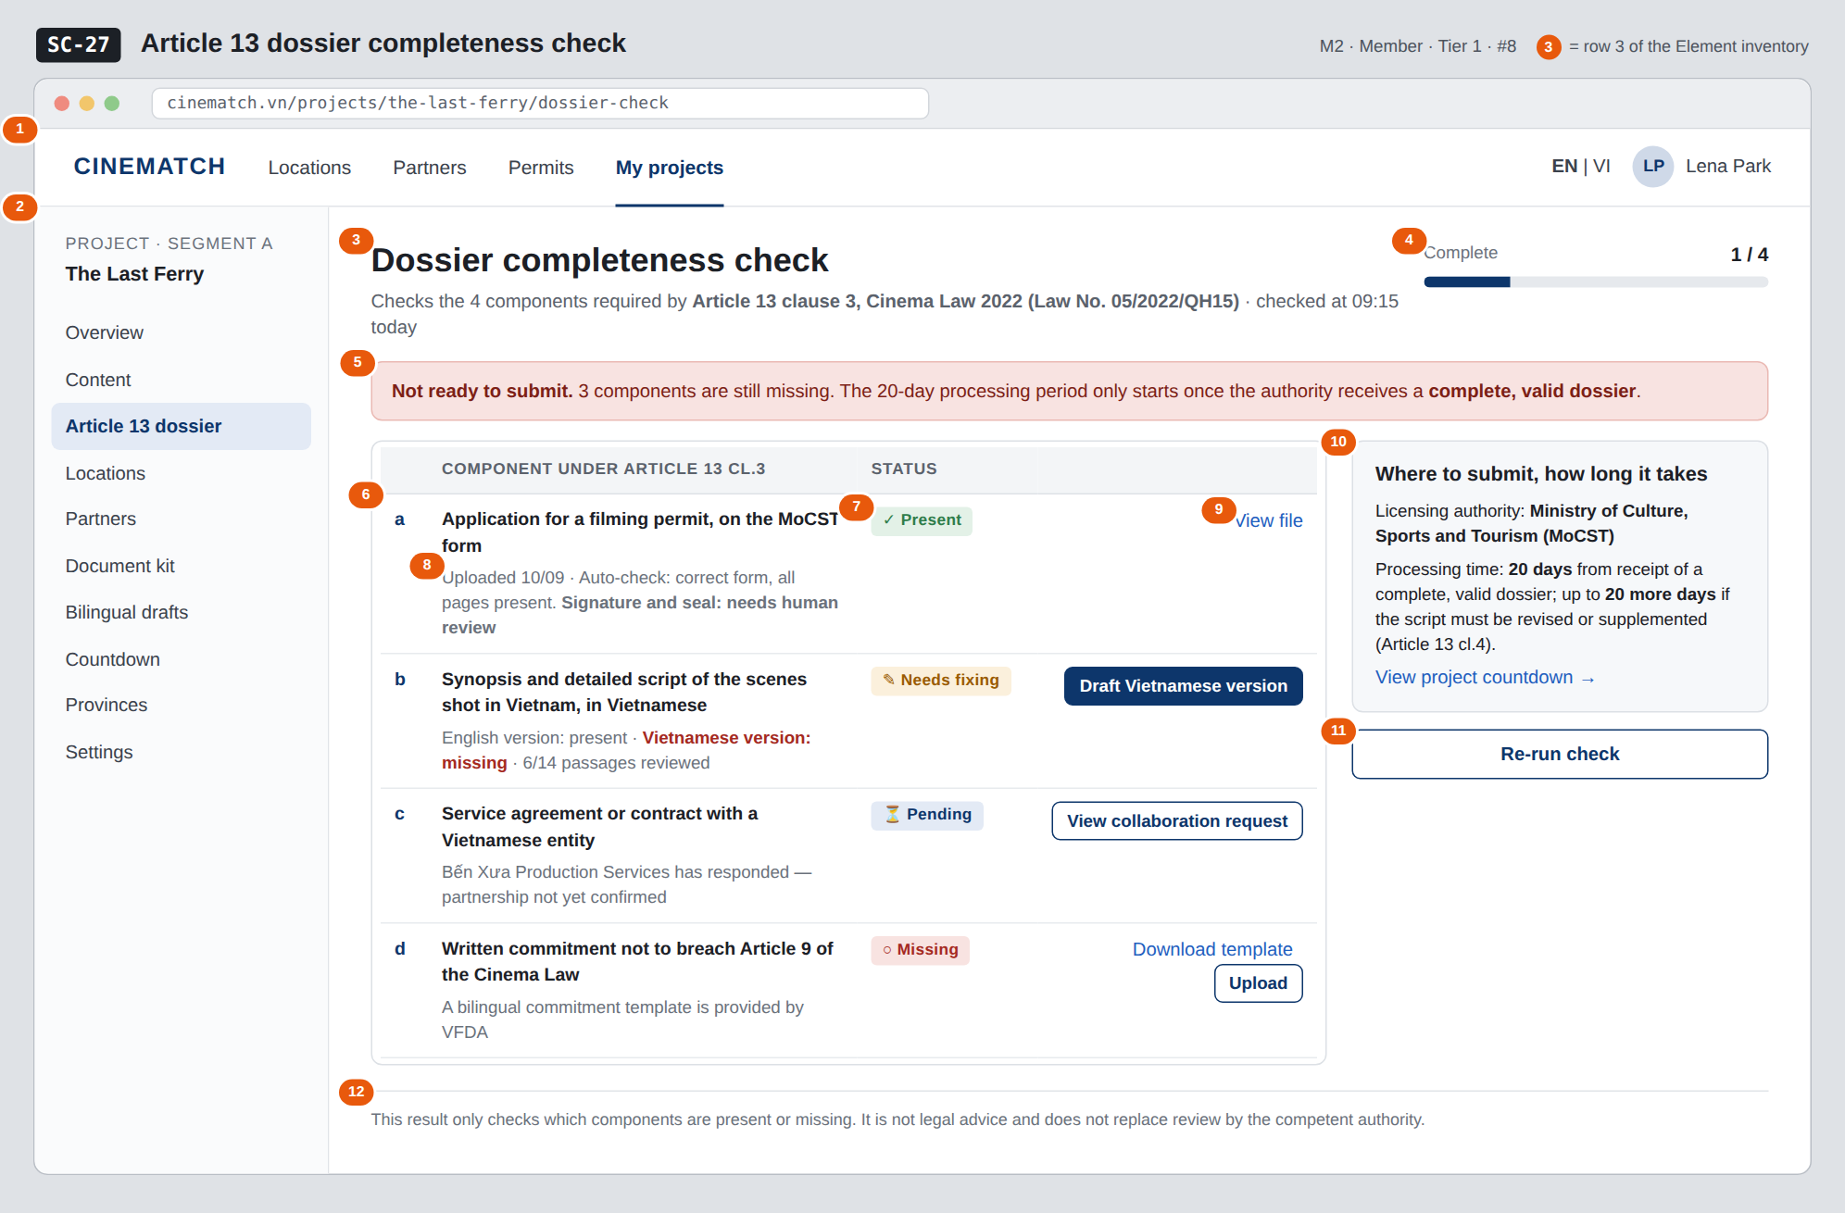
The image is the visual contract (layout, grouping, hierarchy); the tables below are the behavioural contract. All data in the mockup is sample data for one fictional project (The Last Ferry, Harbour Line Films); organisation names, people and phone numbers are examples, not real records.

3. Element inventory
# | Element | Type | Content / data source | Required | Validation
1 | Navigation bar | Header | static | — | —
2 | Project sidebar | List | static; Article 13 dossier item selected | — | —
3 | Title + legal basis + check time | Header + Text | static + dossier_checks.checked_at | Yes | —
4 | Progress x / 4 | Text + bar | count of components with status Present | Yes | 0–4
5 | Verdict banner | Text | derived from progress: 4/4 → All components present; any missing → Not ready to submit | Yes | never use the words passed or approved
6 | Component rows (a, b, c, d) | List | the project's document_slots of type art13_* | Yes | exactly 4 rows, ordered a–d as in Article 13 cl.3
7 | Status label | Text | document_slots.status — present / needs_fix / pending / missing | Yes | always icon plus text
8 | Check details | Text | document_slots.auto_checks + needs_human_review | — | must clearly separate auto-checked from needs human review
9 | Component action | Button / Link | by status: View file / Draft Vietnamese version / View collaboration request / Download template + Upload | — | —
10 | Where to submit, how long it takes block | Text | static; wording approved by the VFDA Legal Board | Yes | quotes Article 13 cl.4 accurately
11 | Re-run check button | Button | static | — | —
12 | Disclaimer | Text | static | Yes | always shown

4. States
State | What the user sees | Trigger
Default | Progress, verdict banner, table of 4 components with status and action, authority & processing-time block. | Screen opens
Empty (no data) | No documents yet: all 4 rows at ○ Missing, red Not ready to submit banner, each row offers Download template and Upload. | Project has no uploads
Loading | Grey placeholders for the 4 rows; title and processing-time block show immediately as they are static. | Loading status
Error | A file cannot be read: that row switches to ✎ Needs fixing with the reason File is corrupted or password-protected — upload an unlocked PDF. Page load failure: Couldn't load dossier status + Try again. | Bad file / query error
Success / confirmation | 4/4 complete: banner turns green All 4 components under Article 13 cl.3 are present. Next step: check the countdown and submit well before the deadline. — never uses the word passed. | 4/4 components Present

5. Interactions and navigation
# | Element | User action | System response | Goes to screen
1 | View file (row a) | tap | Opens a file preview | stays
2 | Draft Vietnamese version (row b) | tap | — | SC-28
3 | View collaboration request (row c) | tap | — | SC-25
4 | Download template / Upload (row d) | tap | Downloads the bilingual template / opens the document kit upload area | SC-26
5 | View project countdown | tap | — | SC-29
6 | Re-run check button | tap | Re-runs F-M2-08, updates the gauge | stays

6. Screen-level rules
Rule ID | Rule | Source
SR-081 | Exactly 4 components under Article 13 clause 3, kept in order a–d; nothing added, nothing merged. | Cinema Law 2022, Article 13 cl.3
SR-082 | Four statuses: Present / Needs fixing / Pending / Missing — always icon plus text, never colour alone. | Screen list file — note #8
SR-083 | Each row clearly separates what the machine checked from what needs human review. The machine must not declare a signature or seal valid. | No-guessing principle
SR-084 | The completeness check is deterministic (rule-based) and does not use a language model. | TL5 §M2
SR-085 | Row c status is synced with the collaboration request: it only becomes Present once the request is confirmed and the agreement has been uploaded. | M4 ↔ M2 link
SR-086 | Row b only becomes Present once all passages of the Vietnamese version have been reviewed on SC-28. | M5 ↔ M2 link

7. Linked requirements
FR ID (from the module spec) | What this screen does for it
FR-008 · spec-M2.md (F-M2-08) | Check the four components under Article 13
FR-009 · spec-M2.md (F-M2-09) | Show missing items
FR-010 · spec-M2.md (F-M2-10) | Update the compliance gauge
FR-003 · spec-M5.md (F-M5-03) | Per-component status

8. Responsive and accessibility notes
- Minimum supported width: 360px.
- Narrow screens: the table becomes 4 stacked cards (letter, name, status, details, button); the processing-time block moves below.
- The table uses a real <table>; statuses have full text for screen readers.
- The verdict banner is a role="status" region.

9. Open questions
# | Question | Blocking? | Status
1 | [NEEDS CLARIFICATION: are the "20 days" in Article 13 cl.4 working days or calendar days — this directly affects the countdown] | Yes | Open
2 | [NEEDS CLARIFICATION: which application form is currently in force, and may VFDA provide a bilingual version of it] | Yes | Open

Completion checklist
- ☒ The mockup is a separate cropped image file, named with the Screen ID (img/SC-27.png).
- ☒ Every visible element in the mockup appears in the element inventory — machine-checked: badge numbers on the image = row numbers in section 3.
- ☒ Every input element has a validation rule or an explicit "—".
- ☒ All five states are filled in, or marked "Not applicable" with a reason.
- ☒ Every navigation target is a Screen ID that exists in docs/screen-list.md — machine-checked.
- ☒ Every element that displays data names the field it displays, matching docs/spec/spec-M2.md section 5.1.
- ☐ Checked by a person: (not signed — a Group C member compares the image with the tables and signs here)

DBIZ3 Session 4 · Group C · CINEMATCH. Built on the DBIZ2 Screen Design (Screen List and Screen Layout).

