Screen Spec: SC-34 Admin — Overview
DBIZ3 Session 4 template — one file per screen. The Screen ID is kept from the DBIZ2 Screen List. The mockup image stays an image; everything around it is text. Each orange numbered badge on the mockup is the row with the same number in section 3 (Element inventory).
Field | Value
Screen ID | SC-34
Screen name | Admin — Overview
Actor | VFDA Staff
Priority | Should
Belongs to module | docs/spec/spec-M10.md
Mockup image | img/SC-34.png
Status | Draft
Route: /admin · Screen list file: M10, item #37 (Added 30/09/2026 — Should) · Design note from the screen list file: Admin home
Notes against Screen List v2.0
- New Screen Spec (30/09/2026). SC-34 was in the Screen List without a mockup; written with the M10 Spec Document.

1. Purpose
Shown when: A VFDA staff member, VFDA Legal Board member or admin signs in and opens the admin area, or clicks Overview in the admin menu of any admin screen (SC-35 … SC-41).
The user leaves this screen when: Each tile opens the queue it counts: SC-38, SC-36, SC-35 or SC-37; the side panels open SC-39, SC-40 and SC-41.

2. Mockup
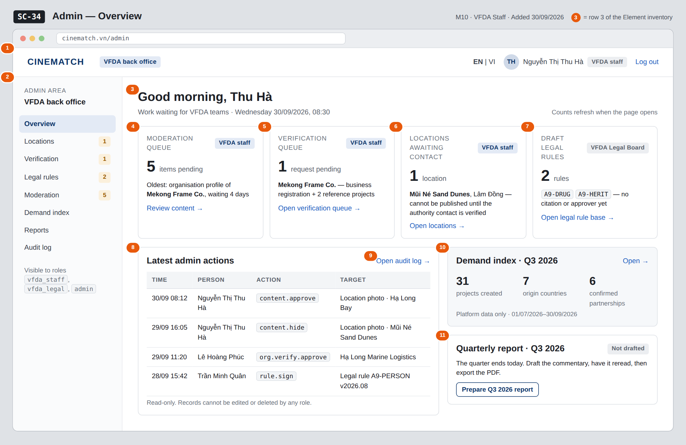
The image is the visual contract (layout, grouping, hierarchy); the tables below are the behavioural contract. All data in the mockup is sample data for one fictional project (The Last Ferry, Harbour Line Films); organisation names, people and phone numbers are examples, not real records.

3. Element inventory
# | Element | Type | Content / data source | Required | Validation
1 | Admin top bar | Header | static; signed-in user's profiles.full_name and role (user_accounts.role) | — | shown only to vfda_staff, vfda_legal, admin
2 | Admin menu | List | static: Overview · Locations · Verification · Legal rules · Moderation · Demand index · Reports · Audit log, with pending counts | — | items the role cannot open are hidden
3 | Greeting and date | Header | signed-in user's first name; server date | — | —
4 | Moderation queue tile | Text + Link | count of moderation_queue items with content_status = pending; oldest submitted_at | Yes | integer ≥ 0
5 | Verification queue tile | Text + Link | count of verification_request with status_filter = pending (M4 FR-009) | Yes | integer ≥ 0
6 | Locations awaiting contact tile | Text + Link | count of locations with intake_status = awaiting_contact (M3 FR-002) | Yes | integer ≥ 0
7 | Draft legal rules tile | Text + Link | count of legal_rule with filter_status = draft (M2 FR-001) | Yes | integer ≥ 0; link opens SC-37 only for vfda_legal
8 | Latest admin actions panel | List | last 4 audit_entries: logged_at, admin_id → name, action, target_id → readable label | — | newest first; read-only
9 | Open audit log link | Link | static | — | shown to admin only (F-M10-09)
10 | Demand index summary | Text + Link | demand_index for the current quarter: indicator 1 total, indicator 2 country count, indicator 5 confirmed count | — | values below 5 records read Not enough data (M10 BR-003)
11 | Quarterly report status | Text + Button | current quarter's report: none / drafted / reread (reread_by) / exported (report_pdf_url) | — | —

4. States
State | What the user sees | Trigger
Default | Four work tiles with counts and the oldest item, latest admin actions on the left, demand summary and quarterly report status on the right — as in the mockup. | Admin area opens
Empty (no data) | Every queue empty: tiles show 0 and Nothing waiting; the audit panel reads No admin actions yet; the demand summary reads Not enough data for the quarter. | Fresh environment / all queues cleared
Loading | Grey skeleton in each tile and panel; each tile loads on its own, so a slow count never blocks the others. | Page opens
Error | A count that fails shows Count unavailable — retry in that tile only; the other tiles and panels stay usable. | One query fails
Success / confirmation | Not applicable — the overview only reads; decisions are taken on the screens it links to. | —

5. Interactions and navigation
# | Element | User action | System response | Goes to screen
1 | Moderation queue tile | tap | Opens the queue filtered to pending items, oldest first | SC-38
2 | Verification queue tile | tap | Opens pending verification requests | SC-36
3 | Locations awaiting contact tile | tap | Opens locations filtered to awaiting_contact | SC-35
4 | Draft legal rules tile | tap | Opens draft rules (VFDA Legal Board only) | SC-37
5 | Open audit log | tap | — | SC-41
6 | Demand index summary | tap | Opens the index for the current quarter | SC-39
7 | Prepare Q3 2026 report | tap | Opens the report for the current quarter | SC-40
8 | Admin menu | tap an item | Opens that admin screen | SC-34 / SC-35 / SC-36 / SC-37 / SC-38 / SC-39 / SC-40 / SC-41

6. Screen-level rules
Rule ID | Rule | Source
SR-371 | The admin area is reachable only by the roles vfda_staff, vfda_legal and admin; other roles get the not-authorised page. | M10 FR-004; SYS BR-002
SR-372 | Each tile counts from the owning module's own status field — M10 moderation, M4 verification, M3 intake_status, M2 rule status — never from a copy. | Spec M10 §1 (Out of scope: those screens belong to M2, M3, M4)
SR-373 | A location counted as awaiting contact cannot be published until its authority contact is verified; the tile says so. | M3 BR-004
SR-374 | The latest-actions panel is read-only and shows no edit or delete control; the full search is on SC-41. | M10 BR-005
SR-375 | Demand figures on this screen follow the same sample-size rule as SC-39. | M10 BR-003

7. Linked requirements
FR ID (from the module spec) | What this screen does for it
FR-001 · spec-M10.md (F-M10-01) | Count of content awaiting review
FR-004 · spec-M10.md (F-M10-04) | Current-quarter demand summary
FR-009 · spec-M10.md (F-M10-09) | Latest audit entries and link to the search
FR-009 · spec-M4.md (F-M4-09) | Count of pending verification requests
FR-001 · spec-M3.md (F-M3-01) | Count of locations not yet published
FR-001 · spec-M2.md (F-M2-01) | Count of draft legal rules

8. Responsive and accessibility notes
- Minimum supported width: 360px.
- Narrow screens: the admin menu collapses behind a Menu button; the four tiles stack two by two, then one per row; side panels move below the audit panel.
- Every count is text, not colour alone; tiles are links reachable with Tab in reading order.
- The audit table becomes a list of cards (time, person, action, target) below 600px.

9. Open questions
# | Question | Blocking? | Status
1 | [NEEDS CLARIFICATION: May VFDA staff (not only admins) read the latest audit entries on the overview, given that the audit log search F-M10-09 is for admins?] | No | Open

Completion checklist
- ☒ The mockup is a separate cropped image file, named with the Screen ID (img/SC-34.png).
- ☒ Every visible element in the mockup appears in the element inventory — machine-checked: badge numbers on the image = row numbers in section 3.
- ☒ Every input element has a validation rule or an explicit "—".
- ☒ All five states are filled in, or marked "Not applicable" with a reason.
- ☒ Every navigation target is a Screen ID that exists in docs/screen-list.md — machine-checked.
- ☒ Every element that displays data names the field it displays, matching docs/spec/spec-M10.md section 5.1.
- ☐ Checked by a person: (not signed — a Group C member compares the image with the tables and signs here)

DBIZ3 Session 4 · Group C · CINEMATCH. Built on the DBIZ2 Screen Design (Screen List and Screen Layout).

