Screen Spec: SC-07 Reset password
DBIZ3 Session 4 template — one file per screen. The Screen ID is kept from the DBIZ2 Screen List. The mockup image stays an image; everything around it is text. Each orange numbered badge on the mockup is the row with the same number in section 3 (Element inventory).
Field | Value
Screen ID | SC-07
Screen name | Reset password
Actor | Guest
Priority | Must
Belongs to module | docs/spec/spec-SYS.md
Mockup image | img/SC-07.png
Status | Draft
Route: /reset-password · Screen list file: SYS, item #22 (Added 30/09/2026 — Must) · Design note from the screen list file: Enter a new password.
Notes against Screen List v2.0
- New Screen Spec written 30/09/2026; the mockup shows the valid-link form (left) and the expired-link panel (right) that replaces it.

1. Purpose
Shown when: A guest opens the reset link from the email sent by SC-06.
The user leaves this screen when: The new password is saved and the user is signed in (to SC-10), or the link has expired and the user requests a new one on SC-06.

2. Mockup
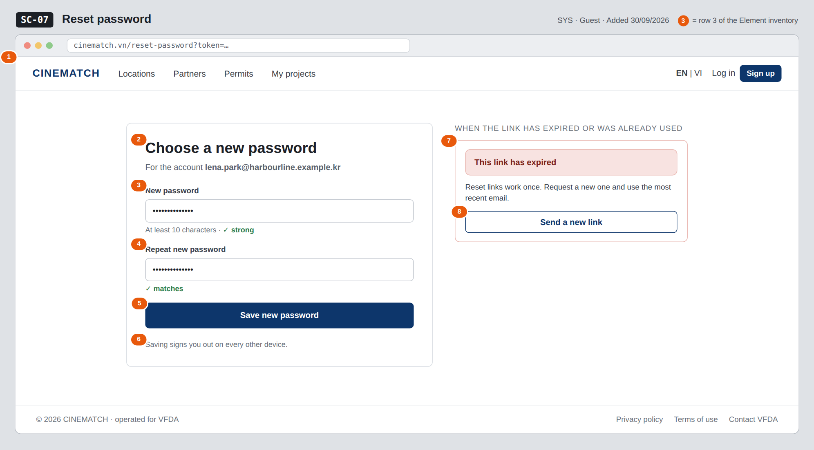
The image is the visual contract (layout, grouping, hierarchy); the tables below are the behavioural contract. All data in the mockup is sample data for one fictional project (The Last Ferry, Harbour Line Films); organisation names, people and phone numbers are examples, not real records.

3. Element inventory
# | Element | Type | Content / data source | Required | Validation
1 | Navigation bar (logged out) | Header | static | — | —
2 | Title + account email | Header | email of the account the reset_token belongs to | Yes | —
3 | New password | Input (password) | FR-003 new_password — sent to Supabase Auth, never stored by the app | Yes | ≥ 10 characters, ≤ 72; strength meter
4 | Repeat new password | Input (password) | client-side only | Yes | must equal row 3
5 | Save new password button | Button | static | — | disabled until rows 3–4 are valid
6 | Sign-out note | Text | static | — | —
7 | Expired-link panel | Container | FR-003 reset_status = expired | — | shown instead of the form
8 | Send a new link button | Button | static | — | —

4. States
State | What the user sees | Trigger
Default | Form with the account email and two empty password fields (the mockup is pre-filled). | Valid reset_token in the link
Empty (no data) | Not applicable — a form with no data list. | —
Loading | Checking your link… skeleton while the token is verified; after submit the button shows Saving… and is disabled. | Page opens / click Save new password
Error | Token expired or already used: the form is replaced by the expired-link panel (rows 7–8). Password too short or fields differ: message under the field; nothing is sent. | reset_status = expired / validation fails
Success / confirmation | Your password has been changed (reset_status = ok); the user is signed in and taken to SC-10 after 3 seconds, or at once with Continue. | Supabase Auth accepts the new password

5. Interactions and navigation
# | Element | User action | System response | Goes to screen
1 | New password fields | type | Live strength meter and match check | stays
2 | Save new password | tap | Sends reset_token + new_password to Supabase Auth; ends other sessions | SC-10
3 | Send a new link | tap | Opens the forgot-password form with the email pre-filled | SC-06
4 | EN | VI switch | tap | Switches interface text; typed passwords are cleared for safety | stays

6. Screen-level rules
Rule ID | Rule | Source
SR-221 | The reset token is verified and consumed by Supabase Auth only; a used or expired token always shows the expired-link panel. | SYS BR-004; FR-003
SR-222 | The new password follows the sign-up rule: at least 10 characters. | SYS §5.1 FR-003
SR-223 | A deactivated account cannot be reactivated through a password reset. | SYS BR-005
SR-224 | After a successful reset, all other sessions of the account are signed out. | Security

7. Linked requirements
FR ID (from the module spec) | What this screen does for it
FR-003 · spec-SYS.md (F-SYS-03) | Set a new password with the single-use token
FR-002 · spec-SYS.md (F-SYS-02) | Sign the user in after the reset

8. Responsive and accessibility notes
- Minimum supported width: 360px.
- Narrow screens: one column; the expired-link panel takes the place of the form.
- Every field has a real <label>; errors are linked with aria-describedby and announced when they appear.
- Password fields use autocomplete=new-password and have a Show toggle with an accessible name.

9. Open questions
# | Question | Blocking? | Status
1 | [NEEDS CLARIFICATION: SEQ-01 has no error branch (email provider down, expired link). Confirm the behaviour written in the edge cases.] | No | Open

Completion checklist
- ☒ The mockup is a separate cropped image file, named with the Screen ID (img/SC-07.png).
- ☒ Every visible element in the mockup appears in the element inventory — machine-checked: badge numbers on the image = row numbers in section 3.
- ☒ Every input element has a validation rule or an explicit "—".
- ☒ All five states are filled in, or marked "Not applicable" with a reason.
- ☒ Every navigation target is a Screen ID that exists in docs/screen-list.md — machine-checked.
- ☒ Every element that displays data names the field it displays, matching docs/spec/spec-SYS.md section 5.1.
- ☐ Checked by a person: (not signed — a Group C member compares the image with the tables and signs here)

DBIZ3 Session 4 · Group C · CINEMATCH. Built on the DBIZ2 Screen Design (Screen List and Screen Layout).

