Screen Spec: SC-08 My account
DBIZ3 Session 4 template — one file per screen. The Screen ID is kept from the DBIZ2 Screen List. The mockup image stays an image; everything around it is text. Each orange numbered badge on the mockup is the row with the same number in section 3 (Element inventory).
Field | Value
Screen ID | SC-08
Screen name | My account
Actor | Member
Priority | Must
Belongs to module | docs/spec/spec-SYS.md
Mockup image | img/SC-08.png
Status | Draft
Route: /account · Screen list file: SYS, item #23 (Added 30/09/2026 — Must) · Design note from the screen list file: Details and preferences.
Notes against Screen List v2.0
- New Screen Spec written 30/09/2026; includes the Delete my account area decided on 30/09/2026 (SYS BR-005).

1. Purpose
Shown when: A signed-in user clicks their name in the navigation bar and chooses My account.
The user leaves this screen when: The user saves and stays, opens SC-09, SC-42 or SC-43, or deletes the account and is signed out to SC-01.

2. Mockup
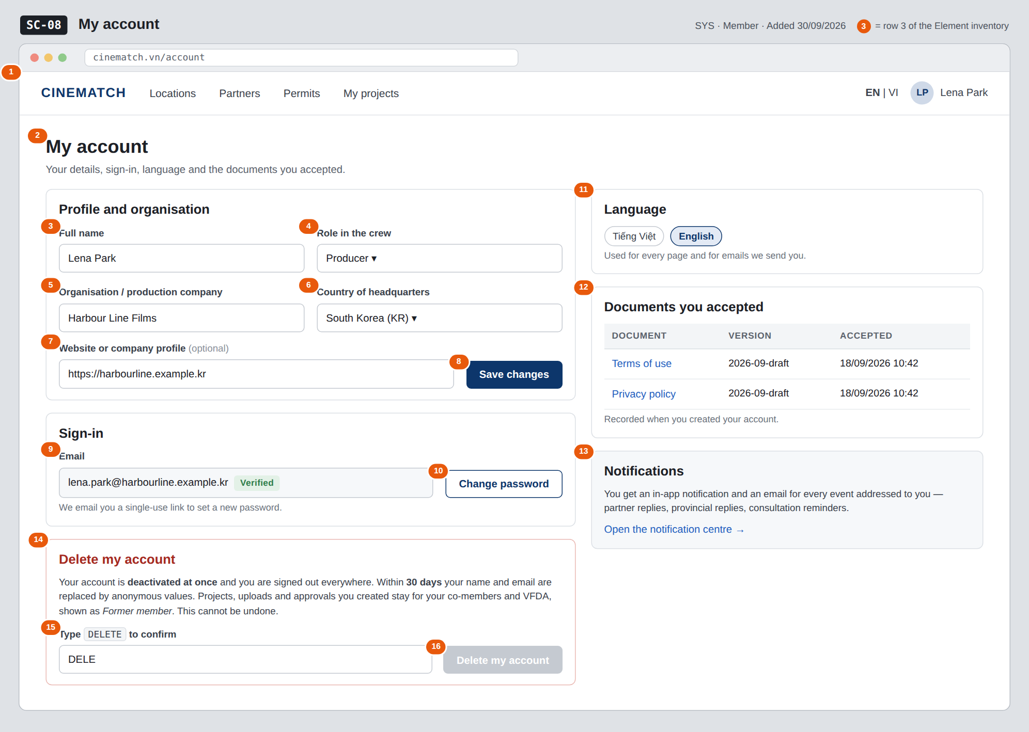
The image is the visual contract (layout, grouping, hierarchy); the tables below are the behavioural contract. All data in the mockup is sample data for one fictional project (The Last Ferry, Harbour Line Films); organisation names, people and phone numbers are examples, not real records.

3. Element inventory
# | Element | Type | Content / data source | Required | Validation
1 | Navigation bar | Header | static; avatar menu | — | —
2 | Title + explanation | Header | static | — | —
3 | Full name | Input | full_name | Yes | 2–120 characters
4 | Role in the crew | Toggle (dropdown) | crew_role — Producer / Director / Production coordinator / Line producer / Other | Yes | enum, 5 values
5 | Organisation / production company | Input | org_name | Yes | 2–200 characters
6 | Country of headquarters | Toggle (dropdown) | country — ISO 3166-1 alpha-2 | Yes | only codes from the list
7 | Website or company profile | Input | website | No | valid URL if provided; ≤ 300 characters
8 | Save changes button | Button | static | — | enabled only when a field changed and all are valid
9 | Email (read-only) | Text | email + email_verified | Yes | —
10 | Change password button | Button | static; sends a reset link (FR-003) | — | —
11 | Language choice | Toggle | locale — vi / en | Yes | enum, 2 values
12 | Documents you accepted | Table | consent_version + acceptance timestamp (CONSENT) | Yes | read-only
13 | Notifications block | Text + link | static | — | —
14 | Delete my account area | Container | static explanation of SYS BR-005 | — | —
15 | Deletion confirmation | Input | client-side only | Yes (to delete) | must equal DELETE exactly
16 | Delete my account button | Button | sets account_status = deactivated (FR-004) | — | disabled until row 15 matches

4. States
State | What the user sees | Trigger
Default | All sections filled from the account; Save changes disabled until something changes; Delete my account disabled. | Open /account
Empty (no data) | Not applicable — every required field was collected at sign-up. An account without an organisation (created before org_name became required) shows the field empty with Please add your organisation. | —
Loading | Grey skeleton for each card; on save the button shows Saving…; on delete the whole page is locked with Deleting your account…. | Page opens / save / delete
Error | Invalid field: message under it, nothing saved. Save fails: Your changes were not saved — try again, typed values kept. Delete fails: Your account was not deleted and nothing changes. | Validation / server error
Success / confirmation | Save: green strip Changes saved. Language: the page re-renders in the chosen language. Delete: signed out and taken to SC-01 with Your account has been deleted. | Save / language change / delete succeeded

5. Interactions and navigation
# | Element | User action | System response | Goes to screen
1 | Save changes | tap | Updates full_name, crew_role, org_name, country, website | stays
2 | Change password | tap | Sends a single-use reset link to the account email; shows Check your inbox | stays
3 | Language chip | tap | Saves locale, sets the locale cookie, re-renders the page | stays
4 | Document link | tap | Opens the document version that was accepted | SC-43 / SC-42
5 | Open the notification centre | tap | — | SC-09
6 | Delete my account | tap | Sets account_status = deactivated, ends every session, schedules anonymisation within 30 days | SC-01

6. Screen-level rules
Rule ID | Rule | Source
SR-231 | The email is the sign-in identity and one account per email; it is shown read-only here. | SYS §3 US-1
SR-232 | The role is not shown as editable; it is set in the database and changed only by an admin. | SYS BR-002; FR-004
SR-233 | Delete my account deactivates at once and removes all access; name, email and phone are anonymised within 30 days; projects, uploads, access logs and approvals stay and show Former member. No hard delete. | SYS BR-005
SR-234 | Deletion requires typing DELETE exactly; the button stays disabled until it matches. | SYS BR-005 (irreversible action)
SR-235 | Consent records are read-only; the table lists each accepted document version with its timestamp. | SYS BR-003

7. Linked requirements
FR ID (from the module spec) | What this screen does for it
FR-001 · spec-SYS.md (F-SYS-01) | Edit the account details collected at sign-up
FR-003 · spec-SYS.md (F-SYS-03) | Change password by reset link
FR-004 · spec-SYS.md (F-SYS-04) | Deactivate the account (account_status)
FR-005 · spec-SYS.md (F-SYS-05) | Choose and remember the interface language

8. Responsive and accessibility notes
- Minimum supported width: 360px.
- Narrow screens: one column; order is Profile, Sign-in, Language, Documents, Notifications, Delete.
- Every field has a real <label>; errors are linked with aria-describedby and announced when they appear.
- The delete area is a separate landmark with a heading; the confirmation field states the exact word in its label.

9. Open questions
# | Question | Blocking? | Status
1 | [NEEDS CLARIFICATION: SYS BR-005 anonymises name, email and phone, but SYS §5.1 has no phone field for an account — which phone field is meant?] | No | Open
2 | [NEEDS CLARIFICATION: May a member turn off email notifications (per event type or all), or is every notification always emailed?] | No | Open

Completion checklist
- ☒ The mockup is a separate cropped image file, named with the Screen ID (img/SC-08.png).
- ☒ Every visible element in the mockup appears in the element inventory — machine-checked: badge numbers on the image = row numbers in section 3.
- ☒ Every input element has a validation rule or an explicit "—".
- ☒ All five states are filled in, or marked "Not applicable" with a reason.
- ☒ Every navigation target is a Screen ID that exists in docs/screen-list.md — machine-checked.
- ☒ Every element that displays data names the field it displays, matching docs/spec/spec-SYS.md section 5.1.
- ☐ Checked by a person: (not signed — a Group C member compares the image with the tables and signs here)

DBIZ3 Session 4 · Group C · CINEMATCH. Built on the DBIZ2 Screen Design (Screen List and Screen Layout).

