Screen Spec: SC-10 Project list / Create new project
DBIZ3 Session 4 template — one file per screen. The Screen ID is kept from the DBIZ2 Screen List. The mockup image stays an image; everything around it is text. Each orange numbered badge on the mockup is the row with the same number in section 3 (Element inventory).
Field | Value
Screen ID | SC-10 (also covers SC-11)
Screen name | Project list / Create new project
Actor | Member
Priority | Must
Belongs to module | docs/spec/spec-M0.md
Mockup image | img/SC-10.png
Status | Draft
Route: /projects · /projects?new=1 · Screen list file: M0, item #4 (Tier 1 — Must) · Design note from the screen list file: Project list and new project creation on the same screen.
Notes against Screen List v2.0
- This screen merges SC-10 Project list and SC-11 Create project per the screen list file (#4). Project creation is a panel that opens to the right of the list (route ?new=1), not a separate page. SC-11 has no separate image file.

1. Purpose
Shown when: A member clicks My projects, has just logged in with an account that already has projects, or has just confirmed a segment on SC-02 (the create project panel opens automatically, pre-filled with the segment).
The user leaves this screen when: The member opens a project card (to SC-12) or successfully creates a new project (to that project's SC-12).

2. Mockup
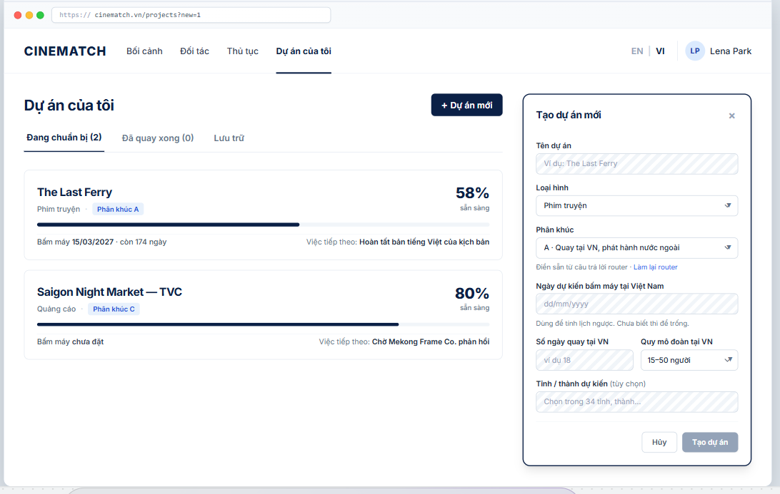
The image is the visual contract (layout, grouping, hierarchy); the tables below are the behavioural contract. All data in the mockup is sample data for one fictional project (The Last Ferry, Harbour Line Films); organisation names, people and phone numbers are examples, not real records.

3. Element inventory
# | Element | Type | Content / data source | Required | Validation
1 | Navigation bar | Header | static; My projects selected | — | —
2 | Title + + New project button | Header + Button | static | — | —
3 | Project status tabs | Toggle | project.stage — preparing / shot / archived, with counts | — | —
4 | Project card | List | project.project_name, project.format, project.segment | — | only projects the user is a member of (Row Level Security (RLS))
5 | Readiness on the card | Text + bar | v_project_readiness.readiness_total | — | 0–100
6 | First shooting day and days remaining | Text | project.shoot_date | — | none → not set
7 | Next step on the card | Text | F-M0-07 — highest-priority task | — | always one sentence
8 | Create new project panel | Container | static | — | —
9 | Project name | Input | project.project_name | Yes | 2–120 characters; unique among the organisation's projects
10 | Format | Toggle (dropdown) | project.format — Feature film / Documentary / Commercial / TV programme / Music video | Yes | enum
11 | Segment | Toggle (dropdown) | project.segment, pre-filled from SC-02 | Yes | A / B / C
12 | Planned first shooting day | Input (date) | project.shoot_date | No | must be after today
13 | Shooting days in Vietnam | Input (number) | project.shoot_days_vn | No | integer 1–365
14 | Crew size in Vietnam | Toggle (dropdown) | project.crew_size_band — <15 / 15–50 / >50 | No | enum
15 | Planned provinces / cities | Toggle (multiple choice) | project_province — list of 34 provincial-level administrative units | No | only codes from the list
16 | Cancel / Create project buttons | Button | static | — | Create project disabled until the 3 required fields are valid

4. States
State | What the user sees | Trigger
Default | Project cards on the left; the create project panel is closed. The mockup shows the panel open. | Open /projects
Empty (no data) | No projects: the list is replaced by a You have no projects yet block and a Create your first project button; the panel opens automatically if the user just came through the router. | User has no projects
Loading | Grey skeletons sized like 2 project cards; the create project panel is usable immediately since it doesn't depend on data. | Loading list
Error | Project creation fails: red strip on the panel Couldn't create the project. Your input has been kept. Duplicate name: error right under the Name field. | DB write error / duplicate name
Success / confirmation | Panel closes and goes to the new project's SC-12; green strip Project The Last Ferry created. | Project created

5. Interactions and navigation
# | Element | User action | System response | Goes to screen
1 | Project card | tap | — | SC-12
2 | + New project button | tap | Opens the panel, adds ?new=1 to the URL | stays
3 | Status tab | tap | Filters the list | stays
4 | redo the router link | tap | — | SC-02
5 | Create project button | tap | Creates project, assigns the creator as owner, generates the gauges for the segment | SC-12
6 | Cancel / ✕ button | tap | Closes the panel; asks for confirmation if something was typed | stays

6. Screen-level rules
Rule ID | Rule | Source
SR-041 | Only 3 required fields (name, format, segment). Everything else can be added later — users aren't expected to know it all up front. | Friction-reduction principle
SR-042 | The province list uses the 34 provincial-level units after the 2025 merger; old names (e.g. Quảng Nam, Hà Giang) are accepted in search and mapped to the new province. | 2025 provincial merger resolution
SR-043 | Project cards always show one next step — from the same source as the dashboard. | TL4 §4
SR-044 | The project creator is the owner; only project members can see the project (RLS on project and project_member). | Database-level security principle

7. Linked requirements
FR ID (from the module spec) | What this screen does for it
FR-001 · spec-M0.md (F-M0-01) | Create project
FR-003 · spec-M0.md (F-M0-03) | My projects list
FR-007 · spec-M0.md (F-M0-07) | Next step on the card
FR-002 · spec-M1.md (F-M1-02) | Receive segment from the router

8. Responsive and accessibility notes
- Minimum supported width: 360px.
- Narrow screens: the Create new project panel opens full screen instead of on the right.
- The panel is a dialog with a title, focus trap, and closes with Esc.
- Percentages always come with a number, not just bar length.

9. Open questions
# | Question | Blocking? | Status
1 | [NEEDS CLARIFICATION: can a project change segment after dossier data exists, and how is the old data handled] | No | Open
2 | [NEEDS CLARIFICATION: can people outside the organisation (e.g. lawyers, freelance line producers) be invited to a project] | No | Open

Completion checklist
- ☒ The mockup is a separate cropped image file, named with the Screen ID (img/SC-10.png).
- ☒ Every visible element in the mockup appears in the element inventory — machine-checked: badge numbers on the image = row numbers in section 3.
- ☒ Every input element has a validation rule or an explicit "—".
- ☒ All five states are filled in, or marked "Not applicable" with a reason.
- ☒ Every navigation target is a Screen ID that exists in docs/screen-list.md — machine-checked.
- ☒ Every element that displays data names the field it displays, matching docs/spec/spec-M0.md section 5.1.
- ☐ Checked by a person: (not signed — a Group C member compares the image with the tables and signs here)

DBIZ3 Session 4 · Group C · CINEMATCH. Built on the DBIZ2 Screen Design (Screen List and Screen Layout).

