Screen Spec: SC-19 Partner directory (12 service groups)
DBIZ3 Session 4 template — one file per screen. The Screen ID is kept from the DBIZ2 Screen List. The mockup image stays an image; everything around it is text. Each orange numbered badge on the mockup is the row with the same number in section 3 (Element inventory).
Field | Value
Screen ID | SC-19
Screen name | Partner directory (12 service groups)
Actor | Guest / Member
Priority | Must
Belongs to module | docs/spec/spec-M4.md
Mockup image | img/SC-19.png
Status | Draft
Route: /partners · Screen list file: M4, item #12 (Tier 1 — Must) · Design note from the screen list file: Filters, VFDA Verified badge.

1. Purpose
Shown when: The user clicks Partners in the navigation bar, the Who is the Vietnamese partner named on the contract? item on SC-01, or the Partners gauge on SC-12 when there are no requests yet.
The user leaves this screen when: The user opens an organisation profile (SC-20) or clicks Send request (SC-23).

2. Mockup
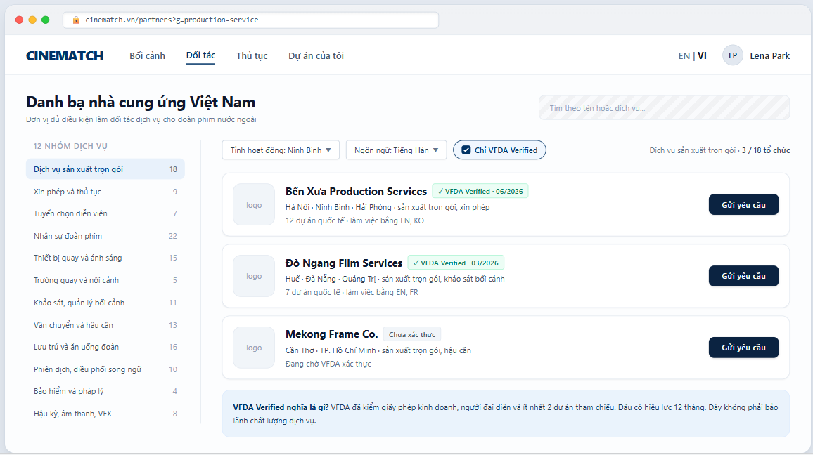
The image is the visual contract (layout, grouping, hierarchy); the tables below are the behavioural contract. All data in the mockup is sample data for one fictional project (The Last Ferry, Harbour Line Films); organisation names, people and phone numbers are examples, not real records.

3. Element inventory
# | Element | Type | Content / data source | Required | Validation
1 | Navigation bar | Header | static | — | —
2 | Title + search box | Header + Input | accent-insensitive search on organisation.org_name, services | No | max 80 characters
3 | 12 service groups list | List | organisation.service_groups — fixed enum of 12 values, with organisation counts | Yes | groups cannot be added freely
4 | Province filter | Toggle (dropdown) | organization_provinces — 34 provinces | No | written to the URL
5 | Working language filter | Toggle (dropdown) | organisation_member_layer.working_languages[] | No | ISO 639-1 codes
6 | VFDA Verified only switch | Toggle | organisation.verified_until >= today | No | on by default
7 | Organisation card | List | organisation.org_name, logo | — | public layer
8 | VFDA Verified badge + verification month | Text | organisation.verified_at | — | shown only while within its 12-month validity
9 | Provinces and services | Text | organization_provinces, organization_services | Yes | public layer
10 | International project count and languages | Text | organisation_member_layer.intl_project_count, working_languages | — | member layer — guests do not see this line
11 | Send request button | Button | static | — | requires login and a project
12 | Not verified label | Text | organisation not yet verified by VFDA | — | shown only when switch 6 is off
13 | What does VFDA Verified mean explainer | Text | static; wording approved by VFDA | Yes | —

4. States
State | What the user sees | Trigger
Default | Left column with 12 groups, first group selected; filters on top; list of organisation cards; Verified explainer banner. | Page opens
Empty (no data) | Group/filters return no organisations: No matching organisations in Ninh Bình yet. Try removing some filters, or ask VFDA for an introduction. + the two corresponding buttons. | 0 results
Loading | The 12 groups list shows immediately (static); grey placeholders for organisation cards. | Loading
Error | Couldn't load the organisation list. + Try again; filters are kept. | Query error
Success / confirmation | No write action on this screen; sending a request happens on SC-23. | —

5. Interactions and navigation
# | Element | User action | System response | Goes to screen
1 | A service group | tap | Re-filters, written to the URL | stays
2 | Province / language filter | tap | Re-filters immediately | stays
3 | VFDA Verified only switch | tap | Shows / hides unverified organisations | stays
4 | Organisation card | tap | — | SC-20
5 | Send request button | tap | Not logged in → SC-04; logged in → compose request | SC-23

6. Screen-level rules
Rule ID | Rule | Source
SR-121 | The 12 service groups are a fixed enum so VFDA can aggregate figures by province. The list in the mockup is a proposal pending VFDA's official names. | TL5 §M4
SR-122 | Three information layers enforced by RLS on three separate tables: public (name, services, provinces, badge) / member (capabilities, project count, languages) / after acceptance (prices, past clients, contacts). | Database-layer security principle
SR-123 | The VFDA Verified only switch is on by default: foreign productions need an eligible entity to sign the agreement under Article 13. | Cinema Law 2022, Article 13
SR-124 | The Verified badge expires after 12 months (F-M4-11); the explainer states clearly that it is not a quality guarantee. | TL5 §M4
SR-125 | No open self-registration for suppliers in the early phase — VFDA invites them and enters their data. | TL4 §8

7. Linked requirements
FR ID (from the module spec) | What this screen does for it
FR-002 · spec-M4.md (F-M4-02) | Public-level profile
FR-003 · spec-M4.md (F-M4-03) | Member-level profile
FR-005 · spec-M4.md (F-M4-05) | Browse by the twelve service groups
FR-006 · spec-M4.md (F-M4-06) | Filter by province and verification badge
FR-007 · spec-M4.md (F-M4-07) | Search

8. Responsive and accessibility notes
- Minimum supported width: 360px.
- Narrow screens: the 12 groups become a dropdown at the top of the page; filters collapse into a Filters button.
- The Verified badge is text, not just an icon.
- Logos have alt set to the organisation name.

9. Open questions
# | Question | Blocking? | Status
1 | [NEEDS CLARIFICATION: VFDA to confirm the official names of the 12 service groups (mockup uses a proposed list)] | Yes | Open
2 | [NEEDS CLARIFICATION: written criteria for granting the VFDA Verified badge] | Yes | Open

Completion checklist
- ☒ The mockup is a separate cropped image file, named with the Screen ID (img/SC-19.png).
- ☒ Every visible element in the mockup appears in the element inventory — machine-checked: badge numbers on the image = row numbers in section 3.
- ☒ Every input element has a validation rule or an explicit "—".
- ☒ All five states are filled in, or marked "Not applicable" with a reason.
- ☒ Every navigation target is a Screen ID that exists in docs/screen-list.md — machine-checked.
- ☒ Every element that displays data names the field it displays, matching docs/spec/spec-M4.md section 5.1.
- ☐ Checked by a person: (not signed — a Group C member compares the image with the tables and signs here)

DBIZ3 Session 4 · Group C · CINEMATCH. Built on the DBIZ2 Screen Design (Screen List and Screen Layout).

