Screen Spec: SC-21 My organisation profile
DBIZ3 Session 4 template — one file per screen. The Screen ID is kept from the DBIZ2 Screen List. The mockup image stays an image; everything around it is text. Each orange numbered badge on the mockup is the row with the same number in section 3 (Element inventory).
Field | Value
Screen ID | SC-21
Screen name | My organisation profile
Actor | Partner
Priority | Must
Belongs to module | docs/spec/spec-M4.md
Mockup image | img/SC-21.png
Status | Draft
Route: /partners/me · Screen list file: M4, item #32 (Added 30/09/2026 — Must) · Design note from the screen list file: Create and edit the profile.
Notes against Screen List v2.0
- New Screen Spec written on 30/09/2026; SC-21 had no spec or mockup in the first set of 20.

1. Purpose
Shown when: The partner accepts VFDA's invitation and signs in for the first time, clicks My organisation in the navigation bar, or opens a VFDA reviewed your profile change notification.
The user leaves this screen when: The partner saves and stays, opens the verification request (SC-22), switches to the request inbox (SC-25), or deactivates the organisation.

2. Mockup
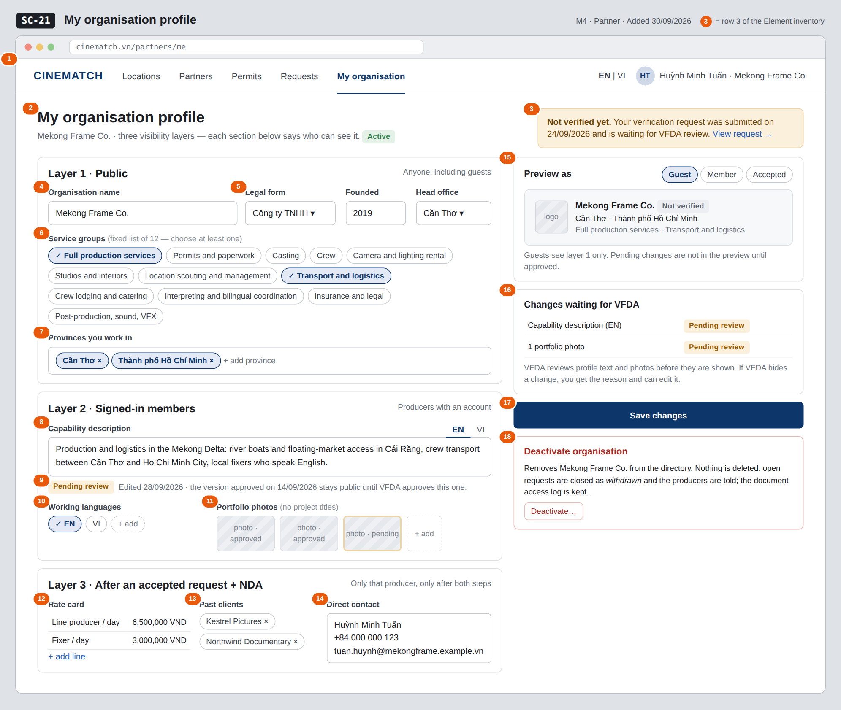
The image is the visual contract (layout, grouping, hierarchy); the tables below are the behavioural contract. All data in the mockup is sample data for one fictional project (The Last Ferry, Harbour Line Films); organisation names, people and phone numbers are examples, not real records.

3. Element inventory
# | Element | Type | Content / data source | Required | Validation
1 | Navigation bar (partner) | Header | static; My organisation selected | — | —
2 | Title + organisation status | Header + Text | org_name, org_status — active / deactivated | Yes | —
3 | Verification status strip | Text + link | latest verification_request.status (pending / approved / rejected) and verified_until | — | shows the rejection reason when the last request was rejected
4 | Organisation name | Input | org_name — layer 1 (public) | Yes | 1–200 characters
5 | Legal form, founded year, head office province | Input + Toggle (dropdown) | legal_form, founded_year, hq_province — layer 1 | Yes | founded year 4 digits, not in the future; province from the 34-province list
6 | Service groups (12) | Toggle (multi-select chips) | service_groups — ENUM(full_production, permits_paperwork, casting, crew, camera_lighting, studios_interiors, location_management, transport_logistics, lodging_catering, interpreting, insurance_legal, post_production)[] | Yes | at least one; only values of the fixed enum (M4 BR-002)
7 | Provinces | Input (multi-select) | province — INTEGER[] of province IDs | Yes | at least one; IDs from the 34-province list
8 | Capability description EN / VI | Input (text area, two tabs) | capability_desc_en, capability_desc_vi — layer 2 (members) | No | free text; goes to moderation when changed (M10 BR-001)
9 | Pending review label + last approved note | Text | moderation item content_status = pending (content type org_profile) | — | shown only while a change is pending
10 | Working languages | Toggle (multi-select chips) | working_languages — CHAR(2)[] ISO 639-1 codes | No | ISO 639-1 codes only
11 | Portfolio photos | Input (image upload) + List | portfolio of the member layer; each photo carries its moderation status | No | JPG / PNG; no project titles in captions (member layer rule on SC-20)
12 | Rate card | Input (table) | rate_card — JSONB, layer 3 | No | amount ≥ 0, currency VND
13 | Past clients | Input (tags) | past_clients — TEXT[], layer 3 | No | —
14 | Direct contact | Input (text area) | direct_contact — layer 3 | No | —
15 | Preview as Guest / Member / Accepted | Toggle + Container | public_profile, member_profile, private_profile outputs of F-M4-02..04 | — | shows approved content only
16 | Changes waiting for VFDA list | List | moderation items of this organisation with content_status | — | empty list is hidden
17 | Save changes button | Button | static | — | disabled until something changed and fields 4–7 are valid
18 | Deactivate organisation block | Button + Text | sets org_status = deactivated | — | confirmation dialog: type the organisation name

4. States
State | What the user sees | Trigger
Default | Three layer sections on the left, preview, pending-changes list, save button and deactivate block on the right, as in the mockup (capability text and one photo pending review). | Page opens
Empty (no data) | First visit after the VFDA invitation: only the organisation name entered by VFDA is filled; every other section shows a short hint of what to add, the preview shows the name only, the pending list is hidden. | New organisation
Loading | Grey placeholders in the three sections; Save changes shows Saving… and is disabled while a save runs. | Page load / save
Error | Field errors under each field (e.g. Choose at least one service group). Save failure: Couldn't save — your edits are kept on this page, try again. Upload failure on a photo: error on that thumbnail only. | Validation / write error
Success / confirmation | Green strip Saved. Structured fields are live; text and photo changes are waiting for VFDA review — the last approved version stays public. After deactivation: red banner Mekong Frame Co. is deactivated, all fields read-only, organisation no longer listed on SC-19. | Saved / deactivated

5. Interactions and navigation
# | Element | User action | System response | Goes to screen
1 | View request in the verification strip | tap | Opens the verification request (new request if none or rejected) | SC-22
2 | Service group chip | tap | Selects / deselects the group | stays
3 | Preview as chip | tap | Switches the preview to that layer | stays
4 | Save changes button | tap | Saves layer fields; text and photo changes create moderation items (F-M10-01) | stays
5 | Deactivate… button | tap | Confirmation dialog explaining BR-008; on confirm org_status = deactivated, open requests closed as withdrawn, producers notified | stays
6 | Requests in the navigation bar | tap | Opens the request inbox | SC-25
7 | Partners in the navigation bar | tap | Opens the directory to see how the profile is listed | SC-19

6. Screen-level rules
Rule ID | Rule | Source
SR-321 | The three layers are three tables with separate RLS policies; the form mirrors them as three sections and says who can see each. | M4 BR-001
SR-322 | Service groups come only from the fixed 12-value enum; an organisation cannot add its own group. | M4 BR-002
SR-323 | Profile text and photos wait in moderation; until VFDA approves, the last approved version stays public and the change shows Pending review. | M10 BR-001
SR-324 | If VFDA hides a change, the reason is shown to the partner next to the item. | M10 BR-002
SR-325 | Deactivate organisation never deletes: org_status = deactivated, open requests are closed as withdrawn with the producer notified, the document access log is kept. | M4 BR-008
SR-326 | The Verified badge and the Article 13 eligibility flag are not editable here; only VFDA sets them (SC-36). | M4 BR-004

7. Linked requirements
FR ID (from the module spec) | What this screen does for it
FR-001 · spec-M4.md (F-M4-01) | Create and edit the organisation profile across the three layers
FR-002 · spec-M4.md (F-M4-02) | Preview of the public layer
FR-003 · spec-M4.md (F-M4-03) | Preview of the member layer
FR-004 · spec-M4.md (F-M4-04) | Preview of the accepted layer
FR-001 · spec-M10.md (F-M10-01) | Text and photo changes enter the moderation queue

8. Responsive and accessibility notes
- Minimum supported width: 360px.
- Narrow screens: the right column moves below the form; the preview collapses into a Preview button; Save changes sticks to the bottom.
- Each layer section is a <fieldset> whose <legend> names the layer and who can see it.
- Pending review is text, not only a colour; the deactivate dialog traps focus and needs typed confirmation.

9. Open questions
# | Question | Blocking? | Status
1 | [NEEDS CLARIFICATION: Official names of the 12 service groups (the mockup uses a proposed list).] | Yes | Open
2 | [NEEDS CLARIFICATION: Do changes to structured fields (service groups, provinces, rate card) also wait in moderation, or only profile text and photos?] | No | Open

Completion checklist
- ☒ The mockup is a separate cropped image file, named with the Screen ID (img/SC-21.png).
- ☒ Every visible element in the mockup appears in the element inventory — machine-checked: badge numbers on the image = row numbers in section 3.
- ☒ Every input element has a validation rule or an explicit "—".
- ☒ All five states are filled in, or marked "Not applicable" with a reason.
- ☒ Every navigation target is a Screen ID that exists in docs/screen-list.md — machine-checked.
- ☒ Every element that displays data names the field it displays, matching docs/spec/spec-M4.md section 5.1.
- ☐ Checked by a person: (not signed — a Group C member compares the image with the tables and signs here)

DBIZ3 Session 4 · Group C · CINEMATCH. Built on the DBIZ2 Screen Design (Screen List and Screen Layout).

