Screen Spec: SC-22 Submit verification
DBIZ3 Session 4 template — one file per screen. The Screen ID is kept from the DBIZ2 Screen List. The mockup image stays an image; everything around it is text. Each orange numbered badge on the mockup is the row with the same number in section 3 (Element inventory).
Field | Value
Screen ID | SC-22
Screen name | Submit verification
Actor | Partner
Priority | Must
Belongs to module | docs/spec/spec-M4.md
Mockup image | img/SC-22.png
Status | Draft
Route: /partners/me/verify · Screen list file: M4, item #33 (Added 30/09/2026 — Must) · Design note from the screen list file: Upload documents and reference projects.
Notes against Screen List v2.0
- New Screen Spec written on 30/09/2026; SC-22 had no spec or mockup in the first set of 20.

1. Purpose
Shown when: The partner clicks the verification strip on SC-21, opens a your badge expires in 30 days reminder (F-M4-11), or opens a verification rejected notification to apply again.
The user leaves this screen when: The partner submits the request (and stays on the page, now read-only with status Pending) or cancels back to SC-21.

2. Mockup
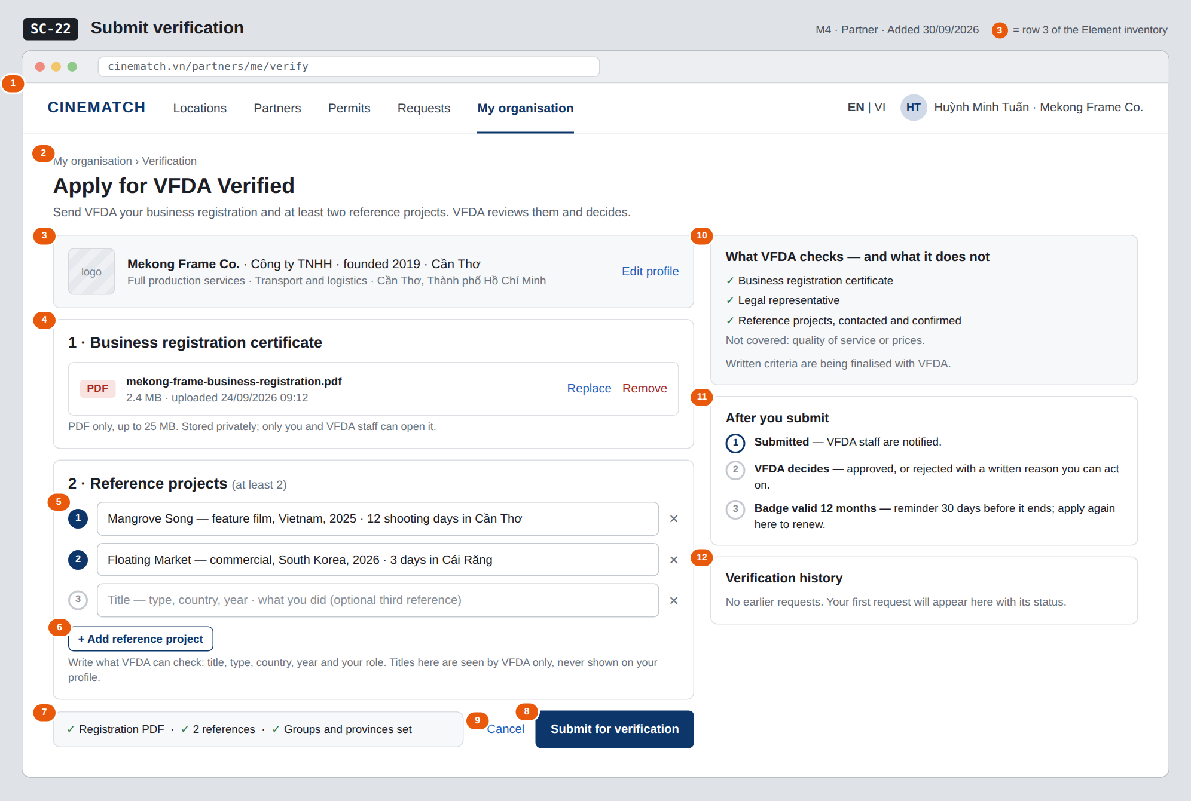
The image is the visual contract (layout, grouping, hierarchy); the tables below are the behavioural contract. All data in the mockup is sample data for one fictional project (The Last Ferry, Harbour Line Films); organisation names, people and phone numbers are examples, not real records.

3. Element inventory
# | Element | Type | Content / data source | Required | Validation
1 | Navigation bar (partner) | Header | static; My organisation selected | — | —
2 | Breadcrumb + title + purpose | Header + Text | static | — | —
3 | Organisation summary | Text | org_id with org_name, legal_form, founded_year, hq_province, service_groups, province (read-only) | Yes | —
4 | Business registration certificate | Input (file) | business_license — FILE, private storage | Yes | PDF only, ≤ 25 MB
5 | Reference project rows | Input (list) | reference_projects — TEXT[] | Yes | at least 2 non-empty rows; empty rows are ignored
6 | + Add reference project button | Button | static | — | —
7 | Submission checklist | Text | computed from fields 3–5 | — | each item turns green when met
8 | Submit for verification button | Button | creates the request; returns verification_request_id | — | disabled until checklist 7 is complete or while a request is pending
9 | Cancel link | Link | static | — | —
10 | What VFDA checks — and what it does not block | Text | static; wording approved by VFDA | Yes | must state that quality and prices are not checked
11 | After you submit steps | List | static | — | —
12 | Verification history | List | earlier verification_request rows of this organisation: status, decision date, reason | — | newest first

4. States
State | What the user sees | Trigger
Default | Organisation summary, upload, reference rows, checklist and submit button on the left; what VFDA checks, next steps and history on the right, as in the mockup. | Page opens with no pending request
Empty (no data) | No file and no references yet: upload area shows Drop the PDF here or choose a file, two empty reference rows, checklist items grey, submit disabled; history shows No earlier requests. | First application
Loading | Upload shows a progress bar on the file row; Submit shows Submitting… and the form is locked. | Uploading / submitting
Error | Wrong type or over 25 MB: error on the file row stating the limit. Fewer than two references: Add at least two reference projects. Submit failure: Couldn't send — nothing was submitted, try again. | Validation / upload / write error
Success / confirmation | Banner Sent to VFDA on 24/09/2026. You'll be notified of the decision.; the form turns read-only with status Pending; the request appears in the history and on SC-21. After a rejection, the reason is shown at the top and the form opens again pre-filled. | Request created / previous request rejected

5. Interactions and navigation
# | Element | User action | System response | Goes to screen
1 | Business registration file row | tap / drop | Uploads the PDF to private storage | stays
2 | + Add reference project | tap | Adds an empty row | stays
3 | ✕ on a reference row | tap | Removes the row | stays
4 | Submit for verification | tap | Creates the request with status pending; VFDA staff are notified | stays
5 | Edit profile / Cancel | tap | — | SC-21

6. Screen-level rules
Rule ID | Rule | Source
SR-331 | A request needs a business registration PDF (≤ 25 MB) and at least two reference projects; the submit button stays disabled until both are present. | M4 FR-008
SR-332 | Only one request per organisation can be pending at a time; while it is pending the form is read-only. | M4 §4.3 (SEQ-07)
SR-333 | The block What VFDA checks also states what is not checked (quality, prices) so the badge is not read as a guarantee. | M4 BR-004
SR-334 | The badge, once granted, is valid 12 months; the renewal reminder 30 days before expiry leads back to this screen. | M4 BR-004
SR-335 | Documents are stored privately: only the organisation's partner users and VFDA staff can open them. | M4 BR-001

7. Linked requirements
FR ID (from the module spec) | What this screen does for it
FR-008 · spec-M4.md (F-M4-08) | Submit the verification request with documents and references
FR-011 · spec-M4.md (F-M4-11) | Renewal entry point after the expiry reminder

8. Responsive and accessibility notes
- Minimum supported width: 360px.
- Narrow screens: the right column moves below the submit button; reference rows take full width.
- The upload area has a Choose file button for keyboard users; progress is announced with aria-live.
- Checklist items use a text tick plus the words, not colour alone.

9. Open questions
# | Question | Blocking? | Status
1 | [NEEDS CLARIFICATION: Written criteria for awarding VFDA Verified.] | Yes | Open
2 | [NEEDS CLARIFICATION: Does VFDA need a named contact person for each reference project to confirm it, and may the partner share that person's details with VFDA?] | No | Open

Completion checklist
- ☒ The mockup is a separate cropped image file, named with the Screen ID (img/SC-22.png).
- ☒ Every visible element in the mockup appears in the element inventory — machine-checked: badge numbers on the image = row numbers in section 3.
- ☒ Every input element has a validation rule or an explicit "—".
- ☒ All five states are filled in, or marked "Not applicable" with a reason.
- ☒ Every navigation target is a Screen ID that exists in docs/screen-list.md — machine-checked.
- ☒ Every element that displays data names the field it displays, matching docs/spec/spec-M4.md section 5.1.
- ☐ Checked by a person: (not signed — a Group C member compares the image with the tables and signs here)

DBIZ3 Session 4 · Group C · CINEMATCH. Built on the DBIZ2 Screen Design (Screen List and Screen Layout).

