Screen Spec: SC-23 Send collaboration request
DBIZ3 Session 4 template — one file per screen. The Screen ID is kept from the DBIZ2 Screen List. The mockup image stays an image; everything around it is text. Each orange numbered badge on the mockup is the row with the same number in section 3 (Element inventory).
Field | Value
Screen ID | SC-23
Screen name | Send collaboration request
Actor | Member
Priority | Must
Belongs to module | docs/spec/spec-M4.md
Mockup image | img/SC-23.png
Status | Draft
Route: /partners/[slug]/request · Screen list file: M4, item #34 (Added 30/09/2026 — Must) · Design note from the screen list file: Choose a project and write a note.
Notes against Screen List v2.0
- New Screen Spec written on 30/09/2026; SC-23 had no spec or mockup in the first set of 20. It is also opened by Propose changes on SC-25.

1. Purpose
Shown when: A signed-in member clicks Send request on an organisation card in SC-19, Send collaboration request on SC-20, or Propose changes on SC-25.
The user leaves this screen when: The member sends the request and lands on its tracking page (SC-25), or cancels back to the partner profile (SC-20).

2. Mockup
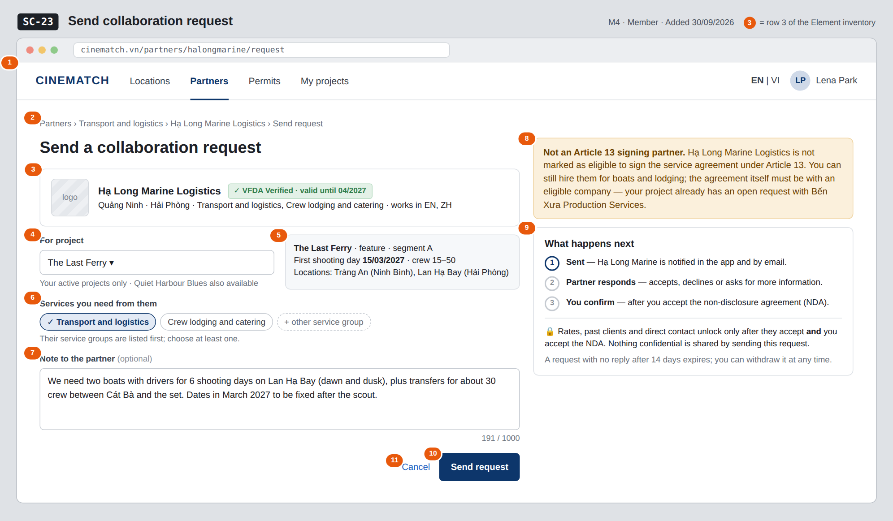
The image is the visual contract (layout, grouping, hierarchy); the tables below are the behavioural contract. All data in the mockup is sample data for one fictional project (The Last Ferry, Harbour Line Films); organisation names, people and phone numbers are examples, not real records.

3. Element inventory
# | Element | Type | Content / data source | Required | Validation
1 | Navigation bar | Header | static; Partners selected | — | —
2 | Breadcrumb | Text | Partners › service group › organisation › Send request | — | —
3 | Recipient organisation summary | Text | org_id → public layer: org_name, Verified badge (verified_until), provinces, service_groups, working_languages | Yes | —
4 | Project selector | Toggle (dropdown) | project_id — the member's projects that are not archived | Yes | must be a project the member belongs to; archived projects are not listed (M0 BR-005)
5 | Project summary | Text | project name, format, segment, first shooting day, crew size band, shortlisted locations (read-only) | — | —
6 | Requested service groups | Toggle (multi-select chips) | services — ENUM[] from the 12 service groups | Yes | at least one; the organisation's own groups listed first
7 | Note to the partner | Input (text area) | note — TEXT | No | max 1000 characters, live counter
8 | Article 13 eligibility notice | Text | art13_eligible of the organisation + open requests of the project | — | shown only when the organisation is not eligible
9 | What happens next block | List + Text | static: 3 steps, NDA and unlock explanation, expiry note | Yes | —
10 | Send request button | Button | creates the request; returns request_id, status = pending | — | disabled until 4 and 6 are valid
11 | Cancel link | Link | static | — | —

4. States
State | What the user sees | Trigger
Default | Recipient summary, project selector with the first active project pre-selected, services, note, and the side blocks, as in the mockup. | Page opens
Empty (no data) | The member has no active project: the form is replaced by A request is tied to a project. Create a project first. with a button to create one (SC-11). | 0 active projects
Loading | Send request shows Sending… and the form is locked; project summary shows a grey placeholder while the selected project loads. | Sending / switching project
Error | Duplicate: You already have an open request with this partner for The Last Ferry + View request link (SC-25). Note over 1000 characters: counter turns red, send disabled. Write failure: Couldn't send — nothing was sent, try again. | Duplicate / validation / write error
Success / confirmation | Redirect to the new request on SC-25 at step 1 Sent with the toast Request sent to Hạ Long Marine Logistics; the partner gets an in-app notification and an email. | Request created

5. Interactions and navigation
# | Element | User action | System response | Goes to screen
1 | Project selector | tap | Lists the member's active projects; changes the project summary | stays
2 | Service group chip | tap | Selects / deselects | stays
3 | Send request button | tap | Creates the request (status = pending), notifies the partner in-app and by email | SC-25
4 | View request in the duplicate error | tap | Opens the open request | SC-25
5 | Cancel / organisation name in breadcrumb | tap | — | SC-20
6 | Service group in breadcrumb | tap | — | SC-19
7 | Create a project (empty state) | tap | — | SC-11

6. Screen-level rules
Rule ID | Rule | Source
SR-341 | Every request is tied to exactly one project of the member; guests are sent to SC-04 first. | M4 FR-012
SR-342 | Only one open request per project and partner: a second one is refused with You already have an open request with this partner. | M4 §3 Edge cases
SR-343 | Archived projects cannot send requests; they are read-only. | M0 BR-005
SR-344 | Sending shares nothing confidential; the accepted layer and project documents open only after acceptance and the NDA (SC-25). | M4 BR-001
SR-345 | A confirmed request with a non-eligible organisation does not complete Article 13 component c; the notice says so up front. | M4 BR-006
SR-346 | Deactivated organisations cannot receive requests; the profile shows No longer active instead of this form. | M4 BR-008

7. Linked requirements
FR ID (from the module spec) | What this screen does for it
FR-012 · spec-M4.md (F-M4-12) | Create the collaboration request with project, services and note
FR-015 · spec-M4.md (F-M4-15) | Notify the partner in-app and by email on sending

8. Responsive and accessibility notes
- Minimum supported width: 360px.
- Narrow screens: the side column moves below the form; Send request sticks to the bottom of the screen.
- The note counter is announced with aria-live="polite" when the limit is near.
- Service chips are real checkboxes with labels.

9. Open questions
# | Question | Blocking? | Status
1 | [NEEDS CLARIFICATION: After how many days does an unanswered request expire?] | No | Open

Completion checklist
- ☒ The mockup is a separate cropped image file, named with the Screen ID (img/SC-23.png).
- ☒ Every visible element in the mockup appears in the element inventory — machine-checked: badge numbers on the image = row numbers in section 3.
- ☒ Every input element has a validation rule or an explicit "—".
- ☒ All five states are filled in, or marked "Not applicable" with a reason.
- ☒ Every navigation target is a Screen ID that exists in docs/screen-list.md — machine-checked.
- ☒ Every element that displays data names the field it displays, matching docs/spec/spec-M4.md section 5.1.
- ☐ Checked by a person: (not signed — a Group C member compares the image with the tables and signs here)

DBIZ3 Session 4 · Group C · CINEMATCH. Built on the DBIZ2 Screen Design (Screen List and Screen Layout).

