Screen Spec: SC-25 Collaboration request + status tracking
DBIZ3 Session 4 template — one file per screen. The Screen ID is kept from the DBIZ2 Screen List. The mockup image stays an image; everything around it is text. Each orange numbered badge on the mockup is the row with the same number in section 3 (Element inventory).
Field | Value
Screen ID | SC-25 (also covers SC-24)
Screen name | Collaboration request + status tracking
Actor | Member / Partner
Priority | Must
Belongs to module | docs/spec/spec-M4.md
Mockup image | img/SC-25.png
Status | Draft
Route: /requests/[id] · Screen list file: M4, item #14 (Tier 1 — Must) · Design note from the screen list file: Statuses: Sent → Partner responded → Confirmed.
Notes against Screen List v2.0
- This screen uses a list–detail layout: the left column is the project's request inbox (SC-24), the rest is the detail of one request (SC-25). The mockup is filed under SC-25; SC-24 has no separate image.

1. Purpose
Shown when: The member clicks the Partners gauge on SC-12, the Partners item in the sidebar, a partner responded notification, or has just sent a request on SC-23.
The user leaves this screen when: The member confirms, declines, proposes changes, or switches to another request in the left column.

2. Mockup
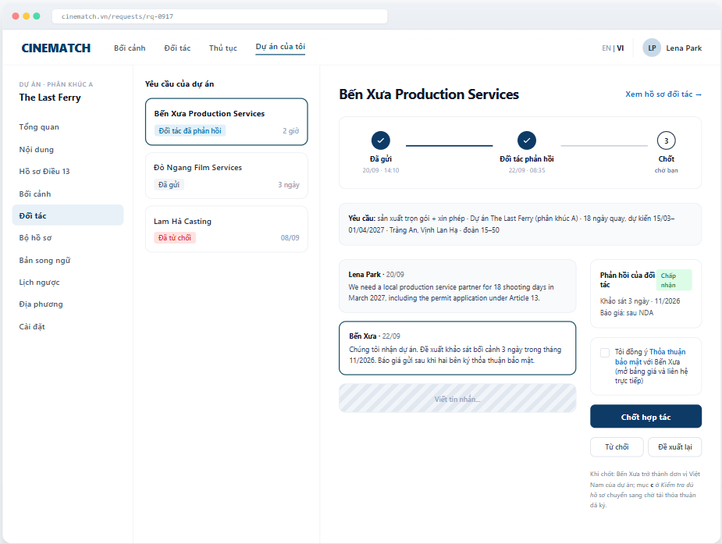
The image is the visual contract (layout, grouping, hierarchy); the tables below are the behavioural contract. All data in the mockup is sample data for one fictional project (The Last Ferry, Harbour Line Films); organisation names, people and phone numbers are examples, not real records.

3. Element inventory
# | Element | Type | Content / data source | Required | Validation
1 | Navigation bar | Header | static | — | —
2 | Project sidebar | List | static; Partners item selected | — | —
3 | Project request list | List | collab_request by project_id | — | sorted by most recently updated
4 | Status on each request | Text | collab_request.status — pending / under_review / info_requested / accepted / declined / confirmed / withdrawn, shown as Sent, Partner responded or Confirmed (M4 §5.1 FR-014) | Yes | always with text
5 | 3-step bar | Chart (stepper) | timestamps collab_request.sent_at, responded_at, confirmed_at | Yes | exactly 3 steps: Sent → Partner responded → Confirmed
6 | Request summary | Text | collab_request.services[], project, dates, locations, crew size | Yes | —
7 | Message thread | List | collab_message | — | shown in the author's original language
8 | Partner response card | Container | collab_request.response_note — accepted / counter-proposal / declined + message | — | shown from step 2 onwards
9 | NDA consent checkbox | Toggle (checkbox) | nda_acceptance — NDA version, timestamp | Yes (to confirm) | must be ticked to enable Confirm partnership
10 | Confirm partnership button | Button | static | — | enabled only when the partner has accepted and the NDA is ticked
11 | Decline / Propose changes buttons | Button | static | — | Decline asks for a reason (optional)
12 | Message composer | Input | collab_message.body | No | 1–2000 characters
13 | Note on consequences of confirming | Text | static | — | always shown next to the confirm button

4. States
State | What the user sees | Trigger
Default | The mockup shows step 2 (Partner responded, accepted). At step 1: the response card is replaced by Waiting for Bến Xưa to respond — usually within 72 hours, confirm button hidden. | Open a request
Empty (no data) | The project has sent no requests: left column shows No requests yet; the detail area is replaced by a Find a partner in the directory link (SC-19). | 0 requests
Loading | Grey placeholders for the message thread; the 3-step bar shows immediately. | Loading
Error | Message failed to send: the message is greyed out with Not sent — Try again. Confirmation failed: Couldn't confirm; the request keeps its previous status. | Write error
Success / confirmation | Clicking Confirm partnership → step 3 fills in, green banner Confirmed with Bến Xưa. Upload the signed service agreement to the document kit to complete item c under Article 13. The Partners gauge goes to 100%. | Confirmed successfully

5. Interactions and navigation
# | Element | User action | System response | Goes to screen
1 | A request in the left column | tap | Opens that request's details | SC-25 (another request)
2 | View partner profile | tap | — | SC-20
3 | Message composer | type + Enter | Sends the message, notifies the partner (F-M4-15) | stays
4 | Non-disclosure agreement link | tap | Opens the full NDA text | stays
5 | Confirm partnership button | tap | collab_request.status = confirmed and confirmed_at set (M4 BR-005); updates the Partners gauge; item c on SC-27 becomes pending until the signed agreement is uploaded (M4 BR-006) | stays
6 | Decline button | tap | Asks for a reason, status = declined | stays
7 | Propose changes button | tap | Opens the form to change services / dates | SC-23

6. Screen-level rules
Rule ID | Rule | Source
SR-141 | Exactly 3 steps are shown: Sent → Partner responded → Confirmed. Declined / withdrawn are end states, not steps. | Screen list file — note #14
SR-142 | Only the sender (the production) can click Confirm; the partner only responds. Every status change notifies the other side. | TL5 §M4
SR-143 | Confirming requires NDA consent; only after the NDA is agreed is layer 3 of the partner profile unlocked (RLS). | F-M4-17
SR-144 | Confirming a partnership does not automatically mark Article 13 item c as Present — the signed agreement must still be uploaded. | No-guessing principle
SR-145 | Every view of an attached document is recorded in the access log (F-M4-18). | TL5 §M4

7. Linked requirements
FR ID (from the module spec) | What this screen does for it
FR-013 · spec-M4.md (F-M4-13) | Request inbox
FR-014 · spec-M4.md (F-M4-14) | Respond to a request
FR-015 · spec-M4.md (F-M4-15) | Notify both sides of the outcome
FR-016 · spec-M4.md (F-M4-16) | Update the partner gauge
FR-017 · spec-M4.md (F-M4-17) | Display and accept the agreement

8. Responsive and accessibility notes
- Minimum supported width: 360px.
- Narrow screens: the list column becomes its own screen; the detail opens when a request is selected; the confirm button sticks to the bottom.
- The 3-step bar is an ordered list (<ol>) with aria-current="step".
- The NDA consent is a real checkbox with a clickable label.

9. Open questions
# | Question | Blocking? | Status
1 | [NEEDS CLARIFICATION: will VFDA provide a standard NDA template, or does each partner use its own NDA] | Yes | Open
2 | [NEEDS CLARIFICATION: after how many days without a response does a request expire automatically] | No | Open

Completion checklist
- ☒ The mockup is a separate cropped image file, named with the Screen ID (img/SC-25.png).
- ☒ Every visible element in the mockup appears in the element inventory — machine-checked: badge numbers on the image = row numbers in section 3.
- ☒ Every input element has a validation rule or an explicit "—".
- ☒ All five states are filled in, or marked "Not applicable" with a reason.
- ☒ Every navigation target is a Screen ID that exists in docs/screen-list.md — machine-checked.
- ☒ Every element that displays data names the field it displays, matching docs/spec/spec-M4.md section 5.1.
- ☐ Checked by a person: (not signed — a Group C member compares the image with the tables and signs here)

DBIZ3 Session 4 · Group C · CINEMATCH. Built on the DBIZ2 Screen Design (Screen List and Screen Layout).

