Screen Spec: SC-31 Requirement detail
DBIZ3 Session 4 template — one file per screen. The Screen ID is kept from the DBIZ2 Screen List. The mockup image stays an image; everything around it is text. Each orange numbered badge on the mockup is the row with the same number in section 3 (Element inventory).
Field | Value
Screen ID | SC-31
Screen name | Requirement detail
Actor | Guest
Priority | Should
Belongs to module | docs/spec/spec-M2.md
Mockup image | img/SC-31.png
Status | Draft
Route: /requirements/[slug] · Screen list file: M2, item #29 (Added 30/09/2026 — Should) · Design note from the screen list file: Bilingual description with citation.
Notes against Screen List v2.0
- Screen Spec added 30/09/2026. SC-31 was in Screen List v2.0 (Should) but had no mockup.

1. Purpose
Shown when: A visitor opens a rule from SC-30, follows a rule code or citation from SC-48, or opens a shared rule link.
The user leaves this screen when: The visitor goes back to the library (SC-30), opens a related rule (SC-31), starts a pre-check (SC-03) or books a VFDA consultation (SC-33).

2. Mockup
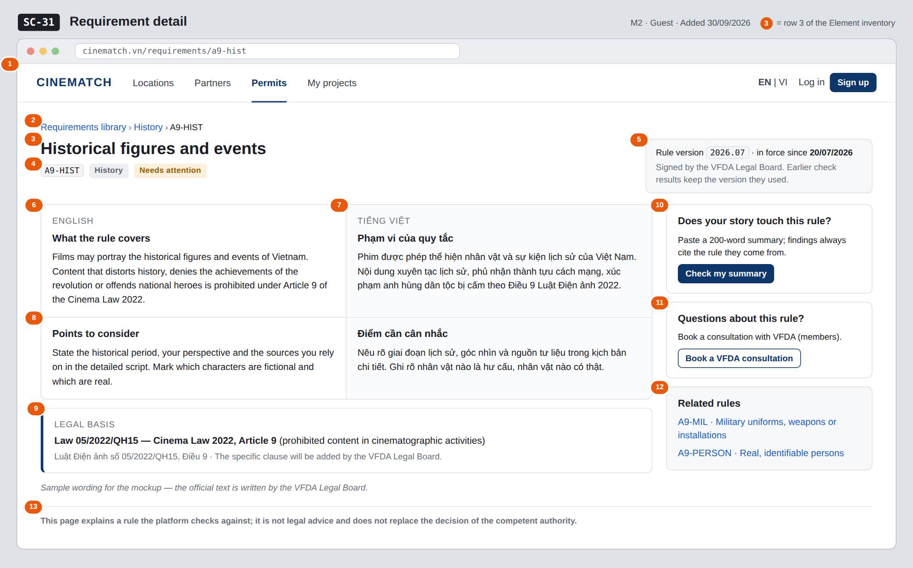
The image is the visual contract (layout, grouping, hierarchy); the tables below are the behavioural contract. All data in the mockup is sample data for one fictional project (The Last Ferry, Harbour Line Films); organisation names, people and phone numbers are examples, not real records.

3. Element inventory
# | Element | Type | Content / data source | Required | Validation
1 | Navigation bar | Header | static; Permits selected; guest view | — | —
2 | Breadcrumb | Link | static + topic + rule_code | — | —
3 | Rule title | Header | title_en / title_vi by interface language | Yes | —
4 | Rule code, topic and severity | Text | rule_code, topic, severity (notice → Needs attention, action → Action required) | Yes | enum values shown with readable labels
5 | Rule version box | Text | rule_version, approved_at of the version in force | Yes | —
6 | Description — English | Text | description_en | Yes | —
7 | Description — Vietnamese | Text | description_vi | Yes | —
8 | Points to consider — English and Vietnamese | Text | guidance_en, guidance_vi | Yes | —
9 | Legal basis (citation) | Text | citation | Yes | never empty (M2 BR-002)
10 | Check my summary card | Button | static | — | —
11 | Book a VFDA consultation card | Button | static | — | guests are asked to sign in first
12 | Related rules | List | other approved rules with the same or a nearby topic | — | approved rules only; max 3
13 | Disclaimer | Text | static | — | always shown

4. States
State | What the user sees | Trigger
Default | Bilingual description and points to consider side by side, citation, version box and actions. | Open /requirements/[slug]
Empty (no data) | Unknown slug, or a rule that is a draft: This rule does not exist or is not public with a link to SC-30. A retired rule opened from an old link shows its last text with a grey strip Retired on … — no longer checked and no pre-check button. | rule_slug not found / not approved / retired
Loading | Grey skeleton for the two language columns and the citation box. | Loading the rule
Error | Couldn't load this rule — try again with Retry. | Query failed
Success / confirmation | Not applicable — read-only screen; no user action changes data here. | —

5. Interactions and navigation
# | Element | User action | System response | Goes to screen
1 | Breadcrumb Requirements library / topic | tap | Back to the library, filtered by the topic when the topic is clicked | SC-30
2 | Check my summary button | tap | Opens the pre-check | SC-03
3 | Book a VFDA consultation button | tap | Signed in: opens booking; guest: sign in first | SC-33
4 | Related rule link | tap | Opens that rule | SC-31
5 | EN / VI in the navigation bar | tap | Switches the interface language; both language columns stay visible | stays

6. Screen-level rules
Rule ID | Rule | Source
SR-291 | One public page per approved rule, always showing both languages and the citation. | M2 FR-016 (F-M2-16)
SR-292 | A rule without a citation cannot be active, so this page never shows a rule without a legal basis. | M2 BR-002
SR-293 | Retired rules are never deleted; an old link still opens and is clearly marked Retired. | M2 BR-008
SR-294 | The version shown is the one in force; findings on SC-48 keep the version they cited, even after the rule changes. | M2 BR-007, M2 BR-008
SR-295 | Text on this page is written by the VFDA Legal Board; the system never generates or rewrites it. | M2 BR-001

7. Linked requirements
FR ID (from the module spec) | What this screen does for it
FR-016 · spec-M2.md (F-M2-16) | Public page per rule with bilingual description and citation

8. Responsive and accessibility notes
- Minimum supported width: 360px.
- Narrow screens: English and Vietnamese stack (interface language first); the right-hand cards move below the citation.
- Each language block carries a lang attribute (en / vi) for screen readers.
- The citation box is a labelled region (Legal basis).

9. Open questions
# | Question | Blocking? | Status
1 | [NEEDS CLARIFICATION: the specific clause of Article 9 for each rule is to be filled in legal_rule.citation by the VFDA Legal Board; the mockup only goes to Article level] | No | Open
2 | [NEEDS CLARIFICATION: should the public rule page list earlier versions of the rule and what changed between them?] | No | Open

Completion checklist
- ☒ The mockup is a separate cropped image file, named with the Screen ID (img/SC-31.png).
- ☒ Every visible element in the mockup appears in the element inventory — machine-checked: badge numbers on the image = row numbers in section 3.
- ☒ Every input element has a validation rule or an explicit "—".
- ☒ All five states are filled in, or marked "Not applicable" with a reason.
- ☒ Every navigation target is a Screen ID that exists in docs/screen-list.md — machine-checked.
- ☒ Every element that displays data names the field it displays, matching docs/spec/spec-M2.md section 5.1.
- ☐ Checked by a person: (not signed — a Group C member compares the image with the tables and signs here)

DBIZ3 Session 4 · Group C · CINEMATCH. Built on the DBIZ2 Screen Design (Screen List and Screen Layout).

