Screen Spec: SC-33 Book a VFDA consultation
DBIZ3 Session 4 template — one file per screen. The Screen ID is kept from the DBIZ2 Screen List. The mockup image stays an image; everything around it is text. Each orange numbered badge on the mockup is the row with the same number in section 3 (Element inventory).
Field | Value
Screen ID | SC-33
Screen name | Book a VFDA consultation
Actor | Member
Priority | Should
Belongs to module | docs/spec/spec-M7.md
Mockup image | img/SC-33.png
Status | Draft
Route: /consult · Screen list file: M7, item #36 (Added 30/09/2026 — Should) · Design note from the screen list file: Topic and time slot.
Notes against Screen List v2.0
- New Screen Spec written on 30/09/2026; SC-33 had no spec or mockup in the first set of 20.

1. Purpose
Shown when: A signed-in member clicks Contact VFDA in the footer, Contact VFDA for an invitation on SC-04, or an Ask VFDA link on a project screen; guests are sent to SC-04 first.
The user leaves this screen when: The member requests a slot and stays on the page with the booking listed under Your bookings, or leaves through the navigation bar.

2. Mockup
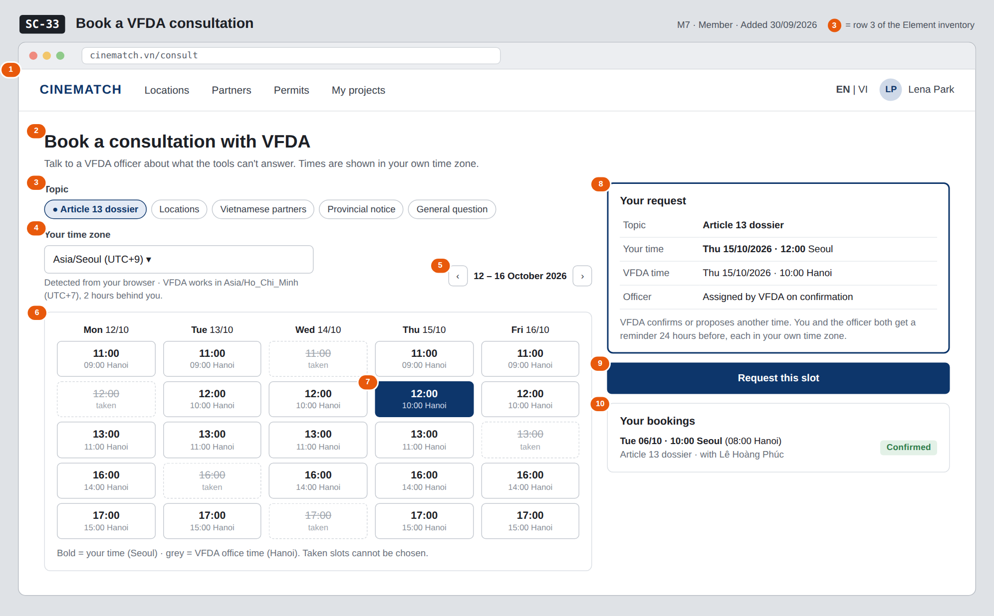
The image is the visual contract (layout, grouping, hierarchy); the tables below are the behavioural contract. All data in the mockup is sample data for one fictional project (The Last Ferry, Harbour Line Films); organisation names, people and phone numbers are examples, not real records.

3. Element inventory
# | Element | Type | Content / data source | Required | Validation
1 | Navigation bar | Header | static | — | —
2 | Title + purpose | Header + Text | static | — | —
3 | Topic | Toggle (single-select chips) | topic — ENUM(dossier, locations, partners, provincial_notice, general) | Yes | exactly one value of the enum
4 | Time zone | Toggle (dropdown) | timezone — IANA name, VARCHAR(40); default from the browser | Yes | must be a valid IANA time zone
5 | Week navigation | Button | static | — | past weeks disabled
6 | Slot grid | List (calendar) | offered slots for the week, each shown in the member's time zone with the Hanoi time below; taken slots greyed | — | past and taken slots cannot be chosen
7 | Selected slot | Toggle | slot_start — TIMESTAMPTZ stored in UTC | Yes | one slot; must still be free when sent
8 | Your request summary | Text | topic, time in timezone, time in Asia/Ho_Chi_Minh, officer (officer_id, empty until confirmed) | — | —
9 | Request this slot button | Button | creates the booking; returns booking_id | — | disabled until 3, 4 and 7 are set
10 | Your bookings list | List | the member's bookings: slot_start in timezone, topic, officer, booking_status — confirmed / rescheduled / waiting | — | upcoming first

4. States
State | What the user sees | Trigger
Default | Topic chips, time zone, week grid with the next available week, summary and Your bookings, as in the mockup. | Page opens
Empty (no data) | No free slot in the shown week: No free times this week with Next week ›. No bookings yet: Your bookings shows None yet. | 0 free slots / 0 bookings
Loading | Grey placeholders in the grid while a week loads; Request this slot shows Sending… and is disabled. | Week change / sending
Error | Slot taken meanwhile: That time was just booked — pick another; the grid refreshes. Unknown time zone: error under the field. Write failure: Couldn't send — nothing was booked, try again. | Conflict / validation / write error
Success / confirmation | Banner Request sent — VFDA will confirm and assign an officer; the booking appears under Your bookings as Waiting for VFDA. When VFDA confirms or reschedules, an in-app notification and email show the time in both time zones. | Booking created / VFDA response

5. Interactions and navigation
# | Element | User action | System response | Goes to screen
1 | Topic chip | tap | Selects the topic | stays
2 | Time zone dropdown | tap | Changes the zone; the grid and summary re-render in the new zone | stays
3 | ‹ / › week buttons | tap | Loads the previous / next week | stays
4 | Free slot | tap | Selects it and fills the summary | stays
5 | Request this slot | tap | Creates the booking, notifies VFDA staff | stays
6 | Log in (guest redirect) | tap | — | SC-04

6. Screen-level rules
Rule ID | Rule | Source
SR-361 | slot_start is stored in UTC with the member's IANA timezone; every time on screen and in messages is shown in the reader's own zone, with Hanoi time alongside for the member. | M7 FR-005
SR-362 | A booking is a request until VFDA staff confirm or reschedule it and assign an officer; the member sees the status. | M7 FR-006
SR-363 | Both sides get a reminder 24 hours before the consultation. | M7 FR-007
SR-364 | The topic is one of five fixed values so VFDA can route and count requests. | M7 §5.1 FR-005
SR-365 | Only signed-in members can book; a deactivated account has no access and cannot book. | SYS BR-005

7. Linked requirements
FR ID (from the module spec) | What this screen does for it
FR-005 · spec-M7.md (F-M7-05) | Book by topic and slot with time-zone handling
FR-006 · spec-M7.md (F-M7-06) | Show VFDA's confirmation / rescheduling and the assigned officer
FR-007 · spec-M7.md (F-M7-07) | Explain and trigger the 24-hour reminders

8. Responsive and accessibility notes
- Minimum supported width: 360px.
- Narrow screens: the week grid becomes one day at a time with day tabs; the summary and button stick to the bottom.
- Each slot is a button whose accessible name includes both times (e.g. Thursday 15 October, 12:00 Seoul, 10:00 Hanoi).
- Taken slots are disabled buttons with the word taken, not only a strike-through.

9. Open questions
# | Question | Blocking? | Status
1 | [NEEDS CLARIFICATION: Which days and hours does VFDA offer for consultations, and how long is one slot?] | Yes | Open
2 | [NEEDS CLARIFICATION: How is the consultation held (video call, phone, at the VFDA office) and who sends the joining details?] | No | Open

Completion checklist
- ☒ The mockup is a separate cropped image file, named with the Screen ID (img/SC-33.png).
- ☒ Every visible element in the mockup appears in the element inventory — machine-checked: badge numbers on the image = row numbers in section 3.
- ☒ Every input element has a validation rule or an explicit "—".
- ☒ All five states are filled in, or marked "Not applicable" with a reason.
- ☒ Every navigation target is a Screen ID that exists in docs/screen-list.md — machine-checked.
- ☒ Every element that displays data names the field it displays, matching docs/spec/spec-M7.md section 5.1.
- ☐ Checked by a person: (not signed — a Group C member compares the image with the tables and signs here)

DBIZ3 Session 4 · Group C · CINEMATCH. Built on the DBIZ2 Screen Design (Screen List and Screen Layout).

