Screen Spec: SC-36 Admin — Verification queue
DBIZ3 Session 4 template — one file per screen. The Screen ID is kept from the DBIZ2 Screen List. The mockup image stays an image; everything around it is text. Each orange numbered badge on the mockup is the row with the same number in section 3 (Element inventory).
Field | Value
Screen ID | SC-36
Screen name | Admin — Verification queue
Actor | VFDA Staff
Priority | Must
Belongs to module | docs/spec/spec-M4.md
Mockup image | img/SC-36.png
Status | Draft
Route: /admin/verification · Screen list file: M4, item #35 (Added 30/09/2026 — Must) · Design note from the screen list file: Review organisation verification.
Notes against Screen List v2.0
- New Screen Spec written on 30/09/2026; SC-36 was listed in the Screen List as a Must screen still without a mockup.

1. Purpose
Shown when: VFDA staff open Verification in the admin menu, or a new verification request email / in-app notification.
The user leaves this screen when: Staff approve or reject the selected request and move to the next one, or switch to another admin section.

2. Mockup
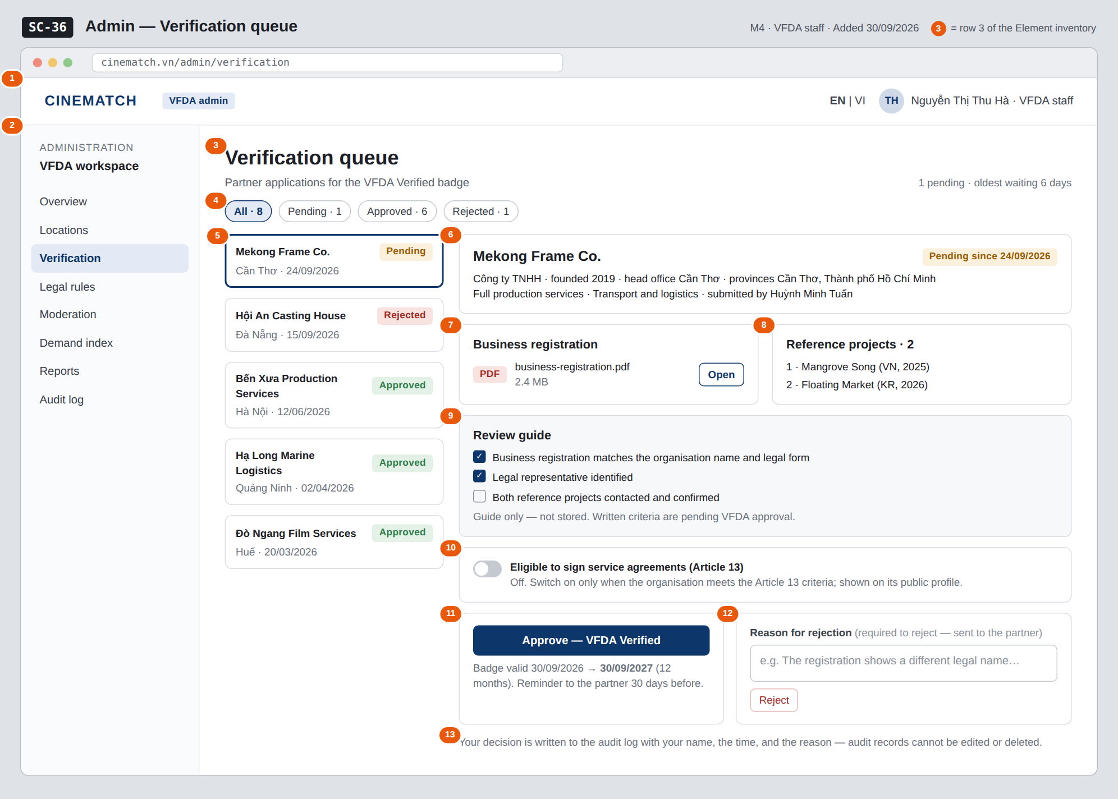
The image is the visual contract (layout, grouping, hierarchy); the tables below are the behavioural contract. All data in the mockup is sample data for one fictional project (The Last Ferry, Harbour Line Films); organisation names, people and phone numbers are examples, not real records.

3. Element inventory
# | Element | Type | Content / data source | Required | Validation
1 | Admin header | Header | static; signed-in staff name and role vfda_staff | — | —
2 | Admin menu | List | static; Verification selected | — | —
3 | Title + queue summary | Header + Text | count of pending requests and age of the oldest | — | —
4 | Status filter | Toggle (chips) | status_filter — ENUM(pending, approved, rejected) or All, with counts | No | enum values only
5 | Request list | List | queue — verification_request[]: organisation, head office, status, date | — | pending first, then newest decision first
6 | Organisation header of the selected request | Text | org_name, legal_form, founded_year, hq_province, province, service_groups, submitting user | Yes | —
7 | Business registration document | Text + Button | business_license (private storage) | Yes | opens in a new tab for staff only
8 | Reference projects | List | reference_projects | Yes | —
9 | Review guide | List (checkboxes) | static guide; ticks are not stored | — | —
10 | Eligible to sign service agreements (Article 13) switch | Toggle | art13_eligible | No | only vfda_staff / admin can change it
11 | Approve button + validity preview | Button + Text | decision = approved → verified, verified_at, verified_until = verified_at + 12 months | — | only for pending requests
12 | Rejection reason + Reject button | Input (text area) + Button | reason with decision = rejected | Yes (to reject) | Reject disabled while the reason is empty
13 | Audit log note | Text | static; audit record per decision (action, admin_id, target_id, logged_at) | — | —

4. States
State | What the user sees | Trigger
Default | Queue on the left with the oldest pending request selected; its documents, references, review guide, Article 13 switch and the two decision panels on the right, as in the mockup. | Page opens
Empty (no data) | No pending requests: Nothing waiting for review. The detail area is replaced by a short list of badges expiring in the next 30 days. | 0 pending with filter Pending
Loading | Grey placeholders in the list and detail; after a click on Approve / Reject both buttons are disabled until the save ends. | Loading / deciding
Error | Reject with an empty reason: A reason is required to reject under the field. Save failure: Decision not saved — nothing was changed and no audit record was written. Request already decided by a colleague: Lê Hoàng Phúc decided this request at 10:42 and the panel reloads read-only. | Validation / write error / concurrent decision
Success / confirmation | Green strip Mekong Frame Co. is VFDA Verified until 30/09/2027 — the partner has been notified, or Rejected — the reason was sent to the partner; the request moves to Approved / Rejected and the next pending request opens. | Decision saved

5. Interactions and navigation
# | Element | User action | System response | Goes to screen
1 | Status filter chip | tap | Re-filters the list | stays
2 | Request in the list | tap | Opens that request's detail; decided requests are read-only with decider, date and reason | stays
3 | Open business registration | tap | Opens the PDF in a new tab | stays
4 | Approve button | tap | Confirmation; sets verified_at, verified_until (+12 months), notifies the partner, writes the audit record | stays
5 | Reject button | tap | Saves the reason, notifies the partner, writes the audit record | stays
6 | Organisation name in the header | tap | Opens the public profile in a new tab | SC-20
7 | Moderation in the admin menu | tap | Opens the moderation queue | SC-38

6. Screen-level rules
Rule ID | Rule | Source
SR-351 | Only vfda_staff and admin can open this screen and decide; the list shows every organisation's requests. | M4 FR-009
SR-352 | Rejecting requires a written reason, which is sent to the partner; who decided and when is recorded. | M4 FR-010
SR-353 | An approved badge is valid 12 months from the decision; the badge states what was checked and what was not. | M4 BR-004
SR-354 | Every decision and every change of the Article 13 switch writes one audit record in the same transaction; audit records cannot be edited or deleted. | M10 BR-005
SR-355 | The review guide ticks are a working aid, not stored evidence, until VFDA's written criteria exist. | M4 §10 #2

7. Linked requirements
FR ID (from the module spec) | What this screen does for it
FR-009 · spec-M4.md (F-M4-09) | Queue of verification requests filterable by status
FR-010 · spec-M4.md (F-M4-10) | Approve or reject with a mandatory reason, recording who and when
FR-011 · spec-M4.md (F-M4-11) | Sets the 12-month validity that drives the reminder and expiry
FR-008 · spec-M10.md (F-M10-08) | Audit record for every decision

8. Responsive and accessibility notes
- Minimum supported width: 360px.
- Admin screens are designed for desktop; below 1024px the admin menu becomes a drop-down and the list and detail stack (list first).
- The Article 13 switch is a real switch role with its label; decision buttons have distinct text, not only colour.
- Focus moves to the next request's heading after a decision.

9. Open questions
# | Question | Blocking? | Status
1 | [NEEDS CLARIFICATION: Written criteria for awarding VFDA Verified.] | Yes | Open
2 | [NEEDS CLARIFICATION: Criteria for the eligible to sign a service agreement under Article 13 flag.] | Yes | Open

Completion checklist
- ☒ The mockup is a separate cropped image file, named with the Screen ID (img/SC-36.png).
- ☒ Every visible element in the mockup appears in the element inventory — machine-checked: badge numbers on the image = row numbers in section 3.
- ☒ Every input element has a validation rule or an explicit "—".
- ☒ All five states are filled in, or marked "Not applicable" with a reason.
- ☒ Every navigation target is a Screen ID that exists in docs/screen-list.md — machine-checked.
- ☒ Every element that displays data names the field it displays, matching docs/spec/spec-M4.md section 5.1.
- ☐ Checked by a person: (not signed — a Group C member compares the image with the tables and signs here)

DBIZ3 Session 4 · Group C · CINEMATCH. Built on the DBIZ2 Screen Design (Screen List and Screen Layout).

