Screen Spec: SC-37 Admin — Legal rule base
DBIZ3 Session 4 template — one file per screen. The Screen ID is kept from the DBIZ2 Screen List. The mockup image stays an image; everything around it is text. Each orange numbered badge on the mockup is the row with the same number in section 3 (Element inventory).
Field | Value
Screen ID | SC-37
Screen name | Admin — Legal rule base
Actor | VFDA Legal (Legal Board)
Priority | Must
Belongs to module | docs/spec/spec-M2.md
Mockup image | img/SC-37.png
Status | Draft
Route: /admin/legal-rules · Screen list file: M2, item #30 (Added 30/09/2026 — Must) · Design note from the screen list file: Write, sign, version rules.
Notes against Screen List v2.0
- Screen Spec added 30/09/2026. SC-37 is a Must screen that had no mockup (Screen List: Must screens still without a mockup). The M2 checks cannot run without it.

1. Purpose
Shown when: A VFDA Legal Board member signs in and chooses Legal rules in the admin menu (from SC-34 or any admin screen).
The user leaves this screen when: The officer moves to another admin screen through the menu (for example SC-41 to see the audit trail) or opens the public page of a rule (SC-31).

2. Mockup
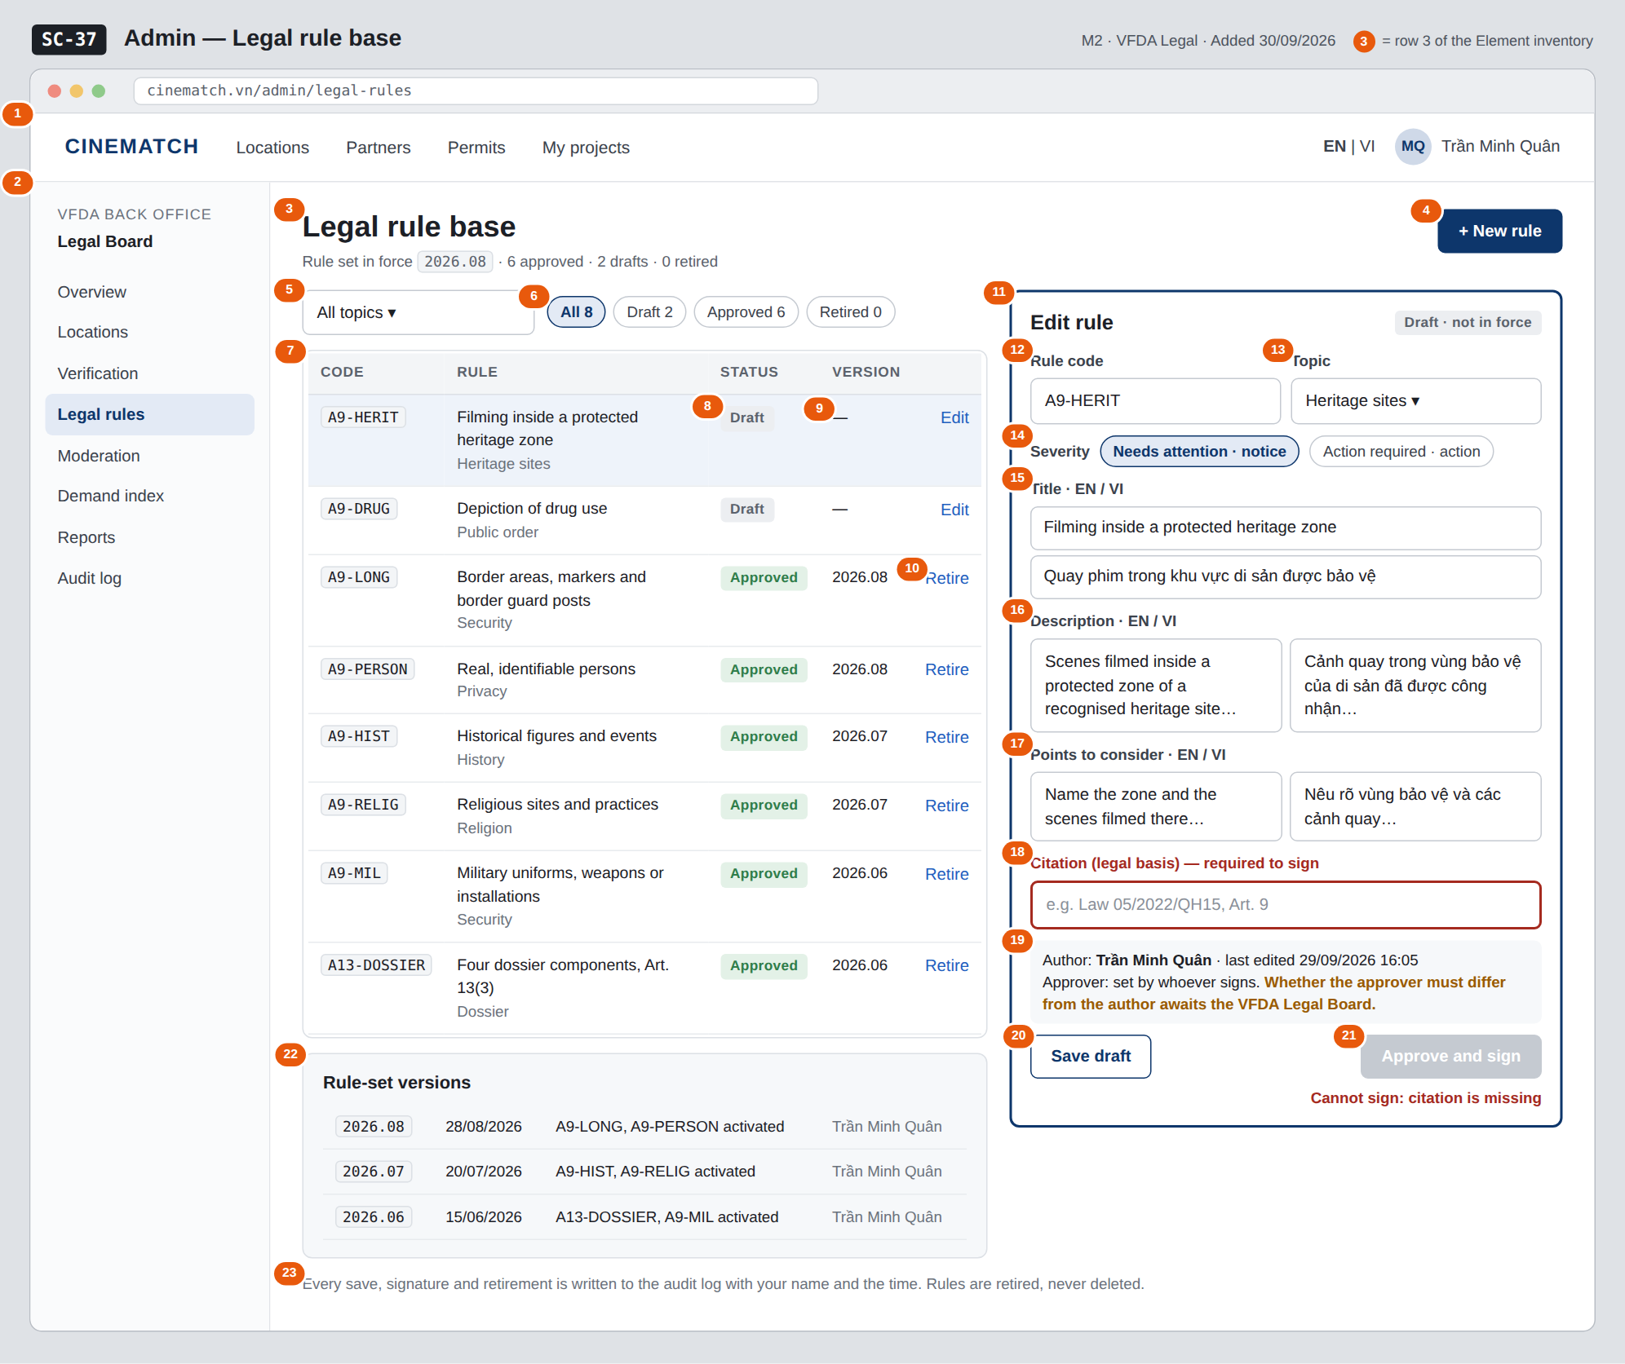
The image is the visual contract (layout, grouping, hierarchy); the tables below are the behavioural contract. All data in the mockup is sample data for one fictional project (The Last Ferry, Harbour Line Films); organisation names, people and phone numbers are examples, not real records.

3. Element inventory
# | Element | Type | Content / data source | Required | Validation
1 | Navigation bar | Header | static; signed in as a VFDA Legal Board member | — | —
2 | Admin menu | List | static; Legal rules selected | — | items shown according to the user's role
3 | Title + rule-set summary | Header | current rule_version; counts of legal_rule by status | — | —
4 | + New rule button | Button | static | — | opens an empty editor with status draft
5 | Topic filter | Toggle (dropdown) | filter_topic — security / history / religion / privacy / dossier / public_order / heritage | No | enum or All topics
6 | Status filter with counts | Toggle (single choice) | filter_status — draft / approved / retired | No | enum or All
7 | Rule table | List | legal_rule (legal_rule[]): rule_code, title_en, topic | — | visible to the vfda_legal role only (Row Level Security)
8 | Rule status | Text | status — Draft / Approved / Retired; Approved means is_active = true | — | enum
9 | Rule version | Text | version / rule_version in which the rule was activated | — | — for drafts
10 | Row action Edit / Retire | Link | draft → Edit; approved → Retire (confirmation dialog); retired → View | — | Retire needs a confirmation; retired rules are read-only
11 | Rule editor | Container | the selected rule | — | editable only while the rule is a draft
12 | Rule code | Input | rule_code | Yes | max 40 characters, capitals, digits and hyphens; unique
13 | Topic | Toggle (dropdown) | topic | Yes | one of the 7 topic values
14 | Severity | Toggle (single choice) | severity — notice (Needs attention) / action (Action required) | Yes | enum, 2 values
15 | Title EN / VI | Input (2 fields) | title_en, title_vi | Yes | max 200 characters each; both required
16 | Description EN / VI | Input (multi-line, 2 fields) | description_en, description_vi | Yes | both required
17 | Points to consider EN / VI | Input (multi-line, 2 fields) | guidance_en, guidance_vi | Yes | both required
18 | Citation | Input | citation | Yes | max 200 characters; required to sign — highlighted when missing
19 | Author and approver line | Text | author, last edit time; approver_id and approved_at once signed | — | —
20 | Save draft button | Button | static | — | enabled when a field changed
21 | Approve and sign button | Button | records approver_id, approved_at, sets is_active | — | disabled while citation or any required field is empty (database CHECK)
22 | Rule-set version history | List | rule_version, created_at, created_by and the rules activated in each | — | newest first; read-only
23 | Audit note | Text | static | — | always shown

4. States
State | What the user sees | Trigger
Default | All rules in the table, the selected rule in the editor, version history below the table. | Open /admin/legal-rules
Empty (no data) | No rules yet: the table shows No rules yet — create the first rule with + New rule; version history reads No rule set in force yet. A filter with no match shows No rules for this filter. | 0 rules / filter returns 0
Loading | Grey skeleton rows in the table; the editor shows a skeleton until the rule has loaded. | Loading rules
Error | Signing refused by the database: red strip Cannot sign — citation missing and the citation field outlined. Duplicate rule code: message under the code field. Save fails: Couldn't save — your text is kept. | CHECK constraint / unique constraint / write error
Success / confirmation | Signed: strip A9-HERIT signed — rule set 2026.09 is now in force, status turns Approved, a new row appears in the version history. Retired: status Retired, strip Rule retired — past results still show its text. Saved draft: Draft saved. | Sign / retire / save succeeded

5. Interactions and navigation
# | Element | User action | System response | Goes to screen
1 | Admin menu item | tap | Opens that admin screen | SC-34
2 | Topic / status filter | tap | Filters the table | stays
3 | Rule row / Edit | tap | Loads the rule into the editor | stays
4 | + New rule button | tap | Empty editor, status draft | stays
5 | Save draft button | tap | Saves the draft and writes an audit record | stays
6 | Approve and sign button | tap | Confirmation dialog; on confirm records the approver, activates the rule, creates a new rule-set version and writes an audit record | stays
7 | Retire link | tap | Confirmation dialog; on confirm sets status retired, removes the rule from future checks and writes an audit record | stays
8 | Rule code of an approved rule | tap | Opens its public page in a new tab | SC-31
9 | Audit note | tap | Opens the audit log filtered to legal rules (admin role) | SC-41

6. Screen-level rules
Rule ID | Rule | Source
SR-301 | A rule becomes active only when it has a citation and an approver; enforced by a database CHECK constraint, not only by the disabled button. | M2 BR-002, M2 FR-003 (F-M2-03)
SR-302 | Every activation creates a new rule-set version; every later check records the version it used. | M2 FR-004 (F-M2-04), M2 BR-007
SR-303 | Rules are retired, never deleted (status = retired); findings keep showing the text of the rule version they cited. There is no Delete action. | M2 BR-008
SR-304 | Only the VFDA Legal Board writes and signs rules; developers and the language model never change rule text. | M2 US-3, M2 BR-001
SR-305 | Every save, signature and retirement writes one audit record in the same transaction. | M10 BR-005 (F-M10-08)

7. Linked requirements
FR ID (from the module spec) | What this screen does for it
FR-001 · spec-M2.md (F-M2-01) | List rules filtered by topic and status
FR-002 · spec-M2.md (F-M2-02) | Create and edit bilingual rules with citation and severity
FR-003 · spec-M2.md (F-M2-03) | Sign (approve) a rule; activation refused without citation or approver
FR-004 · spec-M2.md (F-M2-04) | New rule-set version on every activation; version history
FR-008 · spec-M10.md (F-M10-08) | Audit record for every save, signature and retirement

8. Responsive and accessibility notes
- Minimum supported width: 360px (admin work is expected on desktop; below 1024px the editor opens full screen over the table).
- The admin menu collapses into a menu button on narrow screens.
- Required fields are marked in the label text, not only by colour; the missing citation message is linked to the field with aria-describedby.
- Sign and retire confirmations are dialogs with a focus trap.

9. Open questions
# | Question | Blocking? | Status
1 | [NEEDS CLARIFICATION: Must rule signing require two different people (author ≠ approver)?] | Yes | Open
2 | [NEEDS CLARIFICATION: when an approved rule needs a correction, is a new draft revision created while the signed text stays in force, and does retiring a rule also create a new rule-set version?] | Yes | Open
3 | [NEEDS CLARIFICATION: format of rule_version (the mockups use year.month, e.g. 2026.08) when more than one rule is signed in the same month] | No | Open

Completion checklist
- ☒ The mockup is a separate cropped image file, named with the Screen ID (img/SC-37.png).
- ☒ Every visible element in the mockup appears in the element inventory — machine-checked: badge numbers on the image = row numbers in section 3.
- ☒ Every input element has a validation rule or an explicit "—".
- ☒ All five states are filled in, or marked "Not applicable" with a reason.
- ☒ Every navigation target is a Screen ID that exists in docs/screen-list.md — machine-checked.
- ☒ Every element that displays data names the field it displays, matching docs/spec/spec-M2.md section 5.1.
- ☐ Checked by a person: (not signed — a Group C member compares the image with the tables and signs here)

DBIZ3 Session 4 · Group C · CINEMATCH. Built on the DBIZ2 Screen Design (Screen List and Screen Layout).

