Screen Spec: SC-38 Admin — Content moderation
DBIZ3 Session 4 template — one file per screen. The Screen ID is kept from the DBIZ2 Screen List. The mockup image stays an image; everything around it is text. Each orange numbered badge on the mockup is the row with the same number in section 3 (Element inventory).
Field | Value
Screen ID | SC-38
Screen name | Admin — Content moderation
Actor | VFDA Staff
Priority | Must
Belongs to module | docs/spec/spec-M10.md
Mockup image | img/SC-38.png
Status | Draft
Route: /admin/moderation · Screen list file: M10, item #38 (Added 30/09/2026 — Must (raised 01/10/2026, M10 FR-001–002)) · Design note from the screen list file: Queue of content awaiting review
Notes against Screen List v2.0
- New Screen Spec (30/09/2026). Written with the M10 Spec Document. Content types limited to org_profile and location_image; showcase waits for phase 2.

1. Purpose
Shown when: Staff click the Moderation queue tile or the menu item on SC-34, or open the admin menu from any admin screen.
The user leaves this screen when: Staff decide item after item and stay; View public profile opens SC-20 (or SC-16 for a location photo); the menu leads back to SC-34.

2. Mockup
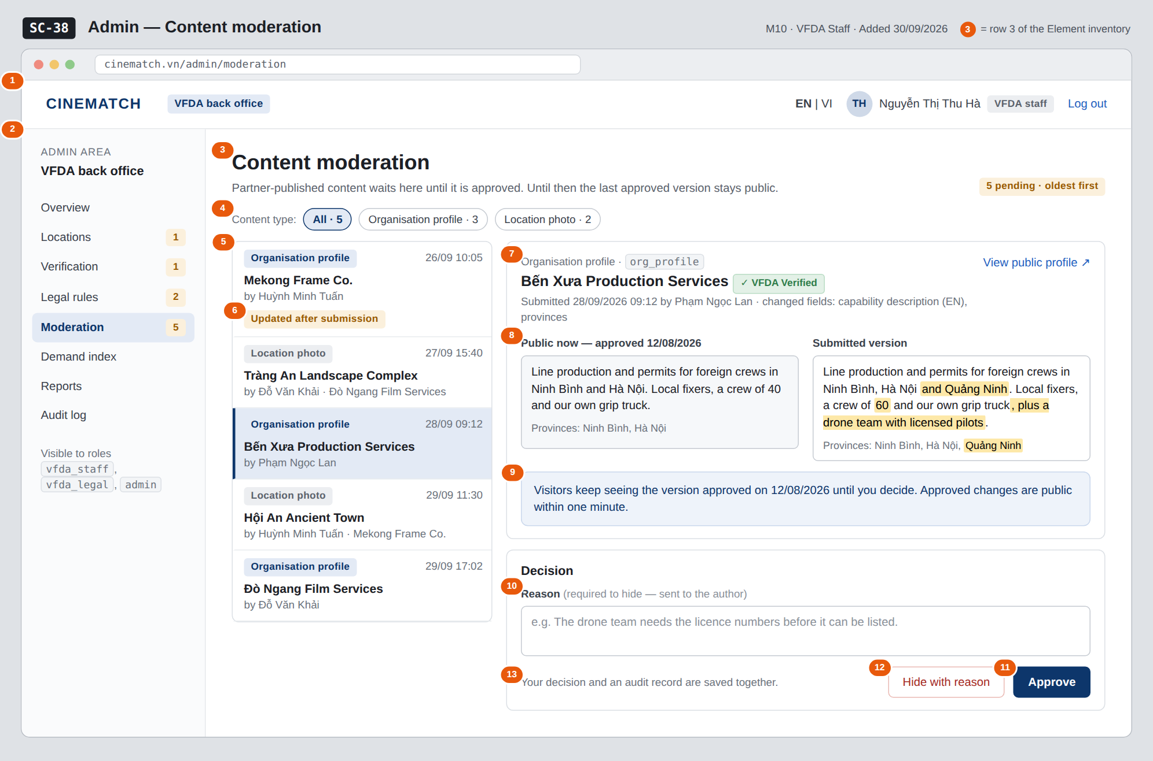
The image is the visual contract (layout, grouping, hierarchy); the tables below are the behavioural contract. All data in the mockup is sample data for one fictional project (The Last Ferry, Harbour Line Films); organisation names, people and phone numbers are examples, not real records.

3. Element inventory
# | Element | Type | Content / data source | Required | Validation
1 | Admin top bar | Header | static; signed-in user and role | — | —
2 | Admin menu | List | static; Moderation selected, pending count | — | —
3 | Title and pending count | Header | count of moderation_queue items with content_status = pending | Yes | —
4 | Content type filter | Toggle | content_type — All / Organisation profile (org_profile) / Location photo (location_image), with counts | No | enum; showcase not offered in this release
5 | Queue list | List | moderation_queue: content_type, target name, submitted_by → name, submitted_at | Yes | oldest submitted_at first
6 | Updated after submission label | Text | item edited again before review; queue keeps only the latest version | — | —
7 | Item header | Header + Link | content_id → organisation name or location name; submitted_by, submitted_at; changed fields | Yes | —
8 | Public now / submitted comparison | Text | last approved version vs submitted version (e.g. capability_desc_en, province); changes highlighted | Yes | for location_image: the photo with image_source and usage_right
9 | Public-version note | Text | date of the last approval of this content | Yes | —
10 | Reason | Input (multi-line) | reason | Required when hiding | required when decision = hidden; 10–1000 characters
11 | Approve button | Button | decision = approved → content_status = approved, audit_log_id | — | —
12 | Hide with reason button | Button | decision = hidden → content_status = hidden, reason sent to the author, audit_log_id | — | refused without a reason: A reason is required to hide content
13 | Audit note | Text | static | — | —

4. States
State | What the user sees | Trigger
Default | Queue on the left (oldest first), selected item on the right with the public and submitted versions side by side, reason box and the two decision buttons. | Screen opens; first item selected
Empty (no data) | Nothing waiting for review with the date of the last decision; the detail area is hidden. | No item with content_status = pending (or none of the filtered type)
Loading | Skeleton rows in the queue; the detail shows a skeleton while the item and its approved version load. Buttons are disabled while a decision is saving. | Queue loads / decision saving
Error | Hide without a reason: A reason is required to hide content under the reason box, nothing saved. Save failure: Decision not saved — nothing changed (decision and audit record are committed together or not at all). | Validation / write failure
Success / confirmation | Green strip Approved — public within one minute or Hidden — the reason was sent to Phạm Ngọc Lan; the item leaves the queue and the next one opens. | Decision saved

5. Interactions and navigation
# | Element | User action | System response | Goes to screen
1 | Content type chip | tap | Filters the queue | stays
2 | Queue item | tap | Opens the item in the detail area | stays
3 | View public profile | tap | Opens the public page (new tab) for an organisation profile | SC-20
4 | View public profile (location photo) | tap | Opens the location page (new tab) | SC-16
5 | Approve | tap | Saves approved, writes content.approve to the audit log, opens the next item | stays
6 | Hide with reason | tap | Checks the reason, saves hidden, notifies the author, writes the audit record, opens the next item | stays
7 | Admin menu | tap an item | Opens that admin screen | SC-34 / SC-35 / SC-36 / SC-37 / SC-38 / SC-39 / SC-40 / SC-41

6. Screen-level rules
Rule ID | Rule | Source
SR-381 | Partner-published profile text and photos are public only after approval; until then the last approved version stays public. | M10 BR-001
SR-382 | Hiding requires a written reason, which is sent to the author. | M10 BR-002
SR-383 | Every decision writes one audit record naming the staff member, the item and the time, in the same transaction as the decision. | M10 BR-005; F-M10-08
SR-384 | Only org_profile and location_image are moderated; locations themselves are published on SC-35. | Spec M10 §5.1 FR-001 note; §9
SR-385 | The queue is oldest first and keeps only the latest version of an item edited again before review, labelled Updated after submission. | Spec M10 §9 (test value); §3 edge cases

7. Linked requirements
FR ID (from the module spec) | What this screen does for it
FR-001 · spec-M10.md (F-M10-01) | Queue of content awaiting review, filter by type
FR-002 · spec-M10.md (F-M10-02) | Approve or hide with a reason
FR-008 · spec-M10.md (F-M10-08) | Audit record for each decision

8. Responsive and accessibility notes
- Minimum supported width: 360px.
- Narrow screens: the queue and the detail become two steps (list → item, with Back to queue); the two versions stack, Public now first.
- Highlighted changes are also marked for screen readers (inserted); colour is never the only signal.
- The reason box has a visible label and its error is announced (aria-live).

9. Open questions
# | Question | Blocking? | Status
1 | [NEEDS CLARIFICATION: Must profile edits by an already verified partner also go through moderation, or only the first publication?] | No | Open

Completion checklist
- ☒ The mockup is a separate cropped image file, named with the Screen ID (img/SC-38.png).
- ☒ Every visible element in the mockup appears in the element inventory — machine-checked: badge numbers on the image = row numbers in section 3.
- ☒ Every input element has a validation rule or an explicit "—".
- ☒ All five states are filled in, or marked "Not applicable" with a reason.
- ☒ Every navigation target is a Screen ID that exists in docs/screen-list.md — machine-checked.
- ☒ Every element that displays data names the field it displays, matching docs/spec/spec-M10.md section 5.1.
- ☐ Checked by a person: (not signed — a Group C member compares the image with the tables and signs here)

DBIZ3 Session 4 · Group C · CINEMATCH. Built on the DBIZ2 Screen Design (Screen List and Screen Layout).

