Screen Spec: SC-40 Admin — Quarterly report
DBIZ3 Session 4 template — one file per screen. The Screen ID is kept from the DBIZ2 Screen List. The mockup image stays an image; everything around it is text. Each orange numbered badge on the mockup is the row with the same number in section 3 (Element inventory).
Field | Value
Screen ID | SC-40
Screen name | Admin — Quarterly report
Actor | VFDA Staff
Priority | Should
Belongs to module | docs/spec/spec-M10.md
Mockup image | img/SC-40.png
Status | Draft
Route: /admin/reports · Screen list file: M10, item #40 (Added 30/09/2026 — Should) · Design note from the screen list file: Generate and export the PDF report
Notes against Screen List v2.0
- New Screen Spec (30/09/2026). Written with the M10 Spec Document; the reread gate (reread_by, M10 BR-004) is a Group C addition recorded in its §11.1.

1. Purpose
Shown when: Staff click Prepare quarterly report on SC-39, Prepare Q3 2026 report on SC-34, or Reports in the admin menu.
The user leaves this screen when: Staff export the PDF and stay; Open in demand index goes to SC-39; the menu leads elsewhere.

2. Mockup
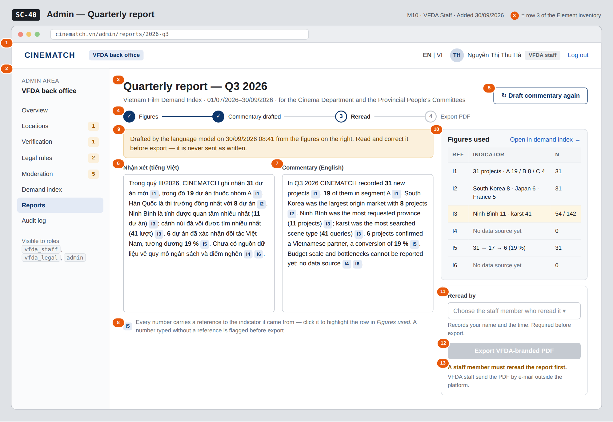
The image is the visual contract (layout, grouping, hierarchy); the tables below are the behavioural contract. All data in the mockup is sample data for one fictional project (The Last Ferry, Harbour Line Films); organisation names, people and phone numbers are examples, not real records.

3. Element inventory
# | Element | Type | Content / data source | Required | Validation
1 | Admin top bar | Header | static; signed-in user and role | — | —
2 | Admin menu | List | static; Reports selected | — | —
3 | Report title and period | Header | report_id → period (quarter, period_start–period_end) | Yes | —
4 | Progress steps | Text | Figures → Commentary drafted (narrative_vi, narrative_en) → Reread (reread_by) → Export (report_pdf_url) | — | —
5 | Draft commentary button | Button | calls the draft from demand_index (F-M10-06) | — | disabled when the period has no data
6 | Vietnamese commentary | Input (multi-line) | narrative_vi | Yes | not empty for export; every number keeps a reference to its indicator
7 | English commentary | Input (multi-line) | narrative_en | Yes | same as row 6
8 | Figure reference | Link | reference from a number to its indicator (I1–I6) in demand_index | Yes | a number without a reference is flagged before export
9 | Model-draft notice | Text | draft time; static wording | Yes | —
10 | Figures used panel | List | demand_index the draft was built from: value and sample size per indicator | Yes | same sample-size rule as SC-39 (M10 BR-003)
11 | Reread by | Toggle (dropdown) | reread_by — staff member (UUID) and time | Yes | a user with role vfda_staff
12 | Export VFDA-branded PDF button | Button | report_pdf_url | — | disabled until reread_by is set
13 | Export gate message | Text | static: A staff member must reread the report first | — | shown while reread_by is empty

4. States
State | What the user sees | Trigger
Default | Commentary drafted in both languages with a reference chip after every number, figures panel on the right, reread not yet recorded, export disabled with the gate message. | Draft exists, not reread
Empty (no data) | Period without data: No figures for this period — the report cannot be drafted; both editors and all buttons are disabled. | Every indicator below 5 records
Loading | Drafting commentary… in both editors; Building the PDF… on the export button. | Draft requested / export requested
Error | Model unavailable: Draft unavailable — write it by hand; editors stay empty and editable, figures and export still work. Export without reread: A staff member must reread the report first. | Model call fails / export refused
Success / confirmation | Green strip Report exported — VFDA_Q3-2026_demand-index.pdf with a download link; the export is written to the audit log; step 4 turns complete. | PDF exported

5. Interactions and navigation
# | Element | User action | System response | Goes to screen
1 | Figure reference chip | tap | Highlights the indicator row in Figures used | stays
2 | Open in demand index | tap | Opens the index for the same quarter | SC-39
3 | Draft commentary again | tap | Asks for confirmation, then replaces both drafts | stays
4 | Commentary editors | type | Saves the draft as the user types | stays
5 | Reread by | choose | Records reread_by and the time; enables export | stays
6 | Export VFDA-branded PDF | tap | Builds the PDF, stores report_pdf_url, writes the audit record, offers the download | stays
7 | Admin menu | tap an item | Opens that admin screen | SC-34 / SC-35 / SC-36 / SC-37 / SC-38 / SC-39 / SC-40 / SC-41

6. Screen-level rules
Rule ID | Rule | Source
SR-401 | A report can be exported only after a named staff member has marked it reread; the model draft is never sent as written. | M10 BR-004
SR-402 | Every number in the commentary carries a reference to the indicator it came from. | F-M10-06; Spec M10 §5.1 FR-006 note
SR-403 | Indicators with no data source are reported as such in the commentary, never estimated. | M10 BR-003; Spec M10 §10 question 1
SR-404 | Each export writes an audit record in the same transaction. | M10 BR-005; §3 US-3
SR-405 | The platform only produces the PDF; VFDA staff send it by e-mail outside the platform. | Spec M10 §1 Out of scope; §9

7. Linked requirements
FR ID (from the module spec) | What this screen does for it
FR-006 · spec-M10.md (F-M10-06) | Vietnamese and English commentary with figure references
FR-007 · spec-M10.md (F-M10-07) | Export of the reread report as a VFDA-branded PDF
FR-008 · spec-M10.md (F-M10-08) | Audit record for the export

8. Responsive and accessibility notes
- Minimum supported width: 360px.
- Narrow screens: the two editors become tabs (VI | EN); Figures used and the reread box move below the editors.
- Reference chips are links with text (indicator 5) for screen readers.
- The disabled export button carries the gate message as its accessible description.

9. Open questions
# | Question | Blocking? | Status
1 | [NEEDS CLARIFICATION: Who must reread and sign the quarterly report before it is sent — any staff member, or a named VFDA leader?] | No | Open
2 | [NEEDS CLARIFICATION: If the commentary is edited after the reread is recorded, must the reread be recorded again before export?] | No | Open

Completion checklist
- ☒ The mockup is a separate cropped image file, named with the Screen ID (img/SC-40.png).
- ☒ Every visible element in the mockup appears in the element inventory — machine-checked: badge numbers on the image = row numbers in section 3.
- ☒ Every input element has a validation rule or an explicit "—".
- ☒ All five states are filled in, or marked "Not applicable" with a reason.
- ☒ Every navigation target is a Screen ID that exists in docs/screen-list.md — machine-checked.
- ☒ Every element that displays data names the field it displays, matching docs/spec/spec-M10.md section 5.1.
- ☐ Checked by a person: (not signed — a Group C member compares the image with the tables and signs here)

DBIZ3 Session 4 · Group C · CINEMATCH. Built on the DBIZ2 Screen Design (Screen List and Screen Layout).

