Screen Spec: SC-41 Admin — Audit log
DBIZ3 Session 4 template — one file per screen. The Screen ID is kept from the DBIZ2 Screen List. The mockup image stays an image; everything around it is text. Each orange numbered badge on the mockup is the row with the same number in section 3 (Element inventory).
Field | Value
Screen ID | SC-41
Screen name | Admin — Audit log
Actor | Admin
Priority | Should
Belongs to module | docs/spec/spec-M10.md
Mockup image | img/SC-41.png
Status | Draft
Route: /admin/audit · Screen list file: M10, item #41 (Added 30/09/2026 — Should) · Design note from the screen list file: Search admin actions
Notes against Screen List v2.0
- New Screen Spec (30/09/2026). Written with the M10 Spec Document. The four typed filters replace the DBIZ2 filter JSONB (M10 §11.1).

1. Purpose
Shown when: An admin clicks Open audit log on SC-34 or Audit log in the admin menu.
The user leaves this screen when: The admin opens the target of a record (SC-38, SC-35 or SC-36) or leaves through the admin menu.

2. Mockup
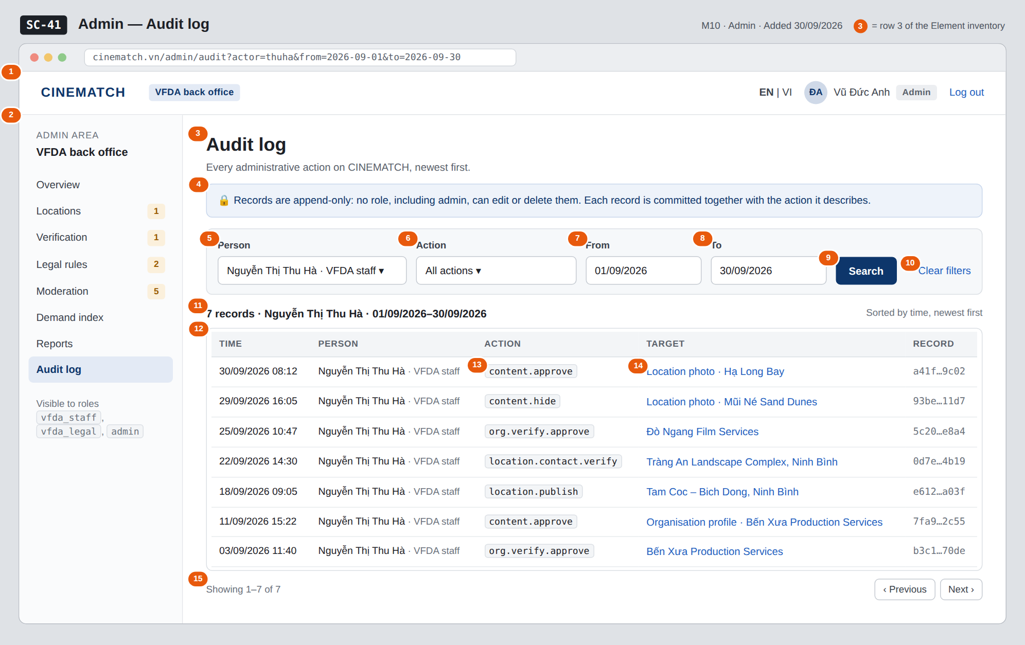
The image is the visual contract (layout, grouping, hierarchy); the tables below are the behavioural contract. All data in the mockup is sample data for one fictional project (The Last Ferry, Harbour Line Films); organisation names, people and phone numbers are examples, not real records.

3. Element inventory
# | Element | Type | Content / data source | Required | Validation
1 | Admin top bar | Header | static; signed-in user (Vũ Đức Anh) and role | — | —
2 | Admin menu | List | static; Audit log selected | — | Audit log shown to admin only
3 | Title | Header | static | — | —
4 | Append-only notice | Text | static | Yes | —
5 | Person filter | Toggle (dropdown, searchable) | actor_id — users with role vfda_staff, vfda_legal or admin | No | an existing user; empty = everyone
6 | Action filter | Toggle (dropdown) | action — action codes present in the log | No | max 60 characters; empty = all actions
7 | From | Input (date) | from_date | No | dd/mm/yyyy; on or before To
8 | To | Input (date) | to_date | No | dd/mm/yyyy; on or after From; not after today
9 | Search button | Button | runs the search → audit_entries | — | —
10 | Clear filters link | Link | static | — | —
11 | Result count and active filters | Text | count of audit_entries for the filters | Yes | —
12 | Results table | List | audit_entries: logged_at, admin_id → name and role, action, target_id, audit_log_id | Yes | newest logged_at first; no edit or delete control
13 | Action code | Text | action | Yes | e.g. content.approve, location.publish
14 | Target link | Link | target_id → readable label of the organisation, location, content item or rule | — | plain text when the target is no longer published or deactivated
15 | Pagination | Button | page of audit_entries | — | 50 records per page

4. States
State | What the user sees | Trigger
Default | Filters for person, action, from and to; the matching records newest first; append-only notice above — as in the mockup (Nguyễn Thị Thu Hà, September 2026). | Admin runs a search
Empty (no data) | No admin actions match these filters with a Clear filters link; the table is hidden. | No matching record
Loading | Skeleton rows in the table; the Search button shows a pending state. | Search running
Error | From after To: The start date must be on or before the end date under the date fields, no search sent. Search failure: The log could not be searched — try again. | Validation / query failure
Success / confirmation | Not applicable — the audit log is read-only; no action on this screen writes data. | —

5. Interactions and navigation
# | Element | User action | System response | Goes to screen
1 | Filters + Search | tap | Runs the search with the four typed filters | stays
2 | Clear filters | tap | Resets the filters and shows the latest records | stays
3 | Target link (content item) | tap | Opens the moderation item | SC-38
4 | Target link (location) | tap | Opens the location in the admin list | SC-35
5 | Target link (organisation) | tap | Opens the organisation's verification record | SC-36
6 | Previous / Next | tap | Pages through the results | stays
7 | Admin menu | tap an item | Opens that admin screen | SC-34 / SC-35 / SC-36 / SC-37 / SC-38 / SC-39 / SC-40 / SC-41

6. Screen-level rules
Rule ID | Rule | Source
SR-411 | Audit records are append-only: no role, including admin, can update or delete them; the screen offers no edit or delete control. | M10 BR-005
SR-412 | One record is written for every administrative action by a database trigger in the same transaction; an action whose record fails is rolled back. | F-M10-08; Spec M10 §4.3, §3 edge cases
SR-413 | Search is available to the role admin only. | F-M10-09 (actor Admin)
SR-414 | Results are listed newest first and filtered only by person, action type, from and to. | Spec M10 §3 US-4; §11.1
SR-415 | Records about accounts that were deleted keep their entries; the person appears as Former member after anonymisation. | SYS BR-005

7. Linked requirements
FR ID (from the module spec) | What this screen does for it
FR-008 · spec-M10.md (F-M10-08) | Records written for every admin action (shown here)
FR-009 · spec-M10.md (F-M10-09) | Search by person, action type and time

8. Responsive and accessibility notes
- Minimum supported width: 360px.
- Narrow screens: filters stack in one column behind a Filters button; each record becomes a card (time, person, action, target).
- The table has a caption and header cells (th scope); action codes are also read as text.
- Date fields accept typed dates as well as the picker.

9. Open questions
# | Question | Blocking? | Status
1 | [NEEDS CLARIFICATION: How long are audit records kept (proposed: for the life of the platform)?] | No | Open
2 | [NEEDS CLARIFICATION: The specs name only the action codes content.approve and location.publish; the full list of action codes (verification, contact check, hide, role grant, rule signing, report export) must be fixed before the Action filter can be built.] | No | Open

Completion checklist
- ☒ The mockup is a separate cropped image file, named with the Screen ID (img/SC-41.png).
- ☒ Every visible element in the mockup appears in the element inventory — machine-checked: badge numbers on the image = row numbers in section 3.
- ☒ Every input element has a validation rule or an explicit "—".
- ☒ All five states are filled in, or marked "Not applicable" with a reason.
- ☒ Every navigation target is a Screen ID that exists in docs/screen-list.md — machine-checked.
- ☒ Every element that displays data names the field it displays, matching docs/spec/spec-M10.md section 5.1.
- ☐ Checked by a person: (not signed — a Group C member compares the image with the tables and signs here)

DBIZ3 Session 4 · Group C · CINEMATCH. Built on the DBIZ2 Screen Design (Screen List and Screen Layout).

