Screen Spec: SC-42 Privacy policy
DBIZ3 Session 4 template — one file per screen. The Screen ID is kept from the DBIZ2 Screen List. The mockup image stays an image; everything around it is text. Each orange numbered badge on the mockup is the row with the same number in section 3 (Element inventory).
Field | Value
Screen ID | SC-42
Screen name | Privacy policy
Actor | Guest
Priority | Must
Belongs to module | docs/spec/spec-SYS.md
Mockup image | img/SC-42.png
Status | Draft
Route: /privacy · Screen list file: SYS, item #25 (Added 30/09/2026 — Must) · Design note from the screen list file: Bilingual, consent recorded.
Notes against Screen List v2.0
- New Screen Spec written 30/09/2026. The policy text in the mockup is a short placeholder, marked as a draft for review by the VFDA Legal Board.

1. Purpose
Shown when: Anyone clicks Privacy policy in the page footer, in the consent line of SC-04, or in Documents you accepted on SC-08.
The user leaves this screen when: The reader goes back, opens SC-04 to create an account, SC-08 to delete an account, or SC-43.

2. Mockup
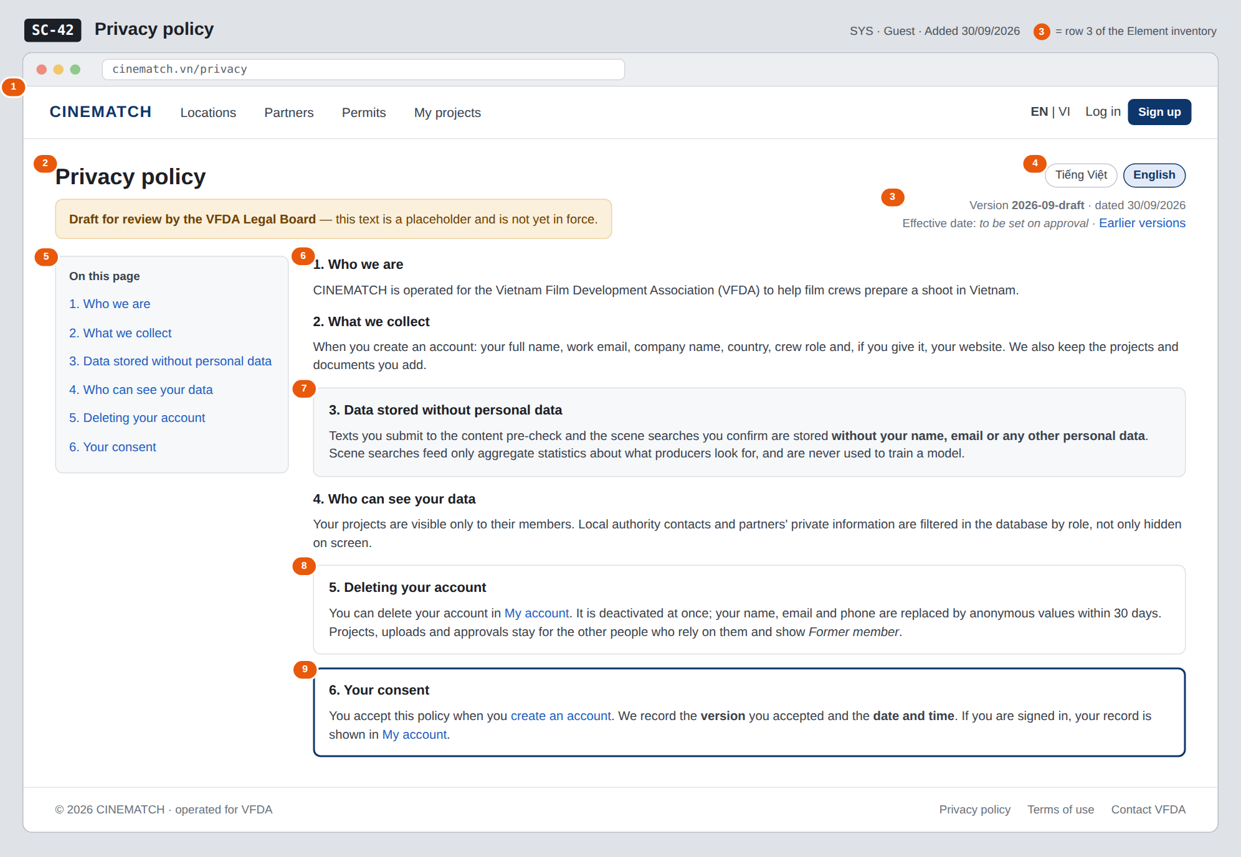
The image is the visual contract (layout, grouping, hierarchy); the tables below are the behavioural contract. All data in the mockup is sample data for one fictional project (The Last Ferry, Harbour Line Films); organisation names, people and phone numbers are examples, not real records.

3. Element inventory
# | Element | Type | Content / data source | Required | Validation
1 | Navigation bar | Header | static; logged out or in | — | —
2 | Title + draft banner | Header | static; banner shown while the version is a draft | Yes | —
3 | Version and date | Text | document version = consent_version value; date of the version | Yes | ≤ 20 characters
4 | Language switch VI / EN | Toggle | locale | Yes | enum vi / en
5 | Table of contents | List | section headings of the current version | — | —
6 | Policy sections | Text | policy text of the current version, per locale | Yes | both languages must exist before publishing
7 | Data stored without personal data section | Text | static text of the current version | Yes | —
8 | Deleting your account section | Text + link | static text of the current version | Yes | —
9 | Your consent box | Text + link | signed in: consent_version + acceptance timestamp; guest: explanation | Yes | —

4. States
State | What the user sees | Trigger
Default | Current version in the user's language, table of contents on the left, draft banner while the Legal Board has not approved it. | Open /privacy
Empty (no data) | Not applicable — the page is static text; publishing requires both language versions. | —
Loading | Not applicable — the page is rendered on the server with its text; switching language reloads it in place. | —
Error | Requested earlier version not found: This version does not exist — showing the current version. | Unknown ?version= parameter
Success / confirmation | Signed in: the consent box reads You accepted version 2026-09-draft on 18/09/2026 at 10:42. | Signed-in user with a consent record

5. Interactions and navigation
# | Element | User action | System response | Goes to screen
1 | Language switch | tap | Shows the same version in the other language, keeps the scroll position | stays
2 | Table of contents entry | tap | Scrolls to the section | stays
3 | Earlier versions | tap | Lists past versions with dates; opens one read-only | stays
4 | My account link | tap | Signed in: opens the account page; guest: log in first | SC-08
5 | create an account link | tap | — | SC-04
6 | Footer Terms of use | tap | — | SC-43

6. Screen-level rules
Rule ID | Rule | Source
SR-251 | Acceptance is stored with the document version and timestamp; the page always shows which version is current. | SYS BR-003
SR-252 | Pre-check texts and confirmed scene searches are described as stored without personal data and never used to train a model. | M3 BR-009; M2 FR-007
SR-253 | Account deletion is described exactly as decided: deactivated at once, anonymised within 30 days, records kept as Former member. | SYS BR-005
SR-254 | The text is shown in Vietnamese and English; a version is published only when both languages exist. | SYS FR-005; FR-006
SR-255 | The text is a draft until approved by the VFDA Legal Board; the draft banner stays until then. | Group C decision 30/09/2026

7. Linked requirements
FR ID (from the module spec) | What this screen does for it
FR-001 · spec-SYS.md (F-SYS-01) | Policy accepted at sign-up; version recorded in consent_version
FR-005 · spec-SYS.md (F-SYS-05) | Show the policy in Vietnamese or English

8. Responsive and accessibility notes
- Minimum supported width: 360px.
- Narrow screens: the table of contents becomes a collapsible On this page menu above the text.
- Headings use a proper outline (h1 → h3) so screen readers can jump between sections.
- Line length is kept under about 80 characters for readability.

9. Open questions
# | Question | Blocking? | Status
1 | [NEEDS CLARIFICATION: How long are pre-check texts kept, and may they be used to improve the rule base? (same question as spec-M2.md question 6)] | Yes | Open
2 | [NEEDS CLARIFICATION: Does one consent_version cover both the privacy policy and the terms of use, or does each document need its own version and acceptance record?] | No | Open

Completion checklist
- ☒ The mockup is a separate cropped image file, named with the Screen ID (img/SC-42.png).
- ☒ Every visible element in the mockup appears in the element inventory — machine-checked: badge numbers on the image = row numbers in section 3.
- ☒ Every input element has a validation rule or an explicit "—".
- ☒ All five states are filled in, or marked "Not applicable" with a reason.
- ☒ Every navigation target is a Screen ID that exists in docs/screen-list.md — machine-checked.
- ☒ Every element that displays data names the field it displays, matching docs/spec/spec-SYS.md section 5.1.
- ☐ Checked by a person: (not signed — a Group C member compares the image with the tables and signs here)

DBIZ3 Session 4 · Group C · CINEMATCH. Built on the DBIZ2 Screen Design (Screen List and Screen Layout).

