Screen Spec: SC-43 Terms of use
DBIZ3 Session 4 template — one file per screen. The Screen ID is kept from the DBIZ2 Screen List. The mockup image stays an image; everything around it is text. Each orange numbered badge on the mockup is the row with the same number in section 3 (Element inventory).
Field | Value
Screen ID | SC-43
Screen name | Terms of use
Actor | Guest
Priority | Must
Belongs to module | docs/spec/spec-SYS.md
Mockup image | img/SC-43.png
Status | Draft
Route: /terms · Screen list file: SYS, item #26 (Added 30/09/2026 — Must) · Design note from the screen list file: Bilingual.
Notes against Screen List v2.0
- New Screen Spec written 30/09/2026. The terms text in the mockup is a short placeholder, marked as a draft for review by the VFDA Legal Board. The mockup shows a signed-in visitor so the acceptance record (row 8) is visible.

1. Purpose
Shown when: Anyone clicks Terms of use in the page footer, in the consent line of SC-04, or in Documents you accepted on SC-08.
The user leaves this screen when: The reader goes back, opens SC-04 to create an account, SC-08, or SC-42.

2. Mockup
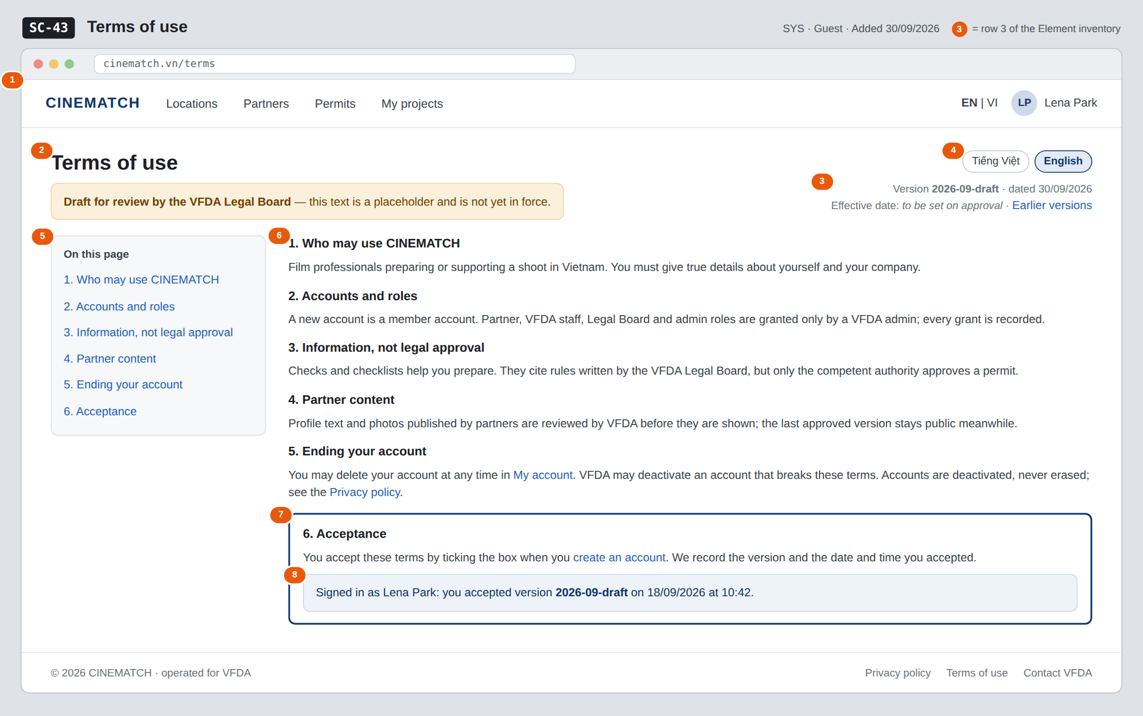
The image is the visual contract (layout, grouping, hierarchy); the tables below are the behavioural contract. All data in the mockup is sample data for one fictional project (The Last Ferry, Harbour Line Films); organisation names, people and phone numbers are examples, not real records.

3. Element inventory
# | Element | Type | Content / data source | Required | Validation
1 | Navigation bar | Header | static; logged out or in | — | —
2 | Title + draft banner | Header | static; banner shown while the version is a draft | Yes | —
3 | Version and date | Text | document version = consent_version value; date of the version | Yes | ≤ 20 characters
4 | Language switch VI / EN | Toggle | locale | Yes | enum vi / en
5 | Table of contents | List | section headings of the current version | — | —
6 | Terms sections | Text | terms text of the current version, per locale | Yes | both languages must exist before publishing
7 | Acceptance section | Text + link | static text of the current version | Yes | —
8 | Acceptance record | Text | consent_version + acceptance timestamp of the signed-in user | — | shown to signed-in users only

4. States
State | What the user sees | Trigger
Default | Current version in the user's language, table of contents, draft banner while not approved. | Open /terms
Empty (no data) | Not applicable — static text; a version is published only with both languages. | —
Loading | Not applicable — rendered on the server with its text. | —
Error | Requested earlier version not found: This version does not exist — showing the current version. | Unknown ?version= parameter
Success / confirmation | Signed in: row 8 shows the version and time the user accepted. If that is older than the current version, it reads You accepted an earlier version (…) with a link to it. | Signed-in user with a consent record

5. Interactions and navigation
# | Element | User action | System response | Goes to screen
1 | Language switch | tap | Shows the same version in the other language, keeps the scroll position | stays
2 | Table of contents entry | tap | Scrolls to the section | stays
3 | My account link | tap | Signed in: opens the account page; guest: log in first | SC-08
4 | Privacy policy link | tap | — | SC-42
5 | create an account link | tap | — | SC-04

6. Screen-level rules
Rule ID | Rule | Source
SR-261 | Acceptance is recorded with the version and timestamp at sign-up; the terms box on SC-04 must be ticked to create an account. | SYS BR-003; FR-001
SR-262 | The text states that partner and VFDA roles are granted only by an admin. | SYS BR-002
SR-263 | The text never calls a check result approved, accepted, legally compliant or safe. | M2 BR-003
SR-264 | The text matches the decided behaviour for partner content and account deletion. | M10 BR-001; SYS BR-005
SR-265 | The text is a draft until approved by the VFDA Legal Board; shown in Vietnamese and English. | SYS FR-005; Group C decision 30/09/2026

7. Linked requirements
FR ID (from the module spec) | What this screen does for it
FR-001 · spec-SYS.md (F-SYS-01) | Terms accepted at sign-up; version recorded in consent_version
FR-005 · spec-SYS.md (F-SYS-05) | Show the terms in Vietnamese or English

8. Responsive and accessibility notes
- Minimum supported width: 360px.
- Narrow screens: the table of contents becomes a collapsible On this page menu above the text.
- Headings use a proper outline (h1 → h3).
- The acceptance record is plain text, not colour-only.

9. Open questions
# | Question | Blocking? | Status
1 | [NEEDS CLARIFICATION: When the terms get a new version, must existing members accept it again (e.g. at their next sign-in) before continuing?] | No | Open

Completion checklist
- ☒ The mockup is a separate cropped image file, named with the Screen ID (img/SC-43.png).
- ☒ Every visible element in the mockup appears in the element inventory — machine-checked: badge numbers on the image = row numbers in section 3.
- ☒ Every input element has a validation rule or an explicit "—".
- ☒ All five states are filled in, or marked "Not applicable" with a reason.
- ☒ Every navigation target is a Screen ID that exists in docs/screen-list.md — machine-checked.
- ☒ Every element that displays data names the field it displays, matching docs/spec/spec-SYS.md section 5.1.
- ☐ Checked by a person: (not signed — a Group C member compares the image with the tables and signs here)

DBIZ3 Session 4 · Group C · CINEMATCH. Built on the DBIZ2 Screen Design (Screen List and Screen Layout).

